1. Key Performance Indicators (KPI) achievement by each of officers observed at 3 monthly intervals. Structured Excel format is a tool used to monitor. Each Excel sheet is labelled according to the different components of activities, liked shown in the sheet below where ‘B’ for publication and ‘G’ for presentation.

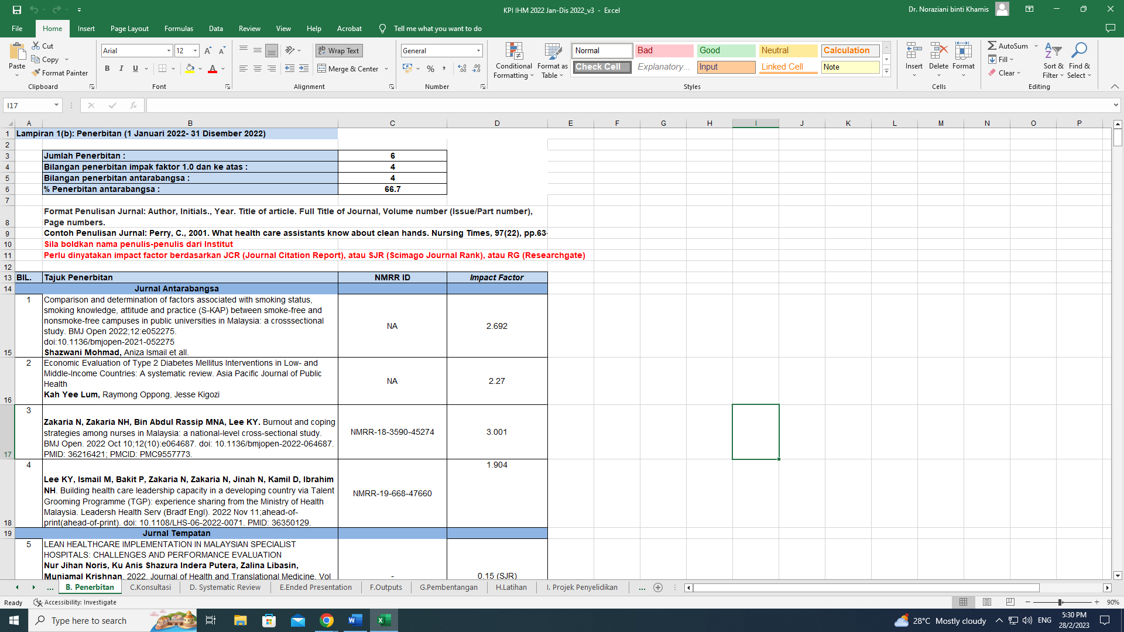

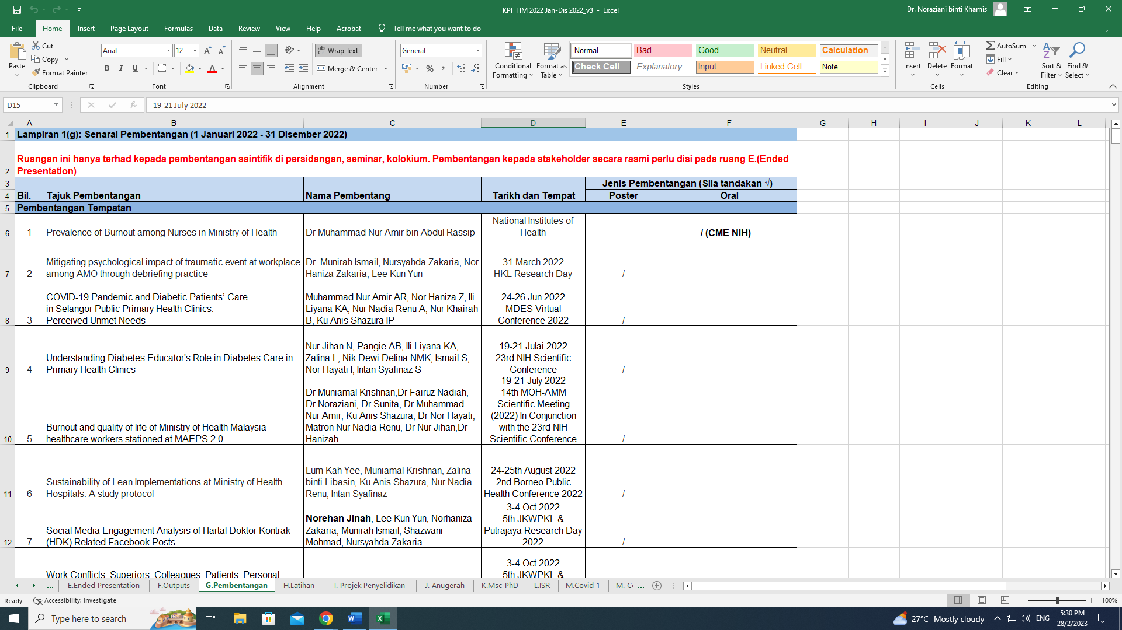

1. Financial and accounts management committee meetings conducted periodically every 3 months at the NIH level. Achievement of expenditure performance by end of year is as showed in the bar graph, which is also part of a review meeting material.

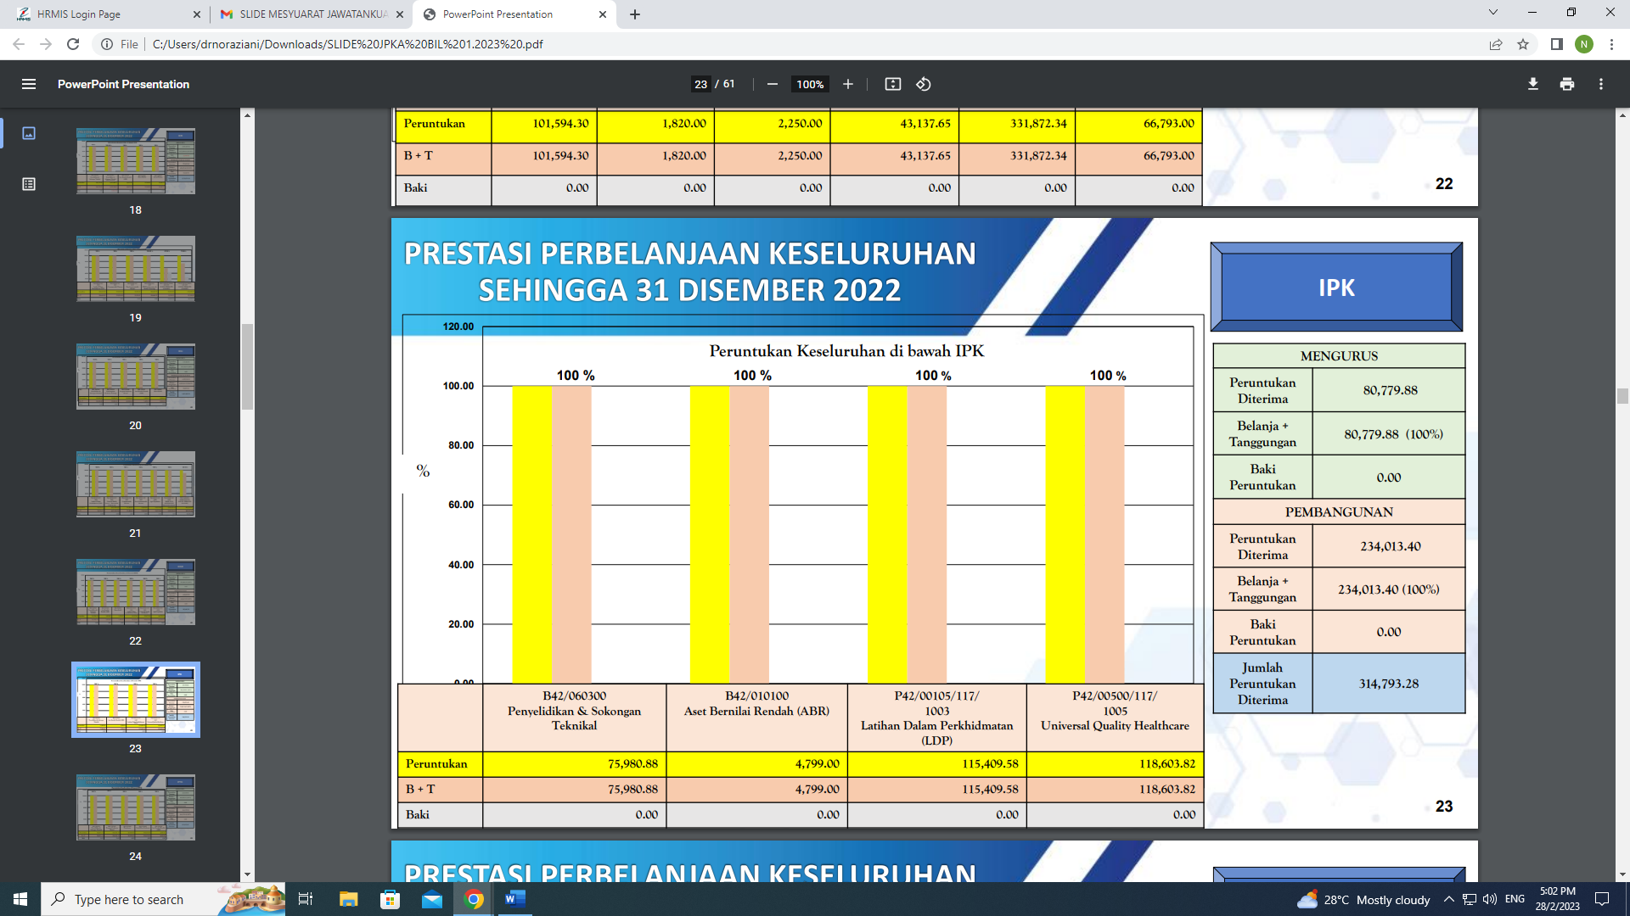

1. SKU implementation replaces SKT along with *MyPerformance* system and LNPT as an annual appraisal method were introduced for the first time by the JPA in 2022. The challenge includes that each different centre having a unique scope of work and yet the output needed to be monitored, recorded and scored collectively at organizational level, in which it makes up the total achievement for the head of the organization. Gantt chart guided the managers to carried out the tasks effectively.

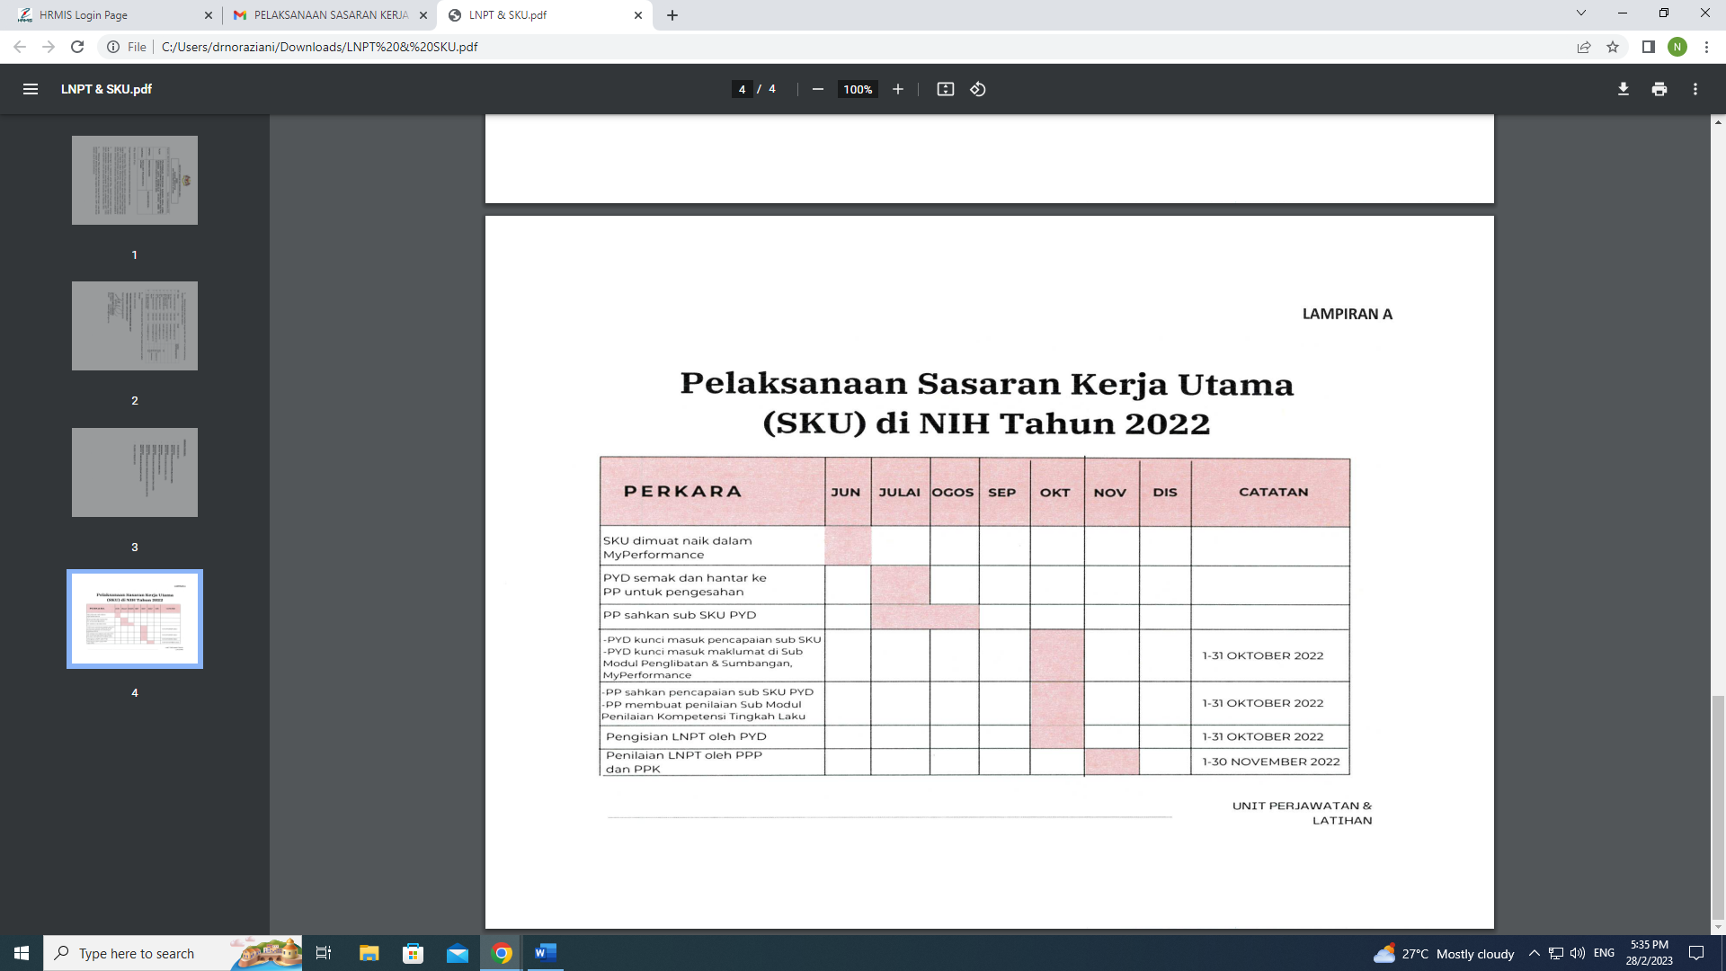

1. The preparation of a newly introduced system, SKU was challenged by the criteria of having to limit the number of different types of SKU statements or choices. SubSKU were further classified according to different categories. Some part of the SKU Statements, the target, the formula assigned to it and the achievement for year 2022 is as shown below.

