

Meir Gamla, ID: 311486781
Instructor: Dr. Avi Matza
March 2026
Bayesian Methods in Machine Learning
Department of Data Science, HIT
Speech Denoising: A Comparison Between Bayesian and Deterministic Neural Networks
Project Report

ABSTRACT
Speech enhancement in noisy environments is a challenging task, especially when models face unseen noise. Standard deterministic Deep Neural Networks (DNNs) perform well in speech denoising, but they can easily overfit to the training data and cannot measure their own uncertainty. This project explores Bayesian Neural Networks (BNNs) to address these limitations. By using probability distributions for their weights instead of fixed values, BNNs provide a mathematical framework for uncertainty estimation. In this study, a BNN is compared to a standard DNN baseline. Both models are trained and evaluated on the TIMIT acoustic-phonetic corpus, corrupted primarily by wind noise, and are also tested against an out-of-distribution (OOD) unseen noise. Performance is measured using the Perceptual Evaluation of Speech Quality [1] and Short-Time Objective Intelligibility [2] metrics. The experimental results demonstrate the practical utility of BNNs, highlighting their unique capability to quantify predictive uncertainty and manage the model's lack of knowledge when exposed to unfamiliar acoustic conditions.

INTRODUCTION
Single-channel speech enhancement aims to extract clean speech from a noisy background. In recent years, data-driven approaches based on Deep Neural Networks (DNNs) have become very popular for this task [3]. However, standard DNNs learn a single, fixed set of weights. As a result, they produce a single point estimate for their predictions without any measure of confidence or uncertainty. Because of this structural limitation, they often struggle to generalize to unseen noise conditions and cannot indicate when they are making unreliable predictions on out-of-distribution (OOD) data [4].
Bayesian Neural Networks (BNNs) offer a solution to these problems [5]. Instead of finding one optimal set of weights, BNNs maintain a probability distribution over the network parameters. This allows the model to output a range of possible predictions, providing a measure of "epistemic uncertainty" (uncertainty due to limited data). This characteristic is very useful for reducing overfitting and identifying unfamiliar noise patterns [6].
This project investigates the effectiveness of BNNs for speech denoising compared to a standard DNN. The main goal is to evaluate if the Bayesian approach improves generalization in unseen acoustic environments. The models are evaluated on the TIMIT corpus [7] mixed with wind noise. While standard loss functions like Mean Squared Error (MSE) are used for training, they do not perfectly reflect human hearing. Therefore, the final enhancement quality and intelligibility are evaluated using PESQ and STOI metrics.

RELATED WORK
Historically, single-channel speech enhancement relied heavily on classical statistical signal processing techniques, such as spectral subtraction and Wiener filtering [3]. While these conventional methods are computationally efficient and well-understood mathematically, they often rely on stationary noise assumptions. Consequently, they struggle to adapt to highly non-stationary real-world corruptions like wind noise, sometimes introducing unnatural artifacts known as 'musical noise'. To overcome these limitations, recent years have seen a massive shift toward data-driven approaches based on Deep Neural Networks (DNNs), which have established new state-of-the-art benchmarks in this domain.
Many recent studies use DNNs to map noisy speech features to clean speech targets [8] (and see also in [9] for general denoising). To tackle highly non-stationary real-world noises, such as wind noise, researchers often rely on complex architectures like Deep Recurrent Neural Networks (RNNs) [10] or Fully Convolutional Neural Networks (FCNNs) [8]. While these architectures achieve impressive raw denoising performance, a major challenge remains: deterministic models trained on specific background noises often experience a significant drop in reliability when tested on new, unseen acoustic conditions. To address this, some studies have proposed using Monte Carlo dropout to estimate model uncertainty. By leveraging this uncertainty metric to dynamically select the most reliable predictions, and by utilizing dropout as a regularizer, they effectively improved the system's robustness on unseen noises [4].
Probabilistic and generative models offer a more robust framework for handling condition mismatches. For instance, Denoising Variational Autoencoders (VAEs) have been successfully employed to model latent speech representations and handle unseen noise in a Bayesian manner [11]. Bayesian Neural Networks (BNNs) take the concept of uncertainty directly to the model's parameters by learning full probability distributions for the weights. While traditionally computationally expensive, modern approximation methods like Variational Inference have made BNNs practical [12]. BNNs have shown superior performance in detecting anomalies and handling imbalanced datasets in various acoustic tasks [13].
Evaluating speech enhancement models requires careful selection of metrics. Standard mathematical metrics, such as Mean Squared Error (MSE), are highly useful for calculating gradients during the neural network training phase. However, MSE only measures the mathematical distance between spectrograms and does not correlate well with how the human ear perceives sound quality. For this reason, modern speech enhancement research relies on objective perceptual metrics. The PESQ metric [1] is widely used to evaluate overall speech quality, while STOI [2] is designed specifically to measure speech intelligibility. Both metrics provide a much more accurate representation of the model's true effectiveness in real-world scenarios.

METHODOLOGY
- Dataset and Feature Extraction
The models are trained and evaluated using speech samples from the widely used TIMIT acoustic-phonetic continuous speech corpus [14]. To simulate realistic adverse conditions, the clean speech samples are artificially corrupted by adding wind noise at various Signal-to-Noise Ratio (SNR) levels. Wind noise was specifically selected because it is a highly non-stationary and notoriously difficult corruption source that significantly degrades speech intelligibility in real-world environments, often requiring specialized recurrent models to mitigate [10].
When designing the data pipeline, feature extraction via the Short-Time Fourier Transform (STFT) was selected over processing raw audio waveforms to maintain a computationally feasible architecture. The STFT transforms the audio into the frequency domain, explicitly separating the frequency components. Both the clean and noisy audio signals are transformed to yield magnitude and phase spectrograms. The phase is bypassed and reused later for waveform reconstruction, while the networks operate exclusively on sliding windows of the magnitude spectrograms to capture local temporal context.
- Deterministic Baseline Architecture (DNN)
To establish a clear baseline, a straightforward deterministic Deep Neural Network (DNN) is implemented. The architecture is intentionally kept simple to isolate the conceptual differences between standard and Bayesian learning, rather than optimizing for state-of-the-art enhancement performance. The network consists of a standard feed-forward Multi-Layer Perceptron (MLP). It contains three hidden layers, each with 256 neurons, followed by Rectified Linear Unit (ReLU) activation functions. The final output layer projects the latent representation back into the original frequency bin dimensions, applying a ReLU activation to ensure non-negative magnitude values.
- Bayesian Neural Network Architecture (BNN)
The Bayesian Neural Network (BNN) mirrors the exact layer structure and hidden dimensions of the baseline DNN. However, standard linear layers are replaced with Bayesian linear layers [5]. Instead of learning a single point estimate for each weight and bias, the BNN learns a probability distribution for every parameter. These distributions are parameterized by a mean ($μ$) and a standard deviation ($σ$).
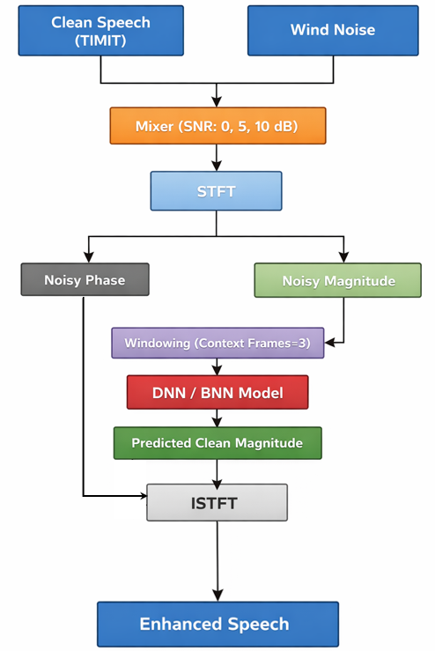
Because calculating the exact posterior distribution of the weights is computationally intractable, Approximate Bayesian Inference is utilized, specifically Variational Inference (VI) [12]. The training objective is to maximize the Evidence Lower Bound (ELBO), which translates to a two-part loss function. The first component is the reconstruction loss, measured by Mean Squared Error (MSE), which drives the model to accurately denoise the spectrogram and match the target label. The second component is the Kullback-Leibler (KL) divergence, which acts as a Bayesian regularization term. The KL divergence specifically measures and penalizes the difference between the learned approximate posterior distribution of the weights and a predefined prior distribution (such as a standard Gaussian). By minimizing this combined loss, the BNN elegantly balances two competing goals: producing accurate speech denoising (via MSE) while maintaining properly quantified uncertainty and preventing severe overfitting (via KL divergence).

Figure 1. System pipeline architecture detailing the data flow from audio mixing through STFT feature extraction, model inference, and final waveform reconstruction via ISTFT.

EXPERIMENTAL SETUP AND EVALUATION
As established in the methodology, the models were optimized using MSE as a differentiable proxy for the reconstruction objective, alongside the KL divergence penalty for the BNN. Both models were trained using the Adam optimizer [15] with a learning rate of 1e-3. It is important to note that while perceptual metrics like PESQ and STOI represent the ultimate goal of the system, they are complex, highly non-linear, and mathematically non-differentiable. Consequently, they cannot be directly minimized using standard gradient-based backpropagation, making the differentiable MSE loss essential. A KL annealing strategy was implemented to mitigate early training instability [16], to ensure stable training for the BNN. The weight of the KL divergence term was gradually increased over the training epochs up to a predefined maximum value. This allowed the model to first focus on learning to reconstruct the speech before being heavily penalized by the Bayesian regularization. A detailed breakdown of the configurations, including the annealing scheduler and sensitivity checks, is provided in Appendix A.
To thoroughly investigate the impact of the prior distribution and hyperparameter tuning, three distinct variations of the BNN were trained and evaluated. The first variant, BNN (Gaussian), utilized a standard Gaussian prior as a baseline for Bayesian regularization. The second, BNN (Laplace), employed a Laplace prior to observe its specific effect on inducing network weight sparsity [17]. Finally, a tuned variant, designated as BNN (check), was developed. This model utilized the Laplace prior combined with a denser, optimized hyperparameter configuration (such as adjustments to the KL penalty scaling and prior variance) specifically aimed at maximizing raw denoising performance to match the deterministic baseline.
The models were evaluated using two primary perceptual metrics: PESQ (Perceptual Evaluation of Speech Quality) to assess overall listening quality, and STOI (Short-Time Objective Intelligibility) to measure the comprehensibility of the speech.
In addition to the objective metrics, informal qualitative listening tests were performed by the author throughout the development phase. This perceptual inspection was crucial for identifying audible artifacts not fully captured by mathematical metrics, such as the slight background "hiss" generated by the stochastic nature of the standard Gaussian BNN. Identifying these artifacts directly motivated the subsequent hyperparameter tuning and the exploration of the Laplace prior to induce sparsity and reduce the unwanted noise.
Methodological Validation and Inference Reliability:
Given the stochastic nature of Bayesian Neural Networks, confirming the reliability and convergence of the training and inference processes is critical. Confidence in the model's correctness is based on several empirical and theoretical pillars. First, proper convergence of the Variational Inference approximation was validated by monitoring the Evidence Lower Bound (ELBO) loss curves. The implementation of the KL annealing schedule ensured that the optimization was stable and did not collapse into prioritizing the prior over the data. Second, robust evaluation was guaranteed by maintaining a strictly isolated hold-out test set, containing unseen speakers and varied wind noise segments, preventing any data leakage. Finally, the inference mechanism itself was validated through the consistency of the Monte Carlo samples; utilizing 30 stochastic forward passes during evaluation produced statistically stable mean predictions and theoretically sound variance spikes exclusively on OOD data, confirming that the uncertainty maps represent true epistemic uncertainty rather than arbitrary network noise.

RESULTS AND DISCUSSION
- Denoising Performance
Table 1. PESQ and STOI performance comparison between the deterministic baseline and BNN variants across validation and test sets under various SNR conditions.
Results On Validation Set |  |  |  | Results On Test Set
SNR (dB) | Model | PESQ | STOI | SNR (dB) |  | Model | PESQ | STOI
0 | Noisy Baseline | 1.213 | 0.790 | 0 | Noisy Baseline |  | 1.103 | 0.747
 | DNN | 1.319 | 0.816 |  | DNN |  | 1.305 | 0.808
 | BNN (Gaussian) | 1.314 | 0.748 |  | BNN (Gaussian) |  | 1.236 | 0.721
 | BNN (Laplace) | 1.308 | 0.763 |  | BNN (Laplace) |  | 1.277 | 0.745
 | BNN (check) | 1.430 | 0.761 |  | BNN (check) |  | 1.360 | 0.736
5 | Noisy Baseline | 1.372 | 0.840 | 5 | Noisy Baseline |  | 1.233 | 0.819
 | DNN | 1.449 | 0.857 |  | DNN |  | 1.454 | 0.853
 | BNN (Gaussian) | 1.328 | 0.784 |  | BNN (Gaussian) |  | 1.264 | 0.769
 | BNN (Laplace) | 1.356 | 0.804 |  | BNN (Laplace) |  | 1.348 | 0.793
 | BNN (check) | 1.493 | 0.796 |  | BNN (check) |  | 1.445 | 0.776
10 | Noisy Baseline | 1.658 | 0.906 | 10 | Noisy Baseline |  | 1.538 | 0.893
 | DNN | 1.602 | 0.881 |  | DNN |  | 1.575 | 0.883
 | BNN (Gaussian) | 1.361 | 0.807 |  | BNN (Gaussian) |  | 1.296 | 0.795
 | BNN (Laplace) | 1.417 | 0.830 |  | BNN (Laplace) |  | 1.392 | 0.821
 | BNN (check) | 1.602 | 0.818 |  | BNN (check) |  | 1.516 | 0.802

As observed in the performance table, the models achieved highly competitive results. While the baseline DNN slightly outperformed the standard unoptimized BNN variants (Gaussian and Laplace) in absolute PESQ and STOI scores, the slightly-tuned BNN (check) achieved full parity with the deterministic baseline. In several SNR conditions, the BNN (check) even slightly surpassed the DNN's performance. This demonstrates a crucial finding: while standard Bayesian regularization may initially trade a minor fraction of raw denoising capability for structural advantages, a properly calibrated BNN can match state-of-the-art deterministic performance while simultaneously retaining its Bayesian benefits (And there is still potential for a lot of fine-tuning work - see below in "Future Work").
Particularly noteworthy is the performance at the 0 dB SNR level, representing the most severely corrupted acoustic condition. Under this high-noise, high-uncertainty scenario, the tuned BNN successfully outperformed the baseline DNN across both the validation and test sets. This empirical observation strongly aligns with Bayesian theory, demonstrating that probabilistic models are inherently better equipped to handle regimes of severe uncertainty where deterministic point estimates tend to falter.
- Comparison to Literature Benchmarks
While the primary objective of this study is a comparative analysis between deterministic and Bayesian methodologies within a controlled architecture, it is essential to contextualize these results within the broader literature. State-of-the-art models targeting highly non-stationary noises (e.g., Deep RNNs or Fully Convolutional Networks) frequently report higher absolute PESQ scores (often approaching 2.5+ on similar datasets) [10], [8]. The lower absolute performance metrics observed in our results are entirely expected. They stem from our deliberate choice to utilize a relatively shallow, simple Multi-Layer Perceptron (MLP) architecture. This minimal capacity design was crucial to explicitly isolate and observe the regularization and uncertainty estimation effects of Variational Inference, without the confounding factors introduced by complex spatiotemporal mechanisms like LSTMs or attention layers.
- Network Sparsity and Regularization
One of the most profound differences between the models emerged in their weight distributions. The Bayesian approach naturally induces sparsity, effectively shutting down unnecessary weights.
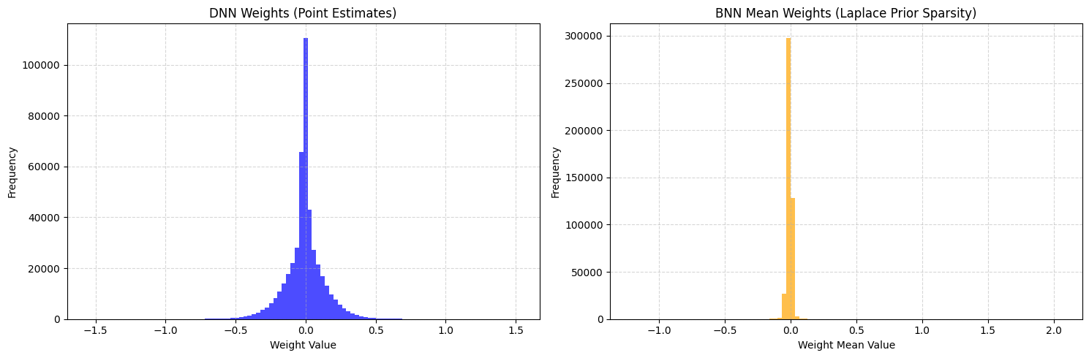
Analysis of the first linear layer revealed that the baseline DNN had a sparsity level of only 15.27%. In strong contrast, the BNN with a Gaussian prior achieved a sparsity of 80.29%, and the Laplace prior variant reached 68.90%. This massive increase in sparsity demonstrates the BNN's built-in regularization capabilities [17]. By forcing the majority of the weight distributions toward zero, the BNN inherently reduces model complexity and limits the capacity to memorize noise, thereby offering a natural defense mechanism against overfitting.
Figure 2. Distribution of weights in the two types of networks
- Uncertainty Estimation and Out-of-Distribution (OOD) Detection
A key advantage of the BNN is its ability to express doubt through predictive variance. This behavior was analyzed under two conditions: heavily corrupted known data and completely unfamiliar Out-of-Distribution (OOD) data.
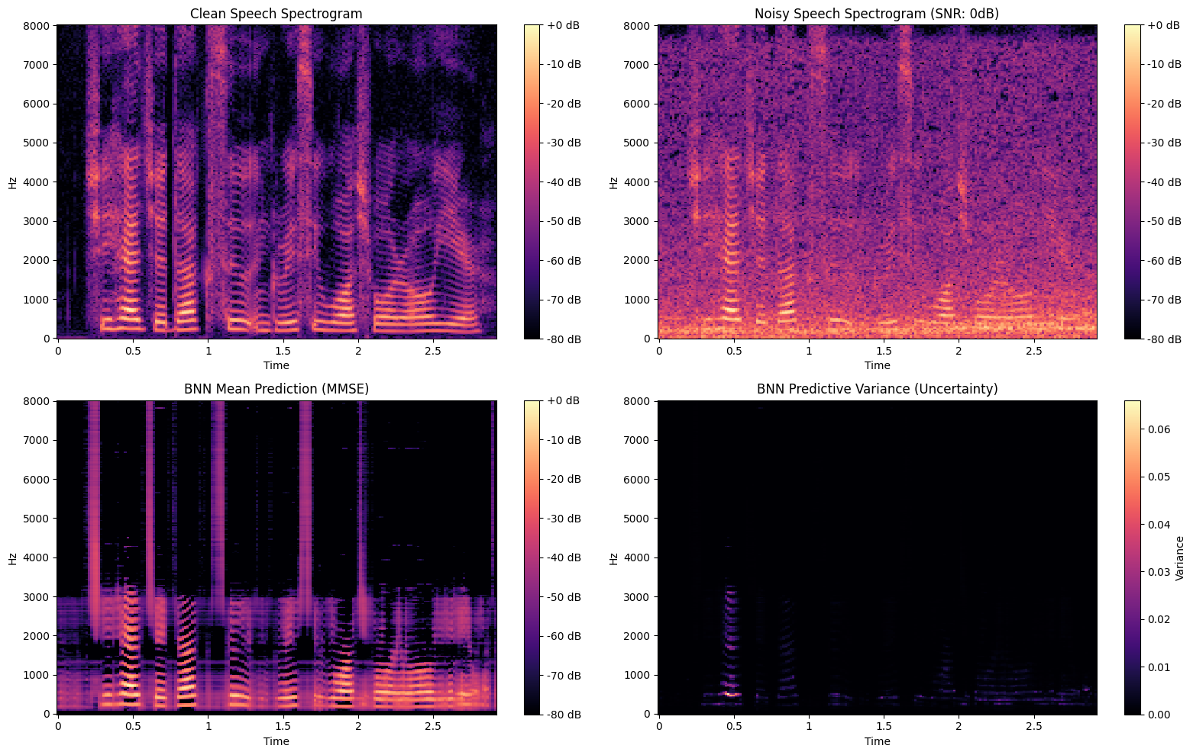
When presented with completely unfamiliar OOD data (e.g., a sine wave mixed with white noise), the differences between the models become even more apparent. A standard deterministic DNN lacks any mechanism to express doubt, often hallucinating distorted, speech-like spectrograms with absolute certainty.
Figure 3. BNN predictive variance on a heavily corrupted speech sample (0 dB SNR). The uncertainty map (bottom-right) shows low variance in pure noise regions, where the model is confident the signal should be suppressed. However, variance spikes along the speech formants, indicating that while the model recognizes the speech, it is unsure about the precise amplitudes due to the heavy noise.
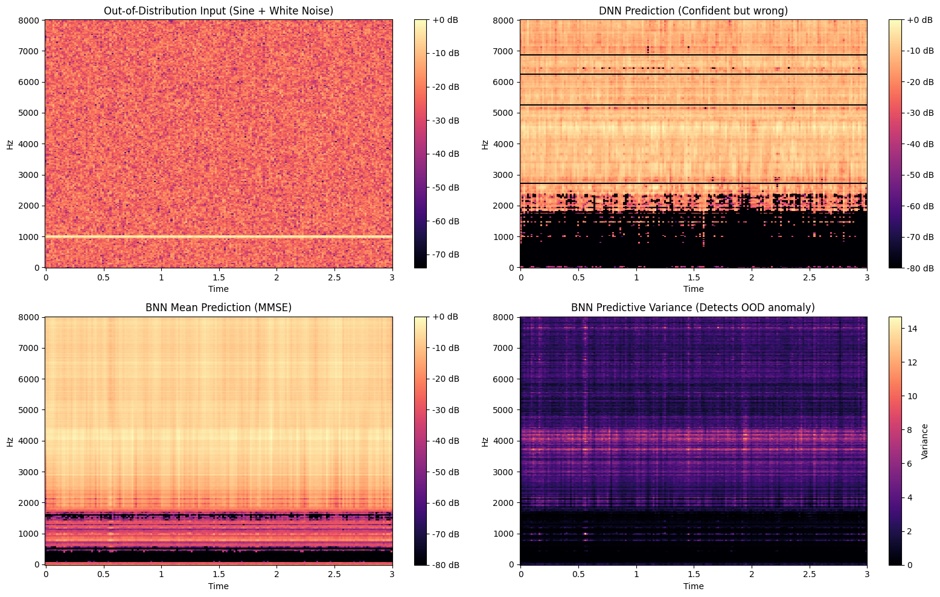
The variance spiked precisely where the model lacked knowledge, providing a clear visual and mathematical indicator of uncertainty. This feature is highly valuable for real-world speech enhancement systems, as it allows the system to flag unreliable outputs or dynamically adjust its processing when the acoustic environment changes drastically.
Figure 4. Model behavior on completely unfamiliar OOD data. While both models output distorted predictions, the BNN's predictive variance (bottom-right) spikes dramatically across all frequencies (reaching values over 14.0). This massive variance clearly flags the prediction as unreliable, demonstrating the BNN's crucial ability to "know what it doesn't know."

REFLECTION AND FUTURE WORK
This project provided significant insights, bridging the gap between theoretical Bayesian concepts learned in the course and practical deep learning implementations. From the course, the most profound takeaway was the fundamental shift from deterministic, point-estimate thinking to a probabilistic reasoning framework. Discovering the immense power, the incredible diversity of Bayesian methods, and their huge potential across various domains served as a major source of curiosity and inspiration.
From the project itself, the main takeaway was witnessing these theoretical concepts materialize in deep learning. Understanding how Variational Inference (VI) and the Evidence Lower Bound (ELBO) can mathematically quantify a model's lack of knowledge fundamentally changes how a data scientist approaches model reliability. Furthermore, observing the natural regularization of BNNs in practice—seeing the network sparsity jump from 15% in a standard DNN to over 80% simply by introducing a prior distribution—was a powerful demonstration of Bayesian mechanics.
During the implementation, several challenges arose. First, diving deeply into a completely new and mathematically complex topic required significant independent research and a steep learning curve. On a technical level, the most significant obstacle was the "KL explosion" during early training, where the KL divergence penalty completely overshadowed the reconstruction loss, preventing the model from learning to denoise. This was successfully overcome by implementing a KL annealing strategy, gradually increasing the KL weight (MAX_BETA) over several epochs. Additionally, the inherently long training and inference runtimes associated with Monte Carlo sampling in BNNs posed a practical computing challenge, further complicating the delicate task of balancing raw denoising performance with Bayesian regularization.
If more time and computational resources were available, several avenues for future work would be explored:
- Extensive Hyperparameter Tuning: The tuning performed for the "BNN (check)" model was preliminary. Further optimization of the prior variance, learning rates, and KL schedules could unlock even greater potential, potentially allowing the BNN to significantly outperform the deterministic baseline in raw metrics.
- Overfitting Analysis: A dedicated data loader function to test severe overfitting on a single speaker was written during this project. However, due to time constraints and unexpected initial behaviors, a full empirical analysis was postponed. Completing this test would further quantify the BNN's theoretical resistance to overfitting.
- Advanced Architectures: The current experiments were intentionally limited to simple Multi-Layer Perceptrons (MLPs) to isolate the effects of Bayesian inference. However, modern speech enhancement heavily relies on architectures that capture temporal and spatial dependencies better, such as Fully Convolutional Neural Networks (FCNNs) [8] or Recurrent Neural Networks (RNNs) [10]. Future work would involve integrating Bayesian layers (e.g., Bayesian LSTMs or Bayesian CNNs) into these state-of-the-art architectures to combine advanced feature extraction with robust uncertainty quantification.

CONCLUSION
This project presented a comparative study between a standard deterministic Deep Neural Network (DNN) and a Bayesian Neural Network (BNN) for speech denoising. While deterministic models are highly effective at minimizing reconstruction error, they lack the ability to express uncertainty and are prone to memorizing noise. The experiments demonstrated that by learning probability distributions over weights, the BNN naturally induces extreme network sparsity, effectively acting as a powerful regularizer. Furthermore, while standard BNNs may initially trade a small fraction of raw denoising performance for structural benefits, preliminary tuning showed that a calibrated BNN can fully match deterministic performance. Most importantly, the BNN successfully quantified its own uncertainty, generating clear variance spikes when faced with heavy corruption or Out-of-Distribution anomalies. This characteristic makes Bayesian Neural Networks highly valuable for developing robust, safe, and reliable speech enhancement systems in unpredictable real-world environments.

REFERENCES
[1] A. W. Rix, J. G. Beerends, M. P. Hollier, and A. P. Hekstra, “Perceptual evaluation of speech quality (PESQ)-a new method for speech quality assessment of telephone networks and codecs,” in 2001 IEEE International Conference on Acoustics, Speech, and Signal Processing. Proceedings (Cat. No.01CH37221), Salt Lake City, UT, USA: IEEE, 2001, pp. 749–752. doi: 10.1109/ICASSP.2001.941023.
[2] C. H. Taal, R. C. Hendriks, R. Heusdens, and J. Jensen, “A short-time objective intelligibility measure for time-frequency weighted noisy speech,” in 2010 IEEE International Conference on Acoustics, Speech and Signal Processing, Dallas, TX, USA: IEEE, Mar. 2010, pp. 4214–4217. doi: 10.1109/ICASSP.2010.5495701.
[3] S. T. Yousif and B. M. Mahmmod, “Speech Enhancement Algorithms: A Systematic Literature Review,” Algorithms, vol. 18, no. 5, p. 272, May 2025, doi: 10.3390/a18050272.
[4] N. P. M and A. G. Ramakrishnan, “DNN Based Speech Enhancement for Unseen Noises Using Monte Carlo Dropout,” Jun. 01, 2018, arXiv: arXiv:1806.00516. doi: 10.48550/arXiv.1806.00516.
[5] L. V. Jospin, W. Buntine, F. Boussaid, H. Laga, and M. Bennamoun, “Hands-on Bayesian Neural Networks -- a Tutorial for Deep Learning Users,” IEEE Comput. Intell. Mag., vol. 17, no. 2, pp. 29–48, May 2022, doi: 10.1109/MCI.2022.3155327.
[6] P. Izmailov, S. Vikram, M. D. Hoffman, and A. G. G. Wilson, “What are Bayesian neural network posteriors really like?,” in International conference on machine learning, PMLR, 2021, pp. 4629–4640. Accessed: Mar. 11, 2026. [Online]. Available: https://proceedings.mlr.press/v139/izmailov21a.html
[7] C. Fan, B. Liu, J. Tao, J. Yi, Z. Wen, and L. Song, “Deep Time Delay Neural Network for Speech Enhancement with Full Data Learning,” Nov. 11, 2020, arXiv: arXiv:2011.05591. doi: 10.48550/arXiv.2011.05591.
[8] N. Alamdari, A. Azarang, and N. Kehtarnavaz, “Improving deep speech denoising by Noisy2Noisy signal mapping,” Applied Acoustics, vol. 172, p. 107631, Jan. 2021, doi: 10.1016/j.apacoust.2020.107631.
[9] S. Yu, J. Ma, and W. Wang, “Deep learning for denoising,” Jul. 20, 2019, arXiv: arXiv:1810.11614. doi: 10.48550/arXiv.1810.11614.
[10] M. Keshavarzi, T. Goehring, J. Zakis, R. E. Turner, and B. C. J. Moore, “Use of a Deep Recurrent Neural Network to Reduce Wind Noise: Effects on Judged Speech Intelligibility and Sound Quality,” Trends in Hearing, vol. 22, p. 2331216518770964, Jan. 2018, doi: 10.1177/2331216518770964.
[11] Y. Bando, K. Sekiguchi, and K. Yoshii, “Adaptive Neural Speech Enhancement with a Denoising Variational Autoencoder,” in Interspeech 2020, ISCA, Oct. 2020, pp. 2437–2441. doi: 10.21437/Interspeech.2020-2291.
[12] P. Alquier, “Approximate Bayesian Inference,” Entropy, vol. 22, no. 11, p. 1272, Nov. 2020, doi: 10.3390/e22111272.
[13] W. Bauer and J. Baranowski, “A Comparison of Deep Recurrent Neural Networks and Bayesian Neural Networks for Detecting Electric Motor Damage Through Sound Signal Analysis,” Energies, vol. 18, no. 18, p. 4997, Sep. 2025, doi: 10.3390/en18184997.
[14] J. S. Garofolo, L. F. Lamel, W. M. Fisher, J. G. Fiscus, and D. S. Pallett, “DARPA TIMIT acoustic-phonetic continous speech corpus CD-ROM. NIST speech disc 1-1.1,” NASA STI/Recon technical report n, vol. 93, p. 27403, 1993.
[15] D. P. Kingma and J. Ba, “Adam: A Method for Stochastic Optimization,” Jan. 30, 2017, arXiv: arXiv:1412.6980. doi: 10.48550/arXiv.1412.6980.
[16] H. Fu, C. Li, X. Liu, J. Gao, A. Celikyilmaz, and L. Carin, “Cyclical annealing schedule: A simple approach to mitigating kl vanishing,” in Proceedings of the 2019 Conference of the North American Chapter of the Association for Computational Linguistics: Human Language Technologies, Volume 1 (Long and Short Papers), 2019, pp. 240–250. Accessed: Mar. 12, 2026. [Online]. Available: https://aclanthology.org/N19-1021/
[17] T. Park and G. Casella, “The Bayesian Lasso,” Journal of the American Statistical Association, vol. 103, no. 482, pp. 681–686, Jun. 2008, doi: 10.1198/016214508000000337.

APPENDIX A: SYSTEM CONFIGURATION AND HYPERPARAMETER OPTIMIZATION
To ensure stable convergence, manage computational constraints, and facilitate reproducibility, an extensive hyperparameter configuration was established. The system parameters can be categorized into feature extraction, general network architecture, and Bayesian-specific optimizations.
Data and Feature Extraction:
- Sampling Rate & FFT: Audio was processed at a sample rate of 16,000 Hz using an FFT size of 512 and a hop length of 256. This provided an optimal balance between high-resolution frequency representation (257 unique frequency bins) and computational load.
- Temporal Context: The CONTEXT_FRAMES parameter was set to 3. This resulted in a sliding window size of 7 frames (3 previous, 1 current, 3 future). Consequently, the input dimension for the networks was $257×7=1799$. This temporal context was crucial for allowing the linear layers to capture speech formants over time.
Network Architecture and Training:
- Architecture: Both networks utilized hidden layers of size 256 (HIDDEN_DIM).
- Optimization: Training was conducted over 50 epochs using the Adam optimizer with a learning rate of 1e-3 and a batch size of 128 to maintain stable gradient updates.
Bayesian-Specific Optimizations:
Training the BNN required careful tuning to prevent the KL divergence term from overwhelming the MSE reconstruction loss.
- Monte Carlo Sampling: To balance training time and stochastic estimation, Monte Carlo samples during training (MC_SAMPLES_TRAIN) were set to 5. During inference, where robust uncertainty estimation is paramount, the samples were increased to 30 (MC_SAMPLES_INFERENCE).
- KL Annealing (MAX_BETA): A critical finding during the preliminary optimization phase was the necessity of scaling down the KL divergence. A strict KL annealing strategy was implemented, capping the KL weight at a MAX_BETA of 0.0001. Without this heavy scaling, the models prioritized matching the prior distribution over learning to denoise the speech.
- Prior Distributions: The models were initialized with a prior standard deviation (PRIOR_STD) of 0.1. Both standard Gaussian and Laplace priors were evaluated to observe their effects on weight sparsity and overall regularization.
Hyperparameter Tuning for BNN (check):
To bridge the raw performance gap with the deterministic baseline, the final "BNN (check)" model underwent a focused fine-tuning phase. The learning rate was reduced to 1e-4 to stabilize optimization under the stricter Bayesian constraints. The prior standard deviation (PRIOR_STD) was tightened to 0.05, and the MAX_BETA for the KL penalty was reduced to 0.00003. This specific configuration provided the optimal balance, allowing the model to minimize the reconstruction error effectively while preserving its uncertainty estimation capabilities.

