**Analisis Algoritma**



**Disusun oleh :**

**Meira Dwiana Anjani**

**140810180015**

**FAKULTAS MATEMATIKA DAN ILMU PENGETAHUAN ALAM**

**UNIVERSITAS PADJADJARAN**

**2020**

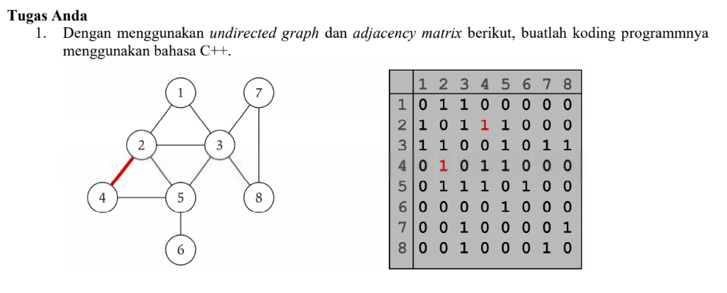

/*

Nama : Meira Dwiana A

NPM : 140810180015

Kelas: A

*/

#include <iostream>

#include <cstdlib>

using namespace std;

#define MAX 20

/*

* Class untuk Adjacency Matrix

*/

class AdjacencyMatrix

{

private:

int n;

int **adj;

bool *visited;

public:

AdjacencyMatrix(int n)

{

this->n = n;

visited = new bool [n];

adj = new int* [n];

for (int i = 0; i < n; i++)

{

adj[i] = new int [n];

for(int j = 0; j < n; j++)

{

adj[i][j] = 0;

}

}

}

/*

* Menambahkan edge ke graf

*/

void add_edge(int origin, int destin)

{

if( origin > n || destin > n || origin < 0 || destin < 0)

{

cout<<"Invalid edge!\n";

}

else

{

adj[origin - 1][destin - 1] = 1;

}

}

/*

* Mencetak graf

*/

void display()

{

int i,j;

for(i = 0;i < n;i++)

{

for(j = 0; j < n; j++)

cout<<adj[i][j]<<" ";

cout<<endl;

}

}

};

/*

* Main

*/

int main()

{

int nodes, max_edges, origin, destin;

cout<<"Enter number of nodes: ";

cin>>nodes;

AdjacencyMatrix am(nodes);

max_edges = nodes * (nodes - 1);

for (int i = 0; i < max_edges; i++)

{

cout<<"Enter edge (-1 -1 to exit): ";

cin>>origin>>destin;

if((origin == -1) && (destin == -1))

break;

am.add_edge(origin, destin);

}

am.display();

return 0;

}

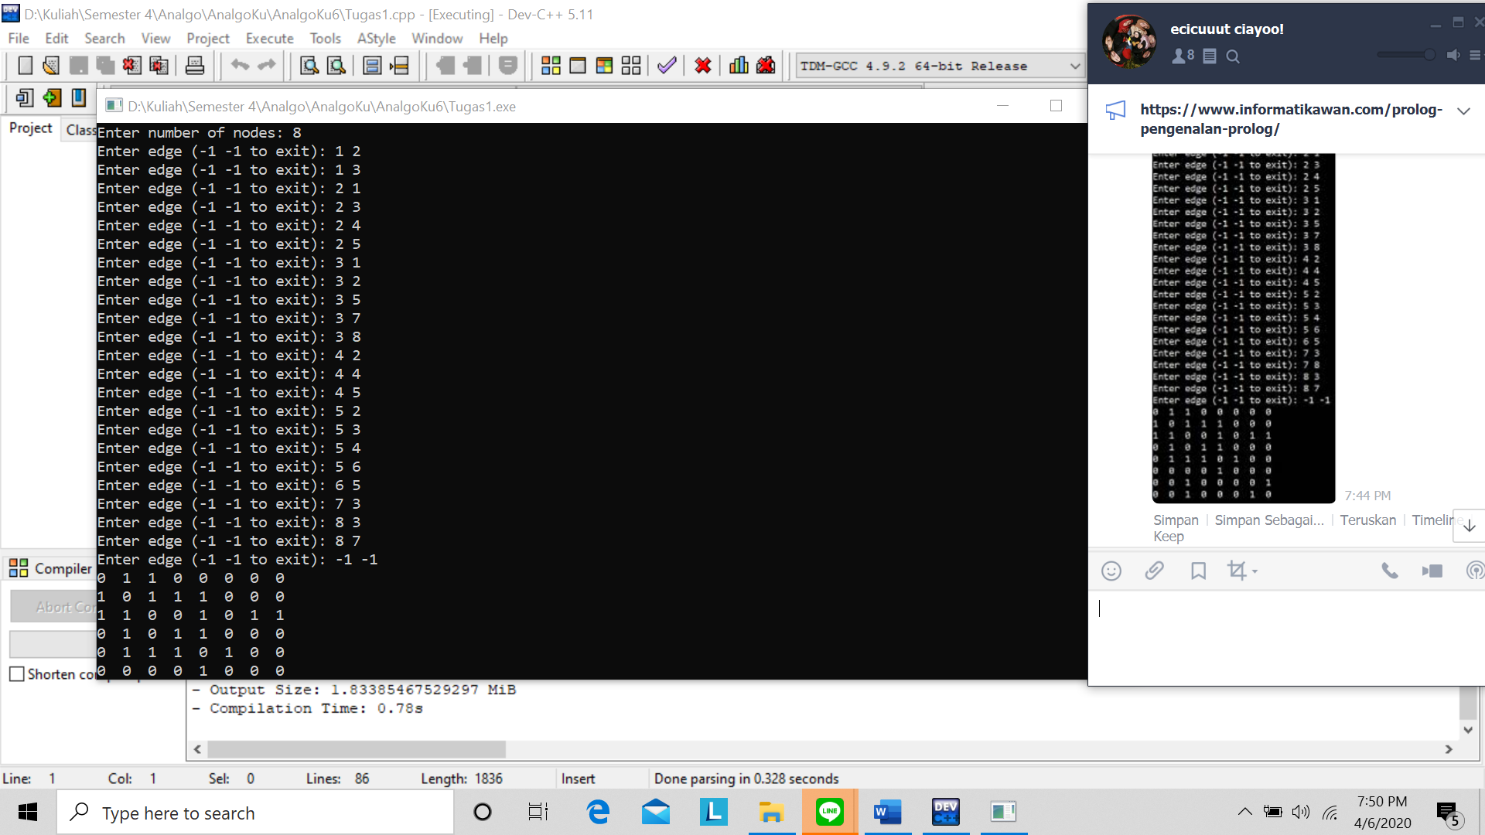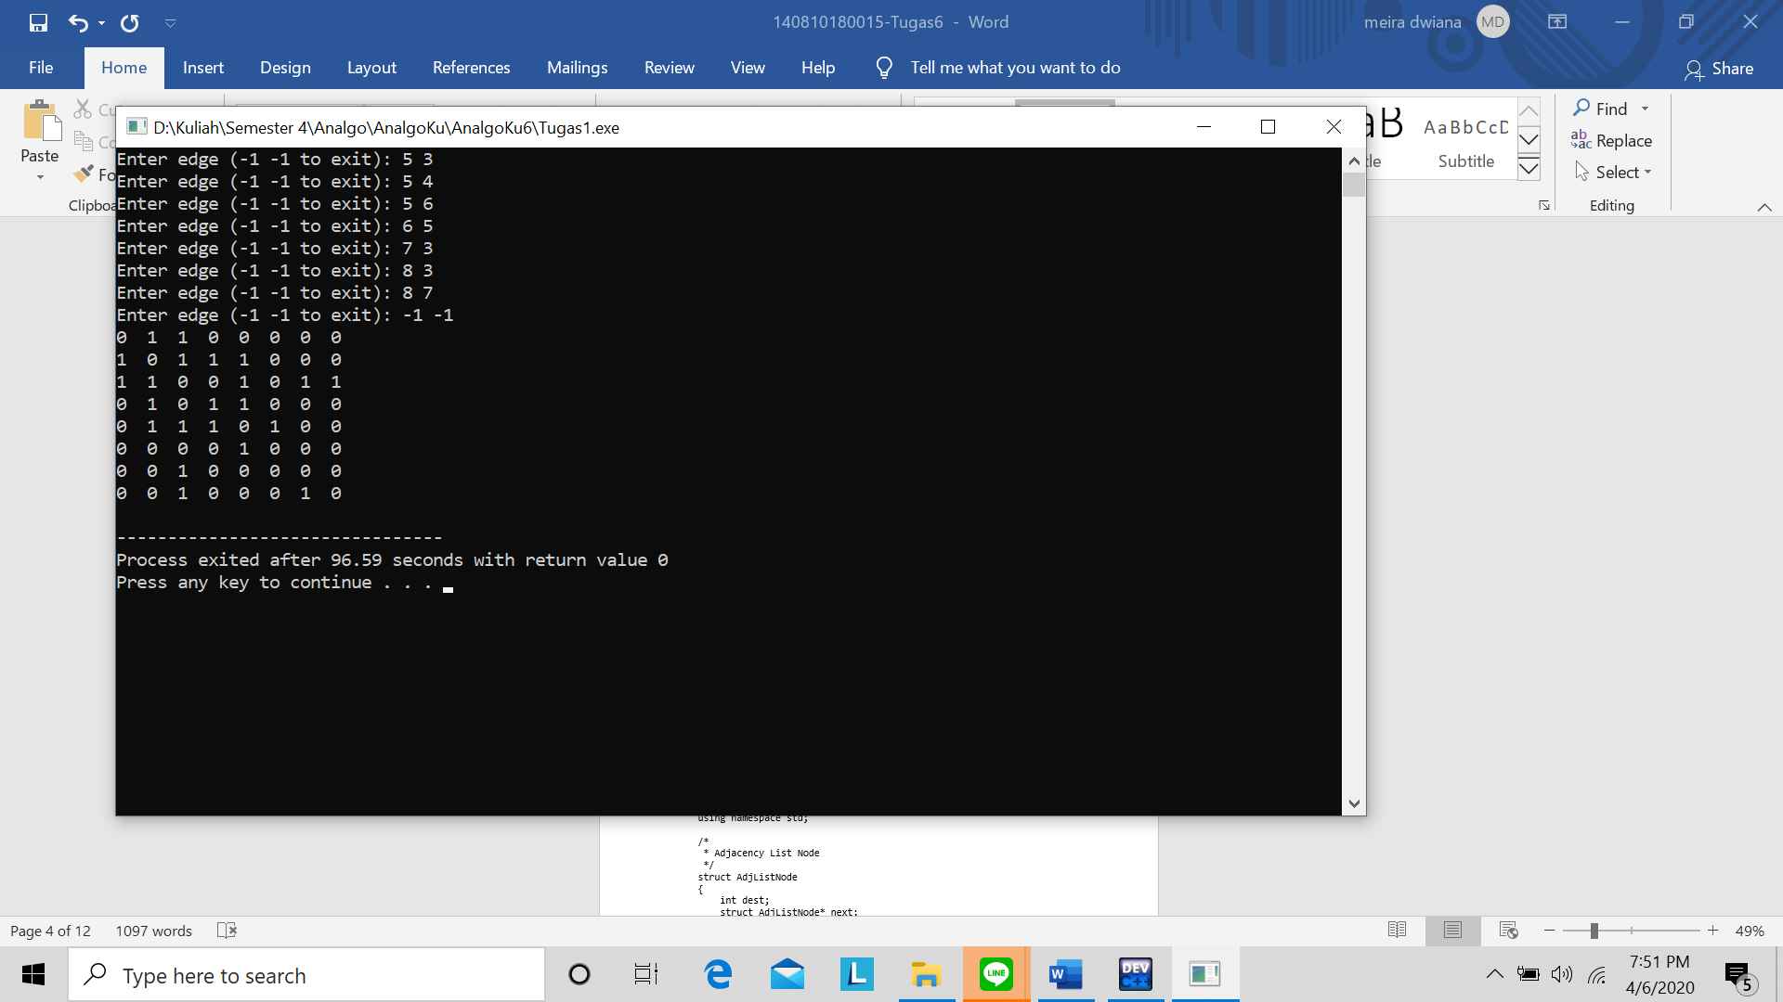

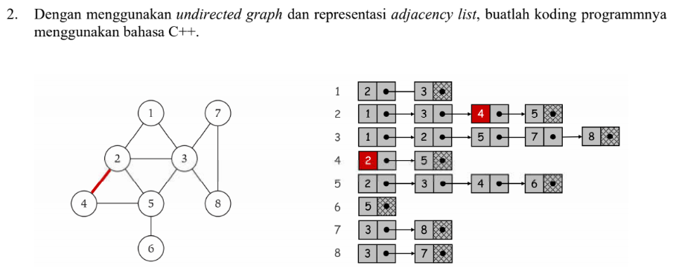

/*

Nama : Meira Dwiana A

NPM : 140810180015

Kelas: A

*/

#include <iostream>

#include <cstdlib>

using namespace std;

/*

* Adjacency List Node

*/

struct AdjListNode

{

int dest;

struct AdjListNode* next;

};

/*

* Adjacency List

*/

struct AdjList

{

struct AdjListNode *head;

};

/*

* Class Graph

*/

class Graph

{

private:

int V;

struct AdjList* array;

public:

Graph(int V)

{

this->V = V;

array = new AdjList [V];

for (int i = 0; i < V; ++i)

array[i].head = NULL;

}

/*

* Creating New Adjacency List Node

*/

AdjListNode* newAdjListNode(int dest)

{

AdjListNode* newNode = new AdjListNode;

newNode->dest = dest;

newNode->next = NULL;

return newNode;

}

/*

* Adding Edge to Graph

*/

void addEdge(int src, int dest)

{

AdjListNode* newNode = newAdjListNode(dest);

newNode->next = array[src].head;

array[src].head = newNode;

newNode = newAdjListNode(src);

newNode->next = array[dest].head;

array[dest].head = newNode;

}

/*

* Print the graph

*/

void printGraph()

{

int v;

for (v = 1; v <= V; ++v)

{

AdjListNode* pCrawl = array[v].head;

cout<<"\n Adjacency list of vertex "<<v<<"\n head ";

while (pCrawl)

{

cout<<"-> "<<pCrawl->dest;

pCrawl = pCrawl->next;

}

cout<<endl;

}

}

};

/*

* Main

*/

int main()

{

Graph gh(8);

gh.addEdge(1, 2);

gh.addEdge(1, 3);

gh.addEdge(2, 4);

gh.addEdge(2, 5);

gh.addEdge(2, 3);

gh.addEdge(3, 7);

gh.addEdge(3, 8);

gh.addEdge(4, 5);

gh.addEdge(5, 3);

gh.addEdge(5, 6);

gh.addEdge(7, 8);

// print the adjacency list representation of the above graph

gh.printGraph();

return 0;

}

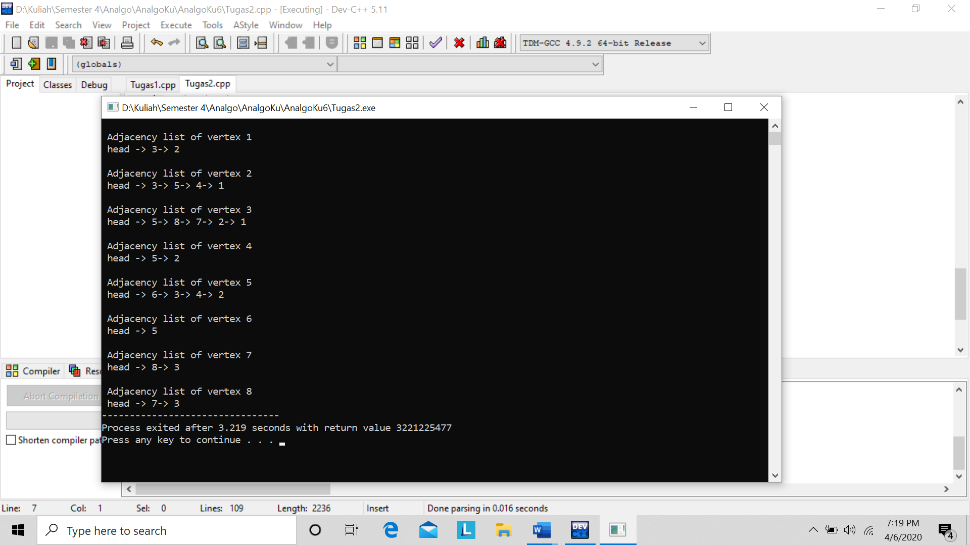

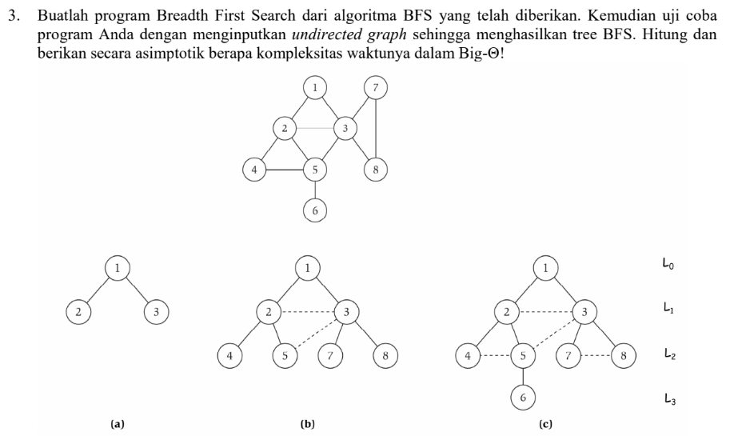

/*

Nama : Meira Dwiana Anjani

NPM : 140810180015

Kelas: A

*/

// Program to print BFS traversal from a given

// source vertex. BFS(int s) traverses vertices

// reachable from s.

#include<iostream>

#include <list>

using namespace std;

// This class represents a directed graph using

// adjacency list representation

class Graph

{

int V; // No. of vertices

// Pointer to an array containing adjacency

// lists

list<int> *adj;

public:

Graph(int V); // Constructor

// function to add an edge to graph

void addEdge(int v, int w);

// prints BFS traversal from a given source s

void BFS(int s);

};

Graph::Graph(int V)

{

this->V = V;

adj = new list<int>[V];

}

void Graph::addEdge(int v, int w)

{

adj[v].push_back(w); // Add w to v’s list.

}

void Graph::BFS(int s)

{

// Mark all the vertices as not visited

bool *visited = new bool[V];

for(int i = 0; i < V; i++)

visited[i] = false;

// Create a queue for BFS

list<int> queue;

// Mark the current node as visited and enqueue it

visited[s] = true;

queue.push_back(s);

// 'i' will be used to get all adjacent

// vertices of a vertex

list<int>::iterator i;

while(!queue.empty())

{

// Dequeue a vertex from queue and print it

s = queue.front();

cout << s << " ";

queue.pop_front();

// Get all adjacent vertices of the dequeued

// vertex s. If a adjacent has not been visited,

// then mark it visited and enqueue it

for (i = adj[s].begin(); i != adj[s].end(); ++i)

{

if (!visited[*i])

{

visited[*i] = true;

queue.push_back(*i);

}

}

}

}

// Driver program to test methods of graph class

int main()

{

// Create a graph given in the above diagram

Graph g(8);

g.addEdge(1, 2);

g.addEdge(1, 3);

g.addEdge(2, 4);

g.addEdge(2, 5);

g.addEdge(2, 3);

g.addEdge(3, 7);

g.addEdge(3, 8);

g.addEdge(4, 5);

g.addEdge(5, 3);

g.addEdge(5, 6);

g.addEdge(7, 8);

cout << "Following is Breadth First Traversal "

<< "(starting from vertex 1) \n";

g.BFS(1);

return 0;

}

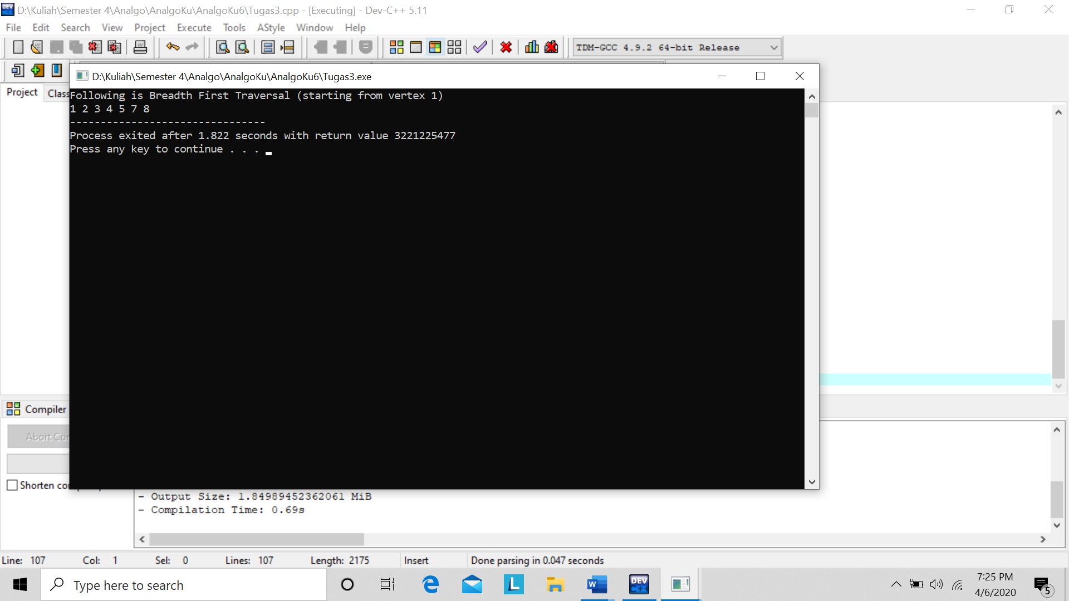

Kompleksitas ruang algoritma DFS adalah O(bm), karena kita hanya hanya perlu menyimpan satu buah lintasan tunggal dari akar sampai daun, ditambah dengan simpul-simpul saudara kandungnya yang belum dikembangkan.

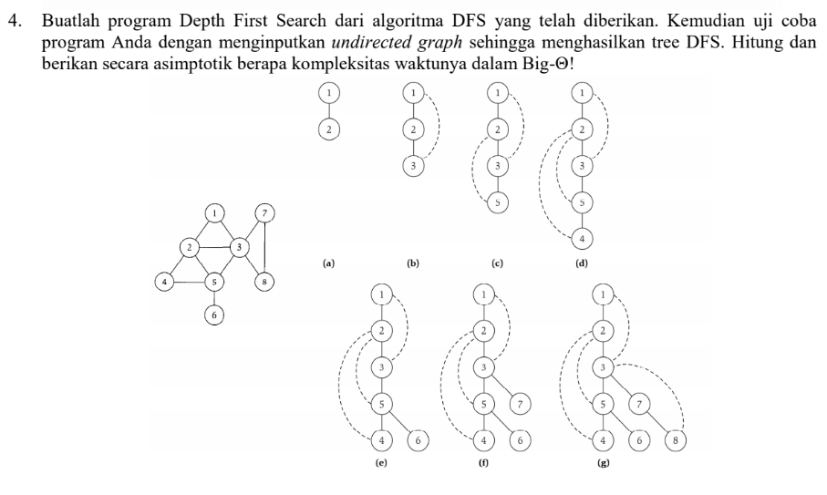

/*

Nama : Meira Dwiana A

NPM : 140810180015

Kelas: A

*/

#include<iostream>

#include<list>

using namespace std;

// Graph class merepresentasikan graf berarah menggunakan representasi adjacency list

class Graph

{

int V; // No. simpul

// Pointer ke array yang memiliki adjacency lists

list<int> *adj;

// Fungsi rekursif yang digunakan DFS

void DFSUtil(int v, bool visited[]);

public:

Graph(int V); // Constructor

// fungsi untuk menambah tepian ke graf

void addEdge(int v, int w);

// DFS traversal dari simpul yang terjangkau dari v

void DFS(int v);

};

Graph::Graph(int V)

{

this->V = V;

adj = new list<int>[V];

}

void Graph::addEdge(int v, int w)

{

adj[v].push_back(w); // Menambah w ke list v.

}

void Graph::DFSUtil(int v, bool visited[])

{

// Menandakan node bersangkutan sudah dikunjungi lalu cetak

visited[v] = true;

cout << v << " ";

// Ulang simpul berdekatan ke node ini

list<int>::iterator i;

for (i = adj[v].begin(); i != adj[v].end(); ++i)

if (!visited[*i])

DFSUtil(*i, visited);

}

// DFS traversal dari simpul terjangkau dari v.

// Menggunakan rekursif DFSUtil()

void Graph::DFS(int v)

{

// Menandakan semua simpul belum dikunjungi

bool *visited = new bool[V];

for (int i = 0; i < V; i++)

visited[i] = false;

// Memanggil fungsi rekursif pembantu untuk mencetak DFS traversal

DFSUtil(v, visited);

}

int main()

{

// Membuat graf di diagram

Graph g(8);

g.addEdge(1, 2);

g.addEdge(1, 3);

g.addEdge(2, 5);

g.addEdge(2, 4);

g.addEdge(5, 6);

g.addEdge(3, 7);

g.addEdge(3, 8);

g.addEdge(7, 8);

cout << "Depth First Traversal"

" (dimulai dari node 1) \n";

g.DFS(1);

return 0;

}

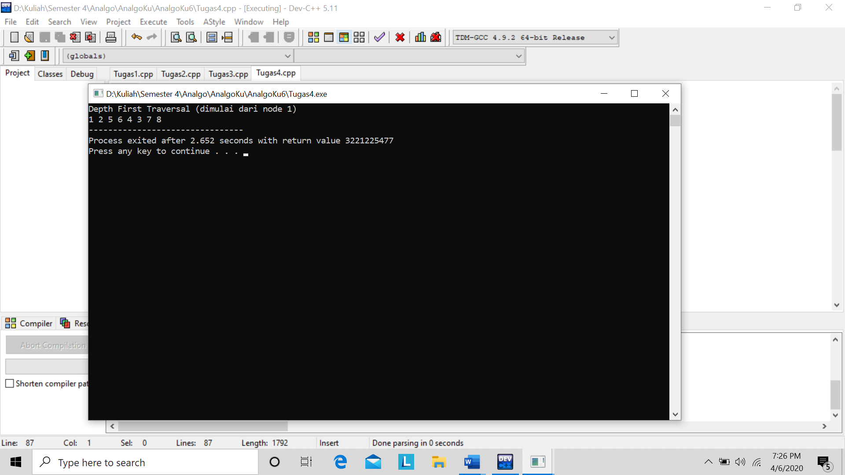

Kompleksitas ruang algoritma DFS adalah O(bm), karena kita hanya hanya perlu menyimpan satu buah lintasan tunggal dari akar sampai daun, ditambah dengan simpul-simpul saudara kandungnya yang belum dikembangkan.