Business Template

Subject areas
Logo / Image

Contents
1 Business Description 3
1.1 Business background 3
1.2 Problems. Current Situation 3
1.3 The benefits of implementing a database. Project Vision 3
2 Model description 3
2.1 Definitions & Acronyms 3
2.2 Logical Scheme 3
2.3 Objects 3

Business Description
Система хранит:
- Восхождения (Climb)
- Альпинистов (Climber)
- Горы (Mountain)
- Локации (страна, регион)
- Участие людей в восхождениях (многие-ко-многим)

Model description

Definitions & Acronyms
1. Climber
climber_id (PK)
first_name
last_name
email
phone
2. Address
address_id (PK)
country
city
street
3. Climber_Address (M:N)
climber_id (FK)
address_id (FK)

4. Mountain
mountain_id (PK)
name
height
location_id (FK)
5. Location
location_id (PK)
country
region

6. Climb
climb_id (PK)
mountain_id (FK)
start_date
end_date
description
7. Climb_Participant (M:N)
climb_id (FK)
climber_id (FK)
role_id (FK)
8. Role
role_id (PK)
role_name (leader, guide, participant)
9. Equipment
equipment_id (PK)
name
type
10. Climb_Equipment (M:N)
climb_id (FK)
equipment_id (FK)
quantity
11. Organization
organization_id (PK)
name
country
12. Climber_Organization (M:N)
climber_id (FK)
organization_id (FK)

Logical Scheme
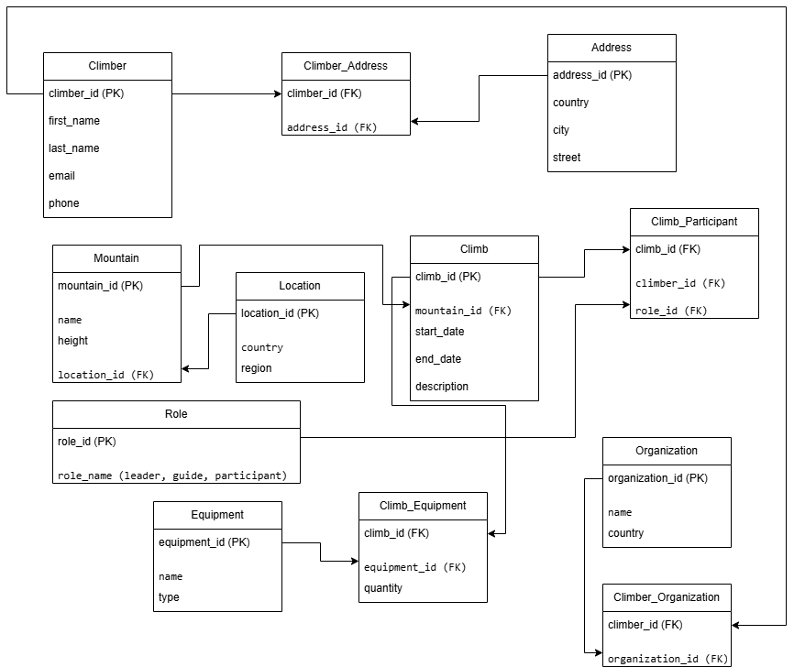

Objects

Table Description
• Climber ↔ Address → M:N
• Climber ↔ Climb → M:N (через Climb_Participant)
• Climb → Mountain → 1:M
• Mountain → Location → M:1
• Climb ↔ Equipment → M:N
• Climber ↔ Organization → M:N

1. Climber
climber_id INT PRIMARY KEY
first_name VARCHAR(100)
last_name VARCHAR(100)
email VARCHAR(255)
phone VARCHAR(20)
2. Address
address_id INT PRIMARY KEY
country VARCHAR(100)
city VARCHAR(100)
street VARCHAR(255)
3. Climber_Address (M:N)
climber_id INT
address_id INT
PRIMARY KEY (climber_id, address_id),
FOREIGN KEY (climber_id) REFERENCES Climber(climber_id),
FOREIGN KEY (address_id) REFERENCES Address(address_id)
4. Mountain
mountain_id INT PRIMARY KEY
name VARCHAR(150)
height INT
location_id INT
FOREIGN KEY (location_id) REFERENCES Location(location_id)
5. Location
location_id INT PRIMARY KEY
country VARCHAR(100)
region VARCHAR(100)
6. Climb
climb_id INT PRIMARY KEY
mountain_id INT
start_date DATE
end_date DATE
description TEXT
FOREIGN KEY (mountain_id) REFERENCES Mountain(mountain_id)
7. Climb_Participant (M:N)
climb_id INT
climber_id INT
role_id INT
PRIMARY KEY (climb_id, climber_id),
FOREIGN KEY (climb_id) REFERENCES Climb(climb_id),
FOREIGN KEY (climber_id) REFERENCES Climber(climber_id),
FOREIGN KEY (role_id) REFERENCES Role(role_id)
8. Role
role_id INT PRIMARY KEY
role_name VARCHAR(50)
9. Equipment
equipment_id INT PRIMARY KEY
name VARCHAR(100)
type VARCHAR(100)
10. Climb_Equipment (M:N)
climb_id INT
equipment_id INT
quantity INT
PRIMARY KEY (climb_id, equipment_id),
FOREIGN KEY (climb_id) REFERENCES Climb(climb_id),
FOREIGN KEY (equipment_id) REFERENCES Equipment(equipment_id)
11. Organization
organization_id INT PRIMARY KEY
name VARCHAR(150)
country VARCHAR(100)
12. Climber_Organization (M:N)
climber_id INT
organization_id INT
PRIMARY KEY (climber_id, organization_id),
FOREIGN KEY (climber_id) REFERENCES Climber(climber_id),
FOREIGN KEY (organization_id) REFERENCES Organization(organization_id)

