Training Evaluating
Loss (MSE)
-1.0 0.0
R
E
A
L

Model
training
I
M
A
G

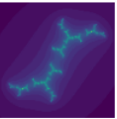
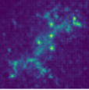

Model
Evaluation
0.0 1.0
create_julia
function

