**Social Learning and diffusion over Pervasive Products:**

**An Empirical Study of an African App-store**

Author: Meisam Hejazi Nia

Advisors: Dr. Norris Bruce, Dr. Brian Ratchford

Date: 08/25/2014

**Position of research:**

Keywords: mobile app store platform, interdependence of consumer preferences, social learning, simultaneous global diffusion model, app category complementarity and substitution, hierarchical mixture Bayesian, state space, structural model, Markov Chain Monte Carlo, big data

**Findings:**

1. Diffusion over a pervasive product (mobile phone) results in a better fit of choice model that incorporate local imitation and innovation forces, rather than global imitation innovation forces (i.e. WWW does not have significant effect)
2. There is a significant complementarity pattern between the different mobile app categories that diffuse globally on an app store
3. Word of mouth rather than innovation forces are significant drivers of aggregate app-store category diffusion
4. Preferences of consumer for mobile apps have bimodal distribution
5. Distribution of market sizes of mobile apps is bimodal
6. Assortment breadth of the mobile app categories does not significantly explain individual consumer choices
7. There are significant heterogeneities in the choice response of individuals to app characteristics

**Managerial implication:**

1. App stores should target their campaigns more toward physical proximity rather than online global village
2. App stores can target their promotion toward one app category in complement categories network to drive the diffusion of app categories
3. To increase aggregate level of diffusion app stores should leverage viral marketing strategies rather than trial based strategies
4. App stores can design incentive compatible mechanisms to leverage bimodal distribution of consumer preferences and bimodal distribution of mobile app market sizes
5. App stores are not suggested to limit the number of free or paid apps within the app categories
6. App stores can use individual choice response information to run targeted trial or viral marketing strategies

**Model:**

Diffusion of the category:







Factor Model of Category characteristics:



Innovation and imitation Forces:



Choice Model:







**Table 1**

**Add-on Basic Statistics**

|  |  |
| --- | --- |
| Variable | Description |
| App Category Weekly Download() | Cumulative number of consumers who download an app in app category j up until a given week t |
| App Category Weekly Download Latent () | Latent cumulative number of consumers who download an app in app category j up until a given week t |
| Internal Market Force () | BDM parameter of ratio of innovators who adopt an app in app category j at a given week |
| External Market Force () | BDM parameter of ratio of imitators who adopt an app in app category j at a given week |
| Market size () | BDM parameter of market size of a given app category |
| Category hierarchy parameters () | Parameter of hierarchical mixture of normal components of app category diffusion parameters |
| Full covariance matrix of state equation() | Full covariance matrix of state equation of BDM model to find complementarity or substitution of app categories |
| Variance of observation equation () | Variance of observation equation of BDM model |
| Category data () | Category j characteristic data at week t, including Average file size, total number of adds featured in the category, average price, variance of price, paid app options, free app options, fraction of free to paid apps within the category, average tenure of each app category, total app options within the category |
| Category Factors() | Reduced factors explaining the variation in category data |
| Factor loading of Category | Factor loading of data item j of category data vector |
| Innovation Force () | Filtered estimated amount of innovation force for app category j at week t |
| Imitation Force () | Filtered estimated amount of imitation force for app category j at week t |
| Consumer utility from app category () | Consumer i’s utility from selecting an app in app category j at week t |
| App category preference () | App category preference of consumers |
| Individual category state () | State of individual i’s purchase in a given category j at week t |
|  | Utility parameters of consumer i |
|  | Probability of selecting an app in category j at time t |
|  | Parameter of hierarchical mixture of normal components of individual choice parameters |
|  | Error terms of observation/state equation and factor model |

**Table 2**

**Literature Position of this Study**

|  |  |  |  |  |  |
| --- | --- | --- | --- | --- | --- |
| Stream of Study | Interdependence of consumer preference | Product complementarity and app store | App Store | Global Simultaneous Diffusion | Assortment breadth |
| Current study | * | * | * | * | * |
| Yang and Allenby (2003), Stephen and Toubia (2010), Lehmmes and Croux (2006), Bell and Song (2007), Aral and Walker (2011), Nair et al. (2010), Bradlow et al. (2005), Hartmann (2010), Yang et al. (2005), Narayan et al. (2011) , Kurt et al. (2011), Chung and Rao (2012), Choi et al. (2010) | * | - | - | - | - |
| Striram et al. (2007), Yang and Ching (2013), Ma et al. (2012), Karaca-Mandic (2011), Lee et al. (2013), Niraj et al. (2008), Wedel and Zhang (2004), Song and Chintagunta (2006) , Oestreichter-Singer and Sundrararajan (2008), Bezawada et al. (2009) | - | * | - | - | - |
| Ghose and Han (2014) , Carare (2012), Garg and Telang (2013) , Liu et al. (2012) , Ghose et al. (2011) , Ghose and Han (2011b) , Ghose and Han (2011a) , Kim et al. (2008) , | - | - | * | - | - |
| Putsis et al. (1997), Dekimpe et al. (2000), Neelamegham and Chintagunta (1999), Talukdar et al. (2002), van den Bulte and Joshi (2007), Gatignon et al. (1989), Takada and Jain (1991) | - | - | - | * | - |
| Kuksov (2010), Villas-Boas (2009), Diehl and Pynor (2010), Chernev and Hamilton (2009), Scheibehenne and Greifeneder (2010), Gourville and Soman (2005), Guo et al. (2012), Kuksov (2004), Kamenica (2008), Boatwright and Nunes (2001), Sela et al. (2009), Sloot et al. (2006), Oppewal and Koelemeijer (2005), Iyengar and Kamenica (2006) | - | - | - | - | * |

**Table 3**

**Categories Basic Statistics**

|  |  |  |  |  |
| --- | --- | --- | --- | --- |
| Category Data Summary | Mean | Variance | Min | Max |
| Number of available apps in the Category | 35 | 1250 | 12 | 141 |
| Average Tenure of App’s in the category (Days) | 316 | 6,386 | 169 | 498 |
| Number of available free apps in the category | 32 | 908 | 7 | 120 |
| Average day’s that an app is featured in the category | 0.12 | 0.05 | 0.00 | 0.71 |
| Average file size of app’s in the category (MB) | 2.00 | 4.00 | 0.50 | 8.00 |
| Variance of prices of app’s in the category | 0.51 | 1.09 | 0.00 | 3.75 |

**Table 4**

**Categories Basic Statistics**

|  |  |  |
| --- | --- | --- |
| index | Category | Total Downloads |
| 1 | Dating | 27 |
| 2 | eBook | 414 |
| 3 | Education & Learning | 24 |
| 4 | Health/Diet/Fitness | 42 |
| 5 | Internet & WAP | 52 |
| 6 | Movie/Trailer | 597 |
| 7 | POI/Guides | 22 |
| 8 | Reference/Dictionaries | 55 |
| 9 | TV/Shows | 135 |
| 10 | Video & TV | 105 |

**Figure 1**

**International Diffusion Curves of Categories**

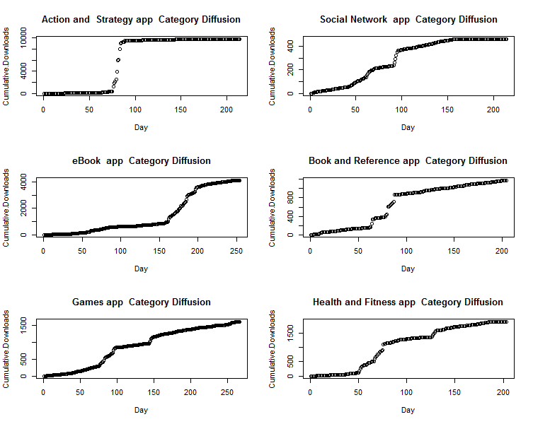

**Figure 2**

**Popularity of App Categories on Apple App Store**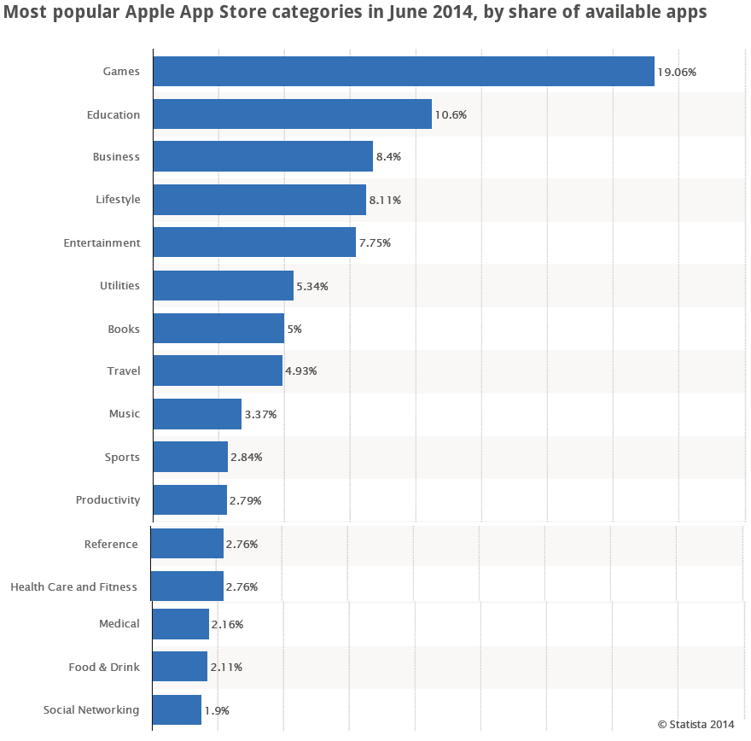

**Figure 3**

**Factor Model Fit Curve**

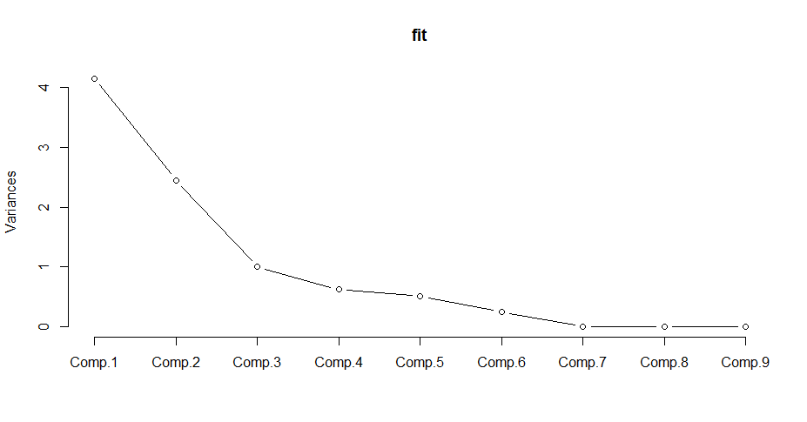

**Table 5**

**Factor Loading Matrix**

|  |  |  |  |  |  |  |  |  |  |
| --- | --- | --- | --- | --- | --- | --- | --- | --- | --- |
| **Loadings/Components** | **C1** | **C2** | **C3** | **C4** | **C5** | **C6** | **C7** | **C8** | **C9** |
| Average File Size | -0.38 |  |  | -0.13 | 0.81 | -0.43 |  |  |  |
| Featured Apps in Category | -0.37 | -0.26 | -0.18 | 0.23 | 0.28 | 0.80 |  |  |  |
| Average of Price |  | -0.61 |  | 0.22 |  | -0.21 | 0.21 | -0.69 |  |
| Variance of Price |  | -0.60 |  | 0.33 |  | -0.21 | -0.14 | 0.67 |  |
| Paid app options | -0.48 |  |  |  | -0.27 | -0.19 | -0.79 | -0.20 |  |
| Free app options | -0.48 |  |  |  | -0.31 |  | 0.45 | 0.12 | -0.67 |
| Fraction of Free to Paid Apps |  | 0.30 | -0.77 | 0.51 |  | -0.21 |  |  |  |
| Average Tenure | 0.11 | -0.33 | -0.61 | -0.71 |  |  |  |  |  |
| Total Options | -0.48 |  |  |  | -0.31 |  | 0.33 |  | 0.74 |

**Table 6**

**Factor Names**

|  |  |
| --- | --- |
| **Factor** | **Name** |
| C1 | Assortment Breadth |
| C2 | Innovative Apps |
| C3 | Paid Category |

**Figure 4**

**Box and Arrow Representation of the Model**

App Store Platform

(Assortment Size, Popularity,

Price Variance, Heterogeneity)

App Category 1

Paid

Free

App Category J

Paid

Free

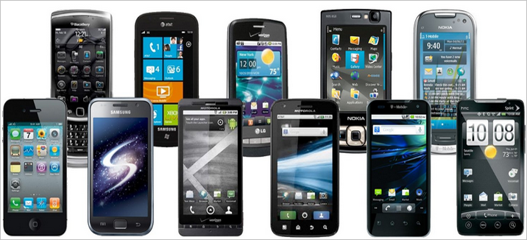

Pervasive Product

Mobile apps

….

App1

Featured

Price

File Size

AppA

Featured

Price

File Size

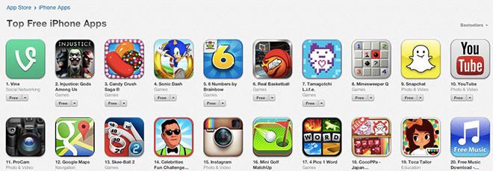

Simultaneous Diffusion

Consumers

(Segments, Tenure, Heterogeneity)

….

Location 1

Direct NE

Innovation

Market Sz

Location L

Direct NE

Innovation

Market Sz



Complementarity

**Table 7**

**MODEL COMPARISON**

|  |  |  |  |  |
| --- | --- | --- | --- | --- |
| **Model** | **Description** | **LL** | **AIC** | **BIC** |
| 1 | Local Diffusion | -5721.04 | 5781.04 | 11515.495 |
| 2 | Global Diffusion | -5.683e13 | 5.68E+13 | 1.14E+14 |
| 3 | Choice Explained by Local Diffusion | -355.41 | 5647.41 | 9.77E+03 |
| 4 | Choice Explained by Global Diffusion | -512.44 | 5804.44 | 1.01E+04 |

**Table 8**

**Performance of the Proposed Model for Four Sample Add-ons and Platform**

|  |  |  |
| --- | --- | --- |
| **Description** | **MAD** | **MSE** |
| Local Category Diffusion | 9.24 | 18.69 |
| International Category Diffusion | 38.52 | 280.01 |

**Figure 5**

**1-Step-ahead Forecast for Local Diffusion of Categories**

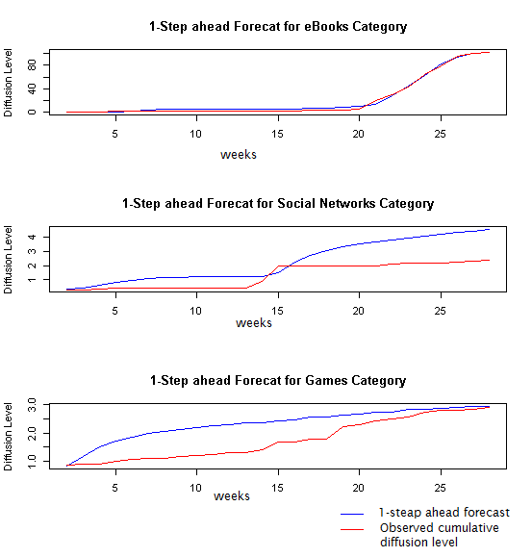

**Figure 6**

**1-Step-ahead Forecast for Global Diffusion of Categories**

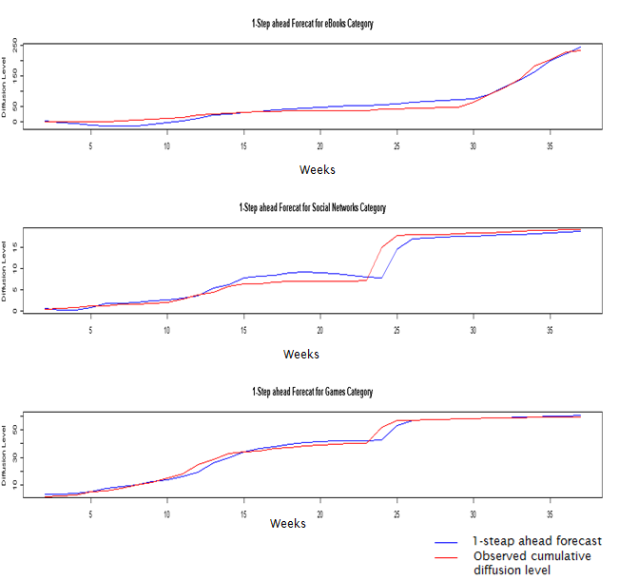

**Table 9**

**PARAMETER ESTIMATES: Local Diffusion**

|  |  |  |  |  |
| --- | --- | --- | --- | --- |
|  | **Estimate** | **Std. Dev.** | **2.5th** | **97.5th** |
| Market Size: |  |  |  |  |
| Device Tools | 99.19 | 2.14 | 95.77 | 102.82 |
| eBooks | 102.31 | 0.24 | 101.93 | 102.71 |
| Games | 3.96 | 2.83 | 2.72 | 9.27 |
| Health/Diet/Fitness | 117.03 | 2.57 | 112.86 | 121.30 |
| Humor/Jokes | 82.53 | 1.91 | 79.51 | 85.87 |
| Internet/WAP | 99.17 | 2.14 | 95.73 | 102.77 |
| Logic/Puzzle/Trivia | 4.96 | 2.61 | 2.72 | 6.85 |
| Reference/Dictionaries | 117.00 | 2.57 | 112.87 | 121.14 |
| Social Networks | 34.57 | 15.73 | 2.74 | 53.53 |
| University | 62.87 | 1.97 | 59.97 | 66.24 |
| External Market Force: |  |  |  |  |
| Device Tools | -0.0008 | 0.0008 | -0.0020 | 0.0006 |
| eBooks | 0.0006 | 0.0004 | -0.0001 | 0.0011 |
| Games | -0.0085 | 0.2878 | -0.3484 | 0.2575 |
| Health/Diet/Fitness | -0.0022 | 0.0006 | -0.0031 | -0.0011 |
| Humor/Jokes | -0.0032 | 0.0045 | -0.0105 | 0.0025 |
| Internet/WAP | -0.0020 | 0.0005 | -0.0027 | -00011 |
| Logic/Puzzle/Trivia | -0.3961 | 0.4517 | -1.1706 | -0.0059 |
| Reference/Dictionaries | -0.0016 | 0.0004 | -0.0021 | -0.0010 |
| Social Networks | 0.0042 | 0.0126 | -0.0028 | 0.0266 |
| University | -0.0028 | 0.0021 | -0.0059 | 0.0010 |
| Internal Market Force: |  |  |  |  |
| Device Tools | 0.102 | 0.0008 | 0.0099 | 0.1911 |
| eBooks | 0.745 | 0.0004 | 0.7356 | 0.7554 |
| Games | 0.847 | 0.2878 | -0.0512 | 2.0762 |
| Health/Diet/Fitness | 0.109 | 0.0006 | 0.0693 | 0.1405 |
| Humor/Jokes | 0.099 | 0.0045 | -0.0459 | 0.3653 |
| Internet/WAP | 0.109 | 0.0005 | 0.0861 | 0.1265 |
| Logic/Puzzle/Trivia | 0.924 | 0.4517 | -0.0055 | 3.0764 |
| Reference/Dictionaries | 0.113 | 0.0004 | 0.0955 | 0.1276 |
| Social Networks | 0.363 | 0.0126 | 0.0289 | 0.5928 |
| University | 0.068 | 0.0021 | 0.0035 | 0.1170 |
| Variance of Observation Equations: |  |  |  |  |
| Device Tools | 2.045 | 0.8826 | 0.8420 | 3.6270 |
| eBooks | 2.7511 | 0.0753 | 0.1635 | 04113 |
| Games | 3.0195 | 5.8025 | 0.4727 | 10.7122 |
| Health/Diet/Fitness | 2.2033 | 0.8128 | 1.0804 | 3.6999 |
| Humor/Jokes | 3.1551 | 1.8861 | 0.06489 | 6.5830 |
| Internet/WAP | 1.4211 | 0.4553 | 0.7809 | 2.2444 |
| Logic/Puzzle/Trivia | 2.9640 | 3.1260 | 0.5883 | 7.1989 |
| Reference/Dictionaries | 1.2121 | 0.3670 | 0.7022 | 1.8857 |
| Social Networks | 1.7677 | 1.8793 | 0.3136 | 5.5010 |
| University | 2.0125 | 0.6813 | 1.0282 | 3.2575 |

**Table 10**

**PARAMETER ESTIMATES: Global Diffusion**

|  |  |  |  |  |
| --- | --- | --- | --- | --- |
|  | **Estimate** | **Std. Dev.** | **2.5th** | **97.5th** |
| Market Size: |  |  |  |  |
| Device Tools | 29.96 | 17.68 | 25.32 | 32.98 |
| eBooks | 330.91 | 42.35 | 297.24 | 416.54 |
| Games | 61.75 | 8.67 | 58.09 | 67.38 |
| Health/Diet/Fitness | 84.16 | 4.25 | 80.90 | 91.54 |
| Humor/Jokes | 75.06 | 48.79 | 68.45 | 80.24 |
| Internet/WAP | 81.47 | 4.22 | 75.66 | 87.03 |
| Logic/Puzzle/Trivia | 72.68 | 3.33 | 69.04 | 76.69 |
| Reference/Dictionaries | 76.85 | 24.48 | 69.15 | 87.45 |
| Social Networks | 19.81 | 14.97 | 16.83 | 22.45 |
| University | 103.23 | 3.35 | 97.13 | 107.05 |
| External Market Force: |  |  |  |  |
| Device Tools | 0.004 | 0.024 | -0.016 | 0.022 |
| eBooks | -0.008 | 0.006 | -0.013 | 0.002 |
| Games | 0.013 | 0.016 | 0.000 | 0.021 |
| Health/Diet/Fitness | 0.016 | 0.005 | 0.006 | 0.019 |
| Humor/Jokes | 0.030 | 0.039 | -0.003 | 0.046 |
| Internet/WAP | 0.006 | 0.006 | -0.002 | 0.015 |
| Logic/Puzzle/Trivia | 0.018 | 0.011 | -0.004 | 0.031 |
| Reference/Dictionaries | 0.014 | 0.007 | 0.001 | 0.021 |
| Social Networks | 0.010 | 0.011 | -0.008 | 0.024 |
| University | 0.020 | 0.008 | 0.012 | 0.036 |
| Internal Market Force: |  |  |  |  |
| Device Tools | 0.16 | 0.044 | 0.103 | 0.236 |
| eBooks | 0.30 | 0.048 | 0.200 | 0.358 |
| Games | 0.17 | 0.032 | 0.117 | 0.224 |
| Health/Diet/Fitness | 0.22 | 0.030 | 0.164 | 0.269 |
| Humor/Jokes | 0.18 | 0.065 | 0.109 | 0.301 |
| Internet/WAP | 0.21 | 0.026 | 0.165 | 0.246 |
| Logic/Puzzle/Trivia | 0.42 | 0.087 | 0.284 | 0.574 |
| Reference/Dictionaries | 0.17 | 0.040 | 0.115 | 0.243 |
| Social Networks | 0.20 | 0.058 | 0.115 | 0.299 |
| University | 0.48 | 0.060 | 0.385 | 0.583 |
| Variance of Observation Equations: |  |  |  |  |
| Device Tools | 3.08 | 17.30 | 0.152 | 7.21 |
| eBooks | 173.69 | 184.09 | 0.002 | 456.55 |
| Games | 11.47 | 29.45 | 0.063 | 54.28 |
| Health/Diet/Fitness | 34.40 | 73.08 | 0.022 | 206.66 |
| Humor/Jokes | 69.09 | 112.93 | 0.011 | 324.53 |
| Internet/WAP | 32.02 | 71.53 | 0.027 | 199.87 |
| Logic/Puzzle/Trivia | 67.18 | 108.71 | 0.017 | 312.67 |
| Reference/Dictionaries | 48.32 | 92.62 | 0.014 | 271.74 |
| Social Networks | 1.99 | 6.90 | 0.225 | 5.25 |
| University | 81.24 | 117.91 | 0.013 | 328.56 |

**Table 11**

**COVARIANCE PARAMETER ESTIMATES: Local Diffusion**

|  |  |  |  |  |
| --- | --- | --- | --- | --- |
|  | **Estimate** | **Std. Dev.** | **2.5th** | **97.5th** |
| Device Tools |  |  |  |  |
| Device Tools | 7.33E-03 | 0.0233 | 0.0028 | 0.0161 |
| eBooks | 2.61E-04 | 0.0016 | -0.0019 | 0.0027 |
| Games | 3.65E-04 | 0.0063 | -0.0032 | 0.0045 |
| Health/Diet/Fitness | 6.89E-05 | 0.0013 | -0.0018 | 0.0020 |
| Humor/Jokes | 1.55E-05 | 0.0023 | -0.0022 | 0.0022 |
| Internet/WAP | 1.63E-04 | 0.0014 | -0.0018 | 0.0022 |
| Logic/Puzzle/Trivia | 7.37E-05 | 0.0053 | -0.0044 | 0.0043 |
| Reference/Dictionaries | 2.23E-04 | 0.0014 | -0.0017 | 0.0024 |
| Social Networks | 2.70E-04 | 0.0023 | -0.0025 | 0.0033 |
| University | 1.00E-04 | 0.0017 | -0.0020 | 0.0022 |
| eBooks |  |  |  |  |
| eBooks | 5.89E-03 | 0.0022 | 0.0033 | 0.0101 |
| Games | 6.66E-04 | 0.0029 | -0.0024 | 0.0049 |
| Health/Diet/Fitness | 2.63E-04 | 0.0012 | -0.0016 | 0.0023 |
| Humor/Jokes | 1.50E-04 | 0.0013 | -0.0018 | 0.0023 |
| Internet/WAP | 4.70E-04 | 0.0013 | -0.0013 | 0.0026 |
| Logic/Puzzle/Trivia | -1.53E-04 | 0.0030 | -0.0045 | 0.0040 |
| Reference/Dictionaries | 5.46E-04 | 0.0013 | -0.0013 | 0.0028 |
| Social Networks | 9.42E-04 | 0.0019 | -0.0015 | 0.0043 |
| University | 2.07E-04 | 0.0013 | -0.0018 | 0.0023 |
| Games |  |  |  |  |
| Games | 1.72E-02 | 0.0592 | 0.0032 | 0.0557 |
| Health/Diet/Fitness | 2.50E-04 | 0.0024 | -0.0026 | 0.0035 |
| Humor/Jokes | 1.59E-04 | 0.0027 | -0.0031 | 0.0036 |
| Internet/WAP | 4.56E-04 | 0.0025 | -0.0023 | 0.0039 |
| Logic/Puzzle/Trivia | 4.08E-04 | 0.0093 | -0.0073 | 0.0085 |
| Reference/Dictionaries | 5.28E-04 | 0.0028 | -0.0022 | 0.0043 |
| Social Networks | 9.05E-04 | 0.0036 | -0.0030 | 0.0065 |
| University | 2.91E-04 | 0.0027 | -0.0028 | 0.0039 |
| Health/Diet/Fitness |  |  |  |  |
| Health/Diet/Fitness | 4.38E-03 | 0.0014 | 0.0026 | 0.0070 |
| Humor/Jokes | 6.33E-05 | 0.0011 | -0.0016 | 0.0017 |
| Internet/WAP | 1.58E-04 | 0.0011 | -0.0015 | 0.0019 |
| Logic/Puzzle/Trivia | 1.49E-05 | 0.0025 | -0.0031 | 0.0032 |
| Reference/Dictionaries | 1.36E-04 | 0.0011 | -0.0015 | 0.0019 |
| Social Networks | 2.85E-04 | 0.0015 | -0.0018 | 0.0028 |
| University | 9.44E-05 | 0.0010 | -0.0015 | 0.0018 |
| Humor/Jokes |  |  |  |  |
| Humor/Jokes | 4.85E-03 | 0.0026 | 0.0027 | 0.0084 |
| Internet/WAP | 1.20E-04 | 0.0011 | -0.0016 | 0.0020 |
| Logic/Puzzle/Trivia | -1.36E-06 | 0.0028 | -0.0037 | 0.0035 |
| Reference/Dictionaries | 8.77E-05 | 0.0012 | -0.0018 | 0.0020 |
| Social Networks | 2.71E-04 | 0.0017 | -0.0021 | 0.0030 |
| University | 5.51E-05 | 0.0012 | -0.0018 | 0.0019 |
| Internet/WAP |  |  |  |  |
| Internet/WAP | 4.58E-03 | 0.0016 | 0.0027 | 0.0075 |
| Logic/Puzzle/Trivia | 8.33E-05 | 0.0030 | -0.0034 | 0.0035 |
| Reference/Dictionaries | 3.32E-04 | 0.0012 | -0.0014 | 0.0023 |
| Social Networks | 5.73E-04 | 0.0016 | -0.0016 | 0.0035 |
| University | 1.71E-04 | 0.0011 | -0.0015 | 0.0020 |
| Logic/Puzzle/Trivia |  |  |  |  |
| Logic/Puzzle/Trivia | 1.79E-02 | 0.0627 | 0.0035 | 0.0552 |
| Reference/Dictionaries | 5.22E-05 | 0.0029 | -0.0035 | 0.0037 |
| Social Networks | 6.97E-06 | 0.0047 | -0.0058 | 0.0056 |
| University | 1.09E-04 | 0.0030 | -0.0033 | 0.0036 |
| Reference/Dictionaries |  |  |  |  |
| Reference/Dictionaries | 4.73E-03 | 0.0017 | 0.0028 | 0.0079 |
| Social Networks | 6.41E-04 | 0.0016 | -0.0015 | 0.0034 |
| University | 1.69E-04 | 0.0012 | -0.0016 | 0.0021 |
| Social Networks |  |  |  |  |
| Social Networks | 7.47E-03 | 0.0049 | 0.0030 | 0.0164 |
| University | 2.91E-04 | 0.0016 | -0.0020 | 0.0030 |
| University |  |  |  |  |
| University | 4.62E-03 | 0.0017 | 0.0027 | 0.0077 |

**Table 12**

**COVARIANCE PARAMETER ESTIMATES: Global Diffusion**

|  |  |  |  |  |
| --- | --- | --- | --- | --- |
|  | **Estimate** | **Std. Dev.** | **2.5th** | **97.5th** |
| Device Tools |  |  |  |  |
| Device Tools | 2.57 | 47.64 | 0.82 | 2.77 |
| eBooks | 0.75 | 7.95 | -3.01 | 4.11 |
| Games | 2.79 | 22.79 | 1.39 | 4.05 |
| Health/Diet/Fitness | 2.48 | 1.40 | 1.18 | 4.32 |
| Humor/Jokes | 1.10 | 0.95 | -0.11 | 2.49 |
| Internet/WAP | 3.16 | 7.34 | 1.78 | 5.28 |
| Logic/Puzzle/Trivia | 1.37 | 1.05 | -0.08 | 3.15 |
| Reference/Dictionaries | 2.23 | 3.42 | 1.03 | 3.92 |
| Social Networks | 1.50 | 0.64 | 0.80 | 2.50 |
| University | 1.71 | 2.43 | -0.11 | 4.00 |
| eBooks |  |  |  |  |
| eBooks | 45.61 | 21.50 | 16.49 | 80.75 |
| Games | 1.46 | 5.48 | -4.73 | 7.81 |
| Health/Diet/Fitness | 1.93 | 5.48 | -7.32 | 10.64 |
| Humor/Jokes | -1.14 | 7.47 | -12.17 | 9.64 |
| Internet/WAP | 1.83 | 4.66 | -5.46 | 9.60 |
| Logic/Puzzle/Trivia | 5.14 | 8.27 | -9.47 | 18.24 |
| Reference/Dictionaries | 0.12 | 5.25 | -8.54 | 8.11 |
| Social Networks | 0.46 | 2.34 | -3.35 | 4.17 |
| University | 1.92 | 10.62 | -15.76 | 17.82 |
| Games |  |  |  |  |
| Games | 4.65 | 13.84 | 2.66 | 7.20 |
| Health/Diet/Fitness | 4.86 | 1.81 | 2.62 | 7.94 |
| Humor/Jokes | 2.32 | 1.60 | 0.35 | 4.75 |
| Internet/WAP | 5.27 | 5.06 | 2.99 | 8.52 |
| Logic/Puzzle/Trivia | 3.31 | 1.75 | 0.99 | 6.42 |
| Reference/Dictionaries | 4.25 | 2.17 | 2.19 | 7.13 |
| Social Networks | 2.47 | 0.88 | 1.41 | 4.01 |
| University | 4.22 | 2.63 | 1.18 | 8.37 |
| Health/Diet/Fitness |  |  |  |  |
| Health/Diet/Fitness | 7.24 | 2.56 | 3.85 | 11.78 |
| Humor/Jokes | 2.62 | 2.15 | -0.33 | 5.78 |
| Internet/WAP | 5.75 | 2.18 | 2.61 | 9.74 |
| Logic/Puzzle/Trivia | 4.87 | 2.54 | 1.36 | 9.43 |
| Reference/Dictionaries | 6.11 | 2.24 | 3.03 | 10.18 |
| Social Networks | 2.63 | 1.01 | 1.32 | 4.49 |
| University | 7.40 | 3.42 | 2.82 | 13.39 |
| Humor/Jokes |  |  |  |  |
| Humor/Jokes | 5.44 | 49.75 | 1.62 | 9.82 |
| Internet/WAP | 2.77 | 2.05 | -0.32 | 5.87 |
| Logic/Puzzle/Trivia | 1.36 | 2.50 | -2.08 | 5.62 |
| Reference/Dictionaries | 2.37 | 2.12 | -0.84 | 5.45 |
| Social Networks | 1.25 | 0.92 | 0.03 | 2.66 |
| University | 3.23 | 3.24 | -0.95 | 8.28 |
| Internet/WAP |  |  |  |  |
| Internet/WAP | 7.73 | 3.72 | 3.96 | 12.69 |
| Logic/Puzzle/Trivia | 2.95 | 2.16 | -0.19 | 6.60 |
| Reference/Dictionaries | 5.47 | 2.22 | 2.74 | 9.11 |
| Social Networks | 3.28 | 1.09 | 1.82 | 5.26 |
| University | 4.22 | 3.21 | -0.07 | 9.61 |
| Logic/Puzzle/Trivia |  |  |  |  |
| Logic/Puzzle/Trivia | 7.86 | 4.48 | 3.07 | 16.45 |
| Reference/Dictionaries | 3.59 | 2.30 | 0.56 | 7.61 |
| Social Networks | 1.36 | 0.96 | -0.02 | 2.98 |
| University | 6.92 | 4.05 | 1.45 | 14.04 |
| Reference/Dictionaries |  |  |  |  |
| Reference/Dictionaries | 6.38 | 2.90 | 3.31 | 11.30 |
| Social Networks | 2.45 | 0.94 | 1.23 | 4.09 |
| University | 5.99 | 3.43 | 1.35 | 11.62 |
| Social Networks |  |  |  |  |
| Social Networks | 1.59 | 0.67 | 0.79 | 2.71 |
| University | 1.94 | 1.40 | 0.09 | 4.41 |
| University |  |  |  |  |
| University | 13.93 | 7.35 | 7.02 | 28.39 |

**Table 13**

**PARAMETER ESTIMATES: Heterogeneity in Local Diffusion Parameters**

|  |  |  |  |  |
| --- | --- | --- | --- | --- |
|  | **Estimate** | **Std. Dev.** | **2.5th** | **97.5th** |
| External Market Force |  |  |  |  |
| Popularity | -0.012 | 0.047 | -0.088 | 0.063 |
| Internal Market Force |  |  |  |  |
| Popularity | 0.041 | 0.066 | -0.058 | 0.158 |
| Market Size |  |  |  |  |
| Popularity | -6.90 | 0.280 | -7.281 | -6.446 |

**Table 14**

**PARAMETER ESTIMATES: Heterogeneity in Global Diffusion Parameters**

|  |  |  |  |  |
| --- | --- | --- | --- | --- |
|  | **Estimate** | **Std. Dev.** | **2.5th** | **97.5th** |
| External Market Force |  |  |  |  |
| Popularity | 0.0004 | 0.0380 | -0.061 | 0.063 |
| Internal Market Force |  |  |  |  |
| Popularity | 0.0078 | 0.0400 | -0.056 | 0.073 |
| Market Size |  |  |  |  |
| Popularity | -1.1858 | 3.704 | -7.212 | 5.0440 |

**Figure 7**

**PARAMETER DISTRIBUTION: Heterogeneity in Local Diffusion Parameters**

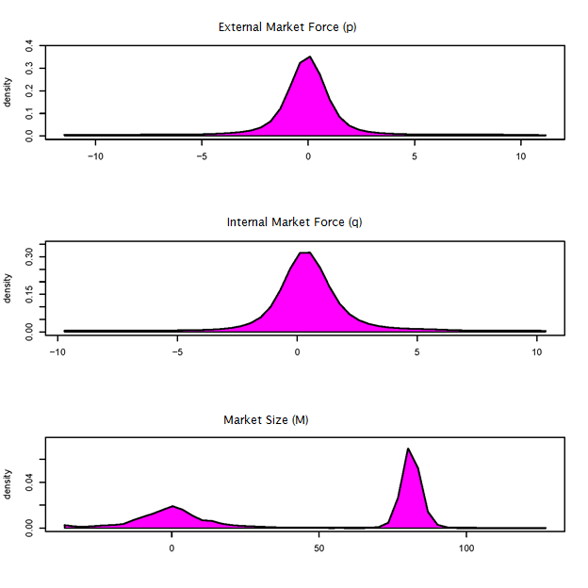

**Figure 8**

**PARAMETER DISTRIBUTION: Heterogeneity in Global Diffusion Parameters**

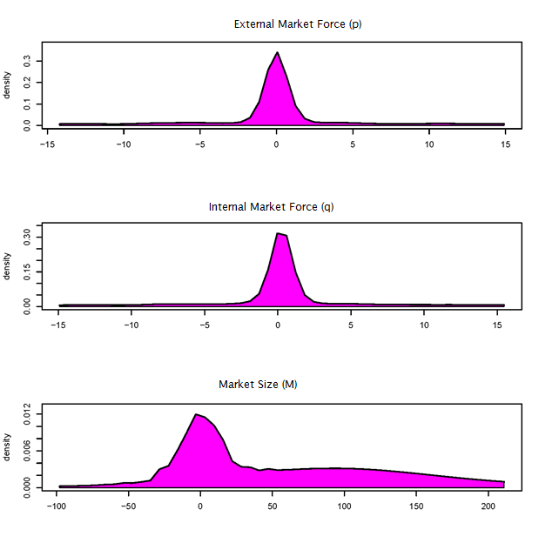

**Figure 9**

**Evolution of Forces: Imitation/Innovation Force in Local Market (scaled variation)**

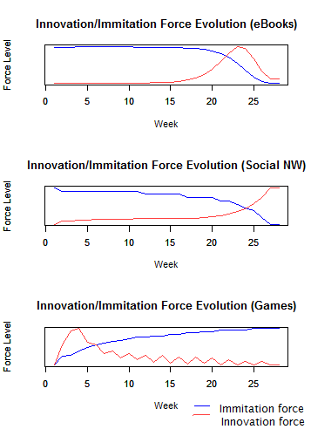

**Figure 10**

**Evolution of Forces: Imitation/Innovation Force in Global Market (scaled variation)**

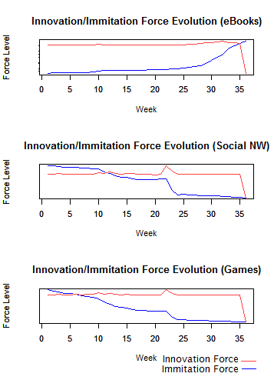

**Table 15**

**PARAMETER ESTIMATES: Individual Choice effect (Local imitators/innovators Model)**

|  |  |  |  |  |
| --- | --- | --- | --- | --- |
|  | **Estimate** | **Std. Dev.** | **2.5th** | **97.5th** |
| Category Preference: |  |  |  |  |
| Device Tools | -10.36 | 5.27 | -16.19 | -2.83 |
| eBooks | -12.46 | 3.01 | -17.55 | -8.19 |
| Games | -14.63 | 5.61 | -21.80 | -5.92 |
| Health/Diet/Fitness | -10.70 | 6.29 | -19.49 | -0.15 |
| Humor/Jokes | -10.15 | 4.69 | -16.85 | -2.38 |
| Internet/WAP | -12.95 | 5.62 | -21.98 | -4.10 |
| Logic/Puzzle/Trivia | -17.20 | 6.73 | -27.38 | -7.50 |
| Reference/Dictionaries | -9.34 | 4.83 | -17.75 | -2.66 |
| Social Networks | -9.39 | 3.32 | -14.66 | -2.21 |
| University | -11.75 | 6.50 | -22.64 | -2.46 |
| States Forces: |  |  |  |  |
| Individual Category State | -77.70 | 8.33 | -89.61 | -65.35 |
| Innovation Force | 4.05 | 6.42 | -5.11 | 14.95 |
| Imitation Force | -1.52 | 1.78 | -4.16 | 2.15 |
| Design components: |  |  |  |  |
| Assortment Breadth | -1.12 | 4.53 | -7.06 | 8.19 |
| Assortment Breadth Square | 0.49 | 5.16 | -6.97 | 8.66 |
| Innovative Apps | 3.37 | 4.47 | -1.92 | 12.09 |
| Innovative Apps Square | -3.36 | 5.29 | -10.96 | 3.86 |
| Paid Category | 0.14 | 3.14 | -5.04 | 5.61 |

**Table 16**

**PARAMETER ESTIMATES: Individual Choice effect (Global imitators/innovators Model)**

|  |  |  |  |  |
| --- | --- | --- | --- | --- |
|  | **Estimate** | **Std. Dev.** | **2.5th** | **97.5th** |
| Category Preference: |  |  |  |  |
| Device Tools | -10.17 | 4.96 | -19.01 | -2.75 |
| eBooks | -47.82 | 26.25 | -97.84 | -4.12 |
| Games | -14.33 | 9.67 | -31.01 | -2.88 |
| Health/Diet/Fitness | -11.16 | 3.42 | -14.68 | -3.52 |
| Humor/Jokes | -12.88 | 6.21 | -19.50 | -1.00 |
| Internet/WAP | -14.70 | 5.28 | -20.66 | -2.78 |
| Logic/Puzzle/Trivia | -20.12 | 5.94 | -28.80 | -12.53 |
| Reference/Dictionaries | -11.50 | 6.34 | -18.52 | 2.19 |
| Social Networks | -9.16 | 3.23 | -14.42 | -3.06 |
| University | -12.71 | 6.87 | -20.67 | -0.14 |
| States Forces: |  |  |  |  |
| Individual Category State | -20.73 | 5.67 | -31.04 | -14.52 |
| Innovation Force | -9.13 | 9.65 | -28.88 | 4.07 |
| Imitation Force | -0.20 | 0.94 | -2.18 | 0.95 |
| Design components: |  |  |  |  |
| Assortment Breadth | 1.02 | 1.67 | -1.22 | 3.32 |
| Assortment Breadth Square | -0.23 | 5.88 | -11.51 | 5.55 |
| Innovative Apps | -5.73 | 4.44 | -14.74 | -1.83 |
| Innovative Apps Square | 1.82 | 4.73 | -3.13 | 11.76 |
| Paid Category | 3.89 | 5.28 | -4.80 | 11.66 |

**Table 17**

**PARAMETER ESTIMATES: Heterogeneity in Individual Choice ( Local imitators/innovators Model)**

|  |  |  |  |  |
| --- | --- | --- | --- | --- |
| Tenure Explaining the following parameters Heterogeneity | **Estimate** | **Std. Dev.** | **2.5th** | **97.5th** |
| Category Preference: |  |  |  |  |
| Device Tools | 0.0063 | 0.0134 | -0.0116 | 0.0363 |
| eBooks | 0.0142 | 0.0245 | -0.0255 | 0.0610 |
| Games | 0.0033 | 0.0137 | -0.0175 | 0.0282 |
| Health/Diet/Fitness | 0.0374 | 0.0180 | 0.0056 | 0.0673 |
| Humor/Jokes | -0.0001 | 0.0183 | -0.0283 | 0.0355 |
| Internet/WAP | 0.0229 | 0.0175 | -0.0019 | 0.0564 |
| Logic/Puzzle/Trivia | -0.1238 | 0.0586 | -0.1816 | -0.0035 |
| Reference/Dictionaries | 0.0282 | 0.0193 | -0.0011 | 0.0612 |
| Social Networks | 0.0339 | 0.0110 | 0.0160 | 0.0522 |
| University | -0.0080 | 0.0178 | -0.0385 | 0.0188 |
| States Forces: |  |  |  |  |
| Individual Category State | -0.0591 | 0.0916 | -0.1644 | 0.0778 |
| Innovation Force | -0.0580 | 0.0222 | -0.0915 | -0.0123 |
| Imitation Force | 0.0005 | 0.0063 | -0.0096 | 0.0101 |
| Design components: |  |  |  |  |
| Assortment Breadth | -0.0366 | 0.0330 | -0.0962 | 0.0184 |
| Assortment Breadth Square | 0.1099 | 0.0623 | 0.0066 | 0.1915 |
| Innovative Apps | -0.0664 | 0.0371 | -0.1062 | 0.0051 |
| Innovative Apps Square | 0.0649 | 0.0380 | -0.0012 | 0.1077 |
| Paid Category | -0.0285 | 0.0365 | -0.0762 | 0.0296 |

**Table 18**

**PARAMETER ESTIMATES: Heterogeneity in Individual Choice ( Global imitators/innovators Model)**

|  |  |  |  |  |
| --- | --- | --- | --- | --- |
| Tenure Explaining the following parameters Heterogeneity | **Estimate** | **Std. Dev.** | **2.5th** | **97.5th** |
| Category Preference: |  |  |  |  |
| Device Tools | -0.031 | 0.018 | -0.06 | 0.00 |
| eBooks | -0.152 | 0.022 | -0.19 | -0.12 |
| Games | 0.006 | 0.019 | -0.02 | 0.04 |
| Health/Diet/Fitness | -0.012 | 0.018 | -0.04 | 0.02 |
| Humor/Jokes | 0.030 | 0.015 | 0.00 | 0.05 |
| Internet/WAP | -0.041 | 0.024 | -0.08 | 0.00 |
| Logic/Puzzle/Trivia | -0.034 | 0.022 | -0.07 | 0.00 |
| Reference/Dictionaries | 0.041 | 0.028 | 0.00 | 0.08 |
| Social Networks | 0.007 | 0.011 | -0.01 | 0.03 |
| University | -0.025 | 0.018 | -0.06 | 0.01 |
| States Forces: |  |  |  |  |
| Individual Category State | -0.014 | 0.024 | -0.05 | 0.02 |
| Innovation Force | -0.033 | 0.013 | -0.05 | -0.01 |
| Imitation Force | 0.014 | 0.004 | 0.01 | 0.02 |
| Design components: |  |  |  |  |
| Assortment Breadth | 0.008 | 0.020 | -0.02 | 0.04 |
| Assortment Breadth Square | 0.014 | 0.017 | -0.01 | 0.04 |
| Innovative Apps | 0.000 | 0.017 | -0.03 | 0.03 |
| Innovative Apps Square | 0.018 | 0.018 | -0.01 | 0.05 |
| Paid Category | -0.052 | 0.050 | -0.13 | 0.02 |

**Figure 11**

**PARAMETER DISTRIBUTION: Heterogeneity in Individual Choice ( Local imitators/innovators Model)**

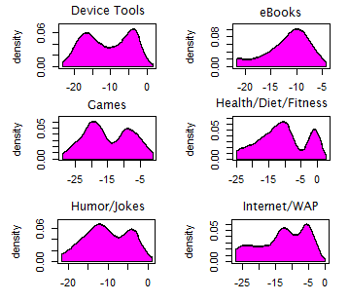

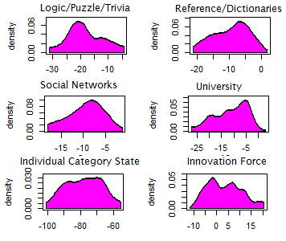

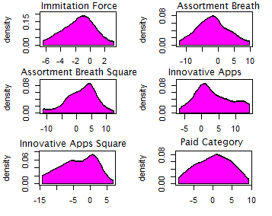

**Figure 12**

**PARAMETER DISTRIBUTION: Heterogeneity in Individual Choice ( Global imitators/innovators Model)**

