Working Paper Document

**Social Learning and diffusion over Pervasive Products:**

**An Empirical Study of an African App-store**

Author: Meisam Hejazi Nia

Advisors: Dr. Norris Bruce, Dr. Brian Ratchford

Date: 08/31/2014

**Abstract**

The mobile app market reached 64 billion downloads with $18 billion revenue in 2012 up from 8.2 billion downloads with $5.2 billion revenue in 2010. As a two-sided platform, App-store matches app developer/publishers with consumers. For pervasive mobiles’ apps, the consumers’ preferences can be interrelated in many ways, ranging from the psychological benefits of social identifications/learning/inclusion to the utilitarian benefits of network externalities. Particularly, the imitation and innovation forces at the local level (for the underlying goods pervasiveness) or at the global level (for the internet communications) may affect consumers’ choices. Interested to know these effects at macro and micro levels, the app-store platform owners may want to know the complementarity/substitution of the mobile app categories and their assortment breadth effects. Thus, to study the diffusion on pervasive goods at both macro and micro level, we combine the benefits of big data and structural models by using hierarchical Bayesian simultaneous non-linear state space and choice models[1]. By applying our approach on a unique dataset of an app-store in Africa[2], we find that local rather than global forces drive consumers’ adoption choices. We also identified an interesting complementarity and heterogeneity pattern for mobile app categories, yet we did not find any effect of app category assortment breadth. We discuss various managerial implication of this study.

Keywords: mobile app store platform, social learning, simultaneous local and global diffusion, app category complementarity and substitution, hierarchical mixture Bayesian, state space, structural model, MCMC, big data

**Introduction**

Smartphones are so pervasive in the telecommunication market that no matter which mobile operator anyone selects in U.S (e.g. T-Mobile, Verizon, AT&T, or Sprint), she has an option to adopt a smartphone handset. To increase the revenue from the smartphones by advertising or sales revenue shares, Google, Apple, Microsoft, and many other intermediaries called App-stores open their platform to third party developers and publishers to develop and publish mobile apps. As two sided platforms, App-stores match consumers and app developers/publishers. For pervasive mobiles’ apps, the consumers’ preferences can be interrelated in many ways, ranging from the psychological benefits of social identifications/learning/inclusion to the utilitarian benefits of network externalities. Particularly, the imitation and innovation forces at the local or at the global level may affect consumers’ choices. Interested to know these effects at macro and micro levels, the app-store platform owners may want to know the complementarity/substitution of the mobile app categories and their assortment breadth effects.

For the app-stores, knowing consumers’ heterogeneous response to imitation and innovation forces has different policy implications, ranging from use of viral marketing to use of trial based strategies. With this knowledge, an app-store can find an optimal interior or corner marketing mix solution to drive each consumer’s adoption. Even at the macro level, knowing whether local or global forces drive consumers’ preferences implies different set or sequence of signaling actions for the app-stores at both local and global levels. The interdependence of consumers’ preferences has long been studied in the marketing in the context of the geographical or social neighborhood by Yang and Allenby (2003), Stephen and Toubia (2010), Lehmmes and Croux (2006), Nair et al. (2010), etc. However, mobile phones are pervasive, as consumers carry their smartphones with, in many social events[3]. This pervasiveness may help the diffusion of the mobile apps in a local market, but it is not clear whether this local social learning or the process of global social learning over the internet drives each consumer’s adoption decision.

To design an optimal app store platform, in addition to knowing the complementarity and substitution of app-categories, an app store platform owner may want to know whether an optimal assortment size exists. There are mixed evidences to address this issue (Scheibehenne et al. 2010). Hinging upon search theories, some studies address detrimental effects of large assortment breadth (Kuksov and Villas-Boas 2010, Diehl and Pynor 2010, Sela, Berger, and Liu [2009](http://www.jstor.org/stable/10.1086/651235#rf110), Gourville and Soman 2005, etc), while others nudge to product fit and signaling effects to argue for larger assortment breadth (Anderson [2006](http://www.jstor.org/stable/10.1086/651235#rf2), Bown et al. 2003, Oppewal and Koelemeijer [2005](http://www.jstor.org/stable/10.1086/651235#rf90), Borle et al. [2005](http://www.jstor.org/stable/10.1086/651235#rf11), Drèze, Berger et al. 2007, etc.). On mobile apps it is not clear which argument has merit. Thus, we ask following substantive questions: (1) whether global or local diffusion of mobile app categories drive the individual choices of consumers? (2) Whether imitation or innovation forces drive the diffusion of an app category? (3) How can an app-store platform optimize its targeted marketing mix policies (e.g. encourage trial, or encourage sharing) to increase the choice probability of individual consumers of an app in a given app category? (4) Which mobile app categories are substitute, and which are complements? (5) What is the optimal assortment breath of each mobile app category?

To answer these questions we need approaches that not only allow flexible heterogeneity patterns, but also take advantages of from both big data and structural modeling targeted policy simulation benefits. As a result, we cast Bass Diffusion Model (BDM) into discrete simultaneous state-space models first to filter imitation and innovation forces that drive app categories diffusion. We then use a factor model to find principle components of mobile app category characteristics. Next we use a hierarchical normal mixture individual choice model over a sample of our big data. We use a dataset of a newly launched app-store in Africa to test our model. To estimate our model, we use Extended Kalman Filter (EKF) and mixture normal logit model to get robust results given potential measurement and process errors. We find that diffusion over pervasive products thesis fits our data better than global diffusion cross country interaction antithesis. We find an interesting pattern of global complementarity between mobile app categories, a significant role of word of mouth in driving mobile app diffusion at aggregate level, and bimodal distributions for app-category preferences. However, our results do not show any significant impact for the category assortment breadth.

Our study is mostly related to studies by Yang and Allenby (2003), Stephen and Toubia (2010), Lehmmes and Croux (2006), Nair et al. (2010) on consumers’ peer effect, studies by Sriram et al. (2007) and Liu et al. (2010) on the complementarity and substitution of digital goods, and studies by Putsis et al. (1997) and Dekimpe et al. (1997) on the global simultaneous diffusion. Although these studies have contributed greatly to our understanding of the phenomenon, none has considered the impact of visibility of goods diffused over other pervasive goods at both macro and micro levels, at local and global levels, by both simultaneous diffusion and choice modeling approaches that combine benefits of big data and structural models. This paper, thus, contributes to the emerging literature on pervasive products and mobile app store platforms in three ways. First, it introduces the combination of macro simultaneous diffusion model and micro choice modeling approaches to study the design choices of the app-stores, an approach that use both the benefits of big data and structural models. Although other studies in marketing have considered the dynamic choice models of digital goods, none has molded the effect of innovation and imitation forces at micro level. Second, the paper examines the complementarity and substitution of different mobile app categories, and the effects of app-category assortment breadth, by joint use of factor models and choice models. This information can help the app store platform to optimize its marketing mix policies for app categories. Third, to estimate the resulting model, the paper employs hierarchical Bayesian mixture normal on the top of both choice and Extended Kalman Filter (EKF) estimation procedures. These approaches that allow for a flexible heterogeneity pattern and for a robust filtering of process and measurement errors should be of interest to academia and a number of commercial entities interested in the macro and micro insights about diffusion over pervasive products processes.

**Literature Review**

This study draws upon several streams within the literature that have investigated: *i*) Interdependence of consumer preference; *ii*) Product Category Complementarity; *iii)* Mobile app store dynamics; *iv)* Global simultaneous diffusion; and *v*) Assortment breadth and product line variety. Given the breadth of these areas across multiple disciplines, what follows is only a brief review of these relevant streams. Table 2 presents a summary of the position of this study.

**Interdependence of consumer preference**

Quantitative models of consumer purchase behavior often do not recognize that consumers’ choices may be driven by the underlying innovation and imitation forces within the population. Economic models of choice typically assume that an individual’s latent utility is a function of brand and attribute preferences, not the preferences of others, yet for pervasive experience goods, a new model which accounts for these underlying forces and preferences may explain the choice of consumers better. Many studies tried to address this issue. Yang and Allenby (2003) uses cross sectional data to model consumer preference dependency, Stephen and Toubia (2010) online social network seller interaction to quantify network value, Lehmmes and Croux (2006) a customer database of an anonymous U.S. wireless telecom company to propose bagging and boosting classification technique to improve churn prediction, Bell and Song (2007) the customer trials data at Netgrocer.com to find spatial exposure importance, Aral and Walker the vivo randomized experiment data to find importance of influence and susceptibility, Nair et al. (2010) the physicians’ prescription choices self-reported information to find significant network influence, Bradlow et al. (2005) the literatures to suggest demographic and psychometric measures importance, Hartmann (2010) a group of customers data to find importance of social interactions as an equilibrium outcome of an empirical discrete game, Yang et al. (2005) the interdependence of TV viewership of spouses data to suggest the importance of accounting for choice interdependency, Narayan et al. (2011) the conjoint experience data to suggest the importance of peer influences, and finally Choi et al. (2010) an internet retailer’s data to show the importance of imitation effects in geographical and demographical proximity.

**App Category Complementarity**

Investigating the complementarity between different product categories has long been the interest of marketing scholars. Sriram et al. (2007) presents a framework of durable good purchasing behavior in related technology product categories, Liu et al. (2010) a framework to study complementarities and the demand for home broadband internet services, Yang and Ching (2013) a life-cycle framework to study consumer’s adoption and usage decision of ATM cards, Ma et al. (2012) a framework to study household’s contemporaneous brand choice and cross-category dependencies, Karaca-Mandic (2011) a framework to study complementarities between DVD player adoption and the DVD content, Lee et al. (2013) a direct utility framework with a latent decision sequence to study asymmetric complementarity effects, and the cross-category purchases and inventories, Niraj et al. (2008) a framework to simultaneously model household decision, Wedel and Zhang (2004) a framework to study cross-category store-level price effects, Song and Chintagunta (2006) a framework to study cross-category effects of marketing activities in aggregate store-level scanner data, Oestreichter-Singer and Sundrararajan (2008) a framework to study “product networks” demand spillover across constituent items, and finally Bezawada et al. (2009) a framework to study the effects of aisle and display placement on the sales affinities between categories

**Mobile app store dynamics**

There is an emerging stream of literature that interests the dynamics of mobile app stores. Ghose and Han (2014) studies Apple and Google platforms’ competition, Carare (2012) bestseller rank information on Apple’s app store, Garg and Telang (2013) rank-demand relationship of paid apps on the Apple’s iTune, Liu et al. (2012) the freemium strategy of Google play, Ghose et al. (2011) difference between mobile phone and personal computers’ browsing behavior, Ghose and Han (2011b) the relationship between content generation/consumption and learning on mobile phones, Ghose and Han (2011a) internet usage relation with mobile internet characteristics, Kim et al. (2008) own- and cross-price elasticity of voice and short message services.

**Global Simultaneous Diffusion models**

There are two main relevant streams of literature in product diffusion related to this study: micro diffusion models, and global simultaneous diffusion models. Chaterjee and Eliashberg (1990) use micro-modeling approach with Bayesian learning information of consumer from information items that emerge with Poisson rate, Young (2009) meta-analytic approach, Lelarge (2010) forward looking coordination game approach, Iyengar and Van den Bulte (2011) micro-network study approach, Song and Chitagunta (2003) dynamic forward-looking choice approach, Dover et al. (2012) network topology approach, Trusov et al. (2013) systematic conditioning approach to study heterogeneous adoption choices of consumers. For more complete review of models please review Peres et al. (2010).

Parallel with micro diffusion literature, Putsis et al. (1997) suggests the importance of pattern of interactions (mixing), Dekimpe et al. (1998) the importance of simultaneous diffusion, Putsis and Srinivasan (2000) the importance of supply-side relationships (e.g. production economies), and omitted variables (e.g. income) correlated across countries, Talukdar et al. (2002) the importance of several macro-environmental variables, Van den Bulte and Joshi (2007) the importance of mixture model of diffusion, to study global market diffusion of digital goods.

**Assortment Breadth**

. There are currently mixed evidences about the influences of assortment breadth (Scheibehenne, et al. (2010) ). On theory side, Kuksov and Villas Boas (2010) argue that if too many alternatives are offered, then the consumer may have to engage in many costly searches or evaluations to find a satisfactory fit, the process that may result in no purchase decision. On the empirical side, Diehl and Pynor (2010) argue for lower satisfaction, Chernev and Hamilton (2009) for concave effects, and Sela et al. ([2009](http://www.jstor.org/stable/10.1086/651235#rf110)) for difficulty and negative justifiability of choices from large assortment breadth. However, Berger et al. (2007) argues for positive perceived quality, Anderson (2006) for long-tail positive impact, Saloot et al. (2006) for higher substantive short-term category benefit, and Oppewal and Koelemeijer (2005) for no effect of larger assortment breadth.

This study is different from above mentioned studies in that it uses a unique long time series of a panel of consumers over a course of 6 months over mobile apps within mobile app categories, which allows us to identify not only the diffusion of mobile app categories, but also the effects of imitation and innovation forces on individual consumer’s decision. To the best of our knowledge we are the first to juxtapose global imitation and innovation forces to local imitation and innovation forces to find the one that gives us a better fit. Our use of Hierarchical Bayesian and SUR model to model the simultaneous diffusion of mobile app categories allows us not only to infer complementarity of different mobile app categories but also to deal with the inherent scarcity of data in the context of our study. Our combined approach of faltering and factoring big data and using structural models not only allows marketing scholars to get both macro and micro level insights but also enables them to optimize marketing mix policies targeted for each consumer, and to run counterfactuals.

**Model**

We start our model with the choice of individuals  on the app-store. Our model starts with the choice of app category, in contrast to the prior studies such as Carare (2011) that not account for consumers’ decision within the app category. More specifically, we assume consumers go through two stages of decision making: First consumer selects an app category that she is interested in among the available app categories, where  denotes the outside good option, and then given the app category in the second stage consumer selects among available apps within the app category, where  denotes outside good option or any app other than the apps under the study. In this specification we assume that if a consumer selects an app category, she will definitely download one of the apps within that category. This modeling decision may be justified by referring to sunk opportunity cost of consumer for decision making, and the miniscule cost of download. More formally we can define the probability of purchase of an app in a given category as:



Consumer information processing theory and household production model assume that consumer considers perceived risk of a purchase decision, and she is more prone to select a product that she has more familiarity with. These studies including Ratchford (1982) and Kok and Xu (2011) suggest that consumer decision can be modeled using nested logit structure. Our different formulation of app choice probability by conditioning on category, allows us to have a more structural model, which in turn facilitates studying search behavior of consumers over different app categories on the app store. Our two stage modeling approach is close to the specification of Kok and Xu (2011) on consumer’s decision among product types in the first stage and among the brands for a given product type in the second stage. Figure below shows consumer’s decision to download an app. Another interpretation of our model is that first consumer faces a universal set, and in this universal set she uses an screening rule to filter only relevant choice sets. We assume the screening rule in our context is selecting the app category. Other screening rules could be to select one of the attributes, as Gilbrid and Allenby (2004) suggest.

Now that we discussed the logic, we can simplify our problem. Conditioning on the choice data, the probability of mobile app choice and the probability of mobile app category choice are independent. Therefore, we can break the problem of choice of an app to two portions: the probability of selecting an app category, and the probability of selecting an app. The first portion is app store platform’s problem, and the second is app developer’s problem. Given that in this study we focus on the app store platform owners’ problem, we focus our study on the first portion, which is selecting a mobile app category. Figure 4 presents box and arrow representation of our model.

We specify the utility of consumers’ choice of app categories on the app store in the following form:

 (1)

Table 1 presents the definition of the variables and the parameters. We accounted for state dependence in our model by incorporating the history of consumers’ downloads of apps in categories j from inception until time t in the individual state variables (). If a consumer downloads an app from the app category j in previous time slot, t-1, then  , otherwise if the consumer selects outside option, then  remains unchanged: i.e. . This specification induces a first-order Markov process on the choices. We explain how we derive factors  from mobile app category characteristics later in this section. Our characterization of the imitation and innovation forces of category j at time t filtered from aggregate diffusionresembles the approach used in choice models to incorporate featured and displayed products in grocery stores at aggregate levels. Our approach serves as an alternative to micro-modeling approach used by Yang and Allenby (2003) to incorporate interdependence of awareness and preferences of consumers, yet it may be more relevant to the context of pervasive goods, as these goods are more conspicuous.

Assuming that random utility term, is type I extreme value distribution, consumer’s i's probability of selecting app category j at time t is given by a multinomial logit model as follows:

 (2)

Here, we assume that the mean utility of outside good is zero, i.e. .

We use the whole dataset to filter innovation and imitation forces in our data. To do so, we use observed cumulative number of downloads, and we cast the Bass model into a state space form as follows:





The first equation denotes the observation equation and the second one the state equation of our state space model. Table 1 presents the definition of the variables and the parameters. Bass diffusion model (1969) suggests a specific hazard rate functional form for the diffusion of a product. In our model  and  are parameters of innovation and imitation forces respectively and  denotes the market size of each app category. In addition,  and denote cumulative observed and latent number of the app categories’ adopters. In the form of seemingly unrelated regressions (SUR), our simultaneous modeling approach of state equations allows us to identify complementarity or substitution of mobile app categories. An alternative approach could be to solve Riccati differential equation as proposed by Bruce et al. (2010). However, such an approach may not fit to our purpose, because in the context of diffusion, as the mean of the state variable is always increasing, we may expect considerable correlation between latent cumulative numbers of adopters. However, such a correlation may not suggest complementarity or substation, so we are interested in the non-word of mouth and non-innovative forces that drive the diffusion of the cumulative mobile apps jointly.

We account for heterogeneity in individual and category parameters, through a random effect model. In order to avoid misspecification of the distribution of consumer heterogeneity in preferences, and allow for multimodal densities of preferences across groups (or “segments”) of consumers, we adopt the method proposed by Dube et al. (2010) to use a flexible semi-parametric heterogeneity specification that consists of a mixture of multivariate normal distributions, to allow for thick tail, skewness, and multimodality. We denote vector of non-state consumer-level parameters by  and vector of non-state category level parameters by . We accommodate consumer and category heterogeneity by assuming that  and are drawn from two separate distribution common across consumers and common across categories. We employ mixture of normal as the first stage prior, to specify an informative prior, and to avoid the over-fitting problem. The first stage consists of a mixture of  multivariate normal distributions respectively, and the second stage consists of priors on the parameters of the mixture of normal:

 (5)

 (6)

represents the hyper-parameters of the priors on the mixing probabilities and the parameters governing each mixture component. To obtain a truly non-parametric estimate using the mixture of normal model it is required that the number of mixture components  increase with the sample size. We adopt the approach proposed by Dube et al. (2010) to fit models with successively large numbers of components and to gauge the adequacy of the number of components by examining the fitted density associated with each number of components. In summery we have molded the interrelated diffusion of mobile app categories using both hierarchical Bayesian and simultaneous equation approach.

To estimate innovation and imitation forces at each point in time, we filter latent cumulative number of app category adopters, and we split the rate of diffusion to innovation and imitation forces as follows:



As app category characteristics result in multicollinearity in our estimation, we use factor model to decompose the variation in app category characteristics into their principle components. Formally, we use the following model as our factor model:



Table 1 presents the definition of variable and parameters. Our use of factor model is also useful to account for inherent sparsity in our data. This closes our model specification.

**Data**

Our data were collected by an African telecom operator on individual choices of downloading mobile apps from the app store platform of its global partner. The app-stores are a type of two sided platform, as they match consumers’ and developers/publishers without taking the ownership of mobile apps. The app-store we studied is launched within around 330 days prior to our study in 2013 and 2014, so we use the aggregate download data for a period of 190 days, and the data on download choices of consumers over this newly launched app store for a period of around 140 days. To deal with sparsity in our data, we aggregate our choice and aggregate diffusion data at weekly level. In addition, we dealt with the inherited sparsity in the data using Bayesian shrinkage method for both mobile app categories’ and individuals’ parameters. We selected 10 different dominant app categories, which have enough data for our estimation, and within each app category we stratified a sample of individual consumers who have at least one downloaded app during the time frame of our study. We investigate geographic source of interdependence of consumer preferences (i.e. within the city) versus global sources of interdependence of consumer preferences (i.e. across the globe).

We create geographic neighborhood (i.e. city) by physical proximity, through mapping IP address of each consumer to the corresponding city. For this purpose we wrote a crawler and scraper in Perl to scrape the location of each corresponding IP in an IP-location mapping website. The data consists of around 20,000 consumers, with around 3,000 consumers in a local city under study, in Africa. This local city has around 4,000 app downloads for the duration of our study. Twenty thousand or three thousand consumers’ daily choice for a course of six month classifies our data as a big data. Structural modeling approaches may not perform well over our big data in a limited estimation time frame. As a result, we draw a random stratified sample of 147 consumers’ individual to study consumers’ choices. Table 4 illustrates the list of the categories that we select and their corresponding total downloads within the local city under this study.

Our data also included longitude and latitude of each IP address, yet as mobile phones are nomadic and ubiquitous, we find the choice of city a more reasonable one. Social nature of mobile phones and mobile apps that diffuse over these pervasive products is another reason which may reinforce that our assumption is innocuous. Particularly, mobile phones have become inseparable part of societies, to the point that not only customers use them when they are alone in the bus, when they are to sleep, or even when they are in the class, but also they use them in their parties, in their offices, in their leisure times, and generally in any social events. Mobile phones use in social events makes mobile apps visible, so it creates social learning opportunities. In the figure I, we plot the diffusion curves of cumulative adoptions of a sample of six mobile app categories.

For each mobile app category, we have average file size, total number of apps featured, average and variance of app prices, and number of paid and free options. Table 3 presents the basic statistics of these variables. To explain heterogeneity in individual responses, we use data on tenure of each customer. We define tenure as the number of days since each customer has subscribed to the app-store. As different types of consumers (i.e. innovator and adopters) with different psychological traits adopt technology at different points in time (Kirton 1976), we use tenure of consumers as a proxy for the psychological traits that can explain heterogeneity in consumers’ choice responses. To explain heterogeneity in app store categories, we use popularity of mobile app categories on the Apple app store. As the Apple app store was the innovator of app-store platforms and its consumers are more affluent ones[4], we may expect that popularity of mobile app categories on the Apple app store explain diffusion of mobile app categories on other app stores as well. Therefore, we use mobile app categories’ popularity on the Apple app store to explain heterogeneity in the mobile app category parameters. These popularity statistics is presented in figure 2.

Finally, it may be relevant to note that mobile apps are more a durable good than a grocery store type of good. Therefore, the consumers’ choice of downloading a mobile app may be sparse in nature filled with outside option choices. Therefore, the time varying characteristics of mobile app categories and the strength of imitation and innovation forces may be an alternative explanation to the consumers’ learning theory. In this alternative explanation, we assume that the consumer is ignorant and passive, rather than learner and active, yet she become interested in downloading a mobile app either when imitation or innovation forces strengthen, or when the mobile app categories’ characteristics becomes more favorable.

**Identification and Estimation**

In order to identify our choice model we use a logit specification, which has a fix scale. To set the location of the utility, we normalize the utility of outside option to zero, as explained before. We identify individual level parameters using a large panel of individuals in our sample. As the likelihood for non-selected choices are unbounded, we adopt the method used by Rossi et al. (2005) to use weighted approach with pooled parameters likelihood to build our proposal density. In addition, Bayesian shrinkage allows us to borrow data across individuals’ choices to overcome this shortcoming. We identify the latent cumulative number of adopters of mobile app categories with observed cumulative number of adopters in the complete dataset. We also use Bayesian shrinkage to overcome inherent sparsity in the data and to identify mobile app categories across our study. In addition, variation in the diffusion level across 27 weeks and simultaneous modeling of app category diffusions allow us to identify joint diffusion of parameters.

In order to estimate our model we use a hybrid sampler, and we break our joint sampler into a series of conditional distributions to make our estimation computationally tractable. Appendix A presents the Direct Acyclic Graph (DAG) of conditional distributions. Our hybrid sampler nests Extended Kalmn Filter (EKF) forward filtering backward sampling recursion into a Gibbs sampler (GS) that incorporates block Metrapolis Hasting (MH) sampler around the mode. Our algorithm is adaptive to find the appropriate tuning parameter for block M-H automatically. We use stochastic time varying estimation method with stationary random walk noises that are orthogonal, per assumption. Putsis and Srinivasan (1999) and Xie et al. (1997) posit that this type of estimation method unlike log likelihood and nonlinear least square methods bring robustness by filtering process and measurement noises. Our estimation consists of three blocks, as presented in Appendix B.

The first block filters the innovation and imitation forces of diffusion, and it consists of three stages. In the first stage, we use EKF recursive algorithm to draw unobserved state of diffusion of mobile app categories. This procedure linearizes the Bass diffusion model (BDM), and it runs through two steps: time updating and measurement updating. In time updating step, the procedure forms the prior on mean and variance of state parameters given fixed parameters. In the measurement updating step, we form posterior on mean and variance of unobserved parameters, by using Kalman gain, which is simply the fraction of variance of observation equation to state equation. Given the latent parameter mean and variance, we draw new latent cumulative diffusion level. In the second stage, given the observation and the state equations, we draw non-state parameters by using standard unconstrained Gibbs sampler algorithm. In the third stage, we use standard unconstrained Gibbs sampler to draw first and second stage hyper parameters of a mixture of normal distribution of category specific fixed parameters. The “label-switching” problem for identification in mixture of normal is not relevant in our application, as we are interested only in the joint posterior distribution of quantity which is label-invariant. Given the results of this block we find the estimated level of innovation and imitation forces of diffusion of each of the mobile app categories.

The second block of estimation consists of a normal factor model that gives us principle component of the categories characteristics. Given the factor loading parameters of each principle component, the result of this block gives us the estimated level of each of the principle components for each of the categories at each point in time. The results of the two blocks together create the input data for the third block which estimates the choice model. The third blocks’ MCMC sampler consists of two stages. The first stage uses Metropolis Hasting algorithm over the pooled MNL proposal density tuned for each consumer by MNL likelihood. We adopted the method proposed by Rossi et al. (2005), chapter 5, to optimize the proposal density to this end. This procedure avoids the problem of undefined likelihood for tuning purposes as suggested by Rossi et al. (2005). In the second stage, we use standard unconstrained Gibbs sampler to draw first and second stage hyper parameters of a mixture of normal distribution of category specific fixed parameters. Again, the “label-switching” problem for identification in mixture of normal is not relevant in our application, as we are interested only in the joint posterior distribution of quantity which is label-invariant. Given the results of this block we find the estimated level of innovation and imitation forces of diffusion of each of the mobile app categories.

**Results**

Table 7 presents the log likelihood, AIC and BIC of the proposed models. The local diffusion model explains the choice of customers better than the global diffusion model. This may suggest that innovation and imitation forces at local level can predict consumers’ choices better than the imitation and innovation forces at global level. In other word, unlike previous studies (e.g. Putsis et al. (1998)), we find that global coordination across countries is not so much relevant on the mobile app stores, stores for mobile apps that are diffused on the pervasive smartphones. Figure 5 and 6 present the one-step ahead forecast versus the observed cumulative number of adopters at both the local and the global level. Table 8 presents the Mean Absolute Deviation (MAD) and the Mean Square Error (MSE) of these one-step ahead forecasts. We benchmarked these two performance criteria against MSE and MAD criteria proposed in Xie et al. (2007), and they follow the same scale. Again, it may worth noting that the advantage of our estimation method is that it allows filtering the process and the measurement noises.

To avoid multicollinearity in mobile app characteristics we use a factor model. Figure 3 and table 5 present the result of the principle component analysis procedure. We limit our analysis to the first 3 factors/principle components that explain most of the variation. The parameter estimates of these three components guided us to name them the assortment breadth, the innovative apps, and the paid categories respectively. To ease our interpretation, we negate the first factor before including it into our choice model.

Table 9 explains local diffusion parameter estimates. At local level we find positive significant imitation forces for all the mobile app categories except Logic/Puzzle/Trivia, Humor/Jokes, and Games. Looking at the innovation forces, we find insignificant innovation forces across app categories, except for Health/Diet/Fitness, Internet/WAP, Logic/Puzzle/Trivia and Reference/Dictionaries app categories. The results may suggest that at local level imitation forces is the main driver of mobile app diffusion. The insignificant imitation forces for three leisure categories may be explained by hedonic nature of these leisure categories, a hedonic nature that drives impulse downloads rather than planned contemplated downloads based on imitation or innovation forces (Tifferet and Herstein 2012). On the other hand negative significant innovation factor may explain resistance to innovation (Cho and Chang 2008). More particularly, one may have technophobia, or she may not be interested in using references and dictionaries. Therefore, although there could be positive chatter about the products within the population, this customer may resist adopting the relevant mobile apps.

Table 10 explains global diffusion parameter estimates. At global level, we find positive significant imitation forces for almost all the mobile app categories. Looking at the innovation forces, we find significant innovation forces only for categories such as games, health/diet/fitness, reference/dictionaries and university. The significant innovation forces within these mobile app categories may suggest that consumers are self-motivated to adopt these types of mobile apps, or that they actively search for them. Again this result also suggests that at global level word of mouth is a dominant force to drive mobile app category adoption. The imitation factor for mobile apps at global level is at the range of imitation factor for VCR, CD-player, Video games, digital watch and radio, while innovation factor for mobile apps at global level is at the range of CD-Player, PC, Cellular phone and VCR (Kohli and Lehmann 1999).

Table 11 and 12 present covariance parameter estimates for state equations of local and global diffusion models. At the local level, we do not observe any significant pattern of substitutions or complementarities between mobile app categories, yet at the global level we observe interesting patterns of complementarities. The reason that we could not find any of such patterns at the local level may be attributed to the inherited sparsity in our data. At global level we find the Internet/WAP mobile app category more complement to the Device Tools app category, than the Games, Health/Diet/Fitness, Reference/Dictionaries and Social Networks mobile app categories, in order. This pattern of complementarity may suggest that those who care about their smartphone devices may also care about their internet first, their leisure next, their health and finally to the references and the socialization. Needless to say, as we identify these patterns at the global level, this may suggest the complementarity at clique or supopulation level rather than the individual levels. Our data does not show any significant pattern of complementarity for eBooks, but we find significant greater complementarity for the Games, with the Health/Diet and the reference and dictionary app categories, than for the Games, with the Humor/Jokes and the Logic/Puzzle/Trivia mobile app categories. This pattern may suggest that the individuals or the subpopulations of consumers who play Games are also concerned about their health and their knowledge. There are anecdotal evidences about the impact of Games on health as well[5]. We find the Health/Diet/Fitness app categories to be complement highly to the reference and dictionaries and the university and internet/WAP app categories, but less and significant complement to the Social Networks and the Logic/Puzzle/Trivia app categories. This finding may suggest that those who are more knowledgeable and updated are probably more conscious about their health. To support this finding, we nudge to studies that find health conscious consumers are more educated (Robinson and Smith 2003). We find Humor/Jokes app categories to be complement to Social Networks app categories. This finding can be traced back to the studies that find group members who occupy the key humor roles are over-chosen on in the social interactions (Duncan 1984). We find the Logic/Puzzle/Trivia mobile app category complement to the University and Reference/Dictionary mobile app categories. This finding also may suggest the existence of a segment of consumers that seek the intellectual challenge. All in all, an app store platform owner may be interested to know these complementarity patterns to reform its website so that complement products be put together to increase the chance of upselling.

We explain the heterogeneity in local and global diffusion parameters with data on the popularity of mobile apps on Apple app store. Table 13 and 14 present the result of this estimation of hierarchy. The only significant parameter is local market size. Local market sizes of mobile app categories have negative relation with the mobile app category popularities on the App store. This result may suggest that the preferences of the users of the mobile app categories on Apple app store are different from the preferences of the users of the mobile app-store platform under our study. This may suggest the different attitude of target customers of these two mobile app-store platforms toward mobile apps. Figure 7 and 8 present heterogeneity in diffusion parameters at the local and the global level. At the local level we observe the bimodal distribution of market size parameters. Allowing a flexible procedure to capture this bimodality is important, as otherwise the parameters’ estimates are biased. In addition, for app-store platform owner, it may be interesting to know this bimodality, as it suggests different mechanism design for different mobile app categories. On the global level we observe a thick tail of Market size distribution. Again allowing for the flexible distribution to estimate the correct thick tail distribution is important, because otherwise the fixed parameters are biased.

Figure 9 and 10 present the extent of imitation and innovation forces at both local and global markets. We scaled the innovation force levels for ease of exposition. At local level we observe different level of forces at each point in time. The curve for mobile games has a different form compared with the social network and eBooks mobile app categories. In Mobile games we observe that innovation forces increase, yet imitation forces decrease during time. This form of effect can be attributed to consumers’ awareness of the app-store. In other word, although chatter about the game category increases suddenly, yet it acts more as a fad[6]. However, as time passes, those who are really interested in game app category discover their favorite apps. At global level we find decrease in the imitation forces during time for the social network and games app categories. This decrease can be attributed to the saturation of the market size of these mobile app categories.

Table 15 summarizes the individual choice parameter estimates for local imitation and innovation forces. Almost all mobile app categories have negative preferences compared with no download option. This may be explained by the choice of the consumers, as if mobile apps were more important than normal life activities, or if they have created huge value for consumers, consumers would have gone to the app store every day to download new mobile apps. However, on average level we observe a higher preference for the social networks, the humor/jokes, the eBooks and the Device tools mobile app categories. These preferences may be explained by the use of mobile phones for the socializing and the fun activities[7]. The negative significant state dependence is expected as on average the life time of a smartphone is around two years[8], and during this life span one may not need to download mobile apps multiple times. Although none of the innovation and imitation forces are significant on average, we observe a right skewed distribution of innovation forces. This may suggest that on individual level a targeting strategy should focus more on trial based strategies than viral marketing strategies, on average, yet individual level parameters allow the app-store platform owner to target different consumers differently. Although none of the assortment breadth, innovative apps and paid categories parameters are significant we observe a right skewed innovative app and left skewed innovative app square effects on the average level. This form of response function looks like a concave parabola, which suggests that on average there should be an optimum number of innovative apps in each mobile app category. Again we should note that these estimates are at average level across individuals within our sample, yet our model gives us the individual level parameters which allow the firm to optimize its marketing mix policies for each consumer.

We explain the heterogeneity in both the locally driven choice models with the tenure of consumers in table 16. The findings indicate that consumers with higher tenure have significantly higher preferences for the Health/Diet/Fitness and the Social Networks mobile app categories. These consumers are significantly more sensitive to the assortment breadth square. However, they are significantly less sensitive to the innovation forces. These findings may be rooted to the study by Roger (1983) that notes that innovators have higher income, and that they can afford greater economic sacrifice to adopt the innovation. These psychological risk seeking traits and demographic characteristics of innovators together with the positive link of the social capital and the affluence suggest that consumers with high tenure or the early adopters of the mobile app-stores are more likely to prefer the social networks and the Health/Diet/Fitness mobile app categories. These consumers prefer the higher assortment, but rather than being influenced by the innovation forces, they are probably more conscious about the adoption of peripheral features. This behavior may be attributed to the learning costs. Another possible explanation for this finding could be analogous with the buying of full feature expensive car, or so called buying unnecessary add-ons[9].

Finally Figure 11 presents the heterogeneity in the individual choice parameters for both the locally driven choice model. We can observe the bimodal distributions of preferences for the device tools, the games, the health/diet/fitness, the humor/jokes and the internet/WAP mobile app categories. This information may be useful for the app store platform mechanism designer to design different incentive compatible mechanisms for the high and low valuation consumers. The thick tales of consumer heterogeneity distributions also suggest that to avoid biased parameters’ estimates, the analysts should allow for flexible mixture of normal distributions of parameters.

**Managerial implications**

First, many industry publications suggest the tradeoff between localization and globalization[10]. Finding better fit for local level imitation and innovation forces suggests mobile app store platform’s owners to adopt the localized marketing policies rather than the global ones. In other words, our finding suggests managers either to use local cultural factors on their app store platform, or use local physical elements in their marketing mix to promote the mobile app category usage. Second, although currently many app stores customize the experience of individual consumers by suggesting preferred mobile apps extracted by collaborative filtering, our findings suggest even more targeted strategies. In particular, our model gives the app store platforms a ground to target customized promotion messages to its consumers based on their sensitivity to the imitation and the innovation forces. In particular, our model allows the app store owner to know what fraction of its promotion budget for each individual should be spend on viral marketing strategies to push imitation force, and what fraction should be spend on the trial based strategies. Third our findings suggest that at the population level the app stores should focus more on viral marketing forces to encourage word of mouth rather than to use the trial based strategies. Fourth, the interesting patterns of complementarities between the different mobile app categories give the app-store platform owners the ground to optimize the design of their app-stores. Particularly, knowing that two products are complements, an app store platform owner can only promote one app category to increase the diffusion of the other app categories, or it can even present bundles of complement or non-complement products based on its objective function. In addition, putting the complement mobile app categories closer on the app store front may increase the upselling of the mobile app store platform, by decreasing the search cost of consumers. The observed heterogeneity in the mobile app categories market sizes and the individuals’ preferences for mobile app categories may also guide the app store platform owners to design incentive compatible mechanisms to maximize their profits contingent upon circumstances. Finally, our findings do not suggest any optimal breadth of assortment within the app stores. Therefore, they do not suggest limiting the assortment breadth to increase individual choice probabilities, by reducing the consumers’ search costs.

**Conclusion**

We model the consumer’s decision to download from the mobile app store, focusing on the complementarity and the substitution of the mobile app categories and the social dependency of consumers’ preferences. Our modeling approach combines the advantages of big data with the advantages of the structural modeling approach, to generate both micro and macro level insights for app-stores owners. Particularly, we use our whole dataset to filter the imitation and the innovation forces of diffusion within the population. Then we stratified a random sample of the dataset to analyze the effects of filtered innovation and imitation forces on the consumers’ individuals’ decisions. We adopted a flexible modeling approach to allow the individual choice parameters and the category diffusion parameters to have various shapes. To do so, we adopted the normal mixture distribution for the first and second level priors. We estimated our model using Extended Kalman Filter (EKF) nested into a hybrid MCMC sampler to estimate the simultaneous diffusion differential equations. We used a unique panel data of a newly launched African app-store to estimate our model.

We find that for the mobile apps that diffuse over the pervasive products (i.e. mobile phones) local diffusion forces explain consumers’ choices better than global diffusion forces. This finding suggested that perhaps the mobile app store platform owners can perform better if they focus their promotional policies more on localization than on sending universal messages across the globe. Second, we find an interesting pattern of global complementarity of mobile app categories. This finding suggests the mobile app platform owners to redesign their online app-store, or to design their mobile app bundles to increase the chance of the mobile apps upselling. We further find that to drive the mobile apps diffusion, an optimal policy may involve more the viral marketing strategies to increase the imitation forces, rather than trial based strategies that increase the innovation forces. The benefits of our individual choice modeling approach that accounts for individual heterogeneity in response are twofold. First, it allows the app store platform to design targeted marketing mix bundles, based on the individual parameters of innovation and imitation forces. Second, it guides the app store platform to design the incentive compatible mechanisms to maximize its objective function. Last but not least, we do not find any significant impact of the breadth of the mobile app categories assortments. This may suggest the app stores that they can remain open to developers and publishers, without worrying about the search cost of consumers.

One extension of this research could involve adding the supply side to this model. In particular, we may be able to model the strategic interaction between mobile app publishers and developers and the heterogeneity in their entrances. Another extension of this research may involve modeling the simultaneous diffusion of the mobile app categories across all 28 cities in our data. This approach may allow us to find the global mixing adoption behavior. The third extension of this work can be to model consumers’ learning in the category. We may posit that consumers have misperception about the merits of mobile apps in each mobile app category, and they solve this misperception with the information items that emerge with Poisson rate. Another extension could be to consider that consumers are forward looking, and they form a step-ahead expectation about the diffusion of the mobile app categories. Also, we can probably use the handset type of individuals to approximate the opportunity cost of their search, and then model the forward looking behavior of consumers to download the mobile apps. We can also analyze “what if” scenarios to find the optimal trial and viral marketing policies and the mobile app bundle designs. In addition, we can simulate how applying the different level of local and global forces can result in an increase in the individual’s choice probabilities.

**Appendix A: Direct Acyclic Graph of Conditional Distributions**

**Appendix B: Conditional Distributions for Estimation**





























Mobile app category











We present list of conditional distributions for our estimation in the following:

First block of estimation:





 (B1)

Here have conjugate prior of Inverse-Wishart (IW) and Multivariate Normal (MVN) distribution, and V has Inverse Gamma (IG) distribution.

Third block of estimation:



 (B2)

The priors for normal mixture distribution of the individual and the category specific parameters used are:



We assessed the prior hyperparameters to provide proper but diffuse distributions:



The Dirichlet prior on  is conjugate to the multinomial distribution, and can be interpreted as the size of a prior sample of data for which the classification”observations” is known. The number of observation of each “type” or mixture component is given by the appropriate element of . This prior assumes that each type is equally likely and that there is only a very small amount of information in the prior equal to a sample size of .5. As the number of normal components increases, we do not change how informative the prior is, through scale of elements of the a vector by .

For drawing from multinomial distribution we have the following conditional probabilities:

 (15)

Where  is discrete random latent variables with outcome probabilities . This conditioning allows us to draw from mixture of normal distribution. Similarly we have conditions to draw from mixture of normal distribution for mobile app categories.

**References**

Anderson, Chris (2006), The Long Tail: Why the Future of Business Is Selling Less of More, *New York: Hyperion*.

Arnold, Stephen J., Tae H. Oum, and Douglas J. Tigert (1983), “Determinant Attributes in Retail Patronage: Seasonal, Temporal, Regional, and International Comparisons,” *Journal of Marketing Research, 20* (2), 149–57.

Bell, D. R., & Song, S. (2007). Neighborhood effects and trial on the Internet: Evidence from online grocery retailing. *Quantitative Marketing and Economics, 5*(4), 361-400.

Berger, Jonah, Michaela Draganska, and Itamar Simonson (2007), “The Influence of Product Variety on Brand Perception and Choice,” *Marketing Science, 26* (4), 460–72.

Bezawada, R., Balachander, S., Kannan, P. K., & Shankar, V. (2009). Cross-category effects of aisle and display placements: A spatial modeling approach and insights. *Journal of Marketing, 73*(3), 99-117.

Boatwright, Peter and Joseph C. Nunes (2001), “Reducing Assortment: An Attribute‐Based Approach,” *Journal of Marketing, 65* (3), 50–63.

Borle, Sharad, Peter Boatwright, Joseph B. Kadane, Joseph C. Nunes, and Galit Shmueli (2005), “The Effect of Product Assortment Changes on Customer Retention,” *Marketing Science, 24* (4), 616–22.

Bown, Nicola J., Daniel Read, and Barbara Summers (2003), “The Lure of Choice,” *Journal of Behavioral Decision Making, 16* (4), 297–308.

Bradlow, E. T., Bronnenberg, B., Russell, G. J., Arora, N., Bell, D. R., Duvvuri, S. D., Yang, S. (2005). Spatial models in marketing. *Marketing Letters, 16*(3-4), 267-278.

Bruce, N. I., Peters, K., Naik, P. A. (2012). Discovering How Advertising Grows Sales and Builds Brands. *Journal of Marketing Research*, *49*(6), 793-806.

Carare, O. (2012). The impact of bestseller rank on demand: evidence from the app market. International *Economic Review, 53*(3), 717-742.

Chatterjee, R. A., & Eliashberg, J. (1990). The innovation diffusion process in a heterogeneous population: A micromodeling approach. *Management Science, 36*(9), 1057-1079.

Chernev, A., & Hamilton, R. (2009). Assortment size and option attractiveness in consumer choice among retailers. *Journal of Marketing Research, 46*(3), 410-420.

Choi, J., Hui, S. K., Bell, D. R. (2010). Spatiotemporal analysis of imitation behavior across new buyers at an online grocery retailer*. Journal of Marketing Research, 47*(1), 75-89.

Cho, S. D., Chang, D. R. (2008). Salesperson's innovation resistance and job satisfaction in intra-organizational diffusion of sales force automation technologies: the case of South Korea. *Industrial Marketing Management*,*37*(7), 841-847.

Craig, C. Samuel, Avijit Ghosh, and Sara McLafferty (1984), “Models of the Retail Location Process: A Review,” *Journal of Retailing, 60* (1), 5–36.

Dekimpe, M. G., Parker, P. M., & Sarvary, M. (2000). Global diffusion of technological innovations: A coupled-hazard approach. *Journal of Marketing Research, 37*(1), 47-59.

Diehl, K., & Poynor, C. (2010). Great expectations?! Assortment size, expectations, and satisfaction. *Journal of Marketing Research, 47*(2), 312-322.

Dover, Y., Goldenberg, J., & Shapira, D. (2012). Network traces on penetration: Uncovering degree distribution from adoption data. *Marketing Science, 31*(4), 689-712.

Drèze, Xavier, Stephen J. Hoch, and Mary E. Purk (1994), “Shelf Management and Space Elasticity,” *Journal of Retailing, 70* (4), 301–26.

Dubé, J. P., Hitsch, G. J., & Rossi, P. E. (2010). State dependence and alternative explanations for consumer inertia. *The RAND Journal of Economics, 41*(3), 417-445.

Duncan, W. J. (1984). Perceived humor and social network patterns in a sample of task-oriented groups: a reexamination of prior research. *Human Relations*, *37*(11), 895-907.

Erdem, T., & Keane, M. P. (1996). Decision-making under uncertainty: Capturing dynamic brand choice processes in turbulent consumer goods markets. *Marketing science, 15*(1), 1-20.

Fasolo, Barbara, Ralph Hertwig, Michaela Huber, and Mark Ludwig (2009), “Size, entropy, and density: what is the difference that makes the difference between small and large real‐world assortments?” *Psychology and Marketing, 26*(3), 254–79.

Garg, R., & Telang, R. (2013). Inferring app demand from publicly available data. *MIS Quarterly, 37*(4), 1253-1264.

Ghose, A., Goldfarb, A., & Han, S. P. (2012). How is the mobile Internet different? Search costs and local activities. *Information Systems Research, 24*(3), 613-631.

------, Han, S. P. (2011). A dynamic structural model of user learning on the mobile Internet. *Available at SSRN 1485049*.

------, Han, S. P. (2011). An empirical analysis of user content generation and usage behavior on the mobile Internet. *Management Science, 57*(9), 1671-1691.

------, Han, S. P. (2014). Estimating demand for mobile applications in the new economy. *Management Science*.

Gilbride, T. J., Allenby, G. M. (2004). A choice model with conjunctive, disjunctive, and compensatory screening rules. *Marketing Science, 23*(3), 391-406.

Gourville, J. T., & Soman, D. (2005). Overchoice and assortment type: When and why variety backfires. *Marketing science, 24*(3), 382-395.

Hartmann, W. R. (2010). Demand estimation with social interactions and the implications for targeted marketing. *Marketing Science, 29*(4), 585-601.

--------, Manchanda, P., Nair, H., Bothner, M., Dodds, P., Godes, D.,Tucker, C. (2008). Modeling social interactions: Identification, empirical methods and policy implications. *Marketing letters, 19*(3-4), 287-304.

Horsky, D., & Simon, L. S. (1983). Advertising and the diffusion of new products. *Marketing Science, 2*(1), 1-17.

Iyengar, Sheena S., Rachael E. Wells, and Barry Schwartz (2006), “Doing Better but Feeling Worse—Looking for the `Best' Job Undermines Satisfaction,” *Psychological Science, 17* (2), 143–50.

Iyengar, R., Van den Bulte, C., & Valente, T. W. (2011). Opinion leadership and social contagion in new product diffusion. *Marketing Science, 30*(2), 195-212.

Jaihak, C., & Rao, V. R. (2011). A General consumer preference model for experience products: application to internet recommendation services. *Johnson School Research Paper Series*, (49-2011).

Kahn, Barbara E. and Darrin R. Lehmann (1991), Modeling Choice among Assortments,” *Journal of Retailing, 67* (3), 274–99.

Koelemeijer, Kitty and Harmen Oppewal (1999), Assessing the Effects of Assortment and Ambience: A Choice Experimental Approach, *Journal of Retailing, 75* (3), 319–45.

Karaca-Mandic, P. (2011). Role of complementarities in technology adoption: The case of DVD players. *Quantitative Marketing and Economics, 9*(2), 179-210.

Kim, Y., Telang, R., Vogt, W. B., & Krishnan, R. (2010). An empirical analysis of mobile voice service and SMS: a structural model. *Management Science, 56*(2), 234-252.

Kirton, M. (1976). Adaptors and innovators: A description and measure. *Journal of applied psychology*, *61*(5), 622.

Kohli, R., Lehmann, D. R., & Pae, J. (1999). Extent and impact of incubation time in new product diffusion. *Journal of Product Innovation Management*,*16*(2), 134-144.

Kuksov, D., & Villas-Boas, J. M. (2010). When more alternatives lead to less choice. *Marketing Science, 29*(3), 507-524.

Kurt, D., Inman, J. J., Argo, J. J. (2011). The influence of friends on consumer spending: The role of agency-communion orientation and self-monitoring. *Journal of Marketing Research, 48*(4), 741-754.

Lee, S., Kim, J., & Allenby, G. M. (2013). A direct utility model for asymmetric complements. *Marketing Science, 32*(3), 454-470.

Lemmens, A., & Croux, C. (2006). Bagging and boosting classification trees to predict churn. *Journal of Marketing Research, 43*(2), 276-286.

Lelarge, M. (2012). Diffusion and cascading behavior in random networks. *Games and Economic Behavior, 75*(2), 752-775.

Liu, C. Z., Au, Y. A., & Choi, H. S. (2012). An empirical study of the freemium strategy for mobile apps: evidence from the Google Play market.

Liu, H., Chintagunta, P. K., & Zhu, T. (2010). complementarities and the demand for home broadband internet services. *Marketing Science, 29*(4), 701-720.

Ma, Y., Seetharaman, P. B., & Narasimhan, C. (2012). Modeling dependencies in brand choice outcomes across complementary categories. *Journal of Retailing, 88*(1), 47-62.

Manski, C. F. (1993). Identification of endogenous social effects: The reflection problem. *The review of economic studies, 60*(3), 531-542.

Moon, S., & Russell, G. J. (2008). Predicting product purchase from inferred customer similarity: An autologistic model approach. *Management Science, 54*(1), 71-82.

Naik, P. A., Prasad, A., & Sethi, S. P. (2008). Building brand awareness in dynamic oligopoly markets. *Management Science, 54*(1), 129-138.

Nair, H. S., Manchanda, P., & Bhatia, T. (2010). Asymmetric social interactions in physician prescription behavior: The role of opinion leaders. *Journal of Marketing Research, 47*(5), 883-895.

Narayan, V., Rao, V. R., & Saunders, C. (2011). How peer influence affects attribute preferences: A Bayesian updating mechanism. *Marketing Science, 30*(2), 368-384.

Niraj, R., Padmanabhan, V., & Seetharaman, P. B. (2008). Research Note-A Cross-Category Model of Households' Incidence and Quantity Decisions. *Marketing Science, 27*(2), 225-235.

Oestreicher-Singer, G., & Sundararajan, A. (2012). The visible hand? Demand effects of recommendation networks in electronic markets*. Management Science, 58*(11), 1963-1981.

Oppewal, Harmen and Kitty Koelemeijer (2005), “More choice is better: effects of assortment size and composition on assortment evaluation,” *International Journal of Research in Marketing, 22*(1), 45–60.

Peres, R., Muller, E., & Mahajan, V. (2010). Innovation diffusion and new product growth models: A critical review and research directions. *International Journal of Research in Marketing, 27*(2), 91-106.

Putsis Jr, W. P., Balasubramanian, S., Kaplan, E. W., Sen, S. K. (1997). Mixing behavior in cross-country diffusion. *Marketing Science, 16*(4), 354-369.

Putsis Jr, W. P., & Srinvasan, V. (2000). estimation techniques for micro-diffusion models. New-product diffusion models.

Peter E. Rossi, Allenby, G. M., & McCulloch, R. E. (2005). Bayesian statistics and marketing. *J. Wiley & Sons*.

Robinson, R., & Smith, C. (2003). Associations between self-reported health conscious consumerism, body-mass index, and attitudes about sustainably produced foods. *Agriculture and Human Values*, *20*(2), 177-187.

Rogers, E. (1983). M.(1983). Diffusion of innovations. *New York*.

Sloot, Laurens M., Dennis Fok, and Peter C. Verhoef (2006), The Short‐ and Long‐Term Impact of an Assortment Reduction on Category Sales, *Journal of Marketing Research, 43* (4), 536–54.

Scheibehenne, B., Greifeneder, R., & Todd, P. M. (2010). Can there ever be too many options? A meta‐analytic review of choice overload. *Journal of Consumer Research, 37*(3), 409-425.

Schwartz, Barry (2004), The Paradox of Choice: Why More Is Less, *New York: Harper Collins*.

Sela, Aner, Jonah Berger, and Wendy Liu (2009), variety, vice, and virtue: how assortment size influences option choice, *Journal of Consumer Research, 35* (6), 941–51.

Simon, H. A. (1972). Theories of bounded rationality. *Decision and organization, 1*, 161-176.

Song, I., Chintagunta, P. K. (2003). A micromodel of new product adoption with heterogeneous and forward-looking consumers: Application to the digital camera category. *Quantitative Marketing and Economics, 1*(4), 371-407.

------------------------------ (2006). Measuring cross-category price effects with aggregate store data. *Management Science, 52*(10), 1594-1609.

Sriram, S., Chintagunta, P. K., & Agarwal, M. K. (2010). Investigating consumer purchase behavior in related technology product categories. *Marketing Science, 29*(2), 291-314.

Stephen, A. T., & Toubia, O. (2010). Deriving value from social commerce networks. *Journal of marketing research, 47*(2), 215-228.

Talukdar, D., Sudhir, K., & Ainslie, A. (2002). Investigating new product diffusion across products and countries. *Marketing Science, 21*(1), 97-114.

Tifferet, S., Herstein, R. (2012). Gender differences in brand commitment, impulse buying, and hedonic consumption. *Journal of Product & Brand Management*, *21*(3), 176-182.

Timmermans, Danielle (1993), “The Impact of task complexity on information use in multi‐attribute decision making,” *Journal of Behavioral Decision Making, 6*(2), 95–111.

Trusov, M., Rand, W., & Joshi, Y. V. (2013). Improving Prelaunch Diffusion Forecasts: Using Synthetic Networks as Simulated Priors. *Journal of Marketing Research, 50*(6), 675-690.

Villas-Boas, J. M. (2008). Information overload with endogenous pricing. *Working paper, University of California*, Berkeley, Berkeley.

Villas-Boas, J. M. (2009). Product variety and endogenous pricing with evaluation costs. *Management Science, 55*(8), 1338-1346.

Wedel, M., Zhang, J. (2004). Analyzing brand competition across subcategories. *Journal of Marketing Research, 41*(4), 448-456.

Xie, J., Song, X. M., Sirbu, M., & Wang, Q. (1997). Kalman filter estimation of new product diffusion models. *Journal of Marketing Research*, 378-393.

Yang, B., & Ching, A. T. (2013). Dynamics of consumer adoption of financial innovation: The case of ATM cards. *Management Science, 60*(4), 903-922.

Young, H. P. (2009). Innovation diffusion in heterogeneous populations: Contagion, social influence, and social learning. *The American economic review*, 1899-1924.

Yang, S., Narayan, V., Assael, H. (2006). Estimating the interdependence of television program viewership between spouses: A Bayesian simultaneous equation model. *Marketing Science, 25*(4), 336-349.

-------, & Allenby, G. M. (2003). Modeling interdependent consumer preferences. *Journal of Marketing Research, 40*(3), 282-294.

Zhao, Y., Yang, S., Narayan, V., Zhao, Y. (2013). Modeling consumer learning from online product reviews. *Marketing Science*, *32*(1), 153-169.

**Table 1**

**Add-on Basic Statistics**

|  |  |
| --- | --- |
| Variable | Description |
| App Category Weekly Download() | Cumulative number of consumers who download an app in app category j up until a given week t |
| App Category Weekly Download Latent () | Latent cumulative number of consumers who download an app in app category j up until a given week t |
| Internal Market Force () | BDM parameter of ratio of innovators who adopt an app in app category j at a given week |
| External Market Force () | BDM parameter of ratio of imitators who adopt an app in app category j at a given week |
| Market size () | BDM parameter of market size of a given app category |
| Category hierarchy parameters () | Parameter of hierarchical mixture of normal components of app category diffusion parameters |
| Full covariance matrix of state equation() | Full covariance matrix of state equation of BDM model to find complementarity or substitution of app categories |
| Variance of observation equation () | Variance of observation equation of BDM model |
| Category data () | Category j characteristic data at week t, including Average file size, total number of adds featured in the category, average price, variance of price, paid app options, free app options, fraction of free to paid apps within the category, average tenure of each app category, total app options within the category |
| Category Factors() | Reduced factors explaining the variation in category data |
| Factor loading of Category | Factor loading of data item j of category data vector |
| Innovation Force () | Filtered estimated amount of innovation force for app category j at week t |
| Imitation Force () | Filtered estimated amount of imitation force for app category j at week t |
| Consumer utility from app category () | Consumer i’s utility from selecting an app in app category j at week t |
| App category preference () | App category j’s preference of consumer i |
| Individual category state () | State of individual i’s purchase in a given category j at week t |
|  | Utility parameters of consumer i |
|  | Probability of selecting an app in category j at time t |
|  | Parameter of hierarchical mixture of normal components of individual choice parameters |
|  | Error terms of observation/state equation and factor model |

**Table 2**

**Literature Position of this Study**

|  |  |  |  |  |  |
| --- | --- | --- | --- | --- | --- |
| Stream of Study | Interdependence of consumer preference | Product complementarity and app store | App Store | Global Simultaneous Diffusion | Assortment breadth |
| Current study | * | * | * | * | * |
| Yang and Allenby (2003), Stephen and Toubia (2010), Lehmmes and Croux (2006), Bell and Song (2007), Aral and Walker (2011), Nair et al. (2010), Bradlow et al. (2005), Hartmann (2010), Yang et al. (2005), Narayan et al. (2011) , Kurt et al. (2011), Chung and Rao (2012), Choi et al. (2010) | * | - | - | - | - |
| Striram et al. (2007), Yang and Ching (2013), Ma et al. (2012), Karaca-Mandic (2011), Lee et al. (2013), Niraj et al. (2008), Wedel and Zhang (2004), Song and Chintagunta (2006) , Oestreichter-Singer and Sundrararajan (2008), Bezawada et al. (2009) | - | * | - | - | - |
| Ghose and Han (2014) , Carare (2012), Garg and Telang (2013) , Liu et al. (2012) , Ghose et al. (2011) , Ghose and Han (2011b) , Ghose and Han (2011a) , Kim et al. (2008) , | - | - | * | - | - |
| Putsis et al. (1997), Dekimpe et al. (2000), Neelamegham and Chintagunta (1999), Talukdar et al. (2002), van den Bulte and Joshi (2007), Gatignon et al. (1989), Takada and Jain (1991) | - | - | - | * | - |
| Kuksov (2010), Villas-Boas (2009), Diehl and Pynor (2010), Chernev and Hamilton (2009), Scheibehenne and Greifeneder (2010), Gourville and Soman (2005), Guo et al. (2012), Kuksov (2004), Kamenica (2008), Boatwright and Nunes (2001), Sela et al. (2009), Sloot et al. (2006), Oppewal and Koelemeijer (2005), Iyengar and Kamenica (2006) | - | - | - | - | * |

**Table 3**

**Categories Basic Statistics**

|  |  |  |  |  |
| --- | --- | --- | --- | --- |
| Category Data Summary | Mean | Variance | Min | Max |
| Number of available apps in the Category | 35 | 1250 | 12 | 141 |
| Average Tenure of App’s in the category (Days) | 316 | 6,386 | 169 | 498 |
| Number of available free apps in the category | 32 | 908 | 7 | 120 |
| Average day’s that an app is featured in the category | 0.12 | 0.05 | 0.00 | 0.71 |
| Average file size of app’s in the category (MB) | 2.00 | 4.00 | 0.50 | 8.00 |
| Variance of prices of app’s in the category | 0.51 | 1.09 | 0.00 | 3.75 |

**Table 4**

**Categories Basic Statistics**

|  |  |  |
| --- | --- | --- |
| index | Category | Total Downloads |
| 1 | Dating | 27 |
| 2 | eBook | 414 |
| 3 | Education & Learning | 24 |
| 4 | Health/Diet/Fitness | 42 |
| 5 | Internet & WAP | 52 |
| 6 | Movie/Trailer | 597 |
| 7 | POI/Guides | 22 |
| 8 | Reference/Dictionaries | 55 |
| 9 | TV/Shows | 135 |
| 10 | Video & TV | 105 |

**Figure 1**

**International Diffusion Curves of Categories**

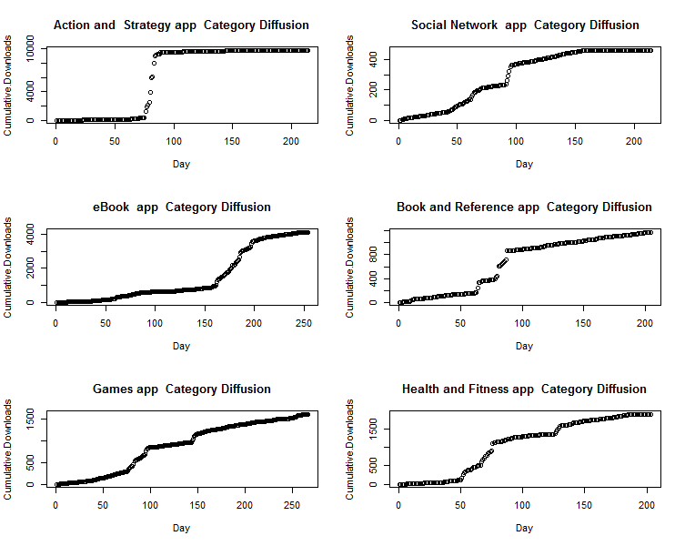

**Figure 2**

**Popularity of App Categories on Apple App Store**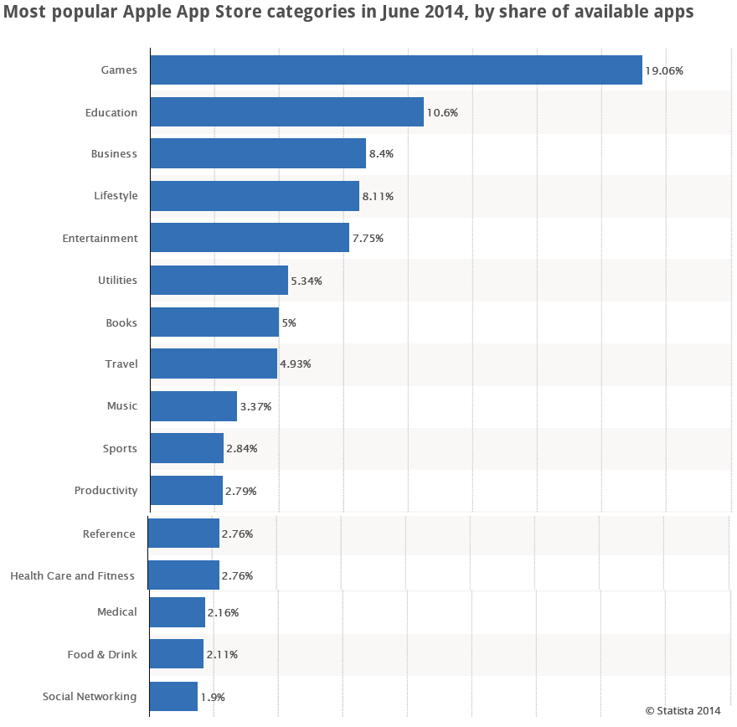

**Figure 3**

**Factor Model Fit Curve**

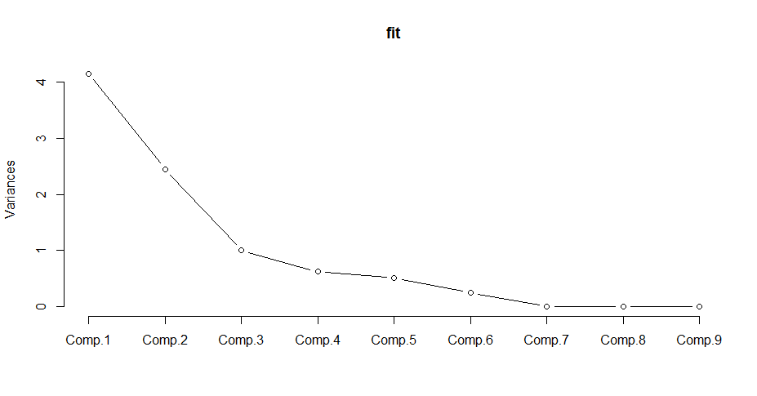

**Table 5**

**Factor Loading Matrix**

|  |  |  |  |  |  |  |  |  |  |
| --- | --- | --- | --- | --- | --- | --- | --- | --- | --- |
| **Loadings/Components** | **C1** | **C2** | **C3** | **C4** | **C5** | **C6** | **C7** | **C8** | **C9** |
| Average File Size | -0.38 |  |  | -0.13 | 0.81 | -0.43 |  |  |  |
| Featured Apps in Category | -0.37 | -0.26 | -0.18 | 0.23 | 0.28 | 0.80 |  |  |  |
| Average of Price |  | -0.61 |  | 0.22 |  | -0.21 | 0.21 | -0.69 |  |
| Variance of Price |  | -0.60 |  | 0.33 |  | -0.21 | -0.14 | 0.67 |  |
| Paid app options | -0.48 |  |  |  | -0.27 | -0.19 | -0.79 | -0.20 |  |
| Free app options | -0.48 |  |  |  | -0.31 |  | 0.45 | 0.12 | -0.67 |
| Fraction of Free to Paid Apps |  | 0.30 | -0.77 | 0.51 |  | -0.21 |  |  |  |
| Average Tenure | 0.11 | -0.33 | -0.61 | -0.71 |  |  |  |  |  |
| Total Options | -0.48 |  |  |  | -0.31 |  | 0.33 |  | 0.74 |

**Table 6**

**Factor Names**

|  |  |
| --- | --- |
| **Factor** | **Name** |
| C1 | Assortment Breadth |
| C2 | Innovative Apps |
| C3 | Paid Category |

**Figure 4**

**Box and Arrow Representation of the Model**  
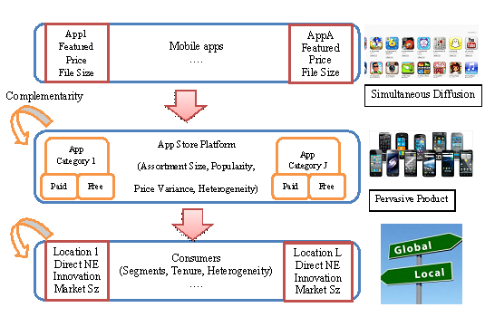

**Table 7**

**MODEL COMPARISON**

|  |  |  |  |  |
| --- | --- | --- | --- | --- |
| **Model** | **Description** | **LL** | **AIC** | **BIC** |
| 1 | Local Diffusion | -5721.04 | 5781.04 | 11515.495 |
| 2 | Global Diffusion | -5.683e13 | 5.68E+13 | 1.14E+14 |
| 3 | Choice Explained by Local Diffusion | -355.41 | 5647.41 | 9.77E+03 |
| 4 | Choice Explained by Global Diffusion | -512.44 | 5804.44 | 1.01E+04 |

**Table 8**

**Performance of the Proposed Model for Four Sample Add-ons and Platform**

|  |  |  |
| --- | --- | --- |
| **Description** | **MAD** | **MSE** |
| Local Category Diffusion | 9.24 | 18.69 |
| International Category Diffusion | 38.52 | 280.01 |

|  |  |
| --- | --- |
| **Figure 5**  **1-Step-ahead Forecast for Local Diffusion of Categories** | **Figure 6**  **1-Step-ahead Forecast for Global Diffusion of Categories** |

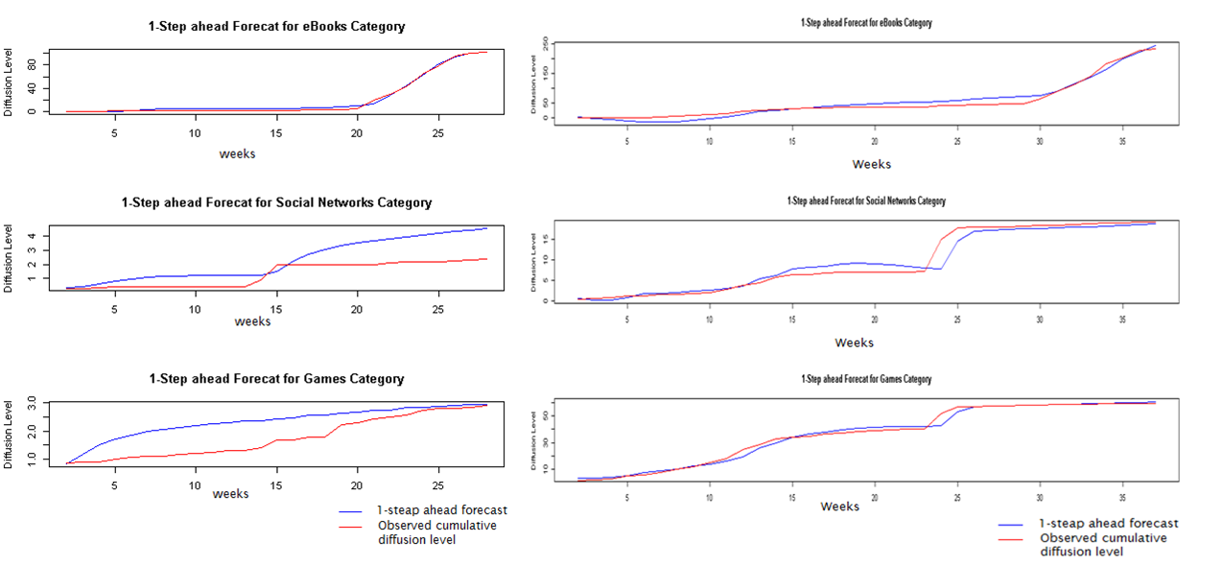

**Table 9**

**PARAMETER ESTIMATES: Local Diffusion**

|  |  |  |  |  |
| --- | --- | --- | --- | --- |
|  | **Estimate** | **Std. Dev.** | **2.5th** | **97.5th** |
| Market Size: |  |  |  |  |
| Device Tools | 99.19 | 2.14 | 95.77 | 102.82 |
| eBooks | 102.31 | 0.24 | 101.93 | 102.71 |
| Games | 3.96 | 2.83 | 2.72 | 9.27 |
| Health/Diet/Fitness | 117.03 | 2.57 | 112.86 | 121.30 |
| Humor/Jokes | 82.53 | 1.91 | 79.51 | 85.87 |
| Internet/WAP | 99.17 | 2.14 | 95.73 | 102.77 |
| Logic/Puzzle/Trivia | 4.96 | 2.61 | 2.72 | 6.85 |
| Reference/Dictionaries | 117.00 | 2.57 | 112.87 | 121.14 |
| Social Networks | 34.57 | 15.73 | 2.74 | 53.53 |
| University | 62.87 | 1.97 | 59.97 | 66.24 |
| External Market Force: |  |  |  |  |
| Device Tools | -0.0008 | 0.0008 | -0.0020 | 0.0006 |
| eBooks | 0.0006 | 0.0004 | -0.0001 | 0.0011 |
| Games | -0.0085 | 0.2878 | -0.3484 | 0.2575 |
| Health/Diet/Fitness | -0.0022 | 0.0006 | -0.0031 | -0.0011 |
| Humor/Jokes | -0.0032 | 0.0045 | -0.0105 | 0.0025 |
| Internet/WAP | -0.0020 | 0.0005 | -0.0027 | -00011 |
| Logic/Puzzle/Trivia | -0.3961 | 0.4517 | -1.1706 | -0.0059 |
| Reference/Dictionaries | -0.0016 | 0.0004 | -0.0021 | -0.0010 |
| Social Networks | 0.0042 | 0.0126 | -0.0028 | 0.0266 |
| University | -0.0028 | 0.0021 | -0.0059 | 0.0010 |
| Internal Market Force: |  |  |  |  |
| Device Tools | 0.102 | 0.0008 | 0.0099 | 0.1911 |
| eBooks | 0.745 | 0.0004 | 0.7356 | 0.7554 |
| Games | 0.847 | 0.2878 | -0.0512 | 2.0762 |
| Health/Diet/Fitness | 0.109 | 0.0006 | 0.0693 | 0.1405 |
| Humor/Jokes | 0.099 | 0.0045 | -0.0459 | 0.3653 |
| Internet/WAP | 0.109 | 0.0005 | 0.0861 | 0.1265 |
| Logic/Puzzle/Trivia | 0.924 | 0.4517 | -0.0055 | 3.0764 |
| Reference/Dictionaries | 0.113 | 0.0004 | 0.0955 | 0.1276 |
| Social Networks | 0.363 | 0.0126 | 0.0289 | 0.5928 |
| University | 0.068 | 0.0021 | 0.0035 | 0.1170 |
| Variance of Observation Equations: |  |  |  |  |
| Device Tools | 2.045 | 0.8826 | 0.8420 | 3.6270 |
| eBooks | 2.7511 | 0.0753 | 0.1635 | 04113 |
| Games | 3.0195 | 5.8025 | 0.4727 | 10.7122 |
| Health/Diet/Fitness | 2.2033 | 0.8128 | 1.0804 | 3.6999 |
| Humor/Jokes | 3.1551 | 1.8861 | 0.06489 | 6.5830 |
| Internet/WAP | 1.4211 | 0.4553 | 0.7809 | 2.2444 |
| Logic/Puzzle/Trivia | 2.9640 | 3.1260 | 0.5883 | 7.1989 |
| Reference/Dictionaries | 1.2121 | 0.3670 | 0.7022 | 1.8857 |
| Social Networks | 1.7677 | 1.8793 | 0.3136 | 5.5010 |
| University | 2.0125 | 0.6813 | 1.0282 | 3.2575 |

**Table 10**

**PARAMETER ESTIMATES: Global Diffusion**

|  |  |  |  |  |
| --- | --- | --- | --- | --- |
|  | **Estimate** | **Std. Dev.** | **2.5th** | **97.5th** |
| Market Size: |  |  |  |  |
| Device Tools | 29.96 | 17.68 | 25.32 | 32.98 |
| eBooks | 330.91 | 42.35 | 297.24 | 416.54 |
| Games | 61.75 | 8.67 | 58.09 | 67.38 |
| Health/Diet/Fitness | 84.16 | 4.25 | 80.90 | 91.54 |
| Humor/Jokes | 75.06 | 48.79 | 68.45 | 80.24 |
| Internet/WAP | 81.47 | 4.22 | 75.66 | 87.03 |
| Logic/Puzzle/Trivia | 72.68 | 3.33 | 69.04 | 76.69 |
| Reference/Dictionaries | 76.85 | 24.48 | 69.15 | 87.45 |
| Social Networks | 19.81 | 14.97 | 16.83 | 22.45 |
| University | 103.23 | 3.35 | 97.13 | 107.05 |
| External Market Force: |  |  |  |  |
| Device Tools | 0.004 | 0.024 | -0.016 | 0.022 |
| eBooks | -0.008 | 0.006 | -0.013 | 0.002 |
| Games | 0.013 | 0.016 | 0.000 | 0.021 |
| Health/Diet/Fitness | 0.016 | 0.005 | 0.006 | 0.019 |
| Humor/Jokes | 0.030 | 0.039 | -0.003 | 0.046 |
| Internet/WAP | 0.006 | 0.006 | -0.002 | 0.015 |
| Logic/Puzzle/Trivia | 0.018 | 0.011 | -0.004 | 0.031 |
| Reference/Dictionaries | 0.014 | 0.007 | 0.001 | 0.021 |
| Social Networks | 0.010 | 0.011 | -0.008 | 0.024 |
| University | 0.020 | 0.008 | 0.012 | 0.036 |
| Internal Market Force: |  |  |  |  |
| Device Tools | 0.16 | 0.044 | 0.103 | 0.236 |
| eBooks | 0.30 | 0.048 | 0.200 | 0.358 |
| Games | 0.17 | 0.032 | 0.117 | 0.224 |
| Health/Diet/Fitness | 0.22 | 0.030 | 0.164 | 0.269 |
| Humor/Jokes | 0.18 | 0.065 | 0.109 | 0.301 |
| Internet/WAP | 0.21 | 0.026 | 0.165 | 0.246 |
| Logic/Puzzle/Trivia | 0.42 | 0.087 | 0.284 | 0.574 |
| Reference/Dictionaries | 0.17 | 0.040 | 0.115 | 0.243 |
| Social Networks | 0.20 | 0.058 | 0.115 | 0.299 |
| University | 0.48 | 0.060 | 0.385 | 0.583 |
| Variance of Observation Equations: |  |  |  |  |
| Device Tools | 3.08 | 17.30 | 0.152 | 7.21 |
| eBooks | 173.69 | 184.09 | 0.002 | 456.55 |
| Games | 11.47 | 29.45 | 0.063 | 54.28 |
| Health/Diet/Fitness | 34.40 | 73.08 | 0.022 | 206.66 |
| Humor/Jokes | 69.09 | 112.93 | 0.011 | 324.53 |
| Internet/WAP | 32.02 | 71.53 | 0.027 | 199.87 |
| Logic/Puzzle/Trivia | 67.18 | 108.71 | 0.017 | 312.67 |
| Reference/Dictionaries | 48.32 | 92.62 | 0.014 | 271.74 |
| Social Networks | 1.99 | 6.90 | 0.225 | 5.25 |
| University | 81.24 | 117.91 | 0.013 | 328.56 |

**Table 11**

**COVARIANCE PARAMETER ESTIMATES: Local Diffusion**

|  |  |  |  |  |
| --- | --- | --- | --- | --- |
|  | **Estimate** | **Std. Dev.** | **2.5th** | **97.5th** |
| Device Tools |  |  |  |  |
| Device Tools | 7.33E-03 | 0.0233 | 0.0028 | 0.0161 |
| eBooks | 2.61E-04 | 0.0016 | -0.0019 | 0.0027 |
| Games | 3.65E-04 | 0.0063 | -0.0032 | 0.0045 |
| Health/Diet/Fitness | 6.89E-05 | 0.0013 | -0.0018 | 0.0020 |
| Humor/Jokes | 1.55E-05 | 0.0023 | -0.0022 | 0.0022 |
| Internet/WAP | 1.63E-04 | 0.0014 | -0.0018 | 0.0022 |
| Logic/Puzzle/Trivia | 7.37E-05 | 0.0053 | -0.0044 | 0.0043 |
| Reference/Dictionaries | 2.23E-04 | 0.0014 | -0.0017 | 0.0024 |
| Social Networks | 2.70E-04 | 0.0023 | -0.0025 | 0.0033 |
| University | 1.00E-04 | 0.0017 | -0.0020 | 0.0022 |
| eBooks |  |  |  |  |
| eBooks | 5.89E-03 | 0.0022 | 0.0033 | 0.0101 |
| Games | 6.66E-04 | 0.0029 | -0.0024 | 0.0049 |
| Health/Diet/Fitness | 2.63E-04 | 0.0012 | -0.0016 | 0.0023 |
| Humor/Jokes | 1.50E-04 | 0.0013 | -0.0018 | 0.0023 |
| Internet/WAP | 4.70E-04 | 0.0013 | -0.0013 | 0.0026 |
| Logic/Puzzle/Trivia | -1.53E-04 | 0.0030 | -0.0045 | 0.0040 |
| Reference/Dictionaries | 5.46E-04 | 0.0013 | -0.0013 | 0.0028 |
| Social Networks | 9.42E-04 | 0.0019 | -0.0015 | 0.0043 |
| University | 2.07E-04 | 0.0013 | -0.0018 | 0.0023 |
| Games |  |  |  |  |
| Games | 1.72E-02 | 0.0592 | 0.0032 | 0.0557 |
| Health/Diet/Fitness | 2.50E-04 | 0.0024 | -0.0026 | 0.0035 |
| Humor/Jokes | 1.59E-04 | 0.0027 | -0.0031 | 0.0036 |
| Internet/WAP | 4.56E-04 | 0.0025 | -0.0023 | 0.0039 |
| Logic/Puzzle/Trivia | 4.08E-04 | 0.0093 | -0.0073 | 0.0085 |
| Reference/Dictionaries | 5.28E-04 | 0.0028 | -0.0022 | 0.0043 |
| Social Networks | 9.05E-04 | 0.0036 | -0.0030 | 0.0065 |
| University | 2.91E-04 | 0.0027 | -0.0028 | 0.0039 |
| Health/Diet/Fitness |  |  |  |  |
| Health/Diet/Fitness | 4.38E-03 | 0.0014 | 0.0026 | 0.0070 |
| Humor/Jokes | 6.33E-05 | 0.0011 | -0.0016 | 0.0017 |
| Internet/WAP | 1.58E-04 | 0.0011 | -0.0015 | 0.0019 |
| Logic/Puzzle/Trivia | 1.49E-05 | 0.0025 | -0.0031 | 0.0032 |
| Reference/Dictionaries | 1.36E-04 | 0.0011 | -0.0015 | 0.0019 |
| Social Networks | 2.85E-04 | 0.0015 | -0.0018 | 0.0028 |
| University | 9.44E-05 | 0.0010 | -0.0015 | 0.0018 |
| Humor/Jokes |  |  |  |  |
| Humor/Jokes | 4.85E-03 | 0.0026 | 0.0027 | 0.0084 |
| Internet/WAP | 1.20E-04 | 0.0011 | -0.0016 | 0.0020 |
| Logic/Puzzle/Trivia | -1.36E-06 | 0.0028 | -0.0037 | 0.0035 |
| Reference/Dictionaries | 8.77E-05 | 0.0012 | -0.0018 | 0.0020 |
| Social Networks | 2.71E-04 | 0.0017 | -0.0021 | 0.0030 |
| University | 5.51E-05 | 0.0012 | -0.0018 | 0.0019 |
| Internet/WAP |  |  |  |  |
| Internet/WAP | 4.58E-03 | 0.0016 | 0.0027 | 0.0075 |
| Logic/Puzzle/Trivia | 8.33E-05 | 0.0030 | -0.0034 | 0.0035 |
| Reference/Dictionaries | 3.32E-04 | 0.0012 | -0.0014 | 0.0023 |
| Social Networks | 5.73E-04 | 0.0016 | -0.0016 | 0.0035 |
| University | 1.71E-04 | 0.0011 | -0.0015 | 0.0020 |
| Logic/Puzzle/Trivia |  |  |  |  |
| Logic/Puzzle/Trivia | 1.79E-02 | 0.0627 | 0.0035 | 0.0552 |
| Reference/Dictionaries | 5.22E-05 | 0.0029 | -0.0035 | 0.0037 |
| Social Networks | 6.97E-06 | 0.0047 | -0.0058 | 0.0056 |
| University | 1.09E-04 | 0.0030 | -0.0033 | 0.0036 |
| Reference/Dictionaries |  |  |  |  |
| Reference/Dictionaries | 4.73E-03 | 0.0017 | 0.0028 | 0.0079 |
| Social Networks | 6.41E-04 | 0.0016 | -0.0015 | 0.0034 |
| University | 1.69E-04 | 0.0012 | -0.0016 | 0.0021 |
| Social Networks |  |  |  |  |
| Social Networks | 7.47E-03 | 0.0049 | 0.0030 | 0.0164 |
| University | 2.91E-04 | 0.0016 | -0.0020 | 0.0030 |
| University |  |  |  |  |
| University | 4.62E-03 | 0.0017 | 0.0027 | 0.0077 |

**Table 12**

**COVARIANCE PARAMETER ESTIMATES: Global Diffusion**

|  |  |  |  |  |
| --- | --- | --- | --- | --- |
|  | **Estimate** | **Std. Dev.** | **2.5th** | **97.5th** |
| Device Tools |  |  |  |  |
| Device Tools | 2.57 | 47.64 | 0.82 | 2.77 |
| eBooks | 0.75 | 7.95 | -3.01 | 4.11 |
| Games | 2.79 | 22.79 | 1.39 | 4.05 |
| Health/Diet/Fitness | 2.48 | 1.40 | 1.18 | 4.32 |
| Humor/Jokes | 1.10 | 0.95 | -0.11 | 2.49 |
| Internet/WAP | 3.16 | 7.34 | 1.78 | 5.28 |
| Logic/Puzzle/Trivia | 1.37 | 1.05 | -0.08 | 3.15 |
| Reference/Dictionaries | 2.23 | 3.42 | 1.03 | 3.92 |
| Social Networks | 1.50 | 0.64 | 0.80 | 2.50 |
| University | 1.71 | 2.43 | -0.11 | 4.00 |
| eBooks |  |  |  |  |
| eBooks | 45.61 | 21.50 | 16.49 | 80.75 |
| Games | 1.46 | 5.48 | -4.73 | 7.81 |
| Health/Diet/Fitness | 1.93 | 5.48 | -7.32 | 10.64 |
| Humor/Jokes | -1.14 | 7.47 | -12.17 | 9.64 |
| Internet/WAP | 1.83 | 4.66 | -5.46 | 9.60 |
| Logic/Puzzle/Trivia | 5.14 | 8.27 | -9.47 | 18.24 |
| Reference/Dictionaries | 0.12 | 5.25 | -8.54 | 8.11 |
| Social Networks | 0.46 | 2.34 | -3.35 | 4.17 |
| University | 1.92 | 10.62 | -15.76 | 17.82 |
| Games |  |  |  |  |
| Games | 4.65 | 13.84 | 2.66 | 7.20 |
| Health/Diet/Fitness | 4.86 | 1.81 | 2.62 | 7.94 |
| Humor/Jokes | 2.32 | 1.60 | 0.35 | 4.75 |
| Internet/WAP | 5.27 | 5.06 | 2.99 | 8.52 |
| Logic/Puzzle/Trivia | 3.31 | 1.75 | 0.99 | 6.42 |
| Reference/Dictionaries | 4.25 | 2.17 | 2.19 | 7.13 |
| Social Networks | 2.47 | 0.88 | 1.41 | 4.01 |
| University | 4.22 | 2.63 | 1.18 | 8.37 |
| Health/Diet/Fitness |  |  |  |  |
| Health/Diet/Fitness | 7.24 | 2.56 | 3.85 | 11.78 |
| Humor/Jokes | 2.62 | 2.15 | -0.33 | 5.78 |
| Internet/WAP | 5.75 | 2.18 | 2.61 | 9.74 |
| Logic/Puzzle/Trivia | 4.87 | 2.54 | 1.36 | 9.43 |
| Reference/Dictionaries | 6.11 | 2.24 | 3.03 | 10.18 |
| Social Networks | 2.63 | 1.01 | 1.32 | 4.49 |
| University | 7.40 | 3.42 | 2.82 | 13.39 |
| Humor/Jokes |  |  |  |  |
| Humor/Jokes | 5.44 | 49.75 | 1.62 | 9.82 |
| Internet/WAP | 2.77 | 2.05 | -0.32 | 5.87 |
| Logic/Puzzle/Trivia | 1.36 | 2.50 | -2.08 | 5.62 |
| Reference/Dictionaries | 2.37 | 2.12 | -0.84 | 5.45 |
| Social Networks | 1.25 | 0.92 | 0.03 | 2.66 |
| University | 3.23 | 3.24 | -0.95 | 8.28 |
| Internet/WAP |  |  |  |  |
| Internet/WAP | 7.73 | 3.72 | 3.96 | 12.69 |
| Logic/Puzzle/Trivia | 2.95 | 2.16 | -0.19 | 6.60 |
| Reference/Dictionaries | 5.47 | 2.22 | 2.74 | 9.11 |
| Social Networks | 3.28 | 1.09 | 1.82 | 5.26 |
| University | 4.22 | 3.21 | -0.07 | 9.61 |
| Logic/Puzzle/Trivia |  |  |  |  |
| Logic/Puzzle/Trivia | 7.86 | 4.48 | 3.07 | 16.45 |
| Reference/Dictionaries | 3.59 | 2.30 | 0.56 | 7.61 |
| Social Networks | 1.36 | 0.96 | -0.02 | 2.98 |
| University | 6.92 | 4.05 | 1.45 | 14.04 |
| Reference/Dictionaries |  |  |  |  |
| Reference/Dictionaries | 6.38 | 2.90 | 3.31 | 11.30 |
| Social Networks | 2.45 | 0.94 | 1.23 | 4.09 |
| University | 5.99 | 3.43 | 1.35 | 11.62 |
| Social Networks |  |  |  |  |
| Social Networks | 1.59 | 0.67 | 0.79 | 2.71 |
| University | 1.94 | 1.40 | 0.09 | 4.41 |
| University |  |  |  |  |
| University | 13.93 | 7.35 | 7.02 | 28.39 |

**Table 13**

**PARAMETER ESTIMATES: Heterogeneity in Local Diffusion Parameters**

|  |  |  |  |  |
| --- | --- | --- | --- | --- |
|  | **Estimate** | **Std. Dev.** | **2.5th** | **97.5th** |
| External Market Force |  |  |  |  |
| Popularity | -0.012 | 0.047 | -0.088 | 0.063 |
| Internal Market Force |  |  |  |  |
| Popularity | 0.041 | 0.066 | -0.058 | 0.158 |
| Market Size |  |  |  |  |
| Popularity | -6.90 | 0.280 | -7.281 | -6.446 |

**Table 14**

**PARAMETER ESTIMATES: Heterogeneity in Global Diffusion Parameters**

|  |  |  |  |  |
| --- | --- | --- | --- | --- |
|  | **Estimate** | **Std. Dev.** | **2.5th** | **97.5th** |
| External Market Force |  |  |  |  |
| Popularity | 0.0004 | 0.0380 | -0.061 | 0.063 |
| Internal Market Force |  |  |  |  |
| Popularity | 0.0078 | 0.0400 | -0.056 | 0.073 |
| Market Size |  |  |  |  |
| Popularity | -1.1858 | 3.704 | -7.212 | 5.0440 |

|  |  |
| --- | --- |
| **Figure 7**  **PARAMETER DISTRIBUTION: Heterogeneity in Local Diffusion Parameters** | **Figure 8**  **PARAMETER DISTRIBUTION: Heterogeneity in Global Diffusion Parameters** |

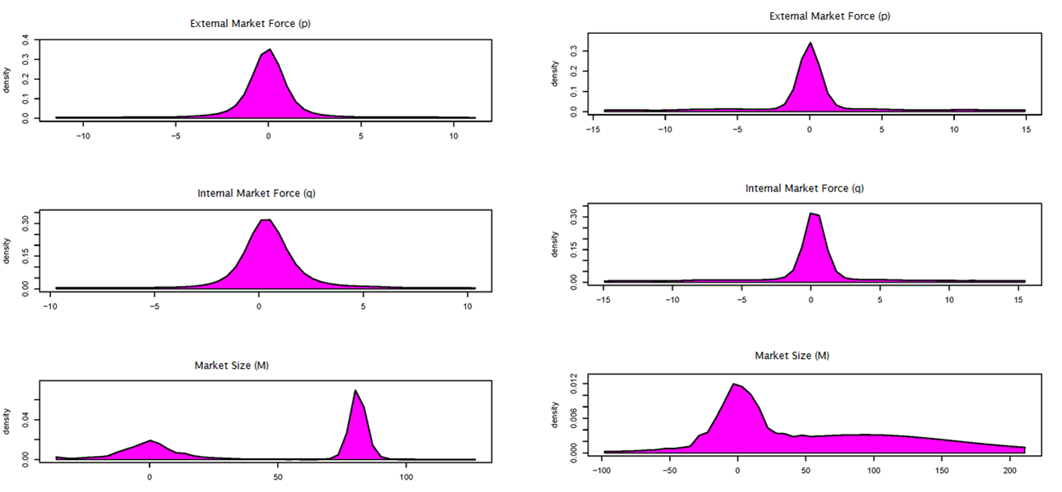

|  |  |
| --- | --- |
| **Figure 9**  **Evolution of Forces: Imitation/Innovation Force in Local Market (scaled variation)** | **Figure 10**  **Evolution of Forces: Imitation/Innovation Force in Global Market (scaled variation)** |

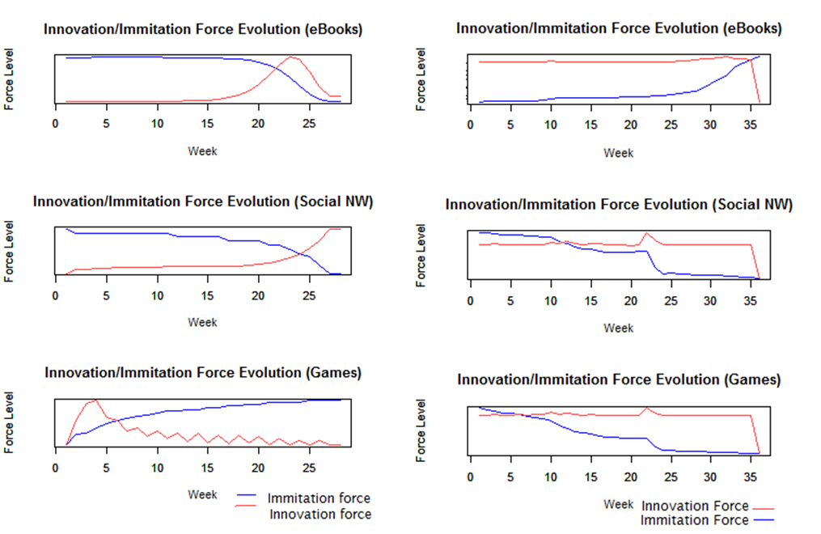

**Table 15**

**PARAMETER ESTIMATES: Individual Choice effect (Local imitators/innovators Model)**

|  |  |  |  |  |
| --- | --- | --- | --- | --- |
|  | **Estimate** | **Std. Dev.** | **2.5th** | **97.5th** |
| Category Preference: |  |  |  |  |
| Device Tools | -10.36 | 5.27 | -16.19 | -2.83 |
| eBooks | -12.46 | 3.01 | -17.55 | -8.19 |
| Games | -14.63 | 5.61 | -21.80 | -5.92 |
| Health/Diet/Fitness | -10.70 | 6.29 | -19.49 | -0.15 |
| Humor/Jokes | -10.15 | 4.69 | -16.85 | -2.38 |
| Internet/WAP | -12.95 | 5.62 | -21.98 | -4.10 |
| Logic/Puzzle/Trivia | -17.20 | 6.73 | -27.38 | -7.50 |
| Reference/Dictionaries | -9.34 | 4.83 | -17.75 | -2.66 |
| Social Networks | -9.39 | 3.32 | -14.66 | -2.21 |
| University | -11.75 | 6.50 | -22.64 | -2.46 |
| States Forces: |  |  |  |  |
| Individual Category State | -77.70 | 8.33 | -89.61 | -65.35 |
| Innovation Force | 4.05 | 6.42 | -5.11 | 14.95 |
| Imitation Force | -1.52 | 1.78 | -4.16 | 2.15 |
| Design components: |  |  |  |  |
| Assortment Breadth | -1.12 | 4.53 | -7.06 | 8.19 |
| Assortment Breadth Square | 0.49 | 5.16 | -6.97 | 8.66 |
| Innovative Apps | 3.37 | 4.47 | -1.92 | 12.09 |
| Innovative Apps Square | -3.36 | 5.29 | -10.96 | 3.86 |
| Paid Category | 0.14 | 3.14 | -5.04 | 5.61 |

**Table 16**

**PARAMETER ESTIMATES: Heterogeneity in Individual Choice ( Local imitators/innovators Model)**

|  |  |  |  |  |
| --- | --- | --- | --- | --- |
| Tenure Explaining the following parameters Heterogeneity | **Estimate** | **Std. Dev.** | **2.5th** | **97.5th** |
| Category Preference: |  |  |  |  |
| Device Tools | 0.0063 | 0.0134 | -0.0116 | 0.0363 |
| eBooks | 0.0142 | 0.0245 | -0.0255 | 0.0610 |
| Games | 0.0033 | 0.0137 | -0.0175 | 0.0282 |
| Health/Diet/Fitness | 0.0374 | 0.0180 | 0.0056 | 0.0673 |
| Humor/Jokes | -0.0001 | 0.0183 | -0.0283 | 0.0355 |
| Internet/WAP | 0.0229 | 0.0175 | -0.0019 | 0.0564 |
| Logic/Puzzle/Trivia | -0.1238 | 0.0586 | -0.1816 | -0.0035 |
| Reference/Dictionaries | 0.0282 | 0.0193 | -0.0011 | 0.0612 |
| Social Networks | 0.0339 | 0.0110 | 0.0160 | 0.0522 |
| University | -0.0080 | 0.0178 | -0.0385 | 0.0188 |
| States Forces: |  |  |  |  |
| Individual Category State | -0.0591 | 0.0916 | -0.1644 | 0.0778 |
| Innovation Force | -0.0580 | 0.0222 | -0.0915 | -0.0123 |
| Imitation Force | 0.0005 | 0.0063 | -0.0096 | 0.0101 |
| Design components: |  |  |  |  |
| Assortment Breadth | -0.0366 | 0.0330 | -0.0962 | 0.0184 |
| Assortment Breadth Square | 0.1099 | 0.0623 | 0.0066 | 0.1915 |
| Innovative Apps | -0.0664 | 0.0371 | -0.1062 | 0.0051 |
| Innovative Apps Square | 0.0649 | 0.0380 | -0.0012 | 0.1077 |
| Paid Category | -0.0285 | 0.0365 | -0.0762 | 0.0296 |

**Figure 11**

**PARAMETER DISTRIBUTION: Heterogeneity in Individual Choice ( Local imitators/innovators Model)**

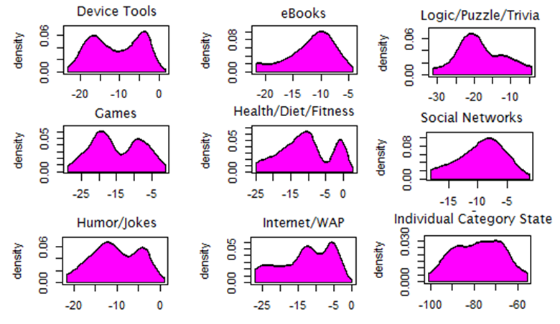

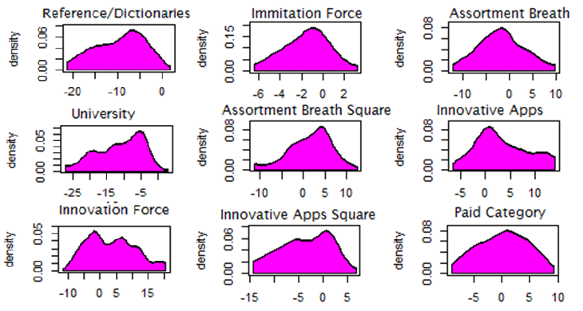

1. I would like to thank Dr. Soysal and Dr. Ratchford for sending me to Duke workshop on structural modeling, and teaching me related techniques. Also I would like to thank Dr. Bruce for teaching me how to conduct a quality empirical research in marketing, and how to code Kalman Filter.
2. I would like to thank Dr. Ying Xie and Dr. Elisabeth Honka for their revision of the proposal I send out to the company. I also would like to thank Dr. Rao for making me to write a lot during his spring seminar, which allowed me to organize my mind, and to position my research paper.
3. This process has been so extensive that some scholars study how cell phone affects social interaction of individuals http://www.michigandaily.com/news/%E2%80%98u%E2%80%99-researchers-identify-link-between-cell-phones-and-socialization-habits
4. http://en.wikipedia.org/wiki/App_Store_(iOS)
5. http://theweek.com/article/index/241121/7-health-benefits-of-playing-video-games
6. http://www.forbes.com/sites/briansolomon/2014/08/12/king-digital-pummeled-as-candy-crush-fad-fizzles-out/
7. http://www.pewinternet.org/fact-sheets/mobile-technology-fact-sheet/
8. http://smallbusiness.chron.com/life-expectancy-smartphone-62979.html
9. http://editorial.autos.msn.com/listarticle.aspx?cp-documentid=1171403
10. http://www.sajan.com/blog/global-marketing-isnt-dead-marketing-localization-matters-now-ever/