1. **Policy Implication**

Given our estimates in table XXX, we can reconsider editorial team efforts (AMO contribution[1]) allocation, as if Mozilla exert soft power by organizing events to encourage more contribution[2], or hire temporary staff to increase the effort[3]. For example we found positive impact of greater editorial team effort, but we want to know what the implications of these results for the Mozilla’s editorial team efforts allocation are. More importantly, could Mozilla have allocated the editorial team effort differently to increase the diffusion of its platform?

To find the answer to this “what if” analysis question, we assume AMO total level of effort is fixed, and Mozilla Firefox wants to internalize the process to maximize diffusion level generated over horizon including value of terminal diffusion. Therefore, we develop a model to find a best editorial committee effort reallocation solution for the 1,424 days period of study. We solve the following large scale non-linear optimization problem to find monthly optimal editorial effort level, as our AMO contribution data is monthly. Thus a planning problem can be conceptualized as finding a sequence of proposed contribution levels  that creates the largest total diffusion level. More formally, we write planning problem as the following subject to the dynamic of diffusion of platform:



where  is expected daily diffusion level of one step ahead forecast over the planning horizon, and denotes the current contribution level of Firefox AMO. Each month Firefox decides on level of contribution hence there are  effort levels, where K denotes sum of real observed effort over the T month of planning horizon. The solution to this problem involves searching over a set of admissible effort sequence of to find a sequence that yield the largest level of expected total diffusion, given estimated non-state parameter values for the dynamic model and covariance matrixes. The total expected diffusion level is based on the information available at the beginning of planning stage, so we use the following algorithm to find the best effort schedule:

1. Assume certain sequence of random effort level as initial population
2. Forecast the mean of diffusion path using Extended Kalman Filter (forward filtering) given non-state parameter estimates
3. Score each member of the current population by the objective function to generate fitness value
4. Select members, called parents, based on their fitness
5. Choose individual solutions in the current population with a favorable fitness as elite, to pass to the next population
6. Produce children from the parents, by random changes to a single parent (mutation), and combining vector entries of the pair of parents (crossover)
7. Replace the current population with the children to form the next generation, and start again until convergence

As finding the optimal solution requires exponential time order processing, we use genetic algorithm (GA) available in MATLAB. Succinctly GA starts with candidate population (random one) and through process of selection, cross over and mutation it produces better offspring (schedules) in the subsequent generation and it converges on a set that is most likely to contain the optimal schedule. Our algorithm extends the one used in Naik et al. (1998), named GA-KF to account for non-linear model, so we can shortly call it GA-EKF.

Table 1, presents real and optimal AMO contribution policy, and Figure 1 contrasts between real allocation and optimal allocation we propose. The proposal allocation suggests higher level of contribution at later stages. It increases the total expected diffusion from 32,645 million accumulative users to 32,654 million accumulative users (0.03% increase), or 9 million extra users.

This reallocation also has an intuitive implication. Close look at figure XX of evolution of platform models data suggest that the significant difference exists between first half and second half of the total 1,424 days of data, between the level of diffusion of Mozilla’s Firefox’s main competitor, Google Chrome. The optimal solution may suggest that Mozilla could probably have used the power of community (opinion leaders), which ,in many case studies, it identifies as its critical success factor against default platform choice of users, IE, if its Editorial Committee has been more responsive when its main competitor Google Chrome challenged his position more.

**Table 1**

**Real versus optimal Editorial Effort Allocation**

|  |  |  |  |
| --- | --- | --- | --- |
| Year | Month | Old Level of Contribution | Optimal Level of contribution |
| 2009 | 7 | 972 | 283 |
| 2009 | 8 | 994 | 13 |
| 2009 | 9 | 1011 | 13 |
| 2009 | 10 | 1375 | 34 |
| 2009 | 11 | 794 | 19 |
| 2009 | 12 | 1673 | 12 |
| 2010 | 1 | 1402 | 17 |
| 2010 | 2 | 1537 | 156 |
| 2010 | 3 | 1159 | 39 |
| 2010 | 4 | 965 | 8 |
| 2010 | 5 | 903 | 378 |
| 2010 | 6 | 835 | 12 |
| 2010 | 7 | 1047 | 449 |
| 2010 | 8 | 923 | 465 |
| 2010 | 9 | 801 | 16 |
| 2010 | 10 | 1233 | 825 |
| 2010 | 11 | 841 | 1863 |
| 2010 | 12 | 2416 | 330 |
| 2011 | 1 | 2620 | 1391 |
| 2011 | 2 | 1776 | 1423 |
| 2011 | 3 | 1235 | 1836 |
| 2011 | 4 | 1624 | 1614 |
| 2011 | 5 | 2054 | 1440 |
| 2011 | 6 | 1834 | 2380 |
| 2011 | 7 | 1729 | 2215 |
| 2011 | 8 | 1276 | 2038 |
| 2011 | 9 | 1498 | 1655 |
| 2011 | 10 | 1346 | 2884 |
| 2011 | 11 | 1790 | 1609 |
| 2011 | 12 | 2275 | 2358 |
| 2012 | 1 | 2294 | 1951 |
| 2012 | 2 | 1360 | 1767 |
| 2012 | 3 | 951 | 2473 |
| 2012 | 4 | 1359 | 2224 |
| 2012 | 5 | 1261 | 2847 |
| 2012 | 6 | 1409 | 2075 |
| 2012 | 7 | 1391 | 2883 |
| 2012 | 8 | 1222 | 1412 |
| 2012 | 9 | 1805 | 2797 |
| 2012 | 10 | 1316 | 2326 |
| 2012 | 11 | 1720 | 1936 |
| 2012 | 12 | 1412 | 2718 |
| 2013 | 1 | 1651 | 2376 |
| 2013 | 2 | 1723 | 2749 |
| 2013 | 3 | 1470 | 1393 |
| 2013 | 4 | 1351 | 2882 |
| 2013 | 5 | 2093 | 3091 |
| 2013 | 6 | 1283 | 1331 |

**Figure 2**

**Box and Arrow Representation of the Model**

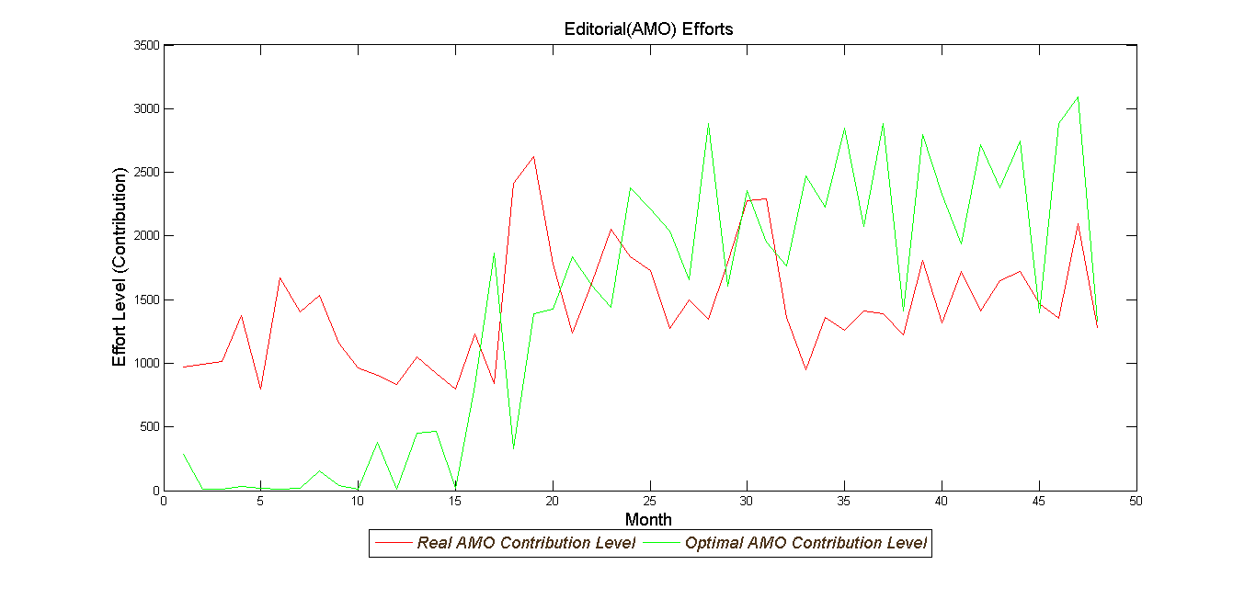

1. https://blog.mozilla.org/addons/2011/02/04/overview-amo-review-process/
2. https://blog.mozilla.org/addons/2009/06/29/amo-review-queue-burndown-a-huge-success/
3. https://blog.mozilla.org/addons/2011/10/05/add-ons-update-4/