**2.0 Conceptual Background**

In principle an open source software (OSS) platform is a type of distributed innovation system in which the platform owner opens its platform to third party contributors, who in turn develop complements to extend the OSS platform (Sawhney et al. 2000, Kogut and Metiu 2001, Boudreau 2010). A community of external developers (developer hub) and end-users drives innovation on an OSS platform. The OSS community members contribute either by developing complements on the platform (Boudreau 2010) or by using, testing, and submitting reviews on the OSS complements. The OSS community developers or users have two types of motives: intrinsic and extrinsic. The intrinsic motives include joy, altruism, and autonomy, and the extrinsic motives include money, skill, and reputation (Bitzer et al. 2007, Shah 2006, Franck and Jungwirth 2003).

To keep the OSS community participants active, the OSS governance should be democratic (Bahrami 2013, Rao et al. 2009, Krishnamurthy 2005). This democracy creates a chaos, a chaos that rise from numerous community feedbacks and requests. To manage this chaos, the OSS developers use an agile release management system (Sharma et al. 2002). This agile release management system differentiates OSS from proprietary software. An OSS developer also uses releases to satisfy consumers who request multiple changes. Bughin et al. (2008) calls such a community interaction “co-creation,” as the same set of members creates and uses the contents. This co-creation of the OSS community facilitates the diffusion of the OSS platform, because it creates direct and indirect network effects. These direct and indirect network effects create visibility for the OSS platform and its complements (Lerner and Tirol 2002).

The OSS community contributes to the OSS platform diffusion by writing documents, addressing support requests, writing reviews, and using the OSS complements (Lerner and Tirol 2002). Some studies suggest that the pricing mechanism affects the success of the two-sided platforms (Rochet and Tirol 2003, 2004, 2006, Parker and Van Alstyne 2005, Economides and Katsamakas 2006), yet for an OSS platform, such a mechanism does not exist. Other studies suggest that the OSS community is the social capital of an OSS platform, and this social capital drives the platform’s diffusion (Roberts et al. 2006). To signal its social capital, an OSS platform shows the OSS potential adopters the OSS complements’ rating distribution, and daily user counts. The rating valence and dispersion act as the community’s word of mouth signals, while the daily user counts act as the community’s observational learning signals. The evidences from meta-analysis of an OSS platform suggest that the following factors affect the OSS platform’s diffusion: the license types, the participation motives, the OSS community’s direct network effect, the OSS complements’ indirect network effect, and the market competition (Subramanian 2009, Nair et al. 2004, Katz and Shapiro 1994, Banaccorsi and Rossi 2003). Thus, the diffusion of an OSS platform likely depends on the OSS community direct and the OSS complements indirect network effects, the OSS legal settings, and the OSS community’s motivations for contributions.

To publish an OSS complement, the developer should submit its complement to the review committee (O'Mahony and Ferraro 2007). When the review committee reviewed the OSS complement, the OSS platform publishes the complement under the developer requested license. From the published OSS complements, the OSS community members can create their own versions as long as they adhere to the license restrictions (Rosen 2005). Managing an OSS community is not easy. Many studies on the OSS platforms emphasize the role of the loose governance and democracy. These studies address the need for the loose governance by nudging to transparency (Shah 2006, O’Mahony and Ferraro 2007, O’Mahoney 2007, Markus 2007), and the paradox of poetry versus pragmatism (Bahrami 2013, Rao et al. 2009, Krishnamurthy 2005). To maintain transparency, the OSS platform uses various forms of licenses, and various tools for motivation management (Subramanian 2009, Nair et al. 2004, Katz and Shapiro 1994, Banaccorsi and Rossi 2003). The licenses may range from very restrictive, such as General Public License (GPL), to less restrictive, such as Berkeley Software Distribution (BSD). The tools for the motivation management may range from asking for a monetary contribution, e.g. requesting a pecuniary contribution from the users, to advertising the developer’s profile. To maintain the balance between poetry and pragmatism, the OSS platform uses an OSS review committee. When a new OSS complement developed, the developer nominates it to the review committee, a committee like an academic journal’s review committee (Wang et al. 2012, Frey 2003).

This committee’s performance is critical to maintain the democracy. An OSS review committee affects the time to release of an OSS complement. Before the OSS platform publishes an OSS complement, the OSS review committee should commit or accept it (Mockus et al 2002). To maintain the democracy, some OSS platforms ask the review committee explicitly not to judge the relevance of an OSS complement, to leave the judgment to the community members. The community members reveal their opinion about the relevance of an OSS complement by their rating and use (Lakhani and Von Hippel 2003). To get feedbacks and engagements from the OSS community rapidly, an OSS developer may release an OSS complement version that performs only the core functionalities, but lacks the secondary features or the final aesthetics, early. Raymond (1999) calls this central tenet of the OSS model a “release early, release often” approach. These rapid evolutions and frequent incremental releases are possible by the rapid and frequent internet-based community feedbacks and requests (Feller and Fitzgerald 2000). These rapid and frequent feedbacks and requests of the OSS community create a chaos, a chaos that the OSS developers can manage by an agile release management system (Sharma et al. 2002).

As in Figure 1, the drivers of the diffusion of an OSS platform and its complements, thus should include: (1) the products rating and the daily users counts of the community (2) the releases of the OSS platform and its complements (3) the review process performance (4) the network externality of the OSS complements (5) the OSS platform’s competitors.

OSS platform

OSS self-organized review committee

H3

OSS

Complement

OSS

Complement

…

H4

OSS platform

H5

New releases

H2

…. User community …

Rating, Usage

H1

The role of an OSS community can be characterized by three variables. First, the valence and the dispersion of ratings and the daily usage counts of an OSS complement capture its relevance to the OSS community. These user generated contents act as the signals of the social capital of an OSS complement, and they inform the potential OSS adopters of the OSS platform and its complements social capital levels (Moe and Trusov 2011, Chavalier and Mayzlin 2006, Bikhchandani and Hirshleifer 1998, Celen and Kariv 2004). Second, the number of the new OSS complements, not only contains information about the extendibility of the OSS platform, but also it signals the community engagement level. Third, the OSS review committee’s contribution level signals the tightness of the community governance. This tightness may in turn affect the community’s motivation to contribute to the OSS platform and its complements (Shah 2006, Caillaud and Tirol 1999).

We theorize that the signals of the positive valuation of the community increases the adoption of the OSS complements, while the fewer OSS complements and the fewer contribution of the OSS review committee diminish the OSS platform’s diffusion. Following the researches on the open platforms (Schultz and Urban 2012, Shah 2006, Mallapragada et al. 2012, Rochet and Tirole 2003), to explain the heterogeneity in the complements sensitivity, we incorporate the following variables: the license types of the OSS complements, the motivations of the OSS developers, and the competitions in the OSS market.

**2.1 Effects of End-User’s Generated Contents**

The OSS community generates four types of contents: the online word of mouth (WOM), the online observational learning signal, the codes’ reviews and the complementary codes. We call the first two shortly the User Generated Contents (UGC). By rating and reviewing, the OSS community generates the online word of mouth, and by using the OSS complements, the OSS community generates the online observational learning signals. By showing the valence and the distribution of the community ratings, an OSS platform broadcasts the online WOM, and by showing the number of daily users of the OSS complement, the OSS platform broadcasts the observational learning signals. To find the role of the community UGC, we use the valence and the dispersion of the community’s ratings, and the levels of the observational learning signals. These quality signals measure the direct network effects of the community’s opinions and actions on the OSS complements’ diffusions.

The ratings valences give the OSS adopters efficient accesses to the opinions of the OSS community (Henning-Thurau and Gwinner 2004), so the more positive the valence of the ratings, the more the community values the OSS complements. By signaling the high valuation of the OSS community, an OSS complement with a high rating valence enjoys the more adopters (Chevalier and Mayzlin 2006). Despite the rating valence point estimates of the community’s valuations, the variance of the rating distribution signals the community’s valuation uncertainty (Sun 2012). Despite deciding not to try a proprietary software with a high valuation uncertainty, a risk averse individual may decide to try an OSS complement. The customers may take the risk to adopt an OSS complement, because the expected benefit of the free launch outweighs the expected loss of a malicious Trojan (Golden 2005). As a free launch, an OSS complement may enjoy a higher dispersion of ratings, because the adopter can expects cognitive benefits from discovering a treasure under a rock (Water 2012), and we hypothesize the following:

*Hypothesis 1a (H1a): As the OSS complements’ rating valence and dispersion increase, the size of the OSS community users of OSS complements increases.*

The large numbers of daily users of an OSS complement may signal the OSS complement’s relevance to the adopters’ needs. In addition, the potential adopters may put different weights on the ratings and daily usage counts. Different studies separate the observational learning from the online WOM, because the first one induces a herding behavior, and it is harder to forge (Chen et al. 2011). In addition, the more daily users of the OSS complement may signal the lower cognitive cost of use, and the user friendliness. In other word, from the daily user counts the consumers form the expectations about the latent community’s cost of adoption. As a result, an OSS potential adopter may adopt an OSS complement with the more daily users, and we hypothesize:

*Hypothesis 1b (H1b): As the numbers of the daily users of an OSS complement increase, the size of the OSS community users of the OSS complement increases.*

**2.2 Release Strategy**

An OSS platform and its complements issue releases more frequently than a proprietary software (Bonaccorsi and Rossi 2003, Feller and Fitzgerald). Making the frequent releases possible, the frequent change requests of the community members can create a chaos (Fogel 2005, Dalle 2003, Godfrey and Tu 2000). To survive in this chaos, an OSS developer uses the frequent release strategy (Von Krogh and Von Hippel 2006). Each release comes with a new enhancement. This new enhancement increases the adoption of an OSS complement (Fogel 2005). Thus, we hypothesize the following:

*Hypothesis 2(H2): As an OSS platform or its developers release a new version, the size of the OSS community users of the OSS complements increases.*

**2.3 OSS review committee governance**

To use the full potential of the active community, an OSS platform benefits from a democratic government. Several studies mention the OSS government system as a key success factor for an OSS platform (Shah 2006, O’Mahony and Ferraro 2007, O’Mahony 2007, Markus 2007). For example, Shah (2006) argues that governance structures affect the evolution of the OSS community motives. The CEO of Mozilla describes the governance system of Mozilla as the combination of poetry and pragmatism[1], the poetry by a democratic loose government, and the pragmatism by the chaos management processes. An OSS platform addresses this poetry-pragmatism paradox in its OSS review process, a process that resembles the review process in academia (Hojat et al. 2003).

Facilitating a quicker quality OSS complement release, the OSS review process’s efficiency increases the OSS platform’s diffusion. In particular, the OSS review process has both the direct and the indirect effects. As opinion leaders in the OSS community, the OSS developers are likely to generate more positive word of mouth, when contribution of the review committee increases. In addition, the quicker quality releases make the community of the users satisfied (Dedrick and West 2004). The satisfied community directly, and the satisfied developer indirectly affect the OSS platform’s diffusion. As a result, we predict that the more review committee contributions can increase the adoption of an OSS platform.

*Hypothesis 3 (H3): As the contributions of the OSS review committee increase, the size of an OSS community increases.*

**2.4 Network Externalities**

Opening the OSS platform to the third party developers to develop the complementary goods is the primary function of an OSS platform (Sawhney et al. 2000, Kogut and Metiu 2001, Boudreau 2010). We characterize the effects of this strategy by using an accumulative number of OSS complements that the OSS community develops. As the OSS developers become more active they develop the more OSS complements. The more OSS complements create the more benefits for the OSS community (Boudreau 2010). Garnering the OSS complements benefits, the OSS community’s size increases. The larger the OSS community is parallel with the larger OSS social capital. The more the OSS social capital is, the more an OSS platform learns from the heterogeneous community needs. Learning more from the OSS community needs allows the OSS developers to develop the more relevant OSS complements in a shorter time frame (Grewal et al. 2006, Mallapragada et al. 2012). Therefore,

*H4: As the number of the OSS complements increases, the size of the OSS community increases.*

**2.5 Platform Competition**

A key distinction between the OSS platform and the proprietary platform is the absence of the pricing mechanisms in the former (e.g. Katz and Shapiro 1985, 1994, Shapiro and Varian 2013). The absence of the pricing mechanisms may suggest the consumers’ simultaneous use of the different OSS platforms. The simultaneous use is relevant as each platform has its own merits, and these OSS platforms’ merits do not have the monetary costs (Cai et al. 2008). However, the consumer search theory suggests that the consumers face cognitive costs of learning, in addition to the monetary cost of acquiring the products (Johnson et al. 2003). Therefore, the open platforms should exhibit the substitution rather than the complementary patterns, not only to the proprietary platforms, but also to the open platforms (Rochet and Tirol 2003). Therefore, we hypothesize:

*Hypothesis 5 (H5): As the size of the community of an OSS platform increases, the size of the community of its peers decreases.*

**3.0 Model Development**

In this study, we want to consider the factors unique to the open source innovation that influences platform-complement adoption over time. Thus, we seek a framework to study the interdependence between the platform and the complements diffusion overtime; particularly, we parameterize the churn and the relevance of the complements to the platform. In addition, we study the roles of user-generated contents, the add-ons’ and the platforms’ new releases, the developers’ incentives types, and the add-ons’ licenses in the add-ons’ diffusion processes, and the proprietary and OSS platforms’ competition, the OSS community’s contributions, and the review committees’ performance on the OSS platform’s diffusion .

In this section, we introduce our joint diffusion model for digital goods that endogenizes the market size of the complements of an OSS platform. From the dynamic modeling point of view, the market size for the complements evolves as more consumers adopt the OSS platform.

In summary, our model consists of two modules. The first module includes the diffusion of the OSS platform and the second one includes the diffusion of add-ons. To model the effects of OSS processes on the diffusion we extended Bass diffusion model (Bass 1969) by endogenizing the market size of complements. We explained innovation and imitation factors of this model by the observed consumer’s learning signals such as product rating and observational learning from daily usage. We allow for potential process and measurement errors in our modeling, so we use a dynamic non-linear state-space model to filter those errors. Our approach also allows for heterogeneity of response in the innovative complements.

**3.1 Diffusion of Platform**

Let  denote latent cumulative number of adopters of the platform at time t, M the market potential, and p and q the external and internal market forces’ parameters. Thus the diffusion differential equation of the platform has the following form:

 (1)

To explain the external diffusion force parameter  in the bass model, we adopt the method proposed by Horskey and Simon (1983). Particularly we classified both competition and platform review committee’s performance as the external market forces, so we model:

 (2)

where  denotes unobserved external force component parameter, a vector of daily usage of chrome and internet explorer, a vector of developer communities’ nominations and the review committee (AMO) ’s performance, and  and vectors of parameters to estimate. Note that at each point in time, we assume both the competition and the review committee affect the external diffusion factor. In our empirical case we include chrome and internet explorer as competitors of Firefox, based on press evidences on close competition between these three browsers.

In addition, we also allow the real market size of the OSS platform to increase with the number of complements that OSS community creates on the platform. In other word any new complement brings new users by covering uncovered region of consumers’ needs, so formally the platforms’ market size evolves with following process:

 (3)

where  denotes the original market size,  the accumulative number of add-ons until time t, and  parameter to estimate.

**3.2 Diffusion of the OSS complements**

As mentioned before, we endogenize the market size of OSS complements in our diffusion framework. Let denote the latent cumulative number of adopters of the OSS complement j at time t, we model the diffusion of OSS complement as follows:

 (4)

where represents the latent cumulative number of platform adopters at time t, and  the external and internal diffusion parameters, the OSS complements’ relevance parameter, and  the disadoption rate parameter. Not clear market structure for the OSS complements, for their innovation, and their similarity with services, guided us to use the method proposed by Libai et al. (2009) to model churn, and to assume that those who disadopt the OSS complement do not spread word of mouth for the product anymore. As OSS complements cannot be used without using the OSS platform, a structural restriction in interval of zero and one for the relevance factor  may be reasonable. Innovative nature of the OSS complements makes us to allowed for heterogeneity in almost all the parameters of the OSS complements’ diffusion models.

We explain the innovation factorwith an unobserved component, and the platform’s and the complements’ new releases  and  respectively with parameters  and :

 (5)

To preserve the smoothed effect of new releases as proposed by Howison (2009) and consumer procrastination theory, we smooth the new releases dummy as follows:

 (6)

where is the last version release time, and the decay factor. We set  to 0.89 the estimated decay factor of discrete time analog model of Nerlove and Arrow (1962). We follow the same procedure to extract. We explain our test for potential endogeneity problem and robustness to this smoothing procedure in appendix C.

We explain imitation factor with and unobserved component , and consumer learning signals, i.e. the variance of OSS complements’ ratings , the discrete average of OSS complements’ ratings , and the observational learning from the daily usage  with parameters , and as follows:

 (7)

To measure the impact of observational learning, we extracted from the relative fraction of daily users of an OSS complement from the daily users of the OSS complements’ category, as consumers do not just care about the absolute value of daily users, but they compare it with the reference at category level, congruent with prospect theory. Figure 2 presents the box and arrow representation of our model.

**4.0 Empirical Analysis**

This section presents the empirical analysis of the theoretical preceding model, with reviewing the data, the empirical model, the identification, and the estimation procedure employed.

**4.1 Data**

Our data includes a sample unbalanced long panel of daily downloads of 52 Firefox Add-ons, and the daily use of Mozilla Firefox, Google Chrome and Microsoft (MS) Internet Explorer browsers (IE). We can innocuously call our data big data as it consists of 1686 days, long time series from 2008 to 2013, with different add-ons launched at the different dates. As historical evidences anecdote that Mozilla rose from the ashes of the Netscape, the old competitor of the MS IE, and as the public press mentions the emerging of Google chrome as a challenge for the Mozilla Firefox, we expected the interrelated diffusions of the Mozilla Firefox, the Internet Explorer and the Chrome. Figure 3 shows the evolution of the users of these three platforms.

-- Insert Figure 3 here –

The OSS complements (i.e. Mozilla Add-ons in our context) are free software components that only those who have installed the OSS platform, the Mozilla Firefox, can use. The Mozilla Firefox categorizes each add-on into one to two categories. Our study sample composes of add-on categories such as appearance (17%), bookmarks (6%), download management (6%), photo and multimedia (17%), game and entertainment (6%), privacy and security (12%), language support (13%), alerts updates (12%) and web development (25%). Our sample is only limited to the add-ons that left their data dashboard open. However, we did not find any significant differences between these add-ons and the other ones by conditioning on the observables.

The add-on developers develop the add-ons either for the intrinsic reasons, such as joy or autonomy, or for the extrinsic reasons, such as skills’ or reputation development. The Mozilla Firefox recognizes these needs and it allows these developers to either use a pay as you want button or a meet the developer button on the main publish page of the add-ons to interact with the potential users. In addition, the Mozilla Firefox allows the developers to protect their intellectual property with various license types, as presented in table 2 and 3. To be published on the Mozilla Platform’s website, an add-on should pass the filter of the Add-on Mozilla Organization review (AMO) committee. The performance of this review committee is presented in figure 3. This self-organized committee that consists of the volunteer experienced developers reviews the add-ons or new releases that the add-on developers nominate. A nominated add-on stands in a queue for the AMO to review it, a review process analogous to the review process in academia. However, this review committee only tests add-ons for decency (e.g. security and privacy), and leaves the judgment about their relevance to the OSS community. The OSS community reveals its opinion about the Add-ons in their product ratings and in usage intensities.

-- Insert Table 2 here –

-- Insert Table 3 here --

For the 52 add-ons in our sample consumers had posted 19,211 ratings for the course of the study. We use the historical data on the ratings to build the discrete rating valence and the continuous rating variance with the same process that Mozilla Firefox generates them daily to present to the community members. As expected, free Mozilla Add-ons earn a high valence of ratings (4.2 stars out of 5), with low variance of 0.5. Located at 1.46 with spread of 0.76, the variance of the community’s ratings’ distribution can be a good measure of the visible distribution of the Add-ons’ ratings. We can conceptualize the valence of the add-ons’ ratings as the average opinion of the community and the variance of add-on ratings as the uncertainty about such an opinion. Given that words may not bind to action, the visible daily users of add-ons my serve as a stronger actual signal of the OSS community’s opinion about the relevance of an add-on to induce a herding behavior, or an observational learning. With the variation of two millions, on average around 900 thousands of the OSS community members use add-ons. Figure 4-6 show the evolution of the daily downloads, the daily users, and the rating variance of four add-ons as an example.

-- Insert Figure 4 here –

-- Insert Figure 5 here --

-- Insert Figure 6 here –

While user generated contents are favorable for the product improvement process, they create a chaos. To manage this chaos, the add-on authors use “release early, release often” approach as Reymond (1999) suggests. Figure 5 illustrates evolution of the add-on smoothed new shocks, for a sample of four add-ons.

-- Insert Figure 5 here --

We approximated the daily users of each web browser (i.e. Mozilla Firefox, Google Chrome and Microsoft Internet Explorer) by multiplying their daily market share to the monthly number of computer hosts. Observing a linear pattern of growth in the internet hosts, we interleaved the daily number of hosts, as the demand or the supply of the personal computers is mature, so stable. We extracted the information about the monthly performance of the Mozilla’s Add-on Organization (AMO) review committee and the daily cumulative number of OSS complements (Add-ons) directly from the Mozilla’s website. To avoid the multicollinearity issue and to maintain the computational tractability, first we scaled the review committee’s performance with a hundred and the daily usage of the Chrome and the IE with ten millions and then, we demeaned them. For the same reason, we also scaled the daily use of the Firefox and the cumulative daily downloads of the Firefox Add-ons with ten millions. We also demeaned the product ratings mean and variance, the observational learning from daily users after the same scaling, and the smoothed new releases’ data. We present the basic statistics of the relevant variables in Tables 4-6.

-- Insert Tables 4-6 here –

**4.2The empirical model**

We assume that our approximation and use of the daily users of the OSS platform is susceptible to both process and measurement errors, so in our state space approach that discretizes the diffusion differential equations the observation and state equations of the OSS platform have the following forms:

, where (8)

, where  (9)

where we assume terms  and  are stationary orthogonal errors with variances  and  respectively.  is the observed cumulative number of adopters of the OSS platform, and , ,  ,  ,  and  are parameters to estimate.

Similarly, we discretize the OSS complements’ Bass diffusion differential equations to cast them into an state space form as follows:

, where  (10)

 where  (11)

Per assumption, the white noises  and are orthogonal zero mean with variances  and respectively.  is observed cumulative number of adopters of the OSS complement j at time t , and , , , ,  and  are parameters to estimate.

**4.3 Identification and endogeneity**

Marketing literature has proposed many ways to estimate the bass diffusion model. We use an stochastic time varying approach, Kalman Filter, to filter any potential measurement or process noises in the cumulative number of users of the Mozilla Firefox, the Google chrome, the Microsoft’s IE, and the cumulative number of adopters of Mozilla Firefox’s add-ons. Marketing literature guided our choice, as the OLS regression estimation suffers from biased estimates (Putsis and Srinivasan 1999), the Maximum Likelihood Estimation (MLE) procedure from downward biased standard errors (Van den Bulte and Lilien 1997), and the non-linear least square (NLLS) from the analytical solution requirement. The long time series and the variation across Mozilla Firefox’s add-ons allow us to identify the diffusion parameters. In addition, we shrink Mozilla Firefox’s add-ons fixed parameters given the potential common factors that may affect all the add-ons simultaneously. In addition, as Mozilla Firefox platform also acts as a common factor across add-ons, conditioning on the Mozilla Firefox’s platform acts as another preemptive action to make the common factors explicit in our model. Furthermore, our use of the Bayesian estimation procedure, not only eases dealing with unbalanced nature of our data, but also allows us to characterize the possible inherent uncertainty in the diffusion parameters, as proposed by Lenk and Rao (1990) and Putsis and Srinivasan (1999).

To test for endogeneity of the AMO performance and the new release smoothing procedure employed, we used the approach proposed by Naik and Tsai (2000) to filter any potential measurement errors in both the AMO performance and the new releases of Mozilla Firefox’s platform and its complements, based on Kalman Filter theory, and we do not find any evidence of such an endogeneity problem. For further detail please see Appendix C. To make our estimation procedure efficient for our big data, we did not integrate the state equation at every time interval, but we used a discrete daily updating procedure. This approach may be innocuous and less susceptible to an interval bias problem addressed by Xie et al. (1997) for our daily data, given that Putsis and Srinivasan (1999) discuss about a less sever interval bias problem when a researcher uses the monthly data, rather than the annual data.

**4.4 The Estimation Procedure**

To estimate our model, we use an MCMC sampler that decomposes the joint distribution of the parameters to a series of conditional distributions to maintain computational tractability. This procedure nests the Extended Kalman Filter (EKF) recursive procedure. The extended Kalman filter basically uses Tailor expansion to linearize the non-linear state space equations. It starts with a prior on the moments of the unobserved state parameters, and in each iteration, it uses the multivariate normal theory to decompose the joint distribution of the time varying state parameters and the observation equation data, and to use Kalman gain (the fraction of variances of observation and state equation) to filter the measurement noise and to update the posterior latent time varying parameters, given the fixed parameters. Then the backward smoothing procedure uses the law of iterative expectations to retrospectively update the initial unobserved states’ moments. Our procedure can be classified as a hybrid MCMC sampler. In the first stage we draw the latent state parameters given the fixed parameters of the OSS platform from the filtering and smoothing densities. Then given these underlying state parameters we use a block Metropolis Hasting (M-H) sampler to draw fixed parameters around the mode to improve the acceptance rate. Then given these fixed parameters, we use a Gibbs sampling algorithm to draw the variance components. We use the same procedure for each of the complements in our parallel sampler. In other word, conditioned on the unobserved stochastic state parameters of the OSS platform, we use a parallel sampler to independently draw the time-varying and the fixed parameters of each of the OSS complements. Our proposed parallel sampler suits our problems’ big data nature, by reducing the estimation time sevenfold on seven cores (workers). Next we use the draws of the fixed parameters of the OSS complements as data, with a Normal and inverse Gamma conjugate prior Gibbs sampler (N-IG Gibbs) to draw the hierarchical parameters. To remain agnostic about the parameters, we use diffused uninformative priors, yet to identify our non-linear model, we impose structural restrictions on the positive sign of market size of the OSS platform and on the zero to one bounded domain of relevance and churn factors of the OSS complements.

**5.0 Results**

Table 7 presents the performance of our model benchmarked against nine contender models in terms of DIC, LL and pD. As we can see our proposed model performs better in terms of DIC, a suitable criterion for hierarchical model selection. Figure 8 and 9 illustrate one step-ahead forecasts’ performance for both the Firefox platform and its four example complements. To quantify these performances, table 8 presents the mean absolute deviations (MAD) and the mean square errors (MSE). Low MAD and MSE and match of one-step-ahead forecast with the actual data in most of the points represent the ability of the model to capture the underlying phenomenon.

To present the parameter estimates, first we start with the histogram of parameter estimates across add-ons in figure 10. The left skewed distribution of relevance parameters emphasizes the fact that in an OSS context, innovation does not have to be necessarily relevant, so the OSS ecosystem allows people with heterogeneous preferences to live together. The right skewed positive distribution of the new release parameters also emphasize the Raymond’s (1999) suggestion of the effectiveness of the “release early and release often strategy” in the OSS ecosystem.

Table 9 presents the parameter estimates for the Mozilla Firefox platform’s diffusion model. While there is a significant indirect network effect of the Firefox’s add-ons, the direct network effect is insignificant, as perhaps the Mozilla Firefox is already a mature internet browser platform. Congruent with the press conjecture, Mozilla Firefox platform not only competes with proprietary default choice of consumers (i.e. MS Internet Explorer), but also it competes with the other OSS platforms (i.e. Google chrome). In addition, the review process plays a critical role for Mozilla Firefox platform’s success, as many case studies on Mozilla pinpoint the role of the OSS community in the Mozilla OSS platforms’ successes.

Table 10 presents the Add-ons’ parameters’ estimates. New releases of the Mozilla Firefox’s platform and the new releases of the Add-ons have positive significant impact on the diffusion of the Firefox’s add-ons. Quality signals such as the product rating s’ valence and variance and the observational learning from the daily usage, all have positive significant impact on the add-ons’ diffusions. The marketing literatures confirm the positive causal effect of the product ratings on sales of proprietary experience goods (Chevalier and Mayzlin 2006), but our findings extend this word of mouth theory to the OSS ecosystem. Congruent with Chen et al. (2011) we also find a positive impact of the observational learning, but our study extend that study with arguing that consumers care about the relative number of users of an Add-on to the total number of users of the add-on category. In addition, while many marketing and economics studies find the positive influence of word of mouth and the observational learning process on the consumers’ proprietary goods’ adoptions, we find such a positive influence in an open source ecosystem. In addition, we find a positive impact of the variance of ratings for the OSS complements, in contrast to Sun (2010) negative findings for the proprietary goods. Choosing the OSS complements with higher dispersion may classify the preference for OSS goods in the same category as preference for movies and beer brand, because both Martin et al. (2007) and Clemons et al. (2006) find the same type of effects in those contexts. However, the core inventor of the freedom of software, Richard Stallman says and we quote: “This is a matter of freedom, not price, so think of “free speech,” not “free beer.”[2] Therefore, we surmise that this finding of positive impact of the OSS complements’ variance can be attributed more to the joy of experiencing freedom, rather than the joy of surprise in the OSS ecosystem.

Finally, table 11 shows the parameter heterogeneity estimates to explain heterogeneity in the Mozilla Add-ons’ parameters with different types of the OSS complements’ licenses, and the OSS developers’ incentives. We do not find any effects for any of the licenses and incentive types, in contrast to the theories suggested by Lerner and Tirol (2002). This may mean that no matter what the incentive types or the licenses of the OSS complements ’ developers are at emergence, when their goods is free for the OSS community, only quality matters, and the licenses and the incentive types do not act as signals to the end users.

**6.0 Open Source Policy implications**

Given our estimates in tables 9 and 10, we can reconsider editorial team efforts (AMO contribution[3]) allocation, as if Mozilla exert its soft power by organizing events to encourage more contributions[4], or it hires temporary staffs to increase the efforts[5]. For example we found positive impacts of the greater editorial team efforts, but we want to know the implications of these results for the optimal Mozilla editorial team effort allocation.. More importantly, we are interest to know whether Mozilla could have allocated the editorial team efforts differently to increase the diffusion of its platform.

To find the answer to this “what if” analysis question, we assume AMO total level of effort is fixed, and Mozilla Firefox wants to internalize the AMO process to maximize its diffusion over the study horizon. Therefore, we develop a model to find a best editorial committee effort reallocation solution for the 1,424 days period of the study. We solve the following large scale non-linear optimization problem to find daily optimal editorial effort level of AMO editors. Thus a planning problem can be conceptualized as finding a sequence of the proposed contribution levels  that create the largest total cumulative diffusion. More formally, we write the planning problem subject to the dynamic of diffusion of platform as follows:



where  is expected daily diffusion level of one step ahead forecast over the planning horizon, and  denotes the current total contribution of Firefox AMO editors. At each month Mozilla Firefox decides on the level of contribution; hence, there are  effort levels, where K denotes the sum of actual AMO observed effort over the T days of the planning horizon. The solution to this problem involves searching over a set of admissible effort sequences of to find a sequence that yield the largest level of the expected total diffusion, given the estimated non-state parameter values for the dynamic model and the var-covariance parameters’ estimates. The total expected diffusion is based on the information available at the beginning of the planning stage, so we use an Extended Kalman Filter (forward filtering) procedure given the non-state parameters’ estimates to maximize the cumulative one-step ahead forecasts of the mean of the diffusion path.

As finding the optimal solution requires exponential time order processing, we use the genetic algorithm (GA) available in MATLAB. Succinctly GA starts with a random candidate population and through the processes of selection, cross over and mutation it produces better offspring s(schedules) in the subsequent generations, and it converges on a set that is most likely to contain the optimal schedule. Our algorithm extends the one used in Naik et al. (1998), named GA-KF to nonlinear models, so we can shortly call it GA-EKF.

Table 13 presents the actual and the optimal AMO contribution policies, and Figure 11 contrasts between the real allocation and the optimal proposal allocation. The proposal allocation suggests higher level of contribution at the later stages. It increases the total expected diffusion from 32,627 million accumulative users to 32,642 million accumulative users (0.05% increase), or 15 million extra users.

This reallocation also has an intuitive implication. The optimal contribution level is more stable than the actual contribution level. The optimal solution may suggest that Mozilla could probably increase its diffusion by reducing the fluctuation of its editorial response to nomination of its developer community, a developer community that may act as opinion leaders. This suggestion is congruent with the case studies on Mozilla Firefox, the case studies that nudge to Mozilla community as a critical success factor for Mozilla that competes against the default platform choice of users, Internet Explorer. In summary, if Mozilla Firefox’s Editorial Committee has been more responsive when Mozilla’s main competitor Google Chrome challenged its competitive position, the Firefox’s community may have strengthen the Mozilla’s competitive position, and the equilibrium results could have changed.

**6.0 Conclusion**

This study concerns about the OSS ecosystem as a distributed innovation system. The OSS ecosystem consists of volunteers who contribute either for intrinsic reasons such as joy and autonomy, or for extrinsic reasons such as skill and reputation development. In the ecosystem studied there is not pricing mechanism, so it is nebulous whether the OSS platforms compete with or complement each-other. In this ecosystem the community has a central role. The OSS community no only reveals its quick opinion with its ratings and use, but also it inspects the bottom line of the goods (i.e. codes), and it develops the OSS complements. To be published, the OSS complements should pass a filter called the OSS review committee (analogous to the review committee in academia) that is a committee formed from volunteers from the OSS community. Governing the OSS platform requires solving the paradox of poetry and pragmatism. In addition, surviving on the OSS platforms requires chaos management mechanisms such as “release early release often”. The nature of the open innovation system of the OSS ecosystem implies an inherent heterogeneity in the behavior of different animals in this system.

To address these various issues we extended the bass model to allow for heterogeneity in processes and endogeneity of market sizes of the interrelated joint diffusion of the OSS platform and its complements. We garner our data from Mozilla Firefox’s platform and its 52 complements, and we cast our 53 Bass diffusion systems of differential equations into a discrete nonlinear state space model. To estimate the joint distribution of the parameters, we use a hybrid MCMC sampler that estimates a series’ of conditional distributions with an extended Kalman filter (EKF), Gibbs samplers, block Metropolis Hastings (M-H), and parallel sampling algorithms, the approaches customized for big data nature of our problem. Our use of an stochastic time varying parameters let us to filter the potential measurement and process errors. In addition, we used our approaches’ flexibility to benchmark our model against nine contenders, and to rule out potential endogeneity concerns in both the AMO performances and the OSS releases with filtering the process and measurement errors.

We find the positive significant indirect network effects of the OSS complements on the diffusion of the OSS platform, but the direct network effects are not significant. This findings suggest that rather than spending on creating awareness, the OSS platforms should allocate their resources to encourage the OSS content creation (i.e. the OSS complements). We find the OSS review process a critical determinant of the diffusion of the OSS platform. This finding suggests the OSS platforms’ either to internalize the OSS review committee or to use more soft power to manage it. Our simulation of the optimal policy with GA-EKF approach suggests the OSS platform to plan and use mechanisms to stabilize the supply of the AMO efforts, given any unstable nominations’ demand of the OSS community. We find the positive influences of the OSS community’s ratings valence and variance, and a positive influence for the observational learning from the daily use of the OSS community on the OSS complements’ diffusions. These findings suggest the OSS platforms to make these quality signals available for their complements to increase their diffusion. After all, the critical role of the OSS platform, as a two-sided platform, is to help the best match between the OSS developers and the OSS community.

Our finding of evidences of competition between the OSS platforms also has various implications. First, the OSS platforms’ should recognize that they are competing for the shared resources as well (i.e. community members). As a result, the OSS platforms should seek a right balance between the democracy and the pragmatism to not dishearten their community members, while getting work done. Another possible policy for the OSS platforms could be to create a switching cost with different loyalty programs. Second, the OSS platforms can use the horizontal differentiation theories in marketing that has long been suggested to proprietary firms. This way, the OSS platforms my create frameworks and policy sets to not only position their goods, but also to form the innovations within their landscape toward specialization and differentiation. In addition, our findings of the positive influences of “release early and release often” concept of Reymond (1999), gives the OSS platforms a tool not only to compete effectively with each other, but also to increase the welfare of the society with their heterogeneous innovations. Our findings on insignificant effects of the licenses and the developers’ commercial incentives also guides the OSS platforms to be more democratic to allow individuals with any type of incentives in their ecosystem, given that they comply with OSS’s constitution.

Like any empirical study, our study is not flawless. Better micro level data on the activity of each OSS member can elucidate more the macro level effects that we find in our study. It may be interesting to extend this study to the commercial open source context, which is a type of an open source model that commercial firms adopt. Joint modeling of the competition between the OSS platforms and the OSS complements with a better data may be an interesting research path to pursue. Knowing the code or bug feedbacks of the OSS community to the OSS developers may give a more micro-level argument for the importance and effectiveness of the OSS community members. It may be interesting to juxtapose the processes and the performance of the OSS ecosystem and the proprietary ecosystem to find the innovation policy implications. All in all, we think of an OSS ecosystem as an understudied area in the marketing, which can guide the innovation and the new product development and management processes of even commercial firms.

**References**

|  |
| --- |
| Bahrami, H. (2013). People operations at mozilla corporation:: scaling a peer-to-peer global community. *California management review*, *56*(1), 67-88. |
| Bikhchandani, S., Hirshleifer, D., & Welch, I. (1998). Learning from the behavior of others: Conformity, fads, and informational cascades. *The Journal of Economic Perspectives*, 151-170. |
| Bitzer, J., Schrettl, W., & Schröder, P. J. (2007). Intrinsic motivation in open source software development. *Journal of Comparative Economics*, *35*(1), 160-169. |
| Bonaccorsi, A., & Rossi, C. (2003). Why open source software can succeed.*Research policy*, *32*(7), 1243-1258. |
| Cai, Y. L., Nee, A. Y. C., & Lu, W. F. (2008). Platform differentiation plan for platform leverage across market niches. *CIRP Annals-Manufacturing Technology*, *57*(1), 141-144. |
| Caillaud, B., Tirole, J. (1999). Party governance and ideological bias.*European Economic Review*, *43*(4), 779-789. |
| Çelen, B., & Kariv, S. (2004). Observational learning under imperfect information. *Games and Economic Behavior*, *47*(1), 72-86. |
| Chen, Y., Wang, Q., & Xie, J. (2011). Online social interactions: A natural experiment on word of mouth versus observational learning. *Journal of Marketing Research*, *48*(2), 238-254. |
| Chen, Y., Wang, Q., & Xie, J. (2011). Online social interactions: A natural experiment on word of mouth versus observational learning. *Journal of Marketing Research*, *48*(2), 238-254. |
| Chevalier, J. A., & Mayzlin, D. (2006). The effect of word of mouth on sales: Online book reviews. *Journal of marketing research*, *43*(3), 345-354. |
| Clemons, E. K., Gao, G. G., & Hitt, L. M. (2006). When online reviews meet hyperdifferentiation: A study of the craft beer industry. *Journal of Management Information Systems*, *23*(2), 149-171. |
| Dalle, J. M., & Jullien, N. (2003). ‘Libre’software: turning fads into institutions?.*Research policy*, *32*(1), 1-11. |
| Dedrick, J., & West, J. (2004, January). An exploratory study into open source platform adoption. In *System Sciences, 2004. Proceedings of the 37th Annual Hawaii International Conference on* (pp. 10-pp). IEEE. |
| Economides, N., & Katsamakas, E. (2006). Two-sided competition of proprietary vs. open source technology platforms and the implications for the software industry. *Management Science*, *52*(7), 1057-1071. |
| Feller, J., & Fitzgerald, B. (2000, December). A framework analysis of the open source software development paradigm. In *Proceedings of the twenty first international conference on Information systems* (pp. 58-69). Association for Information Systems. |
| Fogel, K. (2005). *Producing open source software: How to run a successful free software project*. " O'Reilly Media, Inc.". |
| Franck, E., & Jungwirth, C. (2003). Reconciling rent-seekers and donators–The governance structure of open source. *Journal of Management and Governance*,*7*(4), 401-421. |
| Frey, B. S. (2003). Publishing as prostitution?–Choosing between one's own ideas and academic success. *Public Choice*, *116*(1-2), 205-223. |
| Godfrey, M. W., & Tu, Q. (2000). Evolution in open source software: A case study. In *Software Maintenance, 2000. Proceedings. International Conference on* (pp. 131-142). IEEE. |
| Golden, B. (2005). *Succeeding with open source*. Addison-Wesley Professional. |
| Grewal, R., Lilien, G. L., & Mallapragada, G. (2006). Location, location, location: How network embeddedness affects project success in open source systems.*Management Science*, *52*(7), 1043-1056. |
| Hayagreeva Rao, Robert I. Sutton, David W. Hoyt. "Mozilla: Scaling Through a Community of Volunteers" Stanford Graduate School of Business. (2009): 1-30. |
| Hennig‐Thurau, T., Gwinner, K. P., Walsh, G., & Gremler, D. D. (2004). Electronic word‐of‐mouth via consumer‐opinion platforms: What motivates consumers to articulate themselves on the Internet?. *Journal of interactive marketing*, *18*(1), 38-52. |
| Hojat, M., Gonnella, J. S., & Caelleigh, A. S. (2003). Impartial judgment by the “gatekeepers” of science: fallibility and accountability in the peer review process. *Advances in Health Sciences Education*, *8*(1), 75-96. |
| Johnson, E. J., Bellman, S., & Lohse, G. L. (2003). Cognitive lock-in and the power law of practice. *Journal of Marketing*, *67*(2), 62-75. |
| Katz, M. L., & Shapiro, C. (1994). Systems competition and network effects.*The Journal of Economic Perspectives*, 93-115. |
| Kogut, B., Metiu, A. (2001). Open‐source software development and distributed innovation. *Oxford Review of Economic Policy*, *17*(2), 248-264. |
| Krishnamurthy, S. (2005). The Launching of Mozilla Firefox-A Case Study in Community-Led Marketing. *Online verfügbar unter: http://citeseerx. ist. psu. edu/viewdoc/download*. |
| Lakhani, K. R., & Von Hippel, E. (2003). How open source software works:“free” user-to-user assistance. *Research policy*, *32*(6), 923-943. |
| Lenk, P. J., & Rao, A. G. (1990). New models from old: Forecasting product adoption by hierarchical Bayes procedures. *Marketing Science*, *9*(1), 42-53. |
| Lerner, J., & Tirole, J. (2002). Some simple economics of open source. *The journal of industrial economics*, *50*(2), 197-234. |
| Mallapragada, G., Grewal, R., & Lilien, G. (2012). User-generated open source products: Founder's social capital and time to product release. *Marketing Science*, *31*(3), 474-492. |
| Markus, M. L. (2007). The governance of free/open source software projects: monolithic, multidimensional, or configurational?. *Journal of Management & Governance*, *11*(2), 151-163. |
| Martin, J., Barron, G., & Norton, M. I. (2007). Choosing to be uncertain: Preferences for high variance experiences. *Cambridge, MA: Harvard Business School*. |
| Mockus, A., Fielding, R. T., & Herbsleb, J. D. (2002). Two case studies of open source software development: Apache and Mozilla. *ACM Transactions on Software Engineering and Methodology (TOSEM)*, *11*(3), 309-346. |
| Moe, W. W., & Trusov, M. (2011). The value of social dynamics in online product ratings forums. *Journal of Marketing Research*, *48*(3), 444-456. |
| Naik, P. A., & Tsai, C. L. (2000). Controlling measurement errors in models of advertising competition. *Journal of Marketing Research*, *37*(1), 113-124. |
| Nair, H., Chintagunta, P., & Dubé, J. P. (2004). Empirical analysis of indirect network effects in the market for personal digital assistants. *Quantitative Marketing and Economics*, *2*(1), 23-58. |
| O’Mahony, S. (2007). The governance of open source initiatives: what does it mean to be community managed?. *Journal of Management & Governance*,*11*(2), 139-150. |
| O'Mahony, S., & Ferraro, F. (2007). The emergence of governance in an open source community. *Academy of Management Journal*, *50*(5), 1079-1106. |
| Parker, G. G., & Van Alstyne, M. W. (2005). Two-sided network effects: A theory of information product design. *Management Science*, *51*(10), 1494-1504. |
| Raymond, E. (1999). The cathedral and the bazaar. *Knowledge, Technology & Policy*, *12*(3), 23-49. |
| Raymond, E. (1999). The cathedral and the bazaar. *Knowledge, Technology & Policy*, *12*(3), 23-49. |
| Roberts, J. A., Hann, I. H., & Slaughter, S. A. (2006). Understanding the motivations, participation, and performance of open source software developers: A longitudinal study of the Apache projects. *Management science*,*52*(7), 984-999. |
| Rochet, J. C., & Tirole, J. (2003). Platform competition in two‐sided markets.*Journal of the European Economic Association*, *1*(4), 990-1029. |
| Rochet, J. C., & Tirole, J. (2003). Platform competition in two‐sided markets.*Journal of the European Economic Association*, *1*(4), 990-1029. |
| Rochet, J. C., & Tirole, J. (2006). Two‐sided markets: A progress report. *The RAND Journal of Economics*, *37*(3), 645-667. |
| Rochet, J. C., & Tirole, J. *Two-sided markets: an overview. Vol. 258. IDEI working paper, 2004.* |
| Rosen, L. (2005). *Open source licensing*. Prentice Hall. |
| Sawhney, M., & Prandelli, E. (2000). Managing distributed innovation in turbulent markets. *California management review*, *42*(4), 24-54. |
| Schultz, J., & Urban, J. (2012). Protecting open innovation: The defensive patent license as a new approach to patent threats, transaction costs, and tactical disarmament. *Harvard Journal of Law and Technology*, *26*. |
| Shah, S. K. (2006). Motivation, governance, and the viability of hybrid forms in open source software development. *Management Science*, *52*(7), 1000-1014. |
| Shapiro, C., & Varian, H. R. (2013). *Information rules: a strategic guide to the network economy*. Harvard Business Press. |
| Sharma, S., Sugumaran, V., & Rajagopalan, B. (2002). A framework for creating hybrid‐open source software communities. *Information Systems Journal*, *12*(1), 7-25. |
| Subramaniam, C., Sen, R., & Nelson, M. L. (2009). Determinants of open source software project success: A longitudinal study. *Decision Support Systems*, *46*(2), 576-585. |
| Sun, M. (2012). How does the variance of product ratings matter?.*Management Science*, *58*(4), 696-707. |
| Von Krogh, G., & Von Hippel, E. (2006). The promise of research on open source software. *Management science*, *52*(7), 975-983. |
| Wang, L., Xiang, J., Jing, J., & Zhang, L. (2012). Towards fine-grained access control on browser extensions. In *Information Security Practice and Experience*(pp. 158-169). Springer Berlin Heidelberg. |
| Waters, S. (2012). Getting More than You Paid For: The Parable of the Treasure and the Pearl as the Experience of Transformation. *Pastoral Psychology*, *61*(4), 423-434. |

**Appendix C: The Test for the Endogeneity**

To test for the endogeneity we extended the approach proposed by Naik and Tsai (2000) to the non-linear models. We test for the measurement error in the contributions of the Mozilla Add-on Organization (AMO), and in the smoothed effects of the new releases of the Mozilla platform and its complements. The importance of accounting for the measurement error in the AMO contributions processes raise not only in the estimation procedure, but also in the convergence to the suboptimal solution in the optimization, as proposed by Naik and Tsai (2000). To test for the measurement errors in the AMO contribution process, first we model the AMO process as a first order Markov chain with a drift and a stochastic error term. Then we extend our approach to model the supply side decision of the AMO. In particular, we model that the length of the AMO nomination queue drives the AMO contributions level. More formally in the first step we model:

(E1)

where  denotes the observed AMO contribution level, and  denotes the latent AMO contribution level, and are the parameters to estimate. In the second step we change the state equation of the latent AMO contribution level as the following:

 (E2)

We can rewrite these models in the form of the state space equations, formally as:

 (E3)

(E4)

 (E5)

(E6)

 (E7)

To estimate these models, we use a two-step approach. In the first step conditional on the latent AMO contribution, and the error distribution (), we estimate  using an Extended Kalman Filter (EKF). Then in the second step conditional on , we use (E4) as the observation equation, (E5) as the state equation, and (E6) as the joint variance to estimate the latent AMO contribution. The results of this estimation for both of the models are presented in the table 13. The correlation and the off diagonal elements of the var-cov matrix suggest that there are no measurement errors.

To test for the endogeneity of the smooth version of the new releases of Mozilla platform and its complements, we use the same approach. In particular we model the new releases of the platform and its complements as a separate first order Markov chain with the drifts and the stochastic error terms. In this case our state equation for each add-on consists of two additional equations: a smoothed effect of the Mozilla platform release and a smoothed effect of the add-on release. Therefore, the second stage of the estimation procedure in this case uses three observation equations. The first two observation equations relate the observed smoothed effect with the unobserved new releases effects, and the third observation equation relates the latent diffusion level to the latent unobserved effect of the new releases. Table 14 presents the confidence intervals of these error correlations and var-covarience matrix elements. The correlation and the off diagonal elements of the var-covarience matrix suggest that there is no significant measurement error.

**Table 1**

**Add-on Basic Statistics**

|  |  |
| --- | --- |
| Variable | Description |
| Add-on Daily Download() | The observed cumulative of user’s who download an add-on in a given day |
| Add-on Daily Users() | The daily users of add-on in the previous day, visible to consumers |
| Rating Valence Mean  () | The discrete number of stars that show rate of the product out of 5. We recovered this information from the historical data of rating, the same way Mozilla Firefox generates it. |
| Rating Variance () | The variance of distribution of product ratings. We recovered this from the historical data on distribution of product ratings. |
| New Version of add-on() | An indicator variable that shows new version is issued. We smooth it based on demand and release trend curve presented by Wiggins and Howison (2009)[6] and based on consumer procrastination theory with factor 0.8 that is decay parameter of our estimated Nerlov and Arrow model. |
| Mozilla Firefox daily Users  () | The daily number of users of Mozilla Firefox’s platform. We recovered this information by multiplying daily Mozilla Firefox market share to the monthlyl number of internet hosts. |
| Total number of add-ons created per day() | The cumulative number of add-ons created by the community of developers from the inception of our data. |
| Google Chrome daily Users  () | The daily number of users of Chrome. We recovered this information by multiplying daily Google Chrome’s market share to the monthly total number of internet hosts. We use this variable to explain external diffusion market force. |
| Microsoft Internet Explorer (IE) daily Users () | The daily number of users of Internet Explorer. We recovered this information by multiplying daily Microsoft Internet Explorer’s market share to the monthly total number of internet hosts. We use this variable to explain external diffusion market forces. |
| Total number of monthly AMO Editor’s contribution() | In order for an add-on version to become public and readily available to all, it needs to be submitted to a review committee (AMO). This process is called nomination[7]. AMO engages in four types of activities:[8] Full review nominations, Full review updates, preliminary reviews, and response to info request. [9] Mozilla Firefox forum calls the sum of the number of responses of AMO to these incidences or nominations, total editor contributions, which we capture in this variable.[10] |
| Total length of the monthly AMO nomination queue() | After nomination, the add-on status page will indicate the status of “In Sandbox: Public Nomination”. This means the add-on is in the nomination review queue[11], the size of which we capture in this variable. |
| Ask for money contribution  () | An indicator variable of the existence of money contribution button. In the page of some add-ons there is a portion that suggests if a user has enjoyed the add-on; the developer asks the users to help support the Add-ons’ continued development by making a small money contribution, with a button that user can click to contribute. |
| Meet the developer option  () | An indicator variable of the existence of meet the developer button. In the page of some add-ons there is a section that suggests meeting the developer, to know about why the add-on is created and what’s next for the add-on. By clicking on the link one can see the contact information of the developer and her profile. |
| Fully Free License () | This is an indicator variable specifying whether the license of an add-on is either BSD or MIT/X11 License. |
| Restricted Licenses () | This is an indicator variable specifying whether the license of an add-on is either GNU or Custom License. |
| Mozilla License () | This is an indicator variable specifying whether the license of an add-on is Mozilla License. |

**Table 2**

**License Description[12]**

|  |  |  |  |  |  |  |
| --- | --- | --- | --- | --- | --- | --- |
| **Item** | **BSD** | **MIT/X11** | **Mozilla** | **GNU** | **Custom** | |
| Provides copyright protection | TRUE | TRUE | TRUE | TRUE | TRUE |
| Can be used in commercial applications | TRUE | TRUE | TRUE | TRUE | FALSE |
| Bug fixes / extensions must be released to the public domain | FALSE | FALSE | TRUE | TRUE | TRUE |
| Provides an explicit patent license | FALSE | FALSE | TRUE | FALSE | FALSE |
| Can be used in proprietary (closed source) applications | TRUE | TRUE | TRUE | FALSE | FALSE |

**Table 3**

**Descriptive Statistics of Licenses and Incentives**

|  |  |  |
| --- | --- | --- |
| **Item** | **Type** | **Frequency** |
| License | Fully free (MIT/X11,BSD) | 5 |
|  | Restricted (GNU, Custom) | 41 |
|  | Mozilla | 2 |
| Incentive | Contribute | 25 |
|  | Meet Developer | 10 |

**Table 4**

**Add-on Basic Statistics**

|  |  |  |  |  |
| --- | --- | --- | --- | --- |
|  | **Mean** | **SD** | **Min** | **Max** |
| Daily Downloads (K) | 7.64 | 18.50 | 11.79 | 283.44 |
| Daily Users (M) | 0.88 | 1.95 | 1E-06 | 16.97 |
| Rating Valence Mean | 4.28 | 0.50 | 1.00 | 5.00 |
| Rating Variance | 1.46 | 0.76 | 0.48 | 4.20 |
| New Version of add-on indicator | 0.02 | 0.12 | 0.00 | 1.00 |
| Length of time series | 1321.90 | 456.60 | 260.00 | 1686.00 |

**Table 5**

**Platform Basic Statistics**

|  |  |  |  |  |
| --- | --- | --- | --- | --- |
|  | **Mean** | **SD** | **Min** | **Max** |
| Mozilla Firefox daily Users (M) | 229 | 16 | 185 | 262 |
| Total number of add-ons create per day | 128 | 192 | 4 | 2,418 |
| Google Chrome daily Users (M) | 189 | 119 | 20 | 432 |
| Microsoft Internet Explorer (IE) daily Users (M) | 354 | 47 | 240 | 437 |
| Total number of monthly AMO Editor’s contribution | 1,444 | 442 | 794 | 2,620 |
| Total length of the monthly AMO nomination queue | 362 | 220 | 80 | 949 |

**Table 6**

**Add-on Categories Basic Statistics**

|  |  |
| --- | --- |
| Add-on Categories | Representation in our sample |
| Appearance | 9 (17%) |
| Bookmarks | 3 (6%) |
| Download Management | 3 (6%) |
| Photo and Multimedia | 9 (17%) |
| Game and Entertainment | 3 (6%) |
| Privacy and Security | 6 (12%) |
| Language Support | 7 (13%) |
| Alerts Updates | 6 (12%) |
| Web Development | 13 (25%) |

**Table 7**

**MODEL COMPARISON**

|  |  |  |  |  |
| --- | --- | --- | --- | --- |
| **Model** | **Description** | **DIC** |  |  |
| 1 | No Churn | 393,181,425 | 196,887,137 | 296,425 |
| 2 | No Version Carry Over | 393,249,002 | 196,921,381 | 296,881 |
| 3 | No AMO effect on platform | 393,258,460 | 196,926,790 | 297,560 |
| 4 | Interaction model | 393,224,624 | 196,921,662 | 309,350 |
| 5 | Unexplained internal market force of add-ons | 393,183,354 | 196,889,620 | 297,942 |
| 6 | Unexplained external market force of add-ons | 393,229,107 | 196,907,050 | 292,496 |
| 7 | Unexplained churn | 393,265,094 | 196,298,559 | 297,309 |
| 8 | No cumulative effect of add-on creation on platform | 393,220,649 | 196,903,764 | 293,439 |
| 9 | Unexplained relevance factor | 393,338,158 | 196,971,387 | 302,309 |
| 10 | Proposed Model | 393,029,826 | 196,694,177 | 179,264 |

**Table 8**

**Performance of the Proposed Model for Four Sample Add-ons and Platform**

|  |  |  |
| --- | --- | --- |
| **Description** | **MAD** | **MSE** |
| Firefox Platform | 1.20e-04 | 2.04e-05 |
| Auto-Pager Add-on | 0.0016 | 4.71e-06 |
| Google Translator for Firefox Add-on | 0.0012 | 3.34e-06 |
| Ad-block Plus Add-on | 0.0049 | 3.97e-05 |
| Stealthy Add-on | 0.0032 | 1.32e-05 |

**Table 9**

**PARAMETER ESTIMATES: PLATFORM**

|  |  |  |  |  |
| --- | --- | --- | --- | --- |
|  | **Estimate** | **Std. Dev.** | **2.5th** | **97.5th** |
| Market Size[13]: |  |  |  |  |
| Intercept of Market size | 1.54E-02 | 1.52E-06 | 1.54E-02 | 1.54E-02 |
| Total Add-ons Created | 3.60E-02 | 1.51E-06 | 3.60E-02 | 3.60E-02 |
| External Market Force: |  |  |  |  |
| Unobserved external Market Force | 1.76E-03 | 1.52E-06 | 1.76E-03 | 1.76E-03 |
| Google Chrome competitor | -4.91E-05 | 1.51E-06 | -5.17E-05 | -4.73E-05 |
| Microsoft Internet Explorer competitor | -5.66E-04 | 1.52E-06 | -5.68E-04 | -5.64E-04 |
| AMO Total number of contributions | 3.42E-05 | 1.51E-06 | 3.16E-05 | 3.61E-05 |
| AMO Length of the Queue of nominations | 3.52E-05 | 1.51E-06 | 3.26E-05 | 3.70E-05 |
| Internal Market Force: |  |  |  |  |
| Unobserved Internal Market Force | 1.27E-08 | 9.02E-09 | -2.03E-09 | 2.77E-08 |
| Variances: |  |  |  |  |
| Observation Equation | 1.44E-02 | 4.30E-03 | 8.52E-03 | 2.30E-02 |
| State Equation | 1.12E-01 | 8.35E-03 | 9.75E-02 | 1.25E-01 |

**Table 10**

**PARAMETER ESTIMATES: ADD-ONS**

|  |  |  |  |  |
| --- | --- | --- | --- | --- |
|  | **Estimate** | **Std. Dev.** | **2.5th** | **97.5th** |
| Relevance factor | 0.0142 | 0.0019 | 0.0104 | 0.0179 |
| Churn factor | 0.0174 | 0.0021 | 0.0132 | 0.0215 |
| External Market Force: |  |  |  |  |
| Unobserved | 0.0087 | 0.0018 | 0.0051 | 0.0123 |
| Add-on New Version | 0.0047 | 0.0011 | 0.0026 | 0.0067 |
| Platform New Version | 0.0059 | 0.0012 | 0.0035 | 0.0083 |
| Internal Market Force: |  |  |  |  |
| Unobserved | 0.0057 | 0.0014 | 0.0030 | 0.0085 |
| Rating Variance | 0.0131 | 0.0018 | 0.0096 | 0.0167 |
| Observational Learning | 0.0054 | 0.0016 | 0.0022 | 0.0086 |
| Rating valence mean | 0.0043 | 0.0014 | 0.0016 | 0.0070 |
| Variance: |  |  |  |  |
| Observation Equation | 0.0002 | 1.56E-05 | 0.0002 | 0.0002 |
| State Equation | 0.0002 | 1.74E-05 | 0.0002 | 0.0003 |

**Table 11**

**PARAMETER HETEROGENEITY**

|  |  |  |  |  |  |
| --- | --- | --- | --- | --- | --- |
|  |  | **Estimate** | **STD** | **2.5th** | **97.5th** |
| Relevance factor | Intercept | 0.014 | 0.007 | 0.002 | 0.026 |
|  | Ask for money contribution | 0.010 | 0.016 | -0.017 | 0.038 |
|  | Meet the developer option | -0.003 | 0.020 | -0.037 | 0.030 |
|  | Fully Free License | 0.001 | 0.034 | -0.056 | 0.057 |
|  | Restricted Licenses | 0.006 | 0.027 | -0.039 | 0.051 |
|  | Mozilla License | -0.001 | 0.046 | -0.076 | 0.073 |
| Churn factor | Intercept | 0.014 | 0.007 | 0.003 | 0.026 |
|  | Ask for money contribution | 0.010 | 0.016 | -0.017 | 0.037 |
|  | Meet the developer option | -0.003 | 0.021 | -0.037 | 0.032 |
|  | Fully Free License | 0.001 | 0.034 | -0.055 | 0.056 |
|  | Restricted Licenses | 0.007 | 0.026 | -0.037 | 0.051 |
|  | Mozilla License | 0.000 | 0.045 | -0.073 | 0.073 |
| External Market Force |  |  |  |  |  |
| Unobserved | Intercept | 0.014 | 0.007 | 0.002 | 0.025 |
|  | Ask for money contribution | 0.011 | 0.016 | -0.016 | 0.038 |
|  | Meet the developer option | -0.003 | 0.020 | -0.036 | 0.031 |
|  | Fully Free License | 0.001 | 0.034 | -0.055 | 0.056 |
|  | Restricted Licenses | 0.007 | 0.027 | -0.036 | 0.051 |
|  | Mozilla License | -0.001 | 0.045 | -0.075 | 0.072 |
| Add-on New Version | Intercept | 0.009 | 0.007 | -0.003 | 0.021 |
|  | Ask for money contribution | 0.000 | 0.017 | -0.028 | 0.027 |
|  | Meet the developer option | 0.009 | 0.022 | -0.027 | 0.045 |
|  | Fully Free License | -0.019 | 0.036 | -0.077 | 0.039 |
|  | Restricted Licenses | -0.005 | 0.028 | -0.051 | 0.041 |
|  | Mozilla License | -0.013 | 0.047 | -0.091 | 0.063 |
| Platform New Version | Intercept | 0.005 | 0.007 | -0.007 | 0.016 |
|  | Ask for money contribution | -0.001 | 0.017 | -0.030 | 0.028 |
|  | Meet the developer option | 0.014 | 0.023 | -0.023 | 0.051 |
|  | Fully Free License | -0.014 | 0.036 | -0.074 | 0.045 |
|  | Restricted Licenses | -0.004 | 0.028 | -0.050 | 0.043 |
|  | Mozilla License | 0.000 | 0.048 | -0.080 | 0.078 |
| Internal Market Force |  |  |  |  |  |
| Unobserved | Intercept | 0.014 | 0.007 | 0.003 | 0.026 |
|  | Fully Free License | -0.001 | 0.034 | -0.058 | 0.056 |
|  | Restricted Licenses | 0.006 | 0.027 | -0.039 | 0.050 |
|  | Mozilla License | -0.002 | 0.045 | -0.077 | 0.072 |
|  | Ask for money contribution | 0.000 | 0.029 | -0.048 | 0.047 |
|  | Meet the developer option | -0.003 | 0.021 | -0.037 | 0.032 |
|  | Asked contribution amount | 0.002 | 0.004 | -0.004 | 0.007 |
| Rating Variance | Intercept | 0.009 | 0.007 | -0.004 | 0.021 |
|  | Fully Free License | -0.018 | 0.036 | -0.076 | 0.040 |
|  | Restricted Licenses | -0.005 | 0.028 | -0.051 | 0.042 |
|  | Mozilla License | -0.014 | 0.046 | -0.091 | 0.062 |
|  | Ask for money contribution | 0.001 | 0.029 | -0.048 | 0.049 |
|  | Meet the developer option | 0.009 | 0.022 | -0.026 | 0.045 |
|  | Asked contribution amount | 0.000 | 0.004 | -0.006 | 0.006 |
| Observational Learning | Intercept | 0.005 | 0.007 | -0.007 | 0.017 |
|  | Fully Free License | -0.015 | 0.037 | -0.076 | 0.046 |
|  | Restricted Licenses | -0.004 | 0.029 | -0.051 | 0.043 |
|  | Mozilla License | -0.003 | 0.048 | -0.081 | 0.076 |
|  | Ask for money contribution | -0.003 | 0.029 | -0.051 | 0.046 |
|  | Meet the developer option | 0.013 | 0.022 | -0.024 | 0.049 |
|  | Asked contribution amount | 0.000 | 0.004 | -0.006 | 0.006 |
| Rating mean | Intercept | 0.006 | 0.007 | -0.006 | 0.018 |
|  | Fully Free License | -0.010 | 0.036 | -0.069 | 0.049 |
|  | Restricted Licenses | -0.003 | 0.029 | -0.050 | 0.044 |
|  | Mozilla License | 0.021 | 0.048 | -0.058 | 0.100 |
|  | Ask for money contribution | -0.001 | 0.029 | -0.050 | 0.048 |
|  | Meet the developer option | 0.010 | 0.023 | -0.028 | 0.048 |
|  | Asked contribution amount | 0.000 | 0.004 | -0.006 | 0.006 |

**Table 12**

**Real versus optimal monthly editorial effort allocation**

|  |  |  |  |
| --- | --- | --- | --- |
| Year | Month | Old Level of Contribution | Optimal Level of contribution |
| 2009 | 7 | 972 | 958 |
| 2009 | 8 | 994 | 1526 |
| 2009 | 9 | 1011 | 1642 |
| 2009 | 10 | 1375 | 1380 |
| 2009 | 11 | 794 | 1450 |
| 2009 | 12 | 1673 | 1298 |
| 2010 | 1 | 1402 | 1651 |
| 2010 | 2 | 1537 | 1201 |
| 2010 | 3 | 1159 | 1571 |
| 2010 | 4 | 965 | 1508 |
| 2010 | 5 | 903 | 1435 |
| 2010 | 6 | 835 | 1409 |
| 2010 | 7 | 1047 | 1540 |
| 2010 | 8 | 923 | 1280 |
| 2010 | 9 | 801 | 1332 |
| 2010 | 10 | 1233 | 1554 |
| 2010 | 11 | 841 | 1556 |
| 2010 | 12 | 2416 | 1455 |
| 2011 | 1 | 2620 | 1210 |
| 2011 | 2 | 1776 | 956 |
| 2011 | 3 | 1235 | 1718 |
| 2011 | 4 | 1624 | 1668 |
| 2011 | 5 | 2054 | 1523 |
| 2011 | 6 | 1834 | 1203 |
| 2011 | 7 | 1729 | 1704 |
| 2011 | 8 | 1276 | 1439 |
| 2011 | 9 | 1498 | 1594 |
| 2011 | 10 | 1346 | 1479 |
| 2011 | 11 | 1790 | 1432 |
| 2011 | 12 | 2275 | 1837 |
| 2012 | 1 | 2294 | 1345 |
| 2012 | 2 | 1360 | 1285 |
| 2012 | 3 | 951 | 1670 |
| 2012 | 4 | 1359 | 1347 |
| 2012 | 5 | 1261 | 1472 |
| 2012 | 6 | 1409 | 1407 |
| 2012 | 7 | 1391 | 1485 |
| 2012 | 8 | 1222 | 1631 |
| 2012 | 9 | 1805 | 1532 |
| 2012 | 10 | 1316 | 1538 |
| 2012 | 11 | 1720 | 1283 |
| 2012 | 12 | 1412 | 1329 |
| 2013 | 1 | 1651 | 1640 |
| 2013 | 2 | 1723 | 1492 |
| 2013 | 3 | 1470 | 1608 |
| 2013 | 4 | 1351 | 1462 |
| 2013 | 5 | 2093 | 1380 |
| 2013 | 6 | 1283 | 210 |

**Table 13**

**Potential endogeneity test for Mozilla Add-on Organizations Contributions**

|  |  |  |  |  |  |
| --- | --- | --- | --- | --- | --- |
| Model | Estimate | Mean | STD | 2.5% | 97.5% |
| Model 1 | Corr | 0.014 | 0.126 | -0.198 | 0.223 |
|  |  | 0.0005 | 0.005 | -0.007 | 0.008 |
| Model 2 | Corr | -0.002 | 0.115 | -0.195 | 0.193 |
|  |  | -3.5e-5 | 0.005 | -0.008 | 0.008 |

**Table 14**

**Potential endogeneity test for new releases of Mozilla platform and its Add-ons**

|  |  |  |  |  |  |  |  |  |
| --- | --- | --- | --- | --- | --- | --- | --- | --- |
|  | Corr | | Corr | |  | |  | |
| Add-on | 2.5% | 97.5% | 2.5% | 97.5% | 2.5% | 97.5% | 2.5% | 97.5% |
| 1 | -0.1012 | 0.0001 | -0.1033 | 0.0139 | -0.0004 | 0.0000 | -0.0003 | 0.0000 |
| 2 | -0.0324 | 0.0320 | -0.0332 | 0.0454 | -0.0002 | 0.0001 | -0.0001 | 0.0001 |
| 3 | -0.0951 | 0.0309 | -0.0829 | 0.0623 | -0.0001 | 0.0000 | -0.0003 | 0.0001 |
| 4 | -0.0001 | 0.0000 | -0.0002 | 0.0001 | -0.0603 | 0.0216 | -0.0437 | 0.0378 |
| 5 | -0.0738* | -0.0024* | -0.0172 | 0.0592 | -0.0002 | 0.0000 | -0.0001 | 0.0001 |
| 6 | -0.112* | -0.001* | -0.051 | 0.049 | -8.e-5* | -3.e-5* | -0.0001 | 0.0001 |
| 7 | -0.038 | 0.042 | -0.037 | 0.042 | -0.0001 | 0.0001 | -0.0001 | 0.0001 |
| 8 | -0.054 | 0.025 | -0.024 | 0.063 | -0.0001 | 0.0000 | -0.0001 | 0.0001 |
| 9 | -0.023 | 0.037 | -0.046 | 0.032 | -0.0001 | 0.0001 | -0.0002 | 0.0001 |
| 10 | -0.034 | 0.035 | -0.042 | 0.042 | -0.0001 | 0.0001 | -0.0001 | 0.0001 |
| 11 | -0.063 | 0.028 | -0.024 | 0.070 | -0.0002 | 0.0000 | -0.0002 | 0.0002 |
| 12 | -0.009 | 0.090 | -0.059 | 0.034 | -0.0001 | 0.0001 | -0.0002 | 0.0001 |
| 13 | -0.060 | 0.041 | -0.041 | 0.060 | -0.0002 | 0.0001 | -0.0001 | 0.0001 |
| 14 | -0.092 | 0.006 | -0.025 | 0.067 | -0.0004 | 0.0001 | -0.0002 | 0.0002 |
| 15 | -0.041 | 0.034 | -0.015 | 0.057 | -0.0001 | 0.0000 | -0.0001 | 0.0001 |
| 16 | -0.0888 | 0.0250 | -0.0381 | 0.0690 | -0.0003 | 0.0000 | -0.0002 | 0.0002 |
| 17 | -0.0904 | 0.0387 | -0.0360 | 0.0518 | -0.0003 | 0.0001 | -0.0001 | 0.0001 |
| 18 | -0.0599 | 0.0423 | -0.0690 | 0.0474 | -0.0004 | 0.0002 | -0.0003 | 0.0002 |
| 19 | -0.0865 | 0.0402 | -0.0789 | 0.0490 | -0.0005 | 0.0002 | -0.0005 | 0.0002 |
| 20 | -0.0699 | 0.0325 | -0.0435 | 0.0520 | -0.0002 | 0.0001 | -0.0001 | 0.0001 |
| 21 | -0.061 | 0.032 | -0.040 | 0.055 | -0.0002 | 0.0001 | -0.0001 | 0.0001 |
| 22 | -0.074 | 0.024 | -0.038 | 0.061 | -0.0002 | 0.0001 | -0.0001 | 0.0001 |
| 23 | -0.273* | -0.115* | -0.084 | 0.039 | -0.0002 | -0.0001 | -0.0003 | 0.0001 |
| 24 | -0.132* | -0.010* | -0.063 | 0.049 | -0.0003 | 0.0000 | -0.0004 | 0.0002 |
| 25 | -0.097 | 0.017 | -0.066 | 0.048 | -0.0004 | 0.0001 | -0.0004 | 0.0002 |
| 26 | -0.020 | 0.054 | -0.016 | 0.057 | -0.0001 | 0.0001 | -0.0001 | 0.0001 |
| 27 | -0.094 | 0.049 | -0.059 | 0.075 | -0.0002 | 0.0000 | -0.0002 | 0.0001 |
| 28 | -0.051 | 0.028 | -0.014 | 0.075 | -0.0002 | 0.0001 | -0.0001 | 0.0001 |
| 29 | -0.081 | 0.017 | -0.037 | 0.055 | -0.0001 | 0.0000 | -0.0001 | 0.0001 |
| 30 | -0.083 | 0.008 | -0.026 | 0.074 | -0.0001 | 0.0000 | -0.0001 | 0.0001 |
| 31 | -0.060 | 0.024 | -0.030 | 0.056 | -0.0001 | 0.0000 | -0.0001 | 0.0001 |
| 32 | -0.081 | 0.017 | -0.060 | 0.023 | -0.0001 | 0.0000 | -0.0002 | 0.0000 |
| 33 | -0.010 | 0.047 | -0.068 | -0.007 | -0.0001 | 0.0001 | -0.0002 | 0.0000 |
| 34 | -0.118 | 0.082 | -0.110 | 0.099 | -0.0008 | 0.0004 | -0.0008 | 0.0004 |
| 35 | -0.043 | 0.055 | -0.058 | 0.049 | -0.0001 | 0.0000 | -0.0002 | 0.0001 |
| 36 | -0.081 | 0.045 | -0.072 | 0.057 | -0.0003 | 0.0001 | -0.0003 | 0.0001 |
| 37 | -0.047 | 0.037 | -0.034 | 0.055 | -0.0001 | 0.0001 | -0.0001 | 0.0001 |
| 38 | -0.060 | 0.022 | -0.005 | 0.077 | -0.0001 | 0.0000 | -0.0001 | 0.0001 |
| 39 | -0.043 | 0.037 | -0.023 | 0.059 | -0.0001 | 0.0000 | -0.0001 | 0.0001 |
| 40 | -0.094 | 0.052 | -0.087 | 0.060 | -0.0006 | 0.0003 | -0.0004 | 0.0002 |
| 41 | -0.069 | 0.015 | -0.017 | 0.072 | -0.0001 | 0.0000 | -0.0001 | 0.0001 |
| 42 | -0.091 | 0.014 | -0.049 | 0.061 | -0.0001 | 0.0000 | -0.0001 | 0.0001 |
| 43 | -0.063 | 0.116 | -0.098 | 0.064 | -0.0005 | 0.0005 | -0.0005 | 0.0002 |
| 44 | -0.084 | 0.026 | -0.061 | 0.028 | -0.0003 | 0.0001 | -0.0002 | 0.0001 |
| 45 | -0.058 | 0.022 | -0.035 | 0.047 | -0.0001 | 0.0000 | -0.0001 | 0.0001 |
| 46 | -0.037 | 0.044 | -0.030 | 0.064 | -0.0002 | 0.0001 | -0.0001 | 0.0001 |
| 47 | -0.102 | 0.032 | -0.073 | 0.049 | -0.0005 | 0.0001 | -0.0004 | 0.0002 |
| 48 | -0.062 | 0.037 | -0.036 | 0.060 | -0.0002 | 0.0001 | -0.0001 | 0.0001 |
| 49 | -0.045 | 0.030 | -0.012 | 0.072 | -0.0001 | 0.0000 | -0.0001 | 0.0001 |
| 50 | -0.075 | 0.026 | -0.042 | 0.069 | -0.0002 | 0.0000 | -0.0001 | 0.0001 |
| 51 | -0.1052 | 0.0038 | -0.0665 | 0.0390 | -0.0004 | 0.0000 | -0.0003 | 0.0001 |
| 52 | -0.1080 | 0.0150 | -0.0760 | 0.0453 | -0.0003 | 0.0000 | -0.0004 | 0.0002 |

**Figure 1**

**Mozilla Community Structure**



**Figure 2**

**Box and Arrow Representation of the Model**

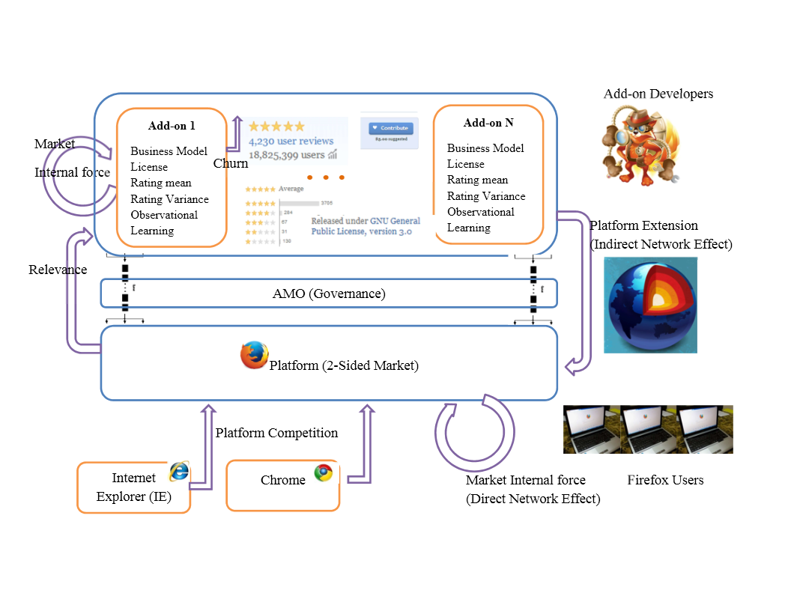

**Figure 3**

**Platform Diffusion Data**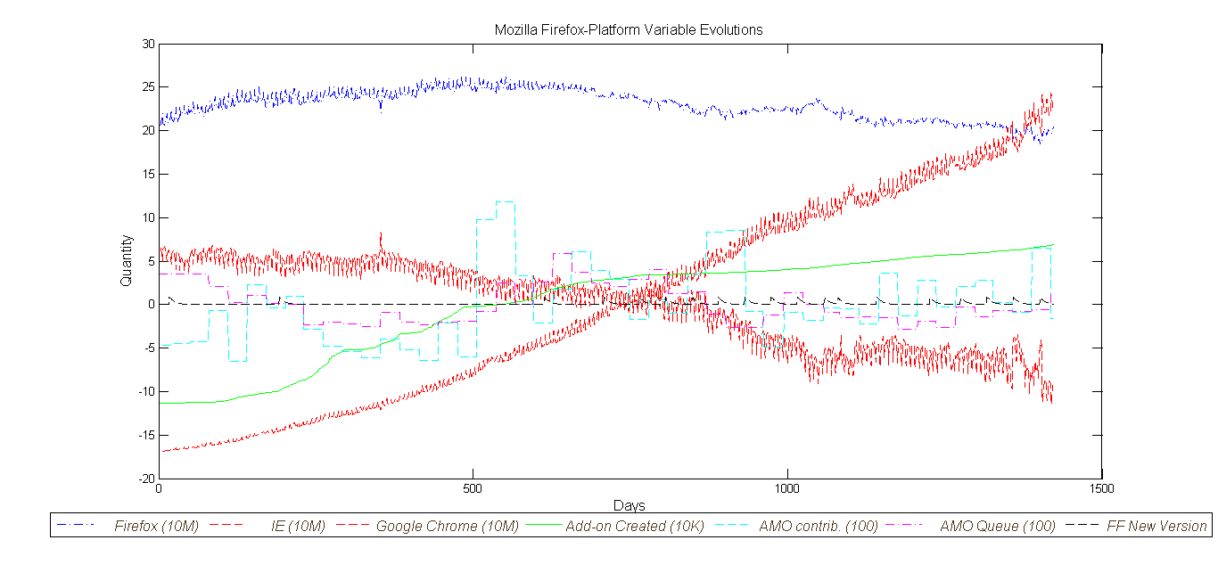

**Figure 4**

**Add-on Daily Downloads**

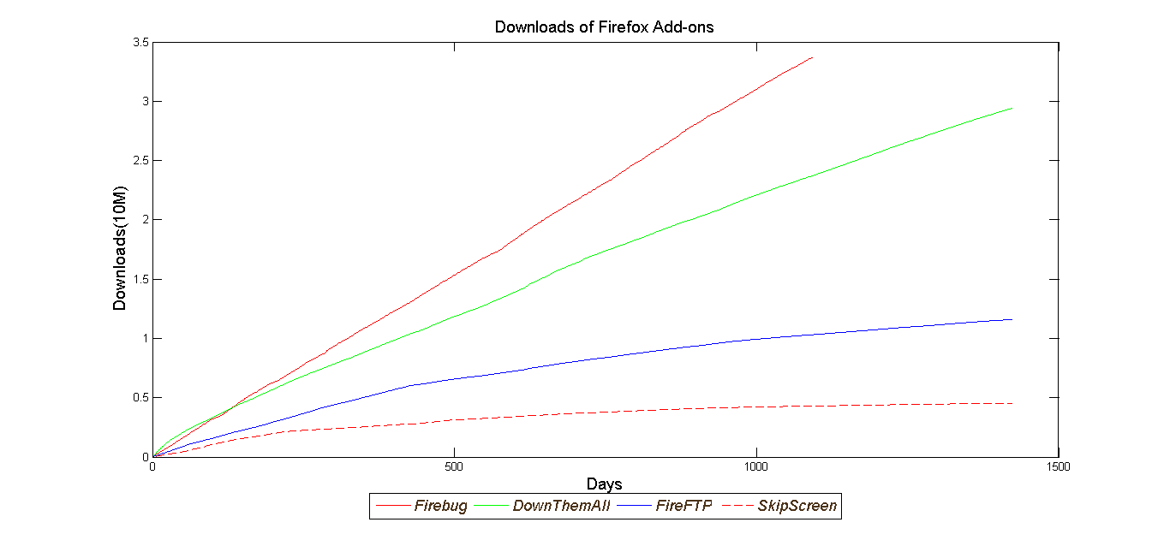

**Figure 5**

**Add-on Daily Variance of Rating**

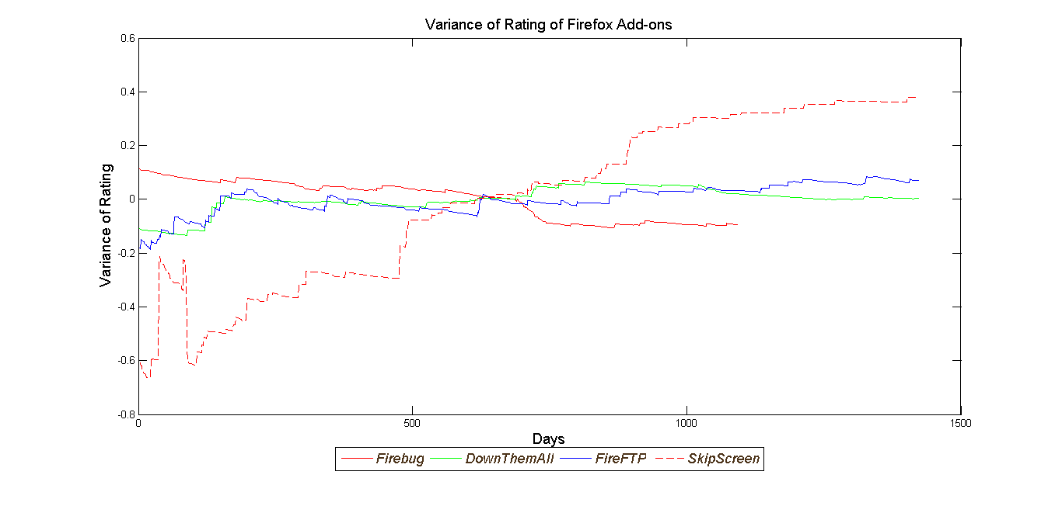

**Figure 6**

**Add-on Daily Users**

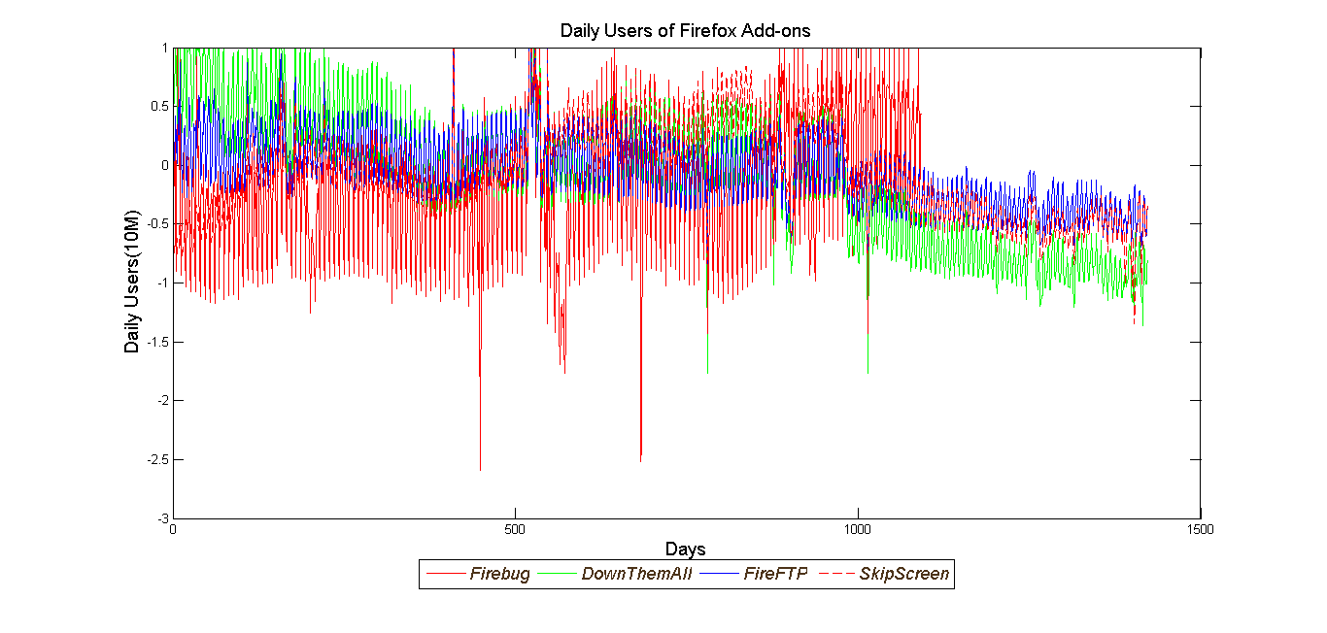

**Figure 7**

**Add-on Daily New Version**

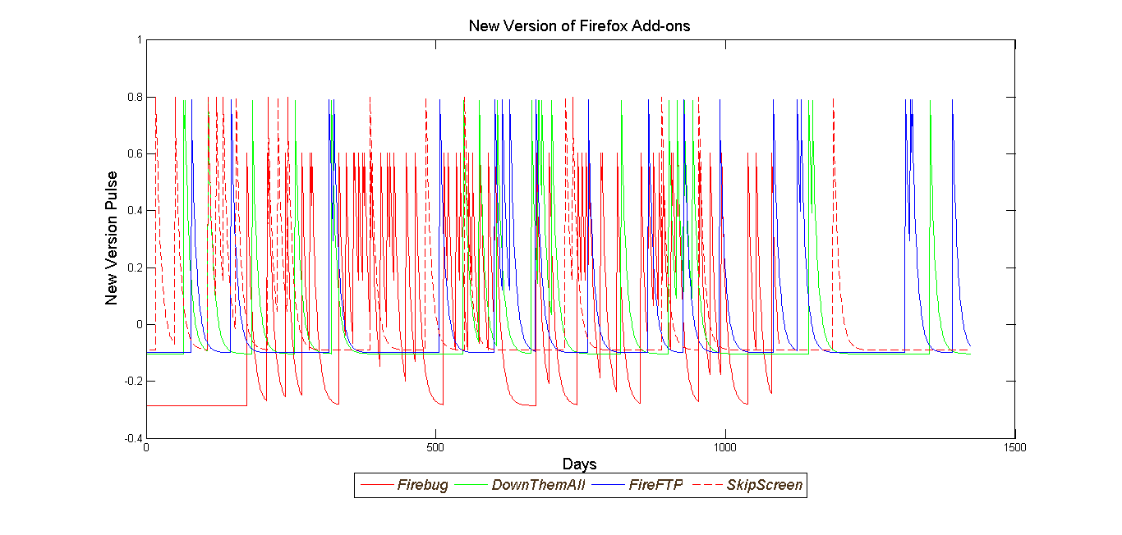

**Figure 8**

**One-Step Ahead Forecast of Four Sample Add-on’s Cumulative Downloads**

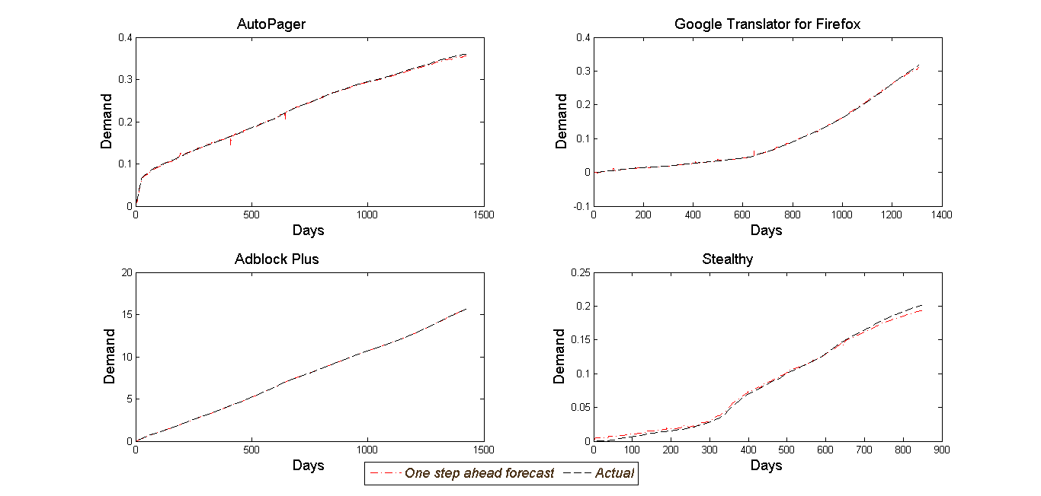

**Figure 9**

**One-Step Ahead Forecast of Firefox Platform Daily Users**

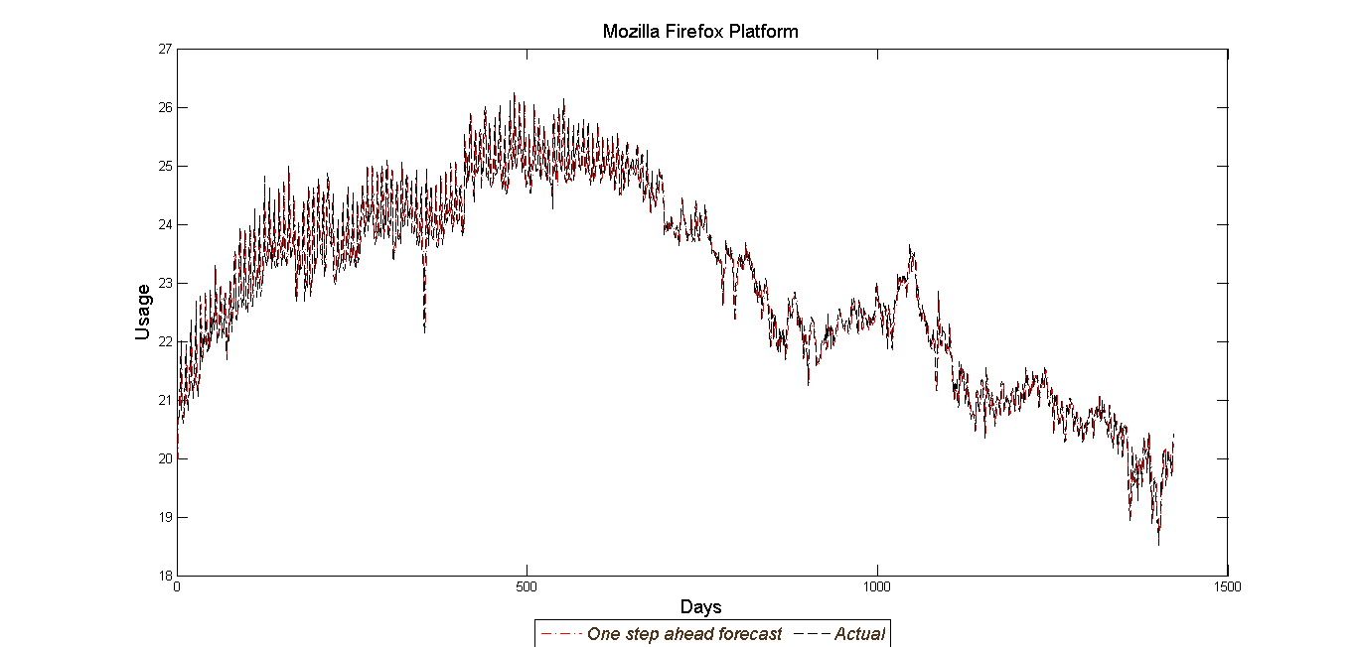

**Figure 10**

**Histogram of Parameter Estimate Across Add-ons**

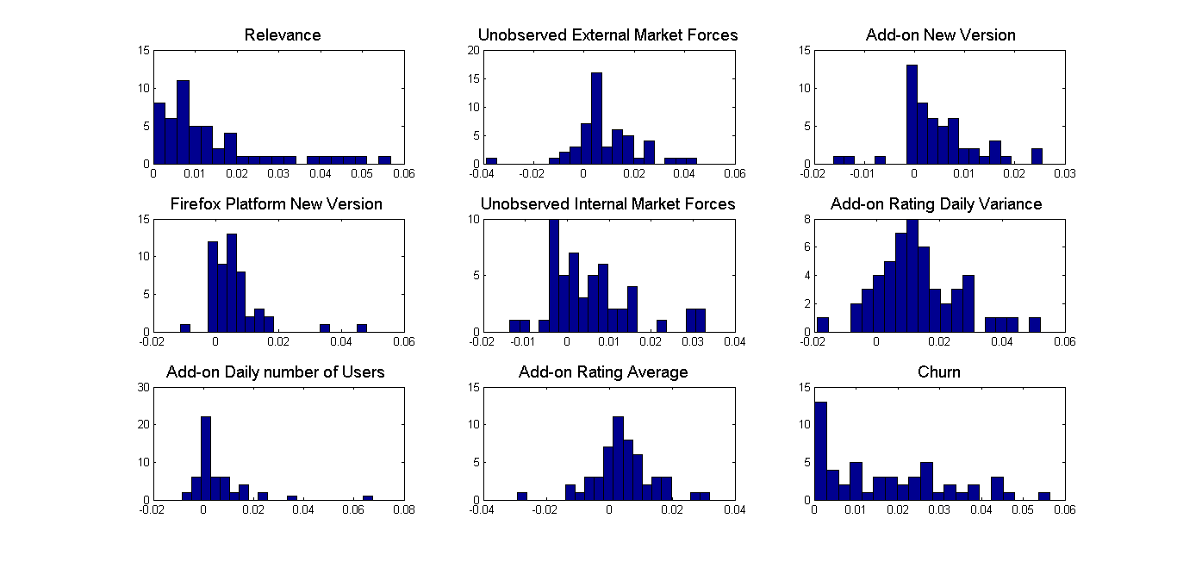

**Figure 11**

**Real versus optimal monthly editorial effort allocation**

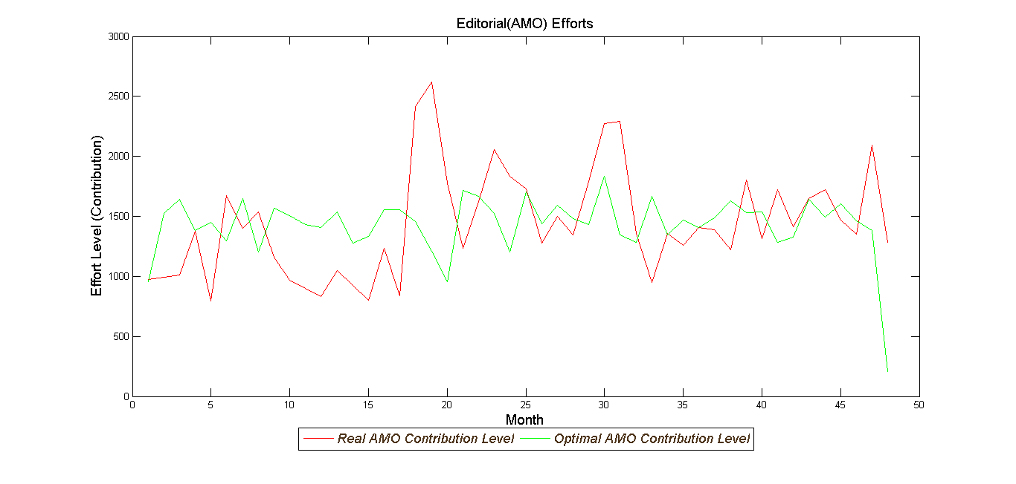

1. https://clarity.fm/questions/270/answers/354/share
2. http://www.gnu.org/philosophy/open-source-misses-the-point.html
3. https://blog.mozilla.org/addons/2011/02/04/overview-amo-review-process/
4. https://blog.mozilla.org/addons/2009/06/29/amo-review-queue-burndown-a-huge-success/
5. https://blog.mozilla.org/addons/2011/10/05/add-ons-update-4/
6. Wiggins, Andrea, James Howison, and Kevin Crowston. "Heartbeat: measuring active user base and potential user interest in FLOSS projects." *Open Source Ecosystems: Diverse Communities Interacting*. Springer Berlin Heidelberg, 2009. 94-104.
7. https://blog.mozilla.org/addons/2010/02/15/the-add-on-review-process-and-you/
8. https://blog.mozilla.org/addons/2011/02/04/overview-amo-review-process/
9. When someone submits a new add-on, it will have to choose between 2 review tracks: Full Review and Preliminary review; the first one checks whether the add-on is safe to use, respects user’s privacy and choice, doesn’t conflict with other add-ons or break existing Firefox features, is easy to use, and is worth publishing to a general audience. The second one, only requires add-on to be safe to use. Add-on with preliminary review approval appear on the site as Experimental, cant’ be featured and get lower search ranking. If an add-on approved in the preliminary review track, it can be nominated to the Full Review track after a 10 day waiting period.
10. https://forums.mozilla.org/addons/viewtopic.php?f=21&t=14313
11. https://blog.mozilla.org/addons/2010/02/15/the-add-on-review-process-and-you/
12. http://www.codeproject.com/info/Licenses.aspx
13. Market size is variable with time according to number of new add-ons 