**Joint Diffusion of Platform and Supplementary Digital Goods: Product Rating and Observational Learning Impacts**

**Meisam Hejazi Nia**

Naveen Jindal School of Management

University of Texas at Dallas

[mxh109420@utdallas.edu](mailto:mxh109420@utdallas.edu)

**Norris Bruce**

Naveen Jindal School of Management

University of Texas at Dallas

[nxb018100@utdallas.edu](mailto:nxb018100@utdallas.edu)

**Abstract**

In many industries such as mobile applications and video games, platform owners (PO) open their platform to third party developers, to facilitate the diffusion of their platforms. In deciding which platform and supplementary product (SP) to adopt, consumers learn from different quality signals, such as signal of usage, observational learning (OL), and signal of referral, product rating (RT). In this paper we investigate the effect of OL, variance of RT on the joint diffusion of SP, by endogenizing SP market size. We explain the internal market force of Bass diffusion model (imitation) in terms of observed factor such as OL and variance of RT and unobserved factors. We also explain the external market forces (innovation) in terms of the impact of platform and SP new generations. We use Extended Kalman Filter method for estimation. To account for heterogeneity, we incorporate hierarchical Bayesian method in our estimation. Unlike proposed methods in literature, our approach does not require integration, scalable for big data. We estimate our model using a unique data set on Firefox browser and 52 add-ons daily downloads for 5 years. The results show that variance of RT has negative effect, and OL has positive effect on the demand for supplementary products. We also find that platform’s new generation has positive impact on the diffusion of add-ons, unlike add-ons’ new version. We estimated churn rate of the add-ons. Our findings have several implications for PO’s to manage SP of their platform.

Keywords: diffusion of digital goods; platform; supplementary products; heterogeneity; variance of product rating; observational learning; experience goods; uncertainty; product generations; churn; platform competition extended Kalman filter; hierarchical Bayesian

1. **Introduction**

1. **Literature Review**

Given the broad impact of online product rating, there is growing body of research in both marketing literature and information technology literature that examines the effects and dynamics of product rating. We review the literature on product ratings in three categories: (i) the effect of product reviews on consumer’s decision (ii) dynamics of generating product reviews and (iii) best response of firms to product reviews. Then, we will review sparse literature on observational learning.

*The effect of product review on consumer’s decision*

To analyze product reviews effect on sales and revenue, different researches measure product reviews through three main metrics, including valence, variance and volume (Moe and Trusov 2011). These studies use number of product reviews to measure volume of ratings, but volume is not informative about the valence. To summarize the effect of valence, some studies only consider average of rating (Chavelier and Mayzlin 2006; Clemons et al. 2006; Dellarocas et al. 2007; Duan et al. 2008; Chintagunta et al. 2010), while others in addition consider variance of ratings by measuring either statistical variance (Clemons et al. 2006; Sun 2012) or entropy (Godes and Mayzlin 2004).

Although the effect of product reviews on business performance, such as sales and revenue is substantially understudied, the empirical results are not unanimous (Moe and Trusov 2011). By comparing different in sales ranks, Chavelear and Mayzlin 2006 found positive significant impact of rating valence on sales of books on Amazon.com and Barnsandnoble.com. Dellarocas et al. 2007 found out that both valence and volume of movie rating can significantly ameliorate the prediction of diffusion model of box office sales. However, Duan et al. 2008 assert that after accounting for endogeneity online user review has insignificant impact on box office revenue. Another study by Chintagunta et al. 2010 found that endogeneity does not distort the positive effect of valence of product reviews on box office performance. Finally Moe and Trusov 2011 decompose the effect of product rating into baseline and social dynamics component, and they observe substantial social dynamics in rating, with noticeable effect on sales. Table 1 summarizes these findings.

*Generation of consumer product review dynamic*

There is growing stream of literature that studies how consumers generate product reviews. Moe and Schweidel 2011 studied how previously posted ratings will affect individual’s decision on whether and what to contribute. They found out that there is selection effect in the decision of whether to contribute, and adjustment effect that influences what to contribute. Other studies found that valence of product rating has downward trend, and it is subjected to self-selection bias (Godes and Silva 2009; Li and Hitt 2008). These studies explain downward trend by heterogeneity of consumer preferences, and they assume that early consumers are those to whom the product is most fit, while late consumers have more distant preferences.

On the other hand, Brandes et al. 2013 by survey evidence finds that consumers who post an online review tend to have more extreme opinions than those consumers who don’t. This finding offers an alternative explanation to downward trend of valence, i.e. reviews that arrive after a long time tend to be similar to the opinion of non-responders. Furthermore, Li and Hitt 2008 nudge to this effect with the name of idiosyncratic preference of early buyer, and they suggest that firms should adapt their marketing mix to generate more positive word-of-mouth at early stages. Moe and Trusov 2011 adopt these explanations and allowed rating social dynamic in their study by modeling the effect of volume of posted rating on subsequent rating behavior.

-- Insert Table 1 here --

*Best response of firms to product reviews*

Parallel with studies on how word of mouth is generated, and how it impacts business performance, another stream of literature focuses on normative models based on analytical studies. Chen and Xie (2005, 2008) suggest that when and how sellers ought to adjust their marketing strategies in response to consumer reviews. They treat product reviews as a new source of information that firm can complement by its other signals to optimize its objective function. Other studies that examine firm’s incentive to post fake reviews conclude that organizational forms affect this incentive. They further predict that that in equilibrium, despite these fake reviews, consumer can infer some information on product quality (Mayzlin 2006; Dellarocas 2006; Mayzlin et al. 2012).

*Observational learning*

Unlike product ratings, observational learning is less explored in marketing literature. Observational learning differs from word of mouth in two different areas: the amount and the credibility of information (Chen et al. 2010). In contrast to product rating that signals the distribution of consumers experience with the product; observational learning reveals only the actions of other consumers in discrete form (Bikhchandani et al. 1998). Nevertheless, since action speaks louder than words, the action-based observational learning might be perceived as more credible information source than product rating. We can track back the concept of observational learning to pioneering works of Bandura 1977, Banerjee 1992, and Bikhchandani et al. 1992. These studies have shown that observational learning may lead to informational cascades and herd behavior, and they prove that it has an inefficient equilibrium. Based on these theories, observational learning information signals may outweigh consumers’ private information in shaping their beliefs. As a result, people follow their predecessors’ action and engage in herd behavior (Banerjee 1992). Zhang 2010 showed that observational learning shapes consumer choices, and he suggests that optimal marketing strategies should take into account this process. Moreover, Chen et al. 2010 showed that positive observational learning information significantly increases sales, but negative observational learning has no effect.

In this article, we consider potential intertemporal influence of product ratings and observational learning on the demand of products by modeling the effect of product ratings and user base size signal on a latent measure that captures attractiveness of download. We also control for new version, product category need, and weekends seasonality. Our model is flexible to allow for heterogeneity in the effect of ratings and user base size signal of different add-ons. In the next section we will elaborate more about it.

1. **Model Development**

In this section, we introduce our joint diffusion model for digital goods that endogenizes the market size for supplementary products. From dynamic modeling point of view, the market size for the supplementary product evolves as more consumers adopt the platform. Therefore, our model consists of two modules. The first module includes the diffusion of the platform and the second one includes the diffusion of add-ons. To model the effect of diffusion we extended Bass diffusion model (Bass 1969) by endogenizing the market size of supplementary products. We also explained innovation and imitation factor of this model by observed consumer’s learning signals such as product rating and observational learning, daily usage. We assume that the number of adopters is observed with perturbation, so we use dynamic non-linear model to filter this measurement error. Moreover, our approach offers flexibility to account for heterogeneity across supplementary products.

* 1. **Diffusion of Platform**

In order to model the diffusion of the platform, we adopt the method proposed by Horskey and Simon (1983) to incorporate platform competition. Let m(t) denote total adopters of the platform at time t, M the market potential, p and q the external and internal parameters, X(t) vector of competitor’s market share. Thus the diffusion of the platform has the following form:

 (1)

where  is the coefficient of competition. Note that at each time, we assume competition affects the external factor of adoption. In our empirical case we include chrome and internet explorer as competitors of Firefox, based on press evidences on close competition between these three browsers.

We assumed that the total number of adopters is observed with error, so we adopt state space approach and discretize the diffusion model of platform as follows:

, where  (2)

 where  (3)

where error term  and  are assume to have normal distribution with mean zero and variance and respectively.  is observed total number of adopters of platform, and , , , ,  and  are parameters to estimate.

* 1. **Diffusion of the supplementary product**

As mentioned before, we endogenize the market size of supplementary products in modeling their diffusions. Let n(j, t) denote total number of adopters of a supplementary product j at time t, we model the diffusion of supplementary products as follows:

 (4)

where m(t) represents the total number of platform adopters at time t, p(j) and q(j) are the external and internal parameters, and  represents the disadoption rate. To account for churn we adopt the method proposed by Libai et al. (2009) that assumes that those who disadopt does not spread word of mouth for the product. In our model we assume that market size of the supplementary product cannot be greater than the market size of platform. This assumption may be reasonable because in order to use the supplementary product one must have the platform. Moreover, we allow different market size for different add-ons by incorporating  coefficient of market size in our model.

We explain external factor, innovation force, in terms of impact of different generations of digital goods as follows:

 (5)

where  is unobserved innovation force parameter, captures the impact of new version of platform, the impact of new version of add-on, and controls for weekend.  is the parameter of platform new version effect,  the parameter of new add-on version effect,  parameter of interaction of new version of add-on just after a new version of platform, and parameter of weekend effect.

According to information diffusion and consumer procrastination theory consumer may receive the information about new version of the platform or add-on later in time or decide to install it later. To allow for such a dynamic effect we created  as follows:

 (6)

where is the time of issuance of last version of the product, and is the decay factor. We set  to 0.89 which is the mean of our estimate of the discrete time analog model of Nerlove and Arrow (1962) on our data. We built variable  with the same convention.

We explain internal factor, imitation force, in terms of impact of different generations of digital goods as follows:

 (7)

where  is unobserved imitation force parameter, captures the impact of variance of add-on ratings, the impact of consumers observing daily users count, and controls for the rate of active users.  is the parameter of variance of product ratings effect,  the parameter of observational learning effect,  the parameter of interaction of observational learning and add-on rating variance, and parameter of active users effect.

In order to measure the impact of observational learning, we assumed that not the absolute value, but the relative value of the number of daily users is relevant. As a result, we divide the number of daily users of add-on  by the total number of add-on users of Firefox platform. This assumption may be reasonable because consumers do not just care about the absolute value, but they compare it with the reference to understand it according to prospect theory.

Like platform diffusion, we assumed that the total number of supplementary product adopters is also observed with error, so we adopt state space approach and discretize the diffusion model of supplementary products as follows:

, where  (8)

 where  (9)

where error term  and  are assume to have normal distribution with mean zero and variance and respectively.  is observed total number of adopters of add-on j at time t , and , , , ,  and  are parameters to estimate.

* 1. **Heterogeneity**

The effects of internal and external factors, churn and market size ratio may differ across supplementary products, as for example effect of advertising, need category, and competition in the market of the supplementary goods may differ. Thus, we also acknowledge such potential heterogeneity by linking these supplementary product specific parameters from equation 9 to a set of supplementary product characteristics, such as add-on share of MS Windows, size of team of developers, package followers, add-on tenure, add-on category, etc.

, where  (10)

1. **Empirical Study**
   1. **Data**

The data that we used for empirical analysis is from a sample of 52 Firefox Add-ons. Add-ons are free software complement to Firefox web browser, which independent authors develop, either for reciprocity or creating goodwill for a relevant business, but Firefox distributes them. Consumers can only benefit from add-on when Firefox is installed on their system. Time period under the study is from 2008 to 2013, and different add-ons are launched during this time span at different points. Time series data consists of daily number of downloads and user base size, despite consumer reviews, and they are publicly available only if the author of the add-on has decided to make the statistics dashboard public. Therefore, our sample is only limited to those add-ons that its author left the dashboard public. We collected all the available reviews, user base size, and download of each of these 52 popular add-ons for the time span of our study. Each add-on in our sample is categorized into one to two categories, including appearance (17%), bookmarks (6%), download management (6%), photo and multimedia (17%), game and entertainment (6%), privacy and security (12%), language support (13%), alerts updates (12%) and web development (25%).

In addition to add-ons we collect the data of users of Firefox Platform. We did not find public data on the number of daily users of platform, so we had to estimate it. In order to estimate the daily users of Firefox add-on we use two datasets. The first one include the daily market share of web browsers, and the second one include total monthly internet hosts published by internet world stats. Observing linear pattern of growth in internet hosts, we interleaved daily number of hosts. This may be reasonable because purchasing new computer requires a fixed cost, so on aggregate level it may not be expected to fluctuate daily. We multiply the number of hosts to the market share of Firefox, Chrome and Internet Explorer to find the number of daily users of each of the browsers. Public press acknowledges that entrance of Chrome browser has challenged Firefox, in addition to its old competitor, Internet Explorer. Figure 1 show the evolution of users of Firefox platform and its main competitors, Chrome and Internet Explorer.

-- Insert Figure 1 here –

For the 52 add-ons in our sample consumers had posted 19,211 ratings. To use distribution of rating in our model for each day we calculated average, variance, and volume of product reviews of a given add-on from the launch day until the given day to build the time series. Average of product rating is high across add-ons 4.2 stars out of 5, with low variance of 0.5. This may be because add-ons are free, and free launch may be appreciated. This high product rating came with the variation. Since Firefox shows the ratings distribution to the consumer, it may be relevant to look at the variance of product ratings. Daily variance of product ratings on average is 1.46, with variation of 0.76, which is much higher than the variance of average of product ratings. Product rating is not the only quality signal available on Firefox website. Consumers can also observe the number of daily users of product. This quality signal is different from product rating signal in that it is not about the chatter, which is vulnerable to cheap talk, but it is consumers observing other consumers’ action. Daily users of add-ons are on average around 900 thousands users a day, with the variation of 2 million users. Figure 2-4 show the evolution of daily download, user base size, and average rating valence for four add-ons as an example.

-- Insert Figure 2 here –

-- Insert Figure 3 here --

-- Insert Figure 4 here –

To the best of our knowledge, user base size includes all active and inactive users who have not removed add-on from their web browser. Since add-ons under our study are free, consumers may download and install it on their system, but then they may find it useless and remove it. Add-on authors on the other hand can play an active role to maintain consumers by issuing new version. Add-on authors may issue a new version either to response to changes in Firefox platform, or to response to bugs and issues that they or current consumers found. Therefore, new version may be an important determinant of attractiveness of download of an add-on. Figure 5 illustrates evolution of number of versions add-on authors have issued, for a sample of four add-ons.

-- Insert Figure 5 here --

Authors of add-on act as an independent firm and define whether they want to ask consumer for discretionary contribution or just make their contact available for networking purposes. They can define how much they want to ask consumer for discretionary money contribution, or whether they want to feature their add-on on the front page. These independent authors, who are analogous to application developers on app-stores, have control on pictures or tags they want to attach to their add-on, but platform owner, here Firefox, reviews these add-ons’ full package before publishing, to ensure stable and safe consumer experience.

We observed seasonality pattern in the download and usage data. Therefore, to account for this seasonality we adopted weekend dummy variable. Add-ons under our study did not have features explicitly listed on the download page. This characteristic makes them similar to other experience goods such as books and movies that their quality could only be ascertained after consumption. Therefore, to explain heterogeneity in demand response we used a set of add-on characteristics that we extracted from each add-ons page. These characteristics included add-on category dummy, rating and number of followers of collection that the add-on belongs to, size of the team of developers, add-on tenure, number of tags, and so on. The basic statistics of relevant variables that significantly explain our results is presented in Table 3.

-- Insert Table 2 here --

* 1. **Estimation**

To describe the estimation procedure used in this study, it is convenient to bind ourselves to formal notation of state space model of West and Harrison (1997). According to this definition we can rewrite equation 2 and 8 that represents observation equation, and equation 3 and 9 that represents state equation after linearizing them as follows.

 (11)

 (12)

The unobserved state variable  captures total adoption count of add-on j or platform p at day t. The transition vector captures the impact of internal and external market forces. Furthermore, we assume that error term and  to be independent normal random variables with zero means.

Recall that Equation 10 links all time-invariant non-state parameters from the preceding equations to add-on characteristics. As a result, Equation 10-12 constitutes our final DLM form.

We estimate the model using MATLAB programming on the entire observed data series of Add-ons. The procedure consists of models of Extended Kalman forward filtering and backward smoothing, MCMC Gibbs, and Metropolis Hasting for both platform and add-ons. Our parallelization method allows estimation procedure to speed up. The primary goal is to estimate the joint posterior distribution of state and non-state parameters for all add-ons and platform. Conditional posterior of state parameters given non-state parameters is a linearized state-space model, so it can be sampled with Extended Kalman forward filtering and backward smoothing algorithm. Moreover, given the state parameters, we will have multivariate linear model with hierarchical priors, so we can sample directly by using standard MCMC methods (Bruce et al. 2012). In other word, Kalman forward filtering and backward smoothing updates the evolution of the state parameters conditional on the non-state parameters, where MCMC Gibbs sampler and Metropolis Hasting updates the non-state parameters given the state parameters. Consequently, we sample from joint distribution of state and non-state parameters (See Appendix A for details).

* 1. **Model Comparison**
  2. **Parameter Estimate**

1. **Conclusion**

**References**

Awad, N., H. Etzion. 2006. Stay out of my forum! Evaluating ﬁrm involvement in online ratings communities. Presentation, Workshop on Information Systems and Economics (WISC), December 9–10, Northwestern University, Evanston, IL.

Bass, F. 1969. A new product growth model for consumer durables. Management Sci. 15(5) 215–227.

Bandura, A. 1977. Social learning theory. Englewood Cliffs, NJ: prentice Hall.

Banerjee, A. 1992. A simple model of herd behavior. Quar. J. Economics. 107(3), 797-817.

Bikhchandani, S., D. Hirshleifer, I. Welch. 1998. Learning from the behavior of others: Conformity, fads, and information cascades. J. Economic Perspective. 12(3), 151-170.

--------------------, S. Sharma. 2001. Herd behavior in financial markets: A Review. IMF Staff Papers. 47 279-310

Brandes, L., D. Godes, D. Mayzlin. 2013. Controlling for self-selection bias in customer reviews. Working Paper. University of South California, California.

Brown, J. J, P. H. Reingen. 1987. Social ties and word-of-mouth referral behavior. J. Consumer Res. 14(3) 350-362.

Boudreau K. 2010. Open platform strategies and innovation: granting access vs. developing control, Management Sci. 56(10) 1849-1872.

Bruce N., N. Z. Foutz, C. Kolsarici. 2012. Dynamic effectiveness of advertising and word of mouth in sequential distribution of new products, J. Marketing Res. 49(2) 469-486.

Chen, Y., Q. Wang, J. Xie. Online social interactions: A natural experiment on word of mouth versus observational learning. Marketing Res. 48(2) 238-254.

----------, J. Xie. 2005. Third-party product review and ﬁrm marketing strategy. Marketing Sci. 24(2) 218–240.

----------, J. Xie. 2008. Online consumer review: A new element of marketing communications mix. Management Sci. 54(3) 477–491.

Chevalier, J., D. Mayzlin. 2006. The effect of word of mouth online: Online book reviews. J. Marketing Res. 43(3) 345–354.

Chintagunta, P. K., S. Gopinath, S. Venkataraman. 2010. The effects of online user reviews on movie box ofﬁce performance: Accounting for sequential rollout and aggregation across local markets. Marketing Sci. 29(5) 944–957.

Clemons, E.K., G. Gao, L. M. Hitt. 2006. When online reviews meet hyperdifferentiation: a study of the craft beer industry. J. Management Inf. Sys. 23(2) 149–71.

Dellarocas, C. 2006. Strategic manipulation of internet opinion forums: Implications for consumers and ﬁrms. Management Sci. 52(10) 1577–1593.

----------------, X. M. Zhang, N. Awad. 2007. Exploring the value of online product reviews in forecasting sales: The case of motion pictures. J. Interactive Marketing 21(4) 23–45.

Duan, W., B. Gu, A. B. Whinston. 2008. Do online reviews matter? — An empirical investigation of panel data. Decision Support Systems 45(4) 1007–1016.

Erdem, T., M. P. Keane. 1996. Decision-making under uncertainty: capturing dynamic brand choice processes in turbulent consumer goods markets. Marketing Sci. 15(1) 1-20.

Gao, G. G., B. Gu, M. Lin. 2006. The dynamics of online consumer reviews. Presentation, Workshop on Information Systems and Economics (WISE), December 9–10, Northwestern University, Evanston, IL.

Gatignon, H. Competition as a moderator of the effect of advertising on sales. J. Marketing Res. 21(4) 387-398.

Gelman, A., J. B. Carlin, H. S. Stern, D. B. [Rubin](http://en.wikipedia.org/wiki/Donald_Rubin). 2004. Bayesian data analysis. Chapman & Hall/CRC. Boca Raton, Florida.

Godes, D., D. Mayzlin. 2004. Using online conversations to study word-of-mouth communication. Marketing Sci. 23(4) 545–560.

------------, J. Silva. 2012. Sequential and temporal dynamics of online opinion. Marketing Sci. 31(3) 448-473.

Greenleaf E. A., D. R. Lehmann. Reasons for substantial delay in consumer decision making. J. Consumer Res. 22(2) 186-199.

Jiang, B.-j., P.-y. Chen. 2007. An economic analysis of online product reviews and ratings. Working paper, Tepper School of Business, Carnegie Mellon University, Pittsburgh.

Krishnamurthy S. 2009. Case: Mozila vs. Godzilla- the launch of the Mozilla Firefox browser. J. Interactive Marketing. 23(3) 259-271.

Lambkin, M., G. S. Day. 1989. Evolutionary process in competitive markets: Beyond the product life cycle. J. Marketing. 53(3) 4-20.

Lattin M. J., L. McAlister. 1985. Using a variety-seeking model to identify substitute and complementary relationships among competing products. J. Marketing Res. 22(3) 330-339.

Li, X., L. M. Hitt. 2008. Self-selection and information role of online product reviews. Marketing Sci. 19(4) 456-474.

Little, J. D. C. (1979), Aggregate advertising models: The state of the art, operations research. 27(4) 629–67.

Liu, Y. 2006. Word of mouth for movies: Its dynamics and impact on box ofﬁce revenue. J. Marketing 70(3) 74–89.

Mayzlin, D. 2006. Promotional chat on the internet. Marketing Sci. 25(2) 155–163.

-------------, Y. Dover, J. A. Chevalier. 2010. Promotional reviews: an empirical investigation of online review manipulation. Working paper, National Bureau of Economic Research, Cambridge.

Moe, W. W., D. A. Schweidel. 2011. Online product opinions: incidence, evaluation, and evolution. Marketing Sci. 31(3) 372-386.

---------------, M. Trusov. 2011. Measuring the value of social dynamics in online product ratings forums. J. Marketing Res. 49(3).

Money, R. B., M. C. Gilly, J. L. Graham. 1998. Exploration of national culture and word of mouth referral behavior in the purchase of industrial services in the United States and Japan. J. Marketing. 62(4) 76-87.

Nerlove, M., K. J. Arrow (1962), Optimal advertising policy under dynamic conditions. Economica 29(114) 129–42.

Oshri I., H. J. de Vries, H. de Vries. 2010. The rise of Firefox in the web browser industry: The role of open source in setting standards. Business History. 52(5) 834-856.

Sun M. 2012. How does the variance of product ratings matter? Marketing Sci. 58(2) 696-707.

Van Heerde, H. J., C. F. Mela, P. Manchanda. 2004. The dynamic effect of innovation on market structure. J. Marketing Res. 41(2) 166-183.

West, M., J. Harrison. 1997. Bayesian Forecasting and Dynamic Models. New York:Springer-Verlag.

Ye, Q., R. Law, B. Gu. 2009. The impact of online user reviews on hotel room sales. Inter. J. Hospitality Management. 28(1) 180-182.

Zhang J. 2010. The sound of silence: observational learning in the U.S. kidney market. Marketing Sci. 29(2) 315-335.

Zhao, Y., S. Yang, V. Narayan, Y. Zhao. 2012. Modeling consumer learning from online product reviews. Marketing Sci. 32(1) 153-169.

**Appendix A**

This appendix reviews the posterior sampling algorithm. The sampling that we present is direct application Extended Kalman Filter (Ristic et al 2004), DLM theory (West and Harrison 1997) and Gibbs sampling (Gelman et al. 2003). Our model is a type of linear state space models with individual level parameters in which we treat component of transition  and variance of components,, , as parameters to estimate along with the sequence of state vectors for both platform () and add-on () over time. Recall that we also explain individual level transition parameters with hyperparameters with components of () and variance of component () that we estimate along with other parameters. We begin with forward filtering step with the most recent values of for platform:

**A.1. Sampling from** 

**Forward Filtering**. We use the standard DLM framework (Equation A1 to A5) to infer the posterior distribution  over time, where includes all information available to researcher at time t. We derive posterior  using multivariate normal theory.

Posterior distribution for,

 (A1)

Prior distribution for, where

, and. (A2)

where, and its Jacobean is .

Prior one-step-ahead forecast distribution: ,

,  (A3)

, with

 (A4)

Posterior distribution for, by marginal properties of normal distribution in (A4),

,, where  (A5)

**Backward Smoothing**. We derive backward smoothing algorithm by using (A1) and (A2) to get joint distribution of parameters at t and t-1, given information of previous moment  to obtain equation (A6):

. (A6)

Then, multivariate normal theory gives us the conditionals:

, (A7)

where and  is random draw from posterior 

We can conduct retrospective analysis using results of A6 and A7. In other word, we derive expectations and variance over all possible draws of posterior. As a result, our backward smoothing algorithm is:

 (A8)

And

. (A9)

**Simulation for**.

For:

Step 1. For compute the moments  for the multivariate normal by sequential updating procedure described in forward filtering section above (Equations A2 - A5).

Step 2. At the end of the series, sample from the posterior distribution: 

Step 3. For sample  conditional on the latest draw.

The outcome of each of the iterations is the draws from the full conditional posterior.

**A.2. Sampling from** 

Conditional on all the states and the data, our state space equations (2) and (3) simplify to a non-linear multivariate system with individual level hyperparameters with unknown parameters, and variance components . Consequently, the Metrapolis Hasting sampler step to estimate the joint posterior of the non-state parameters is as follows:

1. We consider prior distribution.
2. We assume error terms of the observation equation (2) and system Equation (3) are mutually independent. Thus, conditional on  we sample around the mode method and draw  jointly, using Metropolis hasting.
3. conditional on, we then sample  independently.

The outcome is the draws from full conditional posterior.

**A.3. Sampling from** 

**Forward Filtering**. Conditional on all platform state parameters and data  for all the add-ons in parallel we derive posterior  using multivariate normal theory.

Posterior distribution for,

 (A10)

Prior distribution for, where

, and. (A11)

where, and its Jacobean is .

Note that  and in our example is explained in terms of data and non-state parameters and, but for ease of exposition here we did not substitute its content.

Prior one-step-ahead forecast distribution: ,

,  (A12)

, with

 (A13)

Posterior distribution for, by marginal properties of normal distribution in (A13),

,, where  (A14)

**Backward Smoothing**. We derive backward smoothing algorithm by using (A10) and (A11) to get joint distribution of parameters at t and t-1, given information of previous moment  to obtain equation (A15):

. (A15)

Then, multivariate normal theory gives us the conditionals:

, (A16)

where and  is random draw from posterior 

We can conduct retrospective analysis using results of A15 and A16. In other word, we derive expectations and variance over all possible draws of posterior. As a result, our backward smoothing algorithm is:

 (A17)

And

. (A18)

**Simulation for**.

For:

Step 1. For compute the moments  for the multivariate normal by sequential updating procedure described in forward filtering section above (Equations A2 - A5).

Step 2. At the end of the series, sample from the posterior distribution: 

Step 3. For sample  conditional on the latest draw.

The outcome of each of the iterations is the draws from the full conditional posterior.

**A.2. Sampling from** 

Conditional on all the states and the data, our state space equations (8) and (9) simplify to a non-linear multivariate system with individual level hyperparameters with unknown parameters, and variance components . Consequently, the Metropolis Hasting random walk sampler step to estimate the joint posterior of the non-state parameters is as follows:

For:

1. We consider prior distribution from equation (10).
2. We assume error terms of the observation equation (8) and system Equation (9) are mutually independent. Thus, conditional on  we sample  jointly, using Metropolis hasting random walk algorithm.
3. Similarly, conditional on, we sampleseparately.

The outcome is the draws from full conditional posterior.

**A.5. Sampling from** 

Conditional on all the non-state parameters and the data, our equation (10) simplifies to linear multivariate system with unknown parameters and variance components. Therefore, the Gibbs sampler step with conjugate prior to estimate the joint posterior of the parameters is as follows:

1. We consider prior distribution, vague prior.
2. Conditional on, we sample  independently.
3. Similarly, conditional on, we sampleseparately.

Table 1 Previous Research on Consumer Product Ratings and observational learning

|  |  |
| --- | --- |
| **Empirical Studies on Product Rating** | |
|  |  |
| Chavalier and Mayzlin (2006) | Positive impact of average rating on sales, and higher impact of one-star reviews than five-star-reviews |
| Moe and Trusov (2011) | The impact of social dynamics in the rating environment on both sales and subsequent rating behavior. |
| Godes and Silva (2012) | Residual average temporal pattern of product reviews is increasing, after controlling for calendar date. Consumer product ratings tend to plunge over time. |
| Zhao et al. (2012) | Consumers learn more about an experience good from online consumer product reviews than their own experience of product category |
| Moe and Schweidel (2012) | Individual’s decision to provide a product rating is subjected to selection effects, and adjustment effect. Positive ratings environment increases positing incidence, yet negative rating environment discourage posting. |
| Dellarocas et al. (2007) | Better predictability of diffusion model that incorporates consumer review for box office revenue data |
| Duan et al. (2008) | Insignificance of the impact of online user reviews on movies’ box office revenues after accounting for endogeneity |
| Godes and Mayzlin (2004) | Dispersion of conversations across communities can explain dynamic of TV ratings |
| Zhu and Zhang (2010) | Consumer product ratings are more influential for less popular products |
| Gao et al. (2006) | Significant impact of public opinion on consumer product reviews |
| Liu (2006) | Aggregate and weekly box office revenue can significantly be explained by online word of mouth, especially at early weeks of movie release |
| Clemons et al. (2006) | Variance of ratings play significant role in determining which new products grow fastest in the market. |
| Chintagunta et al. (2010) | Valence rather than volume of consumer product reviews drive box office performance |
| Li and Hitt (2008), Brandes et al. (2013) | Online product reviews are subject to self-selection. |
| Ye et al. (2009) | Online consumer reviews have significant relationship with business performance of hotels. |
| **Theoretical Studies on Product Rating** | |
| Monic Sun (2012) | Informational role of variance of product rating on the product subsequent demand |
| Chen and Xie (2008) | Firm’s best response to consumer product reviews |
| Chen and Xie (2005) | Firm’s strategy to adapt consumer product reviews |
| Mayzlin (2006) ,Dellarocas (2006), Mayzlin et al. (2012) | Firm’s online manipulation of consumer product reviews |
| Awad and Etzion (2006) | Firms’ filtering of consumer product reviews |
| Jiang and Chen (2007) | Firm’s dynamic strategy to leverage consumer product review |
| **Studies on observational learning** | |
| Chen et al. (2010) | Positive observational learning information significantly increases sales, whereas, negative observational learning information has no effect. |
| Bikhchandani et al. (1998, 2008) | Observational learning may lead to information cascade and herd behavior. |
| Bikhchandani and Sharma (2001) | Over view of theoretical and empirical research on herd behavior |
| Banerjee (1992) | Herd behavior leads to inefficient equilibrium. |

Figure 1 Diffusion of Firefox Platform and Its Competitors

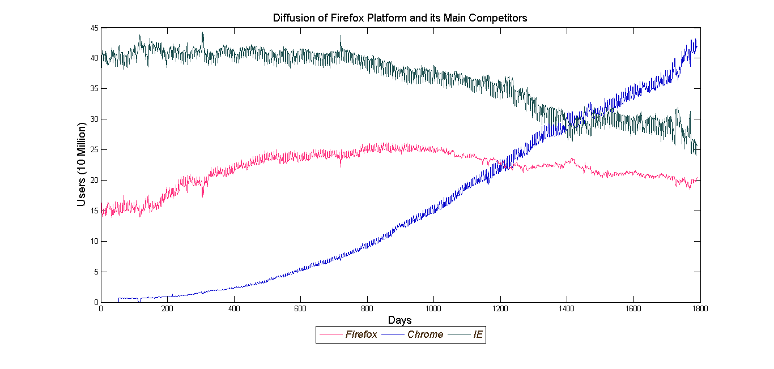

Figure 2 Examples of Demand for Firefox Add-ons

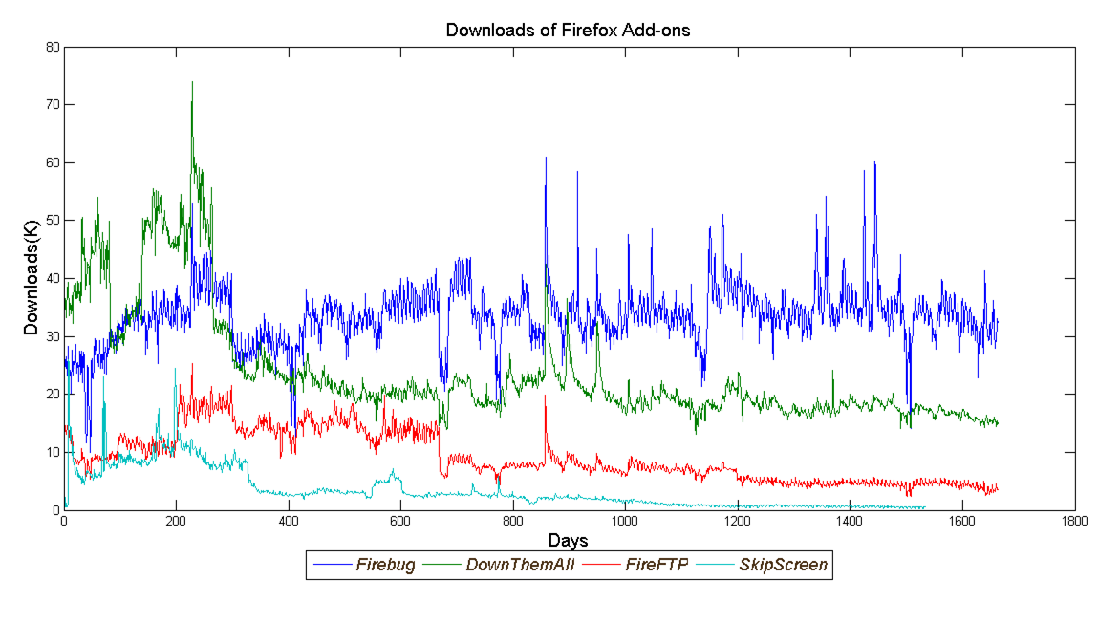

Figure 3 Examples of Size of Usage Base for Firefox Add-ons

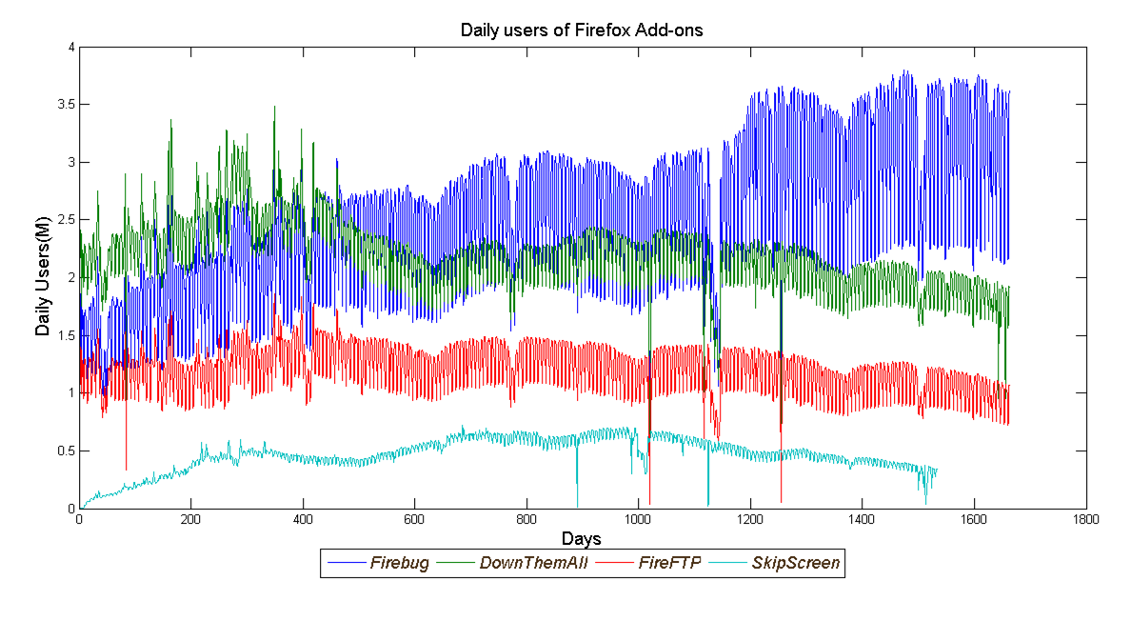

Figure 4 Examples of Valence of Rating for Firefox Add-ons

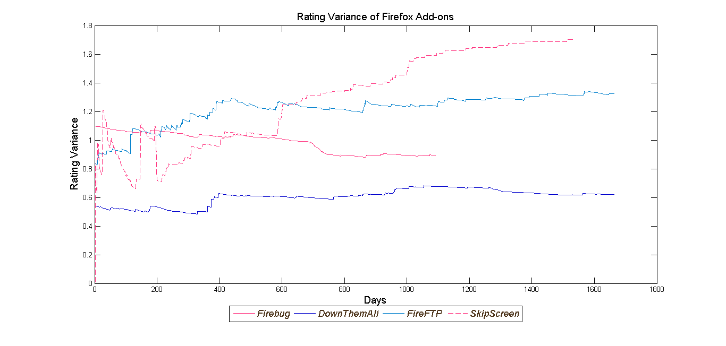

Figure 5 Examples of Number of New Versions for Firefox Add-ons

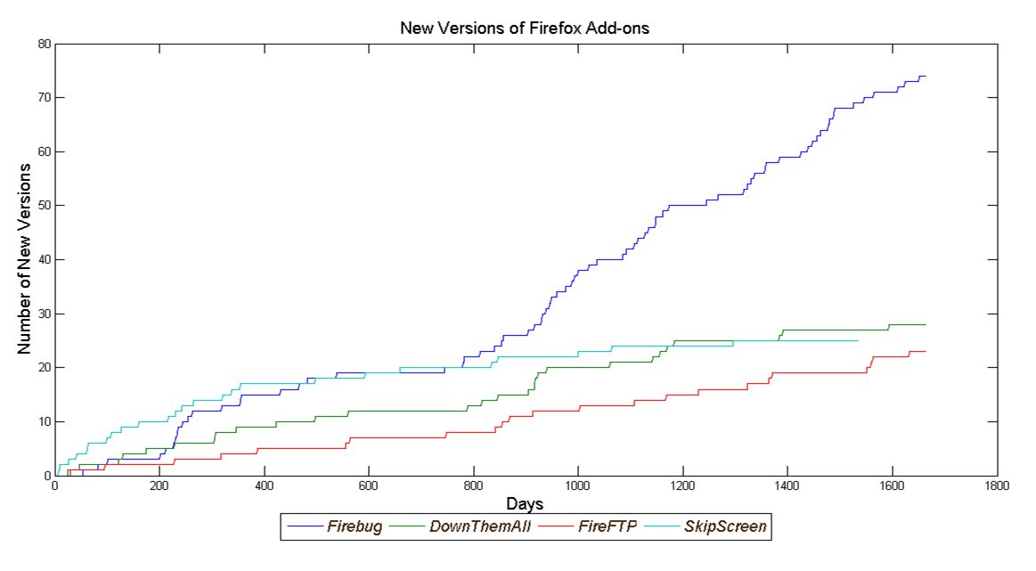

Table 2 Basic Statistics

|  |  |  |  |  |
| --- | --- | --- | --- | --- |
|  | Mean | SD | Min | Max |
| Downloads (K) | 7.641 | 18.502 | 11.79 | 283.44 |
| Daily Users (M) | 0.883 | 1.955 | 1.00E-06 | 16.97 |
| Rating Valence Mean | 4.275 | 0.499 | 1 | 5 |
| New Version of Product | 0.015 | 0.123 | 0 | 1 |
| Product Category Search | 38.753 | 17.566 | 0 | 100 |
| Share of Windows | 0.86 | 0.15 | 0.03 | 1 |
| Number of Reviews | 382.64 | 584.93 | 2 | 3686 |
| Variance of Rating | 1.46 | 0.76 | 0.48 | 4.2 |
| Size of Developer Team | 1.32 | 0.72 | 1 | 4 |
| Length of time series | 1321.9 | 456.6 | 260 | 1686 |

Table 3 Model Comparison

|  |  |  |  |  |
| --- | --- | --- | --- | --- |
| Mode | Description | DIC | Penalty Term  () | Log Likelihood |
| 1 | Joint Diffusion Model (Unexplained Heterogeneity) | 1.42283E+12 | 6.79382E+11 | -3.7172E+11 |

Figure 6 Examples of one step ahead forecast versus actual demand

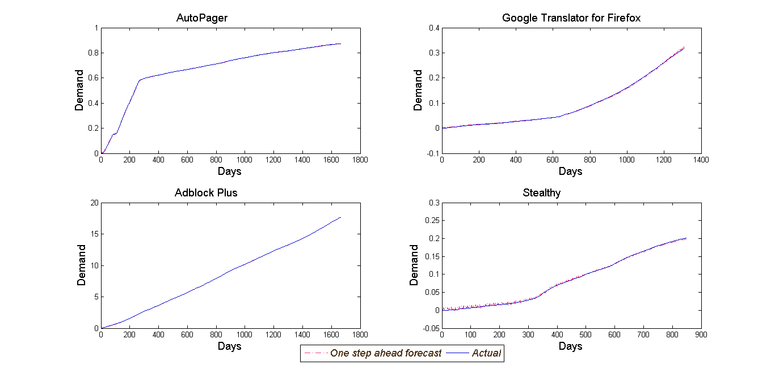

Table 4 Examples of fit statistics

|  |  |  |
| --- | --- | --- |
| Examples of Add-on | Mean Absolute Deviation (MAD) | Mean Square Error (MSE) |
| Auto Pager | 1.1e-3 | 1.9e-6 |
| Adblock Plus | 1.6e-3 | 3.9e-6 |
| Google Translator for Firefox | 4.8e-3 | 3.7e-5 |
| Stealty | 1.9e-3 | 6.1e-6 |

Figure 7 Histogram of Individual Parameter Estimate for 52 Add-ons

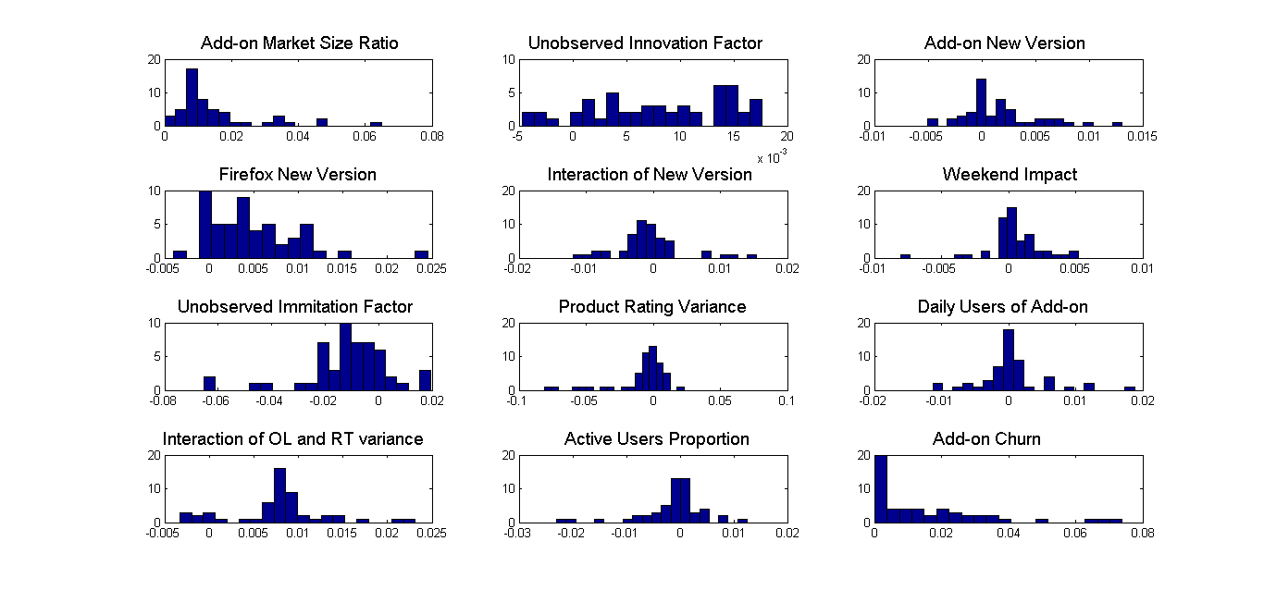

Table 8 Mean Parameter Estimate across Supplementary Products

|  |  |  |  |  |  |
| --- | --- | --- | --- | --- | --- |
|  | | Mean | SD | 2.5 % | 97.5 % |
| Market Size Ratio | 0.0149 | | 0.0017 | 0.0183 | 0.0115 |
| Unobserved Internal Force | 0.0079 | | 0.0009 | 0.0097 | 0.0062 |
| New Version of Platform | 0.0018 | | 0.0005 | 0.0028 | 0.0007 |
| New Version of Add-on | 0.0051 | | 0.0008 | 0.0066 | 0.0036 |
| Interaction of New Version | -0.0004 | | 0.0007 | 0.001 | -0.0017 |
| Weekend | 0.0005 | | 0.0003 | 0.0011 | -0.0001 |
| Unobserved External Force | -0.011 | | 0.0022 | -0.0067 | -0.0152 |
| Product Rating Variance | -0.0085 | | 0.003 | -0.0027 | -0.0143 |
| Daily Users (OL) | 0.0028 | | 0.0008 | 0.0044 | 0.0012 |
| Interaction of OL and RT Var | 0.0089 | | 0.001 | 0.0109 | 0.0069 |
| Active Users Ratio | -0.0007 | | 0.0008 | 0.001 | -0.0023 |
| Churn Rate | 0.0156 | | 0.0025 | 0.0206 | 0.0106 |
|  | 0.0002 | | 0 | 0.0002 | 0.0002 |
|  | 0.0002 | | 0 | 0.0002 | 0.0002 |

Table 9 Significance of effect for individual add-ons

|  |  |
| --- | --- |
|  | Number of Add-on’s |
| Market Size Ratio | 52 |
| Unobserved Internal Force | 35 |
| New Version of Platform | 0 |
| New Version of Add-on | 4 |
| Interaction of New Version | 2 |
| Weekend | 0 |
| Unobserved External Force | 15 |
| Product Rating Variance | 12 |
| Daily Users (OL) | 6 |
| Interaction of OL and RT Var | 7 |
| Active Users Ratio | 6 |
| Churn Rate | 52 |
|  | 52 |
|  | 52 |