**Dynamic Effect of Supplementary Product Rating**

**Meisam Hejazi Nia**

Naveen Jindal School of Management

University of Texas at Dallas

[mxh109420@utdallas.edu](mailto:mxh109420@utdallas.edu)

[**Advisor: Dr.**](http://jindal.utdallas.edu/faculty-and-research/elisabeth-honka/) **Norris Bruce**

Naveen Jindal School of Management

University of Texas at Dallas

[nxb018100@utdallas.edu](mailto:nxb018100@utdallas.edu)

**Abstract**

Researches have shown that product ratings, formed under social influence, affects sales of a product. Thus, product rating can play important and distinct role in simulating new product demand. In this article, the authors construct a dynamic linear model to study the dynamic effects of product rating for heterogeneous products. They further apply the model to examine the effect of product rating and user base size signal of 52 add-ons of Firefox on their daily downloads and estimate the parameters using Kalman filtering/smoothing and Markov chain Monte Carlo methods. The results show that product rating exerts dynamic, yet diverse, influence on demand for supplementary products in the context of experience goods. This finding suggests that if the model does not allow for such dynamic and heterogeneity, the estimation will be biased. Moreover, they find that user base size signal affects daily download positively when there is low uncertainty in valuation.

Keywords: Dynamic effect, Product rating, Experience Goods, Supplementary products, Uncertainty

1. **Introduction**

Consumers search different sources of information before making purchase decision. The search issue becomes more critical in the context of experience good, a type of good that its characteristics can easily be ascertained only upon consumption (Zhang et al. 2012). One important source of information is consumer product review that in many cases complements other sources of information such as business-to-consumer and offline word of mouth. Nielsen in the global trust in advertising report 2012 asserts that consumer product reviews are the second most trusted source of brand information and messaging. Studies also have shown that consumers rely on product reviews more than on their own experience on the product category (Zhao et al. 2012). Therefore, online customer rating is proved to have significant effect on product sales (Chavelier and Mayzlin 2006; Clemsons et al. 2006; Dellarocas et al. 2007).

The relationship between product rating and sales has been modeled and tested in different contexts including books (Chevalier and Mayzlin 2006; Sun 2012), video games (Zhu and Zhang 2010), movie box office (Dellarocas et al. 2007; Duan et al. 2008; Chintagunta et al. 2010), and beauty products (Moe and Trusov 2011), yet there is a gap in literature on the dynamic of this effect in the context of online supplementary software. In response to this importance of product reviews, not only e-commerce websites, but also web sites that offer free open source products such as sourceforge.com and Google play are making the distribution of ratings available using bar charts on their website. Some websites, such as Mozilla.org, even go one step further and make the size of user base of product available to consumers.

Studies have identified two fundamentally distinct approaches to opening a technology platform. First approach entails granting access to a platform and thereby opens up market for complementary components around the platform, while the second entails giving up control over the platform (Boudreau 2010). Between these two strategies, the first one is exerted by Mozilla Firefox web-browser, hereby called Firefox, leading to its stronger position in competition with Microsoft Internet Explorer (Oshri et al. 2010; Krishnamurthy 2009). In other word Firefox allows community of developers to develop complementary products, called add-on, and distributed it on its website according to the business model of the author. This in turn is similar to supplementary products in various industries such as video game, mobile applications, and online contents.

Add-on’s author based on his economic incentive may decide either to ask for money contribution or just makes his contact available for professional purposes. Moreover, the author has to optimize its response to platform changes and bugs found in its add-on via issuing new version. Consumers on the other hand are exposed to alternative products that they may otherwise have to pay for it. Despite zero monetary cost, time and effort cost of using an add-on is not zero. Add-ons due to their nature can be categorized as experience good, since its characteristics are difficult to observe in advance. Thus, signals such as average product rating valence and usage base size may play an important role in consumer’s decision (Zhang et al. 2010).

Therefore, several substantive questions arise on the effect of product reviews on demand for a supplementary product: Whether product rating valence has dynamic effect on demand? How product rating of different supplementary products affects their demand? Whether signals such as user base size and developer team size explain heterogeneity in products demands? What is the role of uncertainty in moderating the effect of different signals?

To accomplish this, we propose a dynamic linear model (DLM) that links add-on’s download to a latent measure that captures attractiveness of download of and add-on. This latent measure parsimoniously summarizes the influence of current and past product rating valence and user base signal. The model extends prior study of effect of product rating on sales by incorporating dynamic and product heterogeneity into the model. We apply the model to a context of Firefox add-ons, and estimate the parameters using Kalman filtering/smoothing and Markov chain Monte Carlo (MCMC) methods. (Bruce et al. 2012; Van Heerde et al. 2004).

Our results show that product rating and user base signal exerts dynamic, yet diverse, influences on demand. These results suggest that if the model does not account for such dynamic and heterogeneity the estimation tend to be biased. Moreover, we found out that user base size signal has positive effect on demand for the product when uncertainty is low, and that consumers tend to ignore low product rating for some add-ons.

In the next section, we review existing literature pertaining to the effect of consumer product review. Included in this review are empirical and theoretical researches that reveal how product reviews affect different business metrics. After the literature review, we describe our model that relates product rating valence and user base signal to product’s demand. We then describe the data used in this article. Finally, we present the results and highlight some of the implications.

1. **Literature**

Given the broad impact of online product rating, there is growing body of research in both marketing literature and information technology literature that examines the effects and dynamics of product rating. We review the literature in three categories: (i) the effect of product review (ii) generation of consumer product review dynamic and (iii) best response of firms to product reviews.

*The effect of product review*

Product review is captured through three main metrics, including valence, variance and volume, in different researches and its effect on sales and revenue is assessed (Moe and Trusov 2011). Volume of rating is commonly represented by the number of product reviews. On the other hand, from distribution point of view valence of rating is captured through average rating (Chavelier and Mayzlin 2006; Clemons et al. 2006; Dellarocas et al. 2007; Duan et al. 2008; Chintagunta et al. 2010), while variance of it is captured through statistical variance (Clemons et al. 2006; Sun 2012) or entropy (Godes and Mayzlin 2004).

Although the effect of product reviews on business performance, such as sales and revenue is substantially understudied, the empirical results are not unanimous (Moe and Trusov 2011). Chavelear and Mayzlin 2006 after controlling for product heterogeneity by comparing different in sales ranks for a sample of books sold on Amazon.com and Barnsandnoble.com found positive significant impact of rating valence on sales, and Dellarocas et al. 2007 also found out that both valence and volume of movie rating can significantly ameliorate the prediction of diffusion model of box office sales. However, Duan et al. 2008 found that after accounting for endogeneity online user review has insignificant impact on box office revenue. Another study by Chintagunta et al. 2010 found that endogeneity does not distort the positive effect of valence of consumer product reviews on box office performance. Table 1 summarizes these findings. Finally Moe and Trusov 2011 found out, after decomposing the effect of rating into baseline and social dynamics component, that there are substantial rating dynamics, and their effects on sales are noticeable.

*Generation of consumer product review dynamic*

There is growing stream of literature that studies how consumers generate product reviews. Moe and Schweidel 2011 studied how previously posted ratings will affect individual’s decision on whether and what to contribute. They found out that there is selection effect in the decision of whether to contribute, and adjustment effect that influences what to contribute. Other studies found downward trend of valence of rating over time and are subjected to self-selection bias (Godes and Silva 2009; Li and Hitt 2008). The argument for downward bias attributes this effect to heterogeneity of consumer preferences, and assumes that early consumers are those to whom the product is most fit, while late consumers have more distant preferences.

On the other hand Brandes et al. 2013 provides survey evidence that confirms that consumers who post an online review tend to have more extreme opinions than those consumers who don’t. This finding implies an alternative explanation to downward trend of valence, which is that reviews that arrive after a long time tend to be similar to the opinion of non-responders. Furthermore, Li and Hitt 2008 nudges to this effect with the name of idiosyncratic preference of early buyer, and suggest that firms adapt their marketing mix to generate more positive word-of-mouth at early stages. Moe and Trusov 2011 adopt these explanations and allowed rating dynamic in their study by modeling the effect of volume of posted rating on subsequent rating behavior.

-- Insert Table 1 here --

*Best response of firms to product reviews*

Parallel with studies on how word of mouth is generated, and how it impacts business performance, another stream of literature focus on normative models based on analytical studies. Chen and Xie (2005, 2008) suggest that when and how sellers ought to adjust their marketing strategies in response to consumer reviews. They treat product reviews as a new source of information, which could be complemented by firms signal to optimize firms objective. Other studies examine firm’s incentive to post fake reviews, concluding that organizational forms affect this incentive and that in equilibrium consumer can exert some information on product quality (Mayzlin 2006; Dellarocas 2006; Mayzlin et al. 2012)

In this article, we consider potential intertemporal influence of product rating on demand for the product by modeling the effect of product rating and user base size signal on a latent measure that captures attractiveness of download. We also control for new version, product category need, and weekends seasonality. Moreover, our model is flexible to account for heterogeneity in the effect of rating and user base size signal of different add-ons. In the next section we will elaborate more about it.

1. **Model Development**

We formed DLM to evaluate the dynamic effect of daily product rating on demand. DLM has been used in marketing to assess the dynamic effects of weekly advertising (Bruce et al. 2012), and to address dynamic market structure (Van Heerde et. al 2004). Here DLM connects demand of supplementary product (Firefox add-on) to its product review and user base size through aggregate sales response function. Moreover, this approach offers flexibility to account for heterogeneity across supplementary products.

* 1. **Aggregate Demand and Goodwill Stock**

Given our interest in assessing the effect of product rating on demand, we exercise aggregated sales response model. We capture attractiveness of download of add-on i at day t in a latent measure  that in turn drives the download  of corresponding add-on. This model is similar to the discrete time analog model of Nerlove and Arrow (1962). Therefore consistent with DLM literature, our observation equation is as follows:

, where (1)

We controlled seasonality of data using which is weekend dummy variable. We assume the error term  has normal distribution with mean zero and variance. Finally, in the model and  are parameters to estimate.

We assume latent measure of attractiveness of download  decays in proportion to its lagged value, yet it is maintained by drift of previous period. Again according to DLM definition our system equation is as follows:

, where (2)

We assume error term  has normal distribution with mean zero and variance, and,  and  are parameters to estimate. Drift of previous period captures the effect of a vector of related variables. The vector  includes average rating valence, quadratic term of average rating valence, user base size, number search of product category, and dummy variable that captures new version. In the context of our study, a new version of add-on may be issued due to different reasons. The first probable reason is that a new problem is discovered by a user, or an author himself, and the author decides to correct it. The second probable reason is that new version of Firefox is published, and the author of add-on issues a new version to make it compatible with new version of platform. Number of search of product category is available on Google trends. We first searched the name of the product in Google trend to get search interest of the product normalized between zero and one hundred. However, for some plug-ins due to low level of search, such data was not available, so we used keyword of “Firefox Add-on” as a proxy to capture search interest in those specific add-ons. Google trend has been used in literature to control for consumer interest in different product categories in the same way (Moe and Schwidel 2012).

* 1. **Heterogeneity**

The effects of average product rating valence, user base size, short term economic shock and carryover may differ across products, as for example effect of advertising, need category, and competition in the market of the supplementary goods may be different. Thus, we also acknowledge such potential heterogeneity by linking carryover rate, effect of average rating valence, user base size, product category search, and new version from equation 1 and 2 to a set of supplementary product characteristics, such as platform share of the product and size of team of developers.

, where  (3)

, where (4)

, where (5)

We tested 47 variables including but not limited to the total followers of the package that includes the add-on, popularity of the add-on, number of users of add-on’s used with this add-on, dummy variable of product category, life of the add-on, and number of versions of it, yet we only winded up into four variables that could explain the heterogeneity of carry-over, user base size effect, average rating valence effect, and search of product category. Therefore, table 2 provides definition of variables that used to explain heterogeneity. None of 47 variables could explain heterogeneity in the effect of weekends and new version, so and are null vectors. Error terms in equation 3-5 are assumed to be normal with variances.

-- Insert Table 2 here --

1. **Empirical Study**
   1. **Data**

Our data is from 52 Add-ons of Firefox and span from one to five years for different add-ons. Time period under study is from 2008 to 2013, and different add-ons are launched during this time span at different points.

-- Insert Figure 1 here –

-- Insert Figure 2 here --

-- Insert Figure 3 here –

-- Insert Figure 4 here --

-- Insert Table 3 here --

* 1. **Estimation**

Gibbs sampler, ffbs, hierarchical model

* 1. **Model Comparison**

-- Insert Figure 5 here –

-- Insert Table 4 here –

-- Insert Table 5 here --

* 1. **Parameter Estimate**

-- Insert Figure 6 here –

-- Insert Table 6 here –

-- Insert Figure 7 here –

-- Insert Figure 8 here –

-- Insert Figure 9 here –

-- Insert Figure 10 here –

-- Insert Figure 11 here –

-- Insert Table 7 here –

1. **Managerial Implication**
2. **Conclusion**

**References**

Awad, N., H. Etzion. 2006. Stay out of my forum! Evaluating ﬁrm involvement in online ratings communities. Presentation, Workshop on Information Systems and Economics (WISC), December 9–10, Northwestern University, Evanston, IL.

Brandes, L., D. Godes, D. Mayzlin. 2013. Controlling for self-selection bias in customer reviews. Working Paper. University of South California, California.

Boudreau K. 2010. Open platform strategies and innovation: granting access vs. developing control, Management Sci. 56(10) 1849-1872.

Bruce N., N. Z. Foutz, C. Kolsarici. 2012. Dynamic effectiveness of advertising and word of mouth in sequential distribution of new products, J. Marketing Res. 49(2) 469-486.

Chen, Y., J. Xie. 2005. Third-party product review and ﬁrm marketing strategy. Marketing Sci. 24(2) 218–240.

Chen, Y., J. Xie. 2008. Online consumer review: A new element of marketing communications mix. Management Sci. 54(3) 477–491.

Chevalier, J., D. Mayzlin. 2006. The effect of word of mouth online: Online book reviews. J. Marketing Res. 43(3) 345–354.

Chintagunta, P. K., S. Gopinath, S. Venkataraman. 2010. The effects of online user reviews on movie box ofﬁce performance: Accounting for sequential rollout and aggregation across local markets. Marketing Sci. 29(5) 944–957.

Clemons, E.K., G. Gao, L. M. Hitt. 2006. When online reviews meet hyperdifferentiation: a study of the craft beer industry. J. Management Inf. Sys. 23(2) 149–71.

Dellarocas, C. 2006. Strategic manipulation of internet opinion forums: Implications for consumers and ﬁrms. Management Sci. 52(10) 1577–1593.

Dellarocas, C., X. M. Zhang, N. Awad. 2007. Exploring the value of online product reviews in forecasting sales: The case of motion pictures. J. Interactive Marketing 21(4) 23–45.

Duan, W., B. Gu, A. B. Whinston. 2008. Do online reviews matter?— An empirical investigation of panel data. Decision Support Systems 45(4) 1007–1016.

Gao, G. G., B. Gu, M. Lin. 2006. The dynamics of online consumer reviews. Presentation, Workshop on Information Systems and

Economics (WISE), December 9–10, Northwestern University, Evanston, IL.

Godes, D., D. Mayzlin. 2004. Using online conversations to study word-of-mouth communication. Marketing Sci. 23(4) 545–560.

Godes, D., J. Silva. 2012. Sequential and temporal dynamics of online opinion. Marketing Sci. 31(3) 448-473.

Jiang, B.-j., P.-y. Chen. 2007. An economic analysis of online product reviews and ratings. Working paper, Tepper School of Business, Carnegie Mellon University, Pittsburgh.

Krishnamurthy S. 2009. Case: Mozila vs. Godzilla- the launch of the Mozilla Firefox browser. J. Interactive Marketing. 23(3) 259-271.

Li, X., L. M. Hitt. 2008. Self-selection and information role of online product reviews. Marketing Sci. 19(4) 456-474.

Liu, Y. 2006. Word of mouth for movies: Its dynamics and impact on box ofﬁce revenue. J. Marketing 70(3) 74–89.

Mayzlin, D. 2006. Promotional chat on the internet. Marketing Sci. 25(2) 155–163.

Mayzlin, D., Y. Dover, J. A. Chevalier. 2010. Promotional reviews: an empirical investigation of online review manipulation. Working paper, National Bureau of Economic Research, Cambridge.

Moe, W. W., D. A. Schweidel. 2011. Online product opinions: incidence, evaluation, and evolution. Marketing Sci. 31(3) 372-386.

Moe, W., M. Trusov. 2011. Measuring the value of social dynamics in online product ratings forums. J. Marketing Res. 49(3).

Oshri I., H. J. de Vries, H. de Vries. 2010. The rise of Firefox in the web browser industry: The role of open source in setting standards. 52(5) 834-856.

Ye, Q., R. Law, B. Gu. 2009. The impact of online user reviews on hotel room sales. Inter. J. Hospitality Management. 28(1) 180-182,

Sun M. 2012. How does the variance of product ratings matter? Marketing Sci. 58(2) 696-707.

Van Heerde, H. J., C. F. Mela, P. Manchanda. 2004. The dynamic effect of innovation on market structure. J. Marketing Res. 41(2) 166-183.

Zhao, Y., S. Yang, V. Narayan, Y. Zhao. 2012. Modeling consumer learning from online product reviews. Marketing Sci. 32(1) 153-169.

Table 1 Previous Research on Consumer Product Reviews

|  |  |
| --- | --- |
| **Empirical Studies** |  |
|  |  |
| Chavalier and Mayzlin (2006) | Positive impact of average rating on sales, and higher impact of one-star reviews than five-star-reviews |
| Moe and Trusov (2011) | The impact of social dynamics in the rating environment on both sales and subsequent rating behavior. |
| Godes and Silva (2012) | Residual average temporal pattern of product reviews is increasing, after controlling for calendar date. Consumer product ratings tend to plunge over time. |
| Zhao et al. (2012) | Consumers learn more about an experience good from online consumer product reviews than their own experience of product category |
| Moe and Schweidel (2012) | Individual’s decision to provide a product rating is subjected to selection effects, and adjustment effect. Positive ratings environment increases positing incidence, yet negative rating environment discourage posting. |
| Dellarocas et al. (2007) | Better predictability of diffusion model that incorporates consumer review for box office revenue data |
| Duan et al. (2008) | Insignificance of the impact of online user reviews on movies’ box office revenues after accounting for endogeneity |
| Godes and Mayzlin (2004) | Dispersion of conversations across communities can explain dynamic of TV ratings |
| Zhu and Zhang (2010) | Consumer product ratings are more influential for less popular products |
| Gao et al. (2006) | Significant impact of public opinion on consumer product reviews |
| Liu (2006) | Aggregate and weekly box office revenue can significantly be explained by online word of mouth, especially at early weeks of movie release |
| Clemons et al. (2006) | Variance of ratings play significant role in determining which new products grow fastest in the market. |
| Chintagunta et al. (2010) | Valence rather than volume of consumer product reviews drive box office performance |
| Li and Hitt (2008), Brandes et al. (2013) | Online product reviews are subject to self-selection. |
| Ye et al. (2009) | Online consumer reviews have significant relationship with business performance of hotels. |
| **Theoretical Studies** |  |
| Monic Sun (2012) | Informational role of variance of product rating on the product subsequent demand |
| Chen and Xie (2008) | Firm’s best response to consumer product reviews |
| Chen and Xie (2005) | Firm’s strategy to adapt consumer product reviews |
| Mayzlin (2006) ,Dellarocas (2006), Mayzlin et al. (2012) | Firm’s online manipulation of consumer product reviews |
| Awad and Etzion (2006) | Firms’ filtering of consumer product reviews |
| Jiang and Chen (2007) | Firm’s dynamic strategy to leverage consumer product review |

Table 2 Definition of variables that explain heterogeneity

|  |  |
| --- | --- |
| Variable | Definition |
|  | Vector that includes one for intercept and share of windows to explain carryover |
|  | Vector includes one for intercept and variance of rating to explain user base size heterogeneity |
| , | Vector that includes one for intercept and variance of rating to explain heterogeneity in the effect of average rating valence |
|  | Vector that includes one for intercept and number of reviews to explain heterogeneity in the effect of product category search |

Figure 1 Examples of Demand for Firefox Add-ons

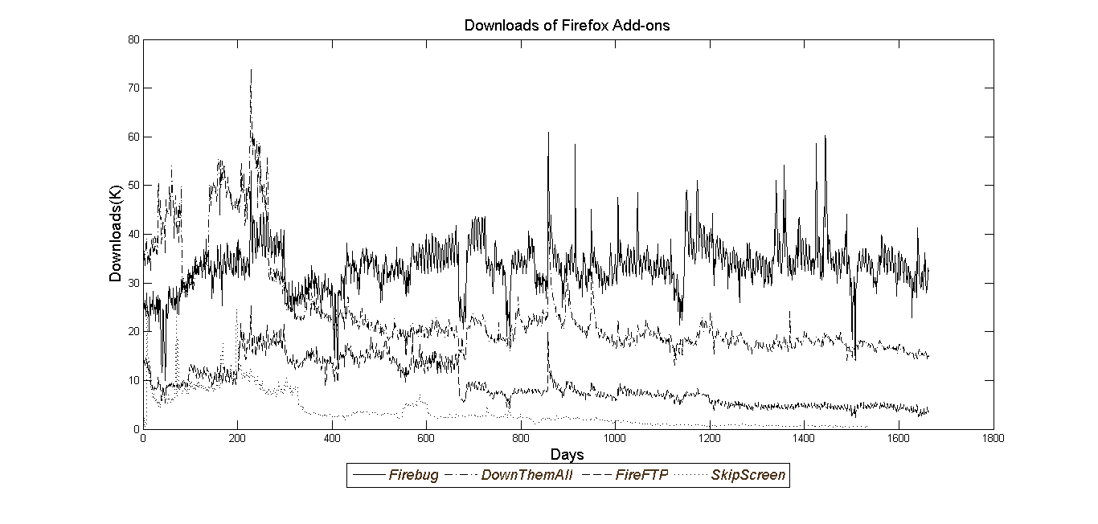

Figure 2 Examples of Size of Usage Base for Firefox Add-ons

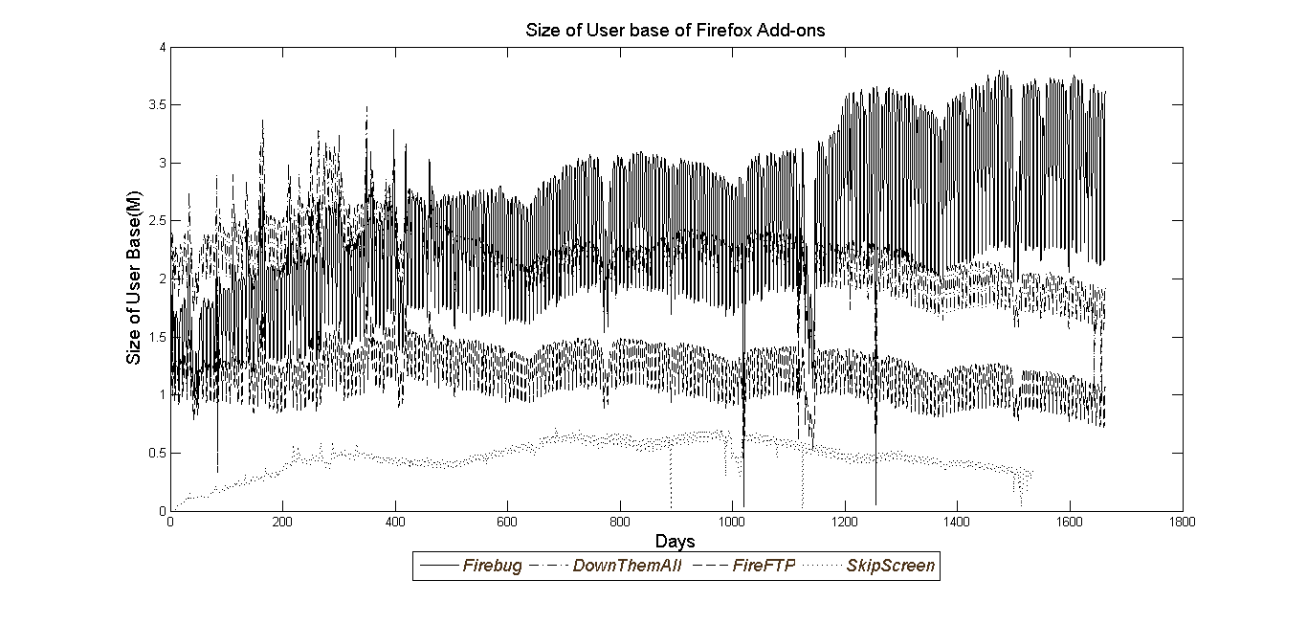

Figure 3 Examples of Valence of Rating for Firefox Add-ons

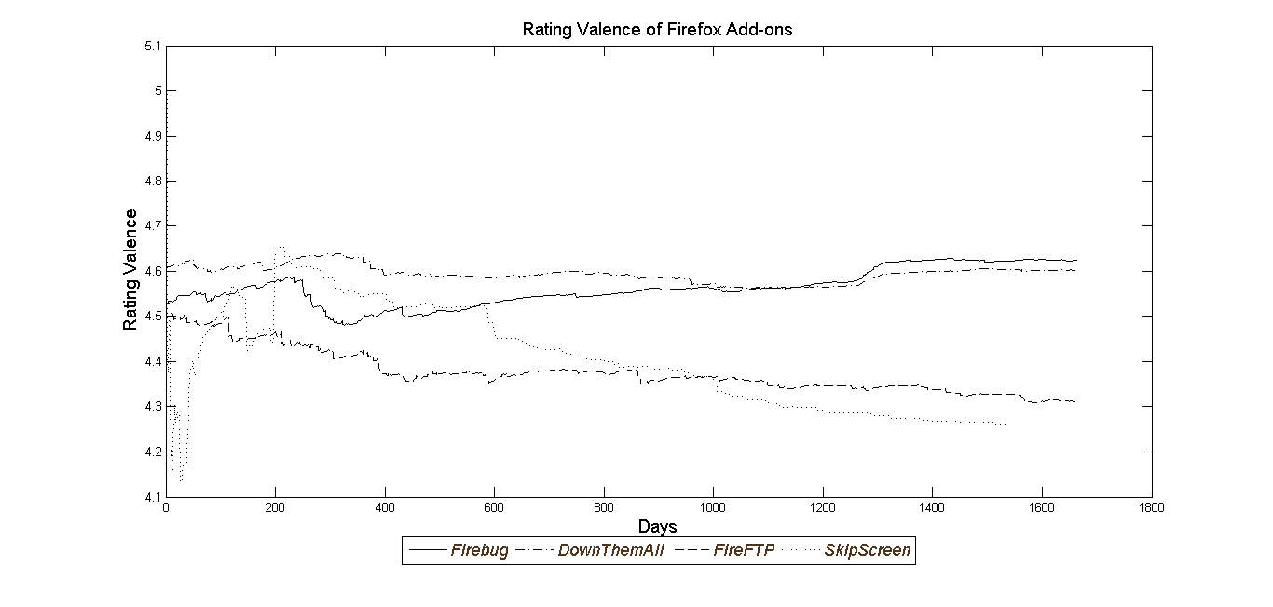

Figure 4 Examples of Number of New Versions for Firefox Add-ons

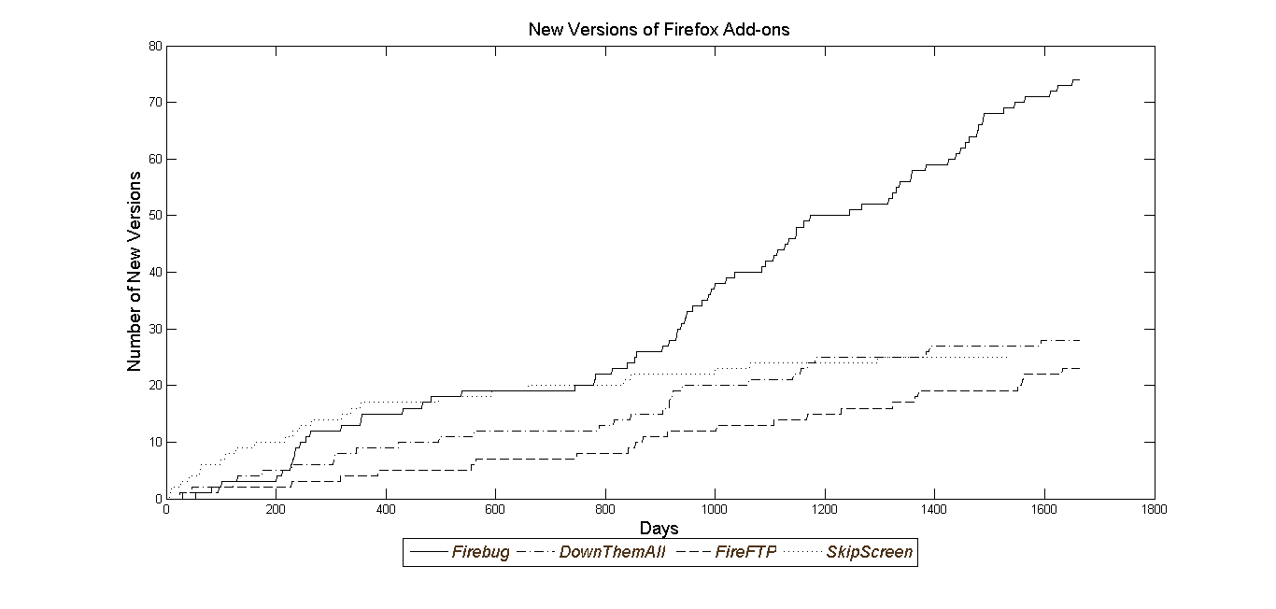

Table 3 Basic Statistics

|  |  |  |  |  |
| --- | --- | --- | --- | --- |
|  | Mean | SD | Min | Max |
| Downloads (K) | 7.641 | 18.502 | 11.79 | 283.44 |
| User Base Size (M) | 0.883 | 1.955 | 1.00E-06 | 16.97 |
| Rating Valence Mean | 4.275 | 0.499 | 1 | 5 |
| New Version of Product | 0.015 | 0.123 | 0 | 1 |
| Product Category Search | 38.753 | 17.566 | 0 | 100 |
| Share of Windows | 0.86 | 0.15 | 0.03 | 1 |
| Number of Reviews | 382.64 | 584.93 | 2 | 3686 |
| Variance of Rating | 1.46 | 0.76 | 0.48 | 4.2 |
| Size of Developer Team | 1.32 | 0.72 | 1 | 4 |
| Length of time series | 1321.9 | 456.6 | 260 | 1686 |

Figure 5 Examples of one step ahead forecast versus actual demand

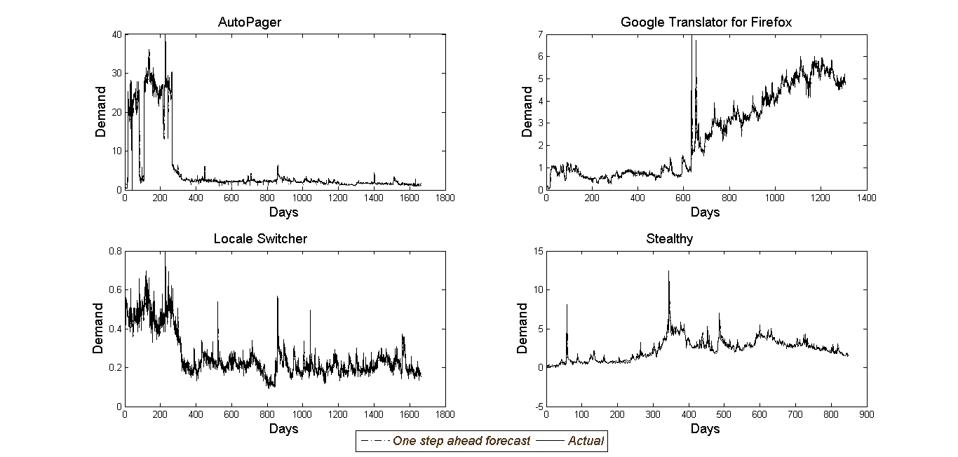

Table 4 Examples of fit statistics

|  |  |  |
| --- | --- | --- |
| Examples of Add-on | Mean Absolute Deviation (MAD) | Mean Square Error (MSE) |
| Auto Pager | 0.522 | 2.413 |
| Local Switcher | 0.026 | 0.001 |
| Google Translator for Firefox | 0.325 | 0.340 |
| Stealty | 0.264 | 0.257 |

Table 5 Model Comparison

|  |  |  |
| --- | --- | --- |
| Model | Description | Deviance information Criteria (DIC) |
| 1 | Proposed Model | -2.30E+03 |

Figure 6 Histogram of Latent Variable Elasticity across Supplementary Products

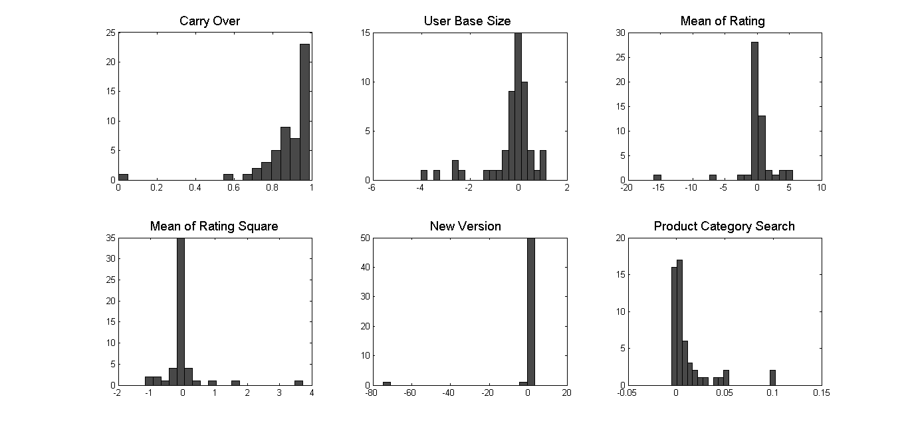

Table 6 Mean Elasticity Parameter Estimate Across Supplementary Products

|  |  |  |  |  |
| --- | --- | --- | --- | --- |
|  | Mean | SD | Min | Max |
| Carry Over | 0.878 | 0.158 | 0.835 | 0.921 |
| User Base Size | -0.307 | 1.064 | -0.596 | -0.018 |
| Mean of Rating Valence | 0.047 | 2.866 | -0.732 | 0.826 |
| Mean of Rating Square | 0.009 | 0.651 | -0.168 | 0.186 |
| Product Category Search | 0.012 | 0.023 | 0.006 | 0.018 |
| Version | 0.629 | 2.986 | -0.183 | 1.440 |
|  | 0.109 | 0.267 | 0.036 | 0.181 |
| Weekend Dummy | -39.799 | 0.000 | -39.799 | -39.798 |
|  | 4.168 | 16.664 | -0.361 | 8.697 |

Figure 7 Significance of effect

|  |  |
| --- | --- |
|  | Number of Add-on’s |
| Carry Over | 52 |
| User Base Size | 25 |
| Mean of Rating Valence | 30 |
| Mean of Rating Square | 29 |
| Product Category Search | 18 |
| Version | 36 |
|  | 52 |
| Weekend Dummy | 52 |
|  | 52 |

Figure 8 Effectiveness of rating valence type 1 response example

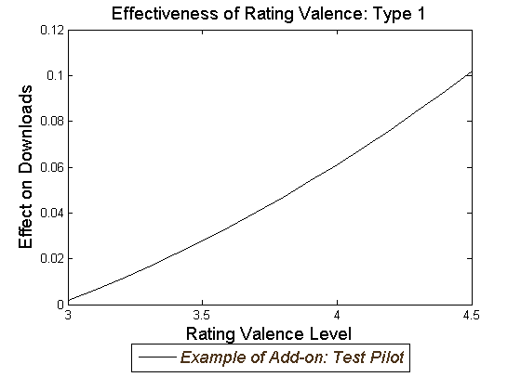

Figure 9 Effectiveness of rating valence type 2 response examples

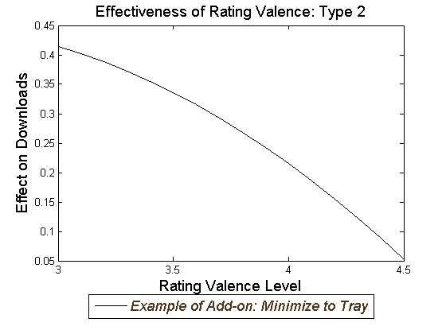

Figure 10 Negative Effect of Average Rating Valence

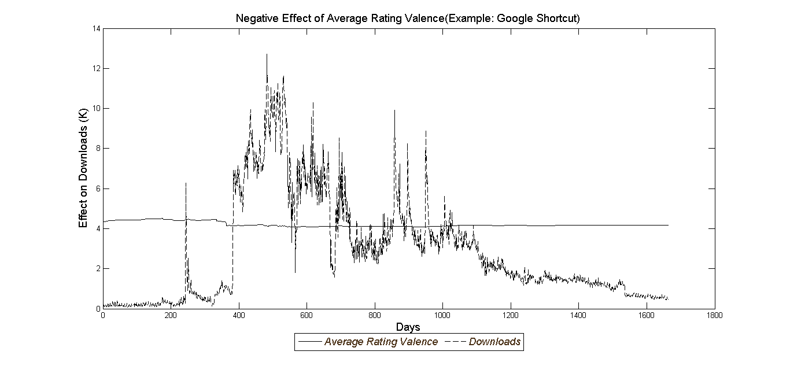

Figure 11 Negative Effect of User Base Size

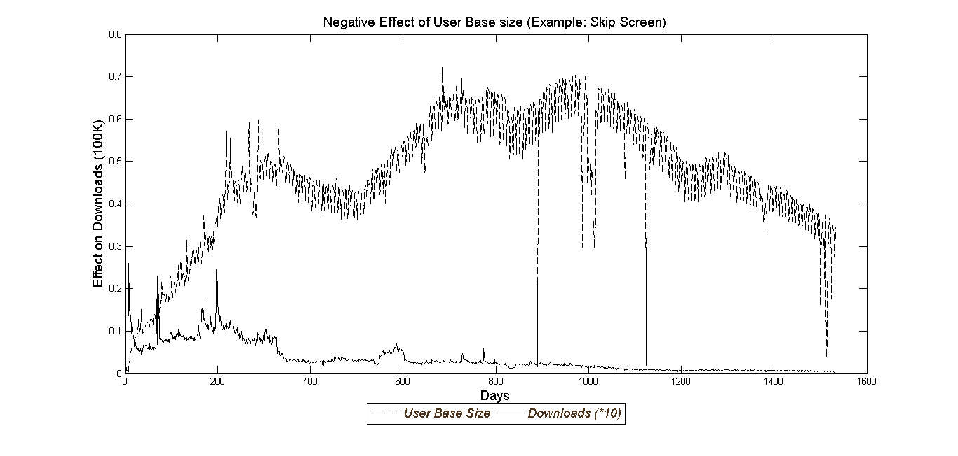

Table 7 Parameter Heterogeneity

|  |  |  |  |  |  |
| --- | --- | --- | --- | --- | --- |
|  |  | Estimate | SD | 2.5 % | 97.5 % |
| Carry Over | Intercept | 0.239 | 0.107 | 0.062 | 0.412 |
|  | Share of Windows | 0.746 | 0.122 | 0.541 | 0.948 |
| User Base Size | Intercept | 0.402 | 0.400 | -0.270 | 1.047 |
|  | Variance of Rating | -0.482 | 0.248 | -0.889 | -0.109 |
| Mean of Rating Valence | Intercept | 1.989 | 0.939 | 0.416 | 3.506 |
|  | Developer Team Size | -1.318 | 0.549 | -2.253 | -0.441 |
| Mean of Rating Square | Intercept | -0.426 | 0.201 | -0.752 | -0.076 |
|  | Developer Team size | 0.291 | 0.120 | 0.085 | 0.486 |
| Product Category Search | Intercept | 0.004 | 0.008 | -0.009 | 0.018 |
|  | Number of Reviews | 0.000 | 0.000 | 0.000 | 0.000 |
|  |  | 0.017 | 0.007 | 0.010 | 0.030 |
|  |  | 1.378 | 0.540 | 0.710 | 2.410 |
|  |  | 9.151 | 3.461 | 4.801 | 15.525 |
|  |  | 0.465 | 0.162 | 0.253 | 0.775 |
|  |  | 0.003 | 0.001 | 0.002 | 0.004 |