**Dynamic Effect of Product Rating and Observational Learning on the Demand of Supplementary Products**

**Meisam Hejazi Nia**

Naveen Jindal School of Management

University of Texas at Dallas

[mxh109420@utdallas.edu](mailto:mxh109420@utdallas.edu)

[**Advisor: Dr.**](http://jindal.utdallas.edu/faculty-and-research/elisabeth-honka/) **Norris Bruce**

Naveen Jindal School of Management

University of Texas at Dallas

[nxb018100@utdallas.edu](mailto:nxb018100@utdallas.edu)

**Abstract**

Firms in many industries facilitate the emergence of supplementary products, especially when their product is experience good. Researchers have shown that consumers’ decision to purchase experience goods, more than any other type of goods, is under influence of their peers’ opinion, captured by product ratings, and their peers’ actions, or observational learning, captured by user base size of the product. Thus, product rating and user base size signal can play an important and distinct role in simulating new product’s demand. In this article, the authors construct a dynamic linear model to study the intertemporal dynamic effects of product rating and observational learning on the demand of supplementary products. They further apply the model to examine the effect of product rating and observational learning on the daily demand of 52 add-ons of Firefox and estimate the parameters using Kalman forward filtering backward smoothing and Markov chain Monte Carlo methods. The results show that product rating and observational learning exerts dynamic, yet diverse, influence on the demand of supplementary products. This finding suggests that if the model does not allow for such dynamic and heterogeneity, the estimation will become biased. Moreover, our findings suggests that: Demand response to product rating is increasing return, and when there is low uncertainty in consumer valuation, observational learning affects daily download more.

Keywords: dynamic effect; heterogeneity; product rating; observational learning; experience goods; supplementary products; uncertainty

1. **Introduction**

Consumers search different sources of information before making purchase decision. Two important sources of information, which complement offline sources, are peers opinion, captured by product review, and peers actions, or observational learning, captured through user base size of the product. In the global trust in advertising report 2012, Nielsen asserts that product reviews are the second most trusted source of brand information and messaging. Studies have further shown that consumers rely on product reviews of experience goods more than on their own experience on the product category (Zhang et al. 2012). Therefore, the relationship between product rating and sales has been modeled and tested in different contexts including books (Chevalier and Mayzlin 2006; Sun 2012), video games (Zhu and Zhang 2010), movie box office (Dellarocas et al. 2007; Duan et al. 2008; Chintagunta et al. 2010), and beauty products (Moe and Trusov 2011), yet there is a potential gap in literature on the extent of this effect for supplementary products in the software industry.

Given the importance of product reviews, not only e-commerce websites that sell experience goods, such as Amazon.com, but also web sites that offer free software, such as sourceforge.com and Google-play, have made the distribution of product ratings available using bar charts on their websites. Mozila.org web site even goes one step further and makes the size of user base of add-ons[1] available to its consumers. Size of user base signals other consumers’ action, which could in turn facilitate observational learning (Bikhchandani et al. 1998). Studies showed that observational learning complements product rating, and both these mechanism affect sales (Chen et al. 2011). However, user base size information is not ubiquitously available on different platforms yet.

Wikipedia defines platform as a term for technology that enables the creation of products and processes that support current and future development. Studies have identified two fundamentally distinct approaches to commercialize a technology platform. First approach entails allowing outsider to participate in technology development and commercialization, whereas the second entails holding control over the platform and thereby not providing interface for third party to extend technology (Boudreau 2010). Mozilla Firefox web-browser, hereby called Firefox, adopted the first approach, leading to its stronger position in competition with Microsoft Internet Explorer (Oshri et al. 2010; Krishnamurthy 2009). In other word, Firefox allows community of developers, consisting of independent authors, to develop complementary products, called add-on, and distributed it on its website. Many other industries such as video game, mobile phone, web publishing, computer devices and movie have adopted the same approach. These supplementary products play the role of complementary product for these platforms, so they are important due to their effect on consumer switching (Lattin and McAlister 1985). Consequently, as a policy maker, platform owners in various industries may find it interesting to know how supplementary products’ rating and user base size signal affects those products’ demand.

Several issues arise in studying product rating and social learning. Studies have shown that product rating has significant static effect on product sales (Chavelier and Mayzlin 2006; Clemsons et al. 2006; Dellarocas et al. 2007). However, some other studies proved that word of mouth could also have dynamic effect on revenue (Bruce et al. 2012). Thus, as a type of word of mouth, product rating may have dynamic effect on the demand. Since observational learning also acts as a type of information, complementing advertising, it is likely that observational learning also exerts intertemporal dynamic effect on demand (Chen et al. 2010). Moreover, researcher tried to control for observable heterogeneity in estimating the effect of product rating on demand (Chavelier and Mayzlin 2006, Moe and Trusov 2011), but heterogeneity could be unobservable. This also suggests that heterogeneity in both product rating and observational learning may influence estimation results.

Researcher may be able to explain heterogeneity based on institutional characteristics of the market. In the market we study there are three different economic agents playing role. First is Firefox platform owner that facilitates the development and commercialization of supplementary products. Second one is Add-on’s author, independent agents who develops and commercializes his add-on and third one is consumers, or so called users. Add-on’s author may decide either to ask for money contribution or just makes his contact available for professional purposes. Moreover, the author is able to optimize its response to platform changes and bugs found in its add-on via issuing new version. Consumers on the other hand are exposed to alternative products that they may otherwise have to pay for it. Despite zero monetary cost, time and effort cost of using an add-on is not zero, because the consumer has to download and learn to use the add-on. Therefore, since consumers are risk averse, we expect them to be sensitive to uncertainty captured by the variance of product rating (Sun 2012, Erdem and Kean 1996).

Number of available choices in the market may also affect consumer’s decision to product ratings, because competition influences sales response to advertising (Gatignon 1984), a type of which is product rating. Competition and number of available choices in the market may be relevant to whether the author is generalist or specialist. To develop the add-on, authors may decide to work with other authors in team. Since team with more members have higher resources, authors working in team are prone to act like a generalist, rather than specialist (Lambkin and Day 1989). Specialists, in contrast to generalists, select a niche market, which has less intense competition, for their offering. Less intense competition implies less option for consumers. Therefore, size of author’s team may affect sensitivity to rating.

Another relevant factor could be segments of the market. Market segments are identified by similarity between customers. Referral generates demand for the product, but homophily, similarity between customers, significantly affects it (Brown and Reingen 1979). Therefore, market segments, due to their homogeneous nature, may affect demand’s dynamic. In the context of add-on we can segment consumers based on operating system they use, i.e. Windows, Linux, and Mac. Due to different size of market share of these three operating systems, and effect of homophily in the cascade of information, we expect that type of operating system explains part of the heterogeneity.

Subsequently, several substantive questions arise on the effect of product rating and observational learning on the demand for a supplementary product: How product rating and observational learning affects the demand? Whether there is any intertemporal dynamic in the effect of product rating valence and observational learning on demand? Is there any heterogeneity in these effects? Can we explain heterogeneity in terms of institutional characteristics such as share of operating system and team size? How does uncertainty play a role in moderating the effect of different processes?

To accomplish this, we propose a dynamic linear model (DLM) that links add-on’s download to a latent measure that captures attractiveness of download of an add-on. This latent measure parsimoniously summarizes the influence of current and past product rating valence and user base signal. The model extends prior study of effect of product rating on sales by incorporating dynamic and product heterogeneity into the model. We apply the model to a context of Firefox add-ons, and estimate the parameters using Kalman forward filtering backward smoothing and Markov chain Monte Carlo (MCMC) methods (Bruce et al. 2012; Van Heerde et al. 2004).

Our results show that product rating and observational learning exerts dynamic, yet diverse, influences on demand. These results suggest that if the model does not account for such dynamic and heterogeneity the estimation tend to be biased. Moreover, we found out that observational learning has more effect on demand for the product when uncertainty is low, and that consumers tend to ignore low product rating for specialist products.

In the next section, we review existing literature pertaining to the effect of product review and observational learning. Included in this review are empirical and theoretical researches that reveal how product reviews and observational learning affect different business metrics. After the literature review, we describe our model that relates product rating valence and user base size to product’s demand. We then describe the data used in this article. Finally, we present the results and highlight some of the implications.

1. **Literature Review**

Given the broad impact of online product rating, there is growing body of research in both marketing literature and information technology literature that examines the effects and dynamics of product rating. We review the literature on product rating in three categories: (i) the effect of product review on consumer’s decision (ii) dynamics of generating product review and (iii) best response of firms to product reviews. Then, we will review sparse literature on observational learning, which could act as complementary to product rating.

*The effect of product review on consumer’s decision*

To analyze its effect on sales and revenue, different researches capture product review through three main metrics, including valence, variance and volume (Moe and Trusov 2011). These studies use number of product reviews to capture volume of ratings, which is not informative about the valence. To summarize the effect of valence, some studies only consider average of rating (Chavelier and Mayzlin 2006; Clemons et al. 2006; Dellarocas et al. 2007; Duan et al. 2008; Chintagunta et al. 2010), while others in addition consider variance of rating, captured through either statistical variance (Clemons et al. 2006; Sun 2012) or entropy (Godes and Mayzlin 2004).

Although the effect of product reviews on business performance, such as sales and revenue is substantially understudied, the empirical results are not unanimous (Moe and Trusov 2011). By comparing different in sales ranks, Chavelear and Mayzlin 2006 found positive significant impact of rating valence on sales of books on Amazon.com and Barnsandnoble.com. Dellarocas et al. 2007 found out that both valence and volume of movie rating can significantly ameliorate the prediction of diffusion model of box office sales. However, Duan et al. 2008 assert that after accounting for endogeneity online user review has insignificant impact on box office revenue. Another study by Chintagunta et al. 2010 found that endogeneity does not distort the positive effect of valence of consumer product reviews on box office performance. Finally Moe and Trusov 2011’s results indicate that after decomposing the effect of rating into baseline and social dynamics component, they observed substantial social dynamics in rating, with noticeable effect on sales. Table 1 summarizes these findings.

*Generation of consumer product review dynamic*

There is growing stream of literature that studies how consumers generate product reviews. Moe and Schweidel 2011 studied how previously posted ratings will affect individual’s decision on whether and what to contribute. They found out that there is selection effect in the decision of whether to contribute, and adjustment effect that influences what to contribute. Other studies found that valence of product rating has downward trend, and it is subjected to self-selection bias (Godes and Silva 2009; Li and Hitt 2008). These studies explain downward trend by heterogeneity of consumer preferences, and assumes that early consumers are those to whom the product is most fit, while late consumers have more distant preferences.

On the other hand, Brandes et al. 2013 provides survey evidence that confirms that consumers who post an online review tend to have more extreme opinions than those consumers who don’t. This finding implies an alternative explanation to downward trend of valence, which is that reviews that arrive after a long time tend to be similar to the opinion of non-responders. Furthermore, Li and Hitt 2008 nudges to this effect with the name of idiosyncratic preference of early buyer, and suggest that firms should adapt their marketing mix to generate more positive word-of-mouth at early stages. Moe and Trusov 2011 adopt these explanations and allowed rating dynamic in their study by modeling the effect of volume of posted rating on subsequent rating behavior.

-- Insert Table 1 here --

*Best response of firms to product reviews*

Parallel with studies on how word of mouth is generated, and how it impacts business performance, another stream of literature focuses on normative models based on analytical studies. Chen and Xie (2005, 2008) suggest that when and how sellers ought to adjust their marketing strategies in response to consumer reviews. They treat product reviews as a new source of information, which could be complemented by firms signal to optimize firms objective. Other studies examine firm’s incentive to post fake reviews, concluding that organizational forms affect this incentive and that in equilibrium consumer can exert some information on product quality (Mayzlin 2006; Dellarocas 2006; Mayzlin et al. 2012).

*Observational learning*

Unlike product rating, observational learning is less explored in marketing literature. Observational learning differs from word of mouth in two different areas: the amount and the credibility of information (Chen et al. 2010). In contrast to product rating that signals the distribution of consumers experience with the product, which may be manipulated by firms (Mayzlin et al. 2012), observational learning reveals only the actions of other consumers in discrete form (Bikhchandani et al. 1998). Nevertheless, since action speaks louder than words, the action-based observational learning might be perceived as more credible information source than product rating. The concept of observational learning could be tracked back to pioneering works of Bandura 1977, Banerjee 1992, and Bikhchandani et al. 1992. These studies have shown that observational learning may lead to informational cascades and herd behavior, which has inefficient equilibrium. Based on this theory, observational learning information signals may outweigh consumers’ private information in shaping their beliefs. Therefore, people follow their predecessors’ action and engage in herd behavior (Banerjee 1992). Zhang 2010 showed that observational learning shapes consumer choices, and suggests that optimal marketing strategies should take into account this process. Moreover, Chen et al. 2010 showed that positive observational learning information significantly increases sales, but negative observational learning has no effect.

In this article, we consider potential intertemporal influence of product rating and observational learning on demand of the products by modeling the effect of product rating and user base size signal on a latent measure that captures attractiveness of download. We also control for new version, product category need, and weekends seasonality. Moreover, our model is flexible to account for heterogeneity in the effect of rating and user base size signal of different add-ons. In the next section we will elaborate more about it.

1. **Model Development**

We formed DLM to evaluate the dynamic effect of daily product rating on demand. DLM has been used in marketing to assess the dynamic effects of weekly advertising (Bruce et al. 2012), and to address dynamic market structure (Van Heerde et. al 2004). Here DLM connects demand of supplementary product (Firefox add-on) to its product review and user base size through aggregate sales response function. Moreover, this approach offers flexibility to account for heterogeneity across supplementary products.

* 1. **Aggregate Demand and Goodwill Stock**

Given our interest in assessing the effect of product rating on demand, we exercise aggregated sales response model. We capture attractiveness of download of add-on i at day t in a latent measure  that in turn drives the download  of corresponding add-on. This model is similar to the discrete time analog model of Nerlove and Arrow (1962). Therefore consistent with DLM literature, our observation equation is as follows:

, where (1)

We controlled for seasonality of data using which is weekend dummy variable. We assume the error term  has normal distribution with mean zero and variance. Finally, in the model and  are parameters to estimate.

We assume latent measure of attractiveness of download  decays in proportion to its lagged value, yet it is maintained by the drift of previous period. Again according to DLM definition our system equation is as follows:

, where (2)

We assume error term  has normal distribution with mean zero and variance, and,  and  are parameters to estimate. Drift of previous period captures the effect of a vector of related variables. The vector  includes average rating valence, quadratic term of average rating valence, user base size, number of searches of product category, and dummy variable that captures new version. In the context of our study, a new version of add-on may be issued due to different reasons. The first probable reason is that a new problem is discovered by a user, or an author himself, and the author decides to correct it. The second probable reason is that new version of Firefox is published, and the author of add-on issues a new version to make it compatible with new version of platform. Number of searches of product category is available on Google trends. We first searched the name of the product in Google trend to get search interest of the product normalized between zero and one hundred. However, for some plug-ins due to low level of search, such data was not available, so we used keyword of “Firefox Add-on” as a proxy to capture product category need for those specific add-ons. Google trend has been used in literature to control for consumer interest in different product categories in the same way (Moe and Schwidel 2012).

* 1. **Heterogeneity**

The effects of average product rating valence, user base size, short term economic shock and carryover may differ across products, as for example effect of advertising, need category, and competition in the market of the supplementary goods may be different. Thus, we also acknowledge such potential heterogeneity by linking carryover rate, effect of average rating valence, user base size, product category search, and new version from equation 1 and 2 to a set of supplementary product characteristics, such as platform share of the product, size of team of developers, and variance and volume of product rating at steady state, i.e. last cross section data we had.

, where  (3)

, where (4)

, where (5)

We tested 47 variables including but not limited to the total followers of the package that includes the add-on, popularity of the add-on, number of users of add-on’s used with this add-on, dummy variable of product category, life of the add-on, and number of versions of it, yet we only winded up into four variables that could explain the heterogeneity of carry-over, user base size effect, average rating valence effect, and search of product category. Table 2 provides definition of variables that used to explain heterogeneity. None of 47 variables could explain heterogeneity in the effect of weekends and new version, so and are null vectors. Error terms in equation 3-5 are assumed to be normal with variances.

-- Insert Table 2 here --

1. **Empirical Study**
   1. **Data**

The data that is used for our empirical analysis is from a sample of 52 Firefox Add-ons. Add-ons are complementary software that is developed by independent author(s), but it is made available on Firefox main website. Consumers can only benefit from add-on when Firefox is installed on their system. Time period under the study is from 2008 to 2013, and different add-ons are launched during this time span at different points. Despite consumer review that is publicly available, time series data related to number of downloads and user base size are publicly available only if the author of the add-on has decided to make the dashboard public. Therefore, our sample is only limited to those add-ons that its author left the dashboard public. We collected all the available reviews, user base size, and download of each of these 52 popular add-ons for the time span of our study. Each add-on in our sample is categorized into one to two categories, including appearance (17%), bookmarks (6%), download management (6%), photo and multimedia (17%), game and entertainment (6%), privacy and security (12%), language support (13%), alerts updates (12%) and web development (25%).

Firefox makes two main signals available on add-on download page. First signal is distribution of add-on rating that is presented through bar chart, and second one is the size of user base of add-on, presented with the name of “users”. For the 52 add-ons in our sample consumers had posted 19,211 ratings. To use distribution of rating in our model for each day we calculated average, variance, and volume of product reviews of a given add-on from the launch day until the given day to build the time series. Since there was not enough variation in data, we further on had to narrow down variable of distribution only to rating valence average. Average rating on the last cross section ranged from 2.5 to 4.7, with 79% of add-ons in our sample received at least four star average rating. Figure 1-3 show the evolution of daily download, user base size, and average rating valence for four add-ons as an example.

-- Insert Figure 1 here –

-- Insert Figure 2 here --

-- Insert Figure 3 here –

To the best of our knowledge, user base size includes all active and inactive users who have not removed add-on from their browser. Since add-ons under our study are free, consumer may download and install it on his system, but then they may find it useless and remove it. Add-on author(s) on the other hand can play an active role to maintain consumers by issuing new version. Add-on author(s) may issue a new version either to response to changes in Firefox platform, or to response to bugs and issues found by him (them) or current consumers. Therefore, new version could be an important determinant of attractiveness of download of an add-on. Figure 4 illustrates evolution of number of versions issued by add-on author(s) for four add-on samples. To control for the effect of new version we defined a dummy variable that captures whether a new version is issued on a given date.

-- Insert Figure 4 here --

In the context of our study, author(s) of add-on act as an independent firm and define whether they want to ask consumer for discretionary contribution or just make their contact available for networking purposes. They further can define how much they want to ask consumer for discretionary money contribution, or whether they want to feature their add-on on the front page. These independent authors, who are analogous to application developers on app-stores, have control on pictures or tags they want to attach to their add-on, but platform owner, here Firefox, reviews these add-ons full package before publishing them, to ensure stable and safe consumer experience. In addition to the shocks on supply side there could be shocks on demand side as well.

To control for shocks on the demand side we used product category search data, similar to Moe and Schewidel 2011. For this purpose we used Google trend for the keyword of name of the product. For those add-ons that such search data was not available, we exerted search for keyword of more general category such as “Firefox Add-on”. Moreover, we observed seasonality in the download and usage data. Therefore, to account for this seasonality we adopted weekend dummy variable.

Add-ons under our study did not have features explicitly listed on the download page. This characteristic makes them similar to other experience goods such as books and movies that their quality could only be ascertained after consumption. Therefore, to explain heterogeneity in demand response we used a set of 47 add-on characteristics derived from each add-ons page. These characteristics included add-on category dummy, rating and number of followers of collection that the add-on belongs to, number of users and level of rating of other add-ons that author(s) of current add-on has developed, size of the team of developers, age of add-on in days, number of tags, and so on. The basic statistics of relevant variables that significantly explain our results is presented in Table 3.

-- Insert Table 3 here --

* 1. **Estimation**

To describe the estimation procedure used in this study, it is convenient to bind ourselves to formal notation of state space model of West and Harrison (1997). According to this definition we can rewrite equation 1, which represents observation equation, and equation 2, which represents state equation as follows.

 (1’)

 (2’)

Here constant variable F reflects the impact of latent measure, as driven by current and past product reviews and user base size signals. The unobserved state variable  captures add-on attractiveness of download. The transition vector  captures decay. Furthermore, we assume that error term and  to be independent normal random variables with zero means.

Recall that Equation 3-5 links all time-invariant non-state parameters from the preceding equations to add-on characteristics. As a result, Equation 1’, 2’, and 3-5 constitute our final DLM.

We estimate the model using MATLAB programming on the entire observed data series of Add-ons. The procedure nests a Kalman forward filtering and backward smoothing inside MCMC Gibbs sampler with conjugate priors (Bruce et al. 2012). The primary goal is to estimate the joint posterior distribution of state and non-state parameters for each add-on. Using conjugate prior enables us to analytically derive and directly sample the conditional posterior of the state parameters given non-state parameters and vice versa (Bruce et al. 2012). Conditional posterior of state parameters given non-state parameters is a linear state-space model, so it can be sampled with standard Kalman forward filtering and backward smoothing algorithm. Moreover, given the state parameters, we will have multivariate linear model with hierarchical priors, so we can sample directly by using standard MCMC methods (Bruce et al. 2012). In other word, Kalman forward filtering and backward smoothing updates the evolution of the state parameters conditional on the non-state parameters, where MCMC Gibbs sampler updates the non-state parameters given the state parameters. Consequently, we sample from joint distribution of state and non-state parameters.

* 1. **Model Comparison**

We benchmarked the proposed model against three alternatives based on Deviance information criterion (DIC) (Table 4). DIC is generalization of Akaike information criterion (AIC) and Bayesian information criteria (BIC) for hierarchical models (Gelman et al. 2003). Model 1 assumes static product rating and user base size signal effects (i.e. ). Model 2 assumes no product heterogeneity in product rating and user base size signal effects (i.e. ), and model 3 leaves heterogeneity of dynamic model unexplained.

-- Insert Table 4 here –

Overall both DIC and log likelihood consistently and clearly favor the model with dynamic and heterogeneity, suggesting that there is dynamic and heterogeneity in the effect of product rating and user base size signal on demand. This result suggests that there could be bias in the estimation of product rating and observational learning sales response model, if it does not account for the dynamics.

Table 5 compares the result of estimation of dynamic with estimates of static and non-heterogeneous models. On our data static model overestimates the effect of product rating and product category search and it underestimates the effect of mean of rating valence and new version. On the other hand, non-heterogeneous model underestimates the effect of carryover, mean of rating valence, and new version, yet it overestimates the effect of user base size signal and product category search. Table 6 compares number of add-ons with significant effect in static model versus dynamic model. The result suggests that the significance of the effect of user base size and rating plunges from 90% of add-ons to 60% of add-ons as we use dynamic rather than static model. Finally, figure 5 displays in sample one step ahead forecast versus actual demand, and table 7 presents mean absolute deviation (MAD) and mean square error (MSE) corresponding to this figure. They both indicate that the proposed model offers a good fit with the data.

-- Insert Figure 5 here –

-- Insert Table 5 here –

-- Insert Table 6 here –

-- Insert Table 7 here –

* 1. **Parameter Estimate**

Figure 6 illustrates the histogram of posterior mean across all 52 add-ons. Table 8 reports posterior means, standard deviation, and 95% high probability density interval (HDPI) of non-state parameters of proposed model across all 52 add-ons. Finally, table 9 summarizes number of add-ons that had significant parameter for each effect, and table 10 displays the estimate of add-on characteristics that contribute to the heterogeneity in carry over, and effects of product rating, user base size, product category and new version. Recall that these characteristics are survivors out of 47 cross sectional characteristics of add-ons.

-- Insert Figure 6 here –

-- Insert Table 8 here –

-- Insert Table 9 here –

-- Insert Table 10 here –

First consider carry-over effect. On the carry-over histogram majority of add-ons have carry over close to one, except one add-on which has carryover close to zero. The add-on that has carryover close to zero has the name of “Romanian Language Pack”. This different effect is likely to be related to the effect of culture on decision making process (Money et al. 1998). Add-ons are of type of experience goods, and consumers are known to rely on recommendation for experience goods significantly more than other types of the products (Zhang et al. 2010). Therefore, this high persistency is probably because add-ons are dependent on referral, which in offline world requires active decision making that entails delay like other consumers decision making processes (Greenleaf and Lehmann 1995).

Our data explained the heterogeneity in carry-over based on add-on’s share of Windows operating system. The higher add-on’s share of windows operating system the higher is the persistency of download attractiveness. This result also may be explained by process of information cascade in referrals. Homophilious ties are more likely to be activated for a flow of referral information (Brown and Reingen 1987). Microsoft Windows operating system (OS) has more than 80 percent share of computer devices in the world, which implies that it owns larger population of users than other OS’s, such as Linux or Mac. This suggests that there is higher likelihood of referral among users of Windows than users of other OS’s. Therefore, higher carryover of add-ons with higher Windows share is likely due to this higher likelihood and delay of referrals.

Next consider the effect of user base size on demand. We found out that 13 add-ons have significant positive effect of user base size, while 12 add-ons have significant negative effect. Two different primitive processes may explain this result: First observational learning, and second diffusion model. Observational learning explains the positive effect of user base size signal, and diffusion model explains the negative effect. In other word, for those add-ons that the effect of user base size on demand is positive, probably observational learning force overcomes the negative force of market saturation, and usage of product by previous consumers positively affects new consumer’s decision to adopt the product (Bikhchandani et al.1998). On the other hand, when market saturation overcomes observational learning, higher user base size implies saturation of the market, leading fewer consumers to adopt the product (Bass 1969). Figure 7 illustrates an example of add-on that diffusion force is dominant to observational learning force. We explained heterogeneity in this effect using variance of rating at steady state. Higher variance of rating leads to lower effect of user base size. In other word, when there is higher uncertainty in rating, consumers learn less from others action than when there is low uncertainty in rating. This is a new finding to add to the literature that suggests positive interaction between product review and observational learning (Chen et al. 2010).

-- Insert Figure 7 here –

Product rating showed two types of effect on demand. Figure 7 and 8 shows these two types of effects. Both type 1 and type 2 are increasing return, yet type 1 effect is positive, and type 2 effect is negative. On 9 add-ons we found type 1 significant, and on 19 add-ons we found type 2. Individual analysis of type 2 effect suggests that two different processes during early and late stage of product cycle may account for this effect. The behavior in the first stage could be attributed to diffusion model. At the early stage innovators will download the product, and due to their high valuation first rating would be positive, yet this high rating does not lead to a jump in downloads. As the add-on ages more consumer will use it, but due to their different taste, the rating will have negative trend (Godes and Silva 2012; Li and Hitt 2008), yet consumers are insensitive to this negative trend. Consumer’s insensitivity to negative product rating may be result of lack of substitute product. Figure 9 illustrates this dynamic for an example add-on. Our model captures these two likely forces in early and late stage in the form of a negative effect of product rating.

Type 1 effect suggests increasing return on rating of add-ons. This type of effect could be attributed to risk aversion (Sun 2012). Author team size explained this heterogeneity. We found that higher author team size pushes add-on to have the effect of type 1, i.e. being sensitive to product rating. This may be related to nature of the market that an add-on is operating in. Larger author team is translated into greater resource. This greater resource enables the add-on to become generalist rather than specialist (Lambkin and Day 1989). Generalists compete in the market that has multiple players, implying more product substitutes. Therefore, consumer’s elasticity of rating is higher for add-ons that are developed and supported by larger team of authors.

-- Insert Figure 8 here –

-- Insert Figure 9 here –

-- Insert Figure 10 here –

Except one, for almost all of the add-ons with significant effect of new version, this effect was positive. Incompleteness or incompatibility of add-on is possible explanation of one negative effect of new version we observed in our data. Moreover, product category need has positive significant effect on demand for 33 add-ons, but negative significant effect for 3 add-ons. The data is not informative for those 3 add-ons that product category search has negative effect, but heterogeneity in product category effect is explained by volume of product reviews. Higher volume of product reviews lead to higher effect of product category search on demand. This relation may be explained by risk aversion. Since consumers are risk averse they tend to select experience product that they know more about its upside and downside (Erdem and Keane 1996). As a result, shocks in product category need tend to affect demand for products with higher volume of product rating, and therefore with less uncertainty. Moreover, weekends has negative effect on demand. This negative effect may be due to downtime on the servers on supply side, or consumers limited access to internet, or consumer’s engagement in activities that does not require usage of add-ons. Finally, we did not find a variable in our data to explain heterogeneity in the effect of new version and weekends on demand.

1. **Conclusion**

Supplementary products are vital to the profitability and survival of many industries -- video game, mobile phone, web publishing, computer devices and movie being a few exemplars. To help achieve these profits firms often face decisions on how to facilitate supplementary product development and commercialization. In this market setting three main actors interact: First, the firm, known as platform owner, second, independent product developer, and third customers. These three actors’ decision is dependent on signals such as word of mouth, capture through product rating, and observational learning, captured through user base size available on web-site. In this study, we constructed a model to quantify the heterogeneous intertemporal dynamic of product rating, as well as observational learning on demand. We estimate the proposed state-space model, applied to Firefox add-ons, with Kalman forward filtering backward smoothing nested within MCMC methods. As a result, we are able to investigate a crucial yet unexplored area – namely, the dynamic effect of product rating and observational learning on the demand for supplementary products – and implications of these effects for best response of three actors.

We believe that several novel findings emerge from this work. First, it supplies empirical evidence that product rating has dynamic, yet diverse, and increasing return effect on demand. Second, observational learning dynamically affects demand, more when there is uncertainty, and this effect is heterogeneous. Thus, our third finding shows that product rating affects demand both directly and indirectly through enhancing observational learning effectiveness. Fourth, we explained heterogeneity in the effect of product rating, and observational learning in terms of contextual characteristics of add-on, such as size of team of authors, share of MS Windows, and number of product reviews. Finally, although our study focuses on the software industry, the findings underscore the value of investigating the dynamic effect of product rating, and observational learning across different products. It also suggests that if such effects are not taken into account in estimation, the estimates would be biased.

Notwithstanding these contributions, this research has limitations that could lead to future inquiries. For example, we did not account for endogeneity in our model. Further research could control for endogeneity in estimation, and examine whether the estimation result would change. Furthermore, we did not have enough variation in our data to estimate the direct effect of variance, mean, and volume of product rating jointly on demand. Future studies could not only investigate the effect of variance, mean and volume of product rating on demand jointly, but they can also account for dynamic interaction between product rating and observational learning. Another extension of this study could account for heterogeneity in the preference of consumers of different supplementary products, in the form of latent model and integrated them out, to compare estimates with our proposed model.

**References**

Awad, N., H. Etzion. 2006. Stay out of my forum! Evaluating ﬁrm involvement in online ratings communities. Presentation, Workshop on Information Systems and Economics (WISC), December 9–10, Northwestern University, Evanston, IL.

Bass, F. 1969. A new product growth model for consumer durables. Management Sci. 15(5) 215–227.

Bandura, A. 1977. Social learning theory. Englewood Cliffs, NJ: prentice Hall.

Banerjee, A. 1992. A simple model of herd behavior. Quar. J. Economics. 107(3), 797-817.

Bikhchandani, S., D. Hirshleifer, I. Welch. 1998. Learning from the behavior of others: Conformity, fads, and information cascades. J. Economic Perspective. 12(3), 151-170.

--------------------, S. Sharma. 2001. Herd behavior in financial markets: A Review. IMF Staff Papers. 47 279-310

Brandes, L., D. Godes, D. Mayzlin. 2013. Controlling for self-selection bias in customer reviews. Working Paper. University of South California, California.

Brown, J. J, P. H. Reingen. 1987. Social ties and word-of-mouth referral behavior. J. Consumer Res. 14(3) 350-362.

Boudreau K. 2010. Open platform strategies and innovation: granting access vs. developing control, Management Sci. 56(10) 1849-1872.

Bruce N., N. Z. Foutz, C. Kolsarici. 2012. Dynamic effectiveness of advertising and word of mouth in sequential distribution of new products, J. Marketing Res. 49(2) 469-486.

Chen, Y., Q. Wang, J. Xie. Online social interactions: A natural experiment on word of mouth versus observational learning. Marketing Res. 48(2) 238-254.

----------, J. Xie. 2005. Third-party product review and ﬁrm marketing strategy. Marketing Sci. 24(2) 218–240.

----------, J. Xie. 2008. Online consumer review: A new element of marketing communications mix. Management Sci. 54(3) 477–491.

Chevalier, J., D. Mayzlin. 2006. The effect of word of mouth online: Online book reviews. J. Marketing Res. 43(3) 345–354.

Chintagunta, P. K., S. Gopinath, S. Venkataraman. 2010. The effects of online user reviews on movie box ofﬁce performance: Accounting for sequential rollout and aggregation across local markets. Marketing Sci. 29(5) 944–957.

Clemons, E.K., G. Gao, L. M. Hitt. 2006. When online reviews meet hyperdifferentiation: a study of the craft beer industry. J. Management Inf. Sys. 23(2) 149–71.

Dellarocas, C. 2006. Strategic manipulation of internet opinion forums: Implications for consumers and ﬁrms. Management Sci. 52(10) 1577–1593.

Dellarocas, C., X. M. Zhang, N. Awad. 2007. Exploring the value of online product reviews in forecasting sales: The case of motion pictures. J. Interactive Marketing 21(4) 23–45.

Duan, W., B. Gu, A. B. Whinston. 2008. Do online reviews matter? — An empirical investigation of panel data. Decision Support Systems 45(4) 1007–1016.

Erdem, T., M. P. Keane. 1996. Decision-making under uncertainty: capturing dynamic brand choice processes in turbulent consumer goods markets. Marketing Sci. 15(1) 1-20.

Gao, G. G., B. Gu, M. Lin. 2006. The dynamics of online consumer reviews. Presentation, Workshop on Information Systems and Economics (WISE), December 9–10, Northwestern University, Evanston, IL.

Gatignon, H. Competition as a moderator of the effect of advertising on sales. J. Marketing Res. 21(4) 387-398.

Gelman, A., J. B. Carlin, H. S. Stern, D. B. [Rubin](http://en.wikipedia.org/wiki/Donald_Rubin). 2004. Bayesian data analysis. Chapman & Hall/CRC. Boca Raton, Florida.

Godes, D., D. Mayzlin. 2004. Using online conversations to study word-of-mouth communication. Marketing Sci. 23(4) 545–560.

Godes, D., J. Silva. 2012. Sequential and temporal dynamics of online opinion. Marketing Sci. 31(3) 448-473.

Greenleaf E. A., D. R. Lehmann. Reasons for substantial delay in consumer decision making. J. Consumer Res. 22(2) 186-199.

Jiang, B.-j., P.-y. Chen. 2007. An economic analysis of online product reviews and ratings. Working paper, Tepper School of Business, Carnegie Mellon University, Pittsburgh.

Krishnamurthy S. 2009. Case: Mozila vs. Godzilla- the launch of the Mozilla Firefox browser. J. Interactive Marketing. 23(3) 259-271.

Lambkin, M., G. S. Day. 1989. Evolutionary process in competitive markets: Beyond the product life cycle. J. Marketing. 53(3) 4-20.

Lattin M. J., L. McAlister. 1985. Using a variety-seeking model to identify substitute and complementary relationships among competing products. J. Marketing Res. 22(3) 330-339.

Li, X., L. M. Hitt. 2008. Self-selection and information role of online product reviews. Marketing Sci. 19(4) 456-474.

Liu, Y. 2006. Word of mouth for movies: Its dynamics and impact on box ofﬁce revenue. J. Marketing 70(3) 74–89.

Mayzlin, D. 2006. Promotional chat on the internet. Marketing Sci. 25(2) 155–163.

Mayzlin, D., Y. Dover, J. A. Chevalier. 2010. Promotional reviews: an empirical investigation of online review manipulation. Working paper, National Bureau of Economic Research, Cambridge.

Moe, W. W., D. A. Schweidel. 2011. Online product opinions: incidence, evaluation, and evolution. Marketing Sci. 31(3) 372-386.

Moe, W., M. Trusov. 2011. Measuring the value of social dynamics in online product ratings forums. J. Marketing Res. 49(3).

Money, R. B., M. C. Gilly, J. L. Graham. 1998. Exploration of national culture and word of mouth referral behavior in the purchase of industrial services in the United States and Japan. J. Marketing. 62(4) 76-87.

Nerlove, M., K. J. Arrow (1962), Optimal advertising policy under dynamic conditions. Economica 29(114) 129–42.

Oshri I., H. J. de Vries, H. de Vries. 2010. The rise of Firefox in the web browser industry: The role of open source in setting standards. Business History. 52(5) 834-856.

Sun M. 2012. How does the variance of product ratings matter? Marketing Sci. 58(2) 696-707.

Van Heerde, H. J., C. F. Mela, P. Manchanda. 2004. The dynamic effect of innovation on market structure. J. Marketing Res. 41(2) 166-183.

West, M., J. Harrison. 1997. Bayesian Forecasting and Dynamic Models. New York:Springer-Verlag.

Ye, Q., R. Law, B. Gu. 2009. The impact of online user reviews on hotel room sales. Inter. J. Hospitality Management. 28(1) 180-182.

Zhang J. 2010. The sound of silence: observational learning in the U.S. kidney market. Marketing Sci. 29(2) 315-335.

Zhao, Y., S. Yang, V. Narayan, Y. Zhao. 2012. Modeling consumer learning from online product reviews. Marketing Sci. 32(1) 153-169.

Table 1 Previous Research on Consumer Product Ratings and observational learning

|  |  |
| --- | --- |
| **Empirical Studies on Product Rating** | |
|  |  |
| Chavalier and Mayzlin (2006) | Positive impact of average rating on sales, and higher impact of one-star reviews than five-star-reviews |
| Moe and Trusov (2011) | The impact of social dynamics in the rating environment on both sales and subsequent rating behavior. |
| Godes and Silva (2012) | Residual average temporal pattern of product reviews is increasing, after controlling for calendar date. Consumer product ratings tend to plunge over time. |
| Zhao et al. (2012) | Consumers learn more about an experience good from online consumer product reviews than their own experience of product category |
| Moe and Schweidel (2012) | Individual’s decision to provide a product rating is subjected to selection effects, and adjustment effect. Positive ratings environment increases positing incidence, yet negative rating environment discourage posting. |
| Dellarocas et al. (2007) | Better predictability of diffusion model that incorporates consumer review for box office revenue data |
| Duan et al. (2008) | Insignificance of the impact of online user reviews on movies’ box office revenues after accounting for endogeneity |
| Godes and Mayzlin (2004) | Dispersion of conversations across communities can explain dynamic of TV ratings |
| Zhu and Zhang (2010) | Consumer product ratings are more influential for less popular products |
| Gao et al. (2006) | Significant impact of public opinion on consumer product reviews |
| Liu (2006) | Aggregate and weekly box office revenue can significantly be explained by online word of mouth, especially at early weeks of movie release |
| Clemons et al. (2006) | Variance of ratings play significant role in determining which new products grow fastest in the market. |
| Chintagunta et al. (2010) | Valence rather than volume of consumer product reviews drive box office performance |
| Li and Hitt (2008), Brandes et al. (2013) | Online product reviews are subject to self-selection. |
| Ye et al. (2009) | Online consumer reviews have significant relationship with business performance of hotels. |
| **Theoretical Studies on Product Rating** | |
| Monic Sun (2012) | Informational role of variance of product rating on the product subsequent demand |
| Chen and Xie (2008) | Firm’s best response to consumer product reviews |
| Chen and Xie (2005) | Firm’s strategy to adapt consumer product reviews |
| Mayzlin (2006) ,Dellarocas (2006), Mayzlin et al. (2012) | Firm’s online manipulation of consumer product reviews |
| Awad and Etzion (2006) | Firms’ filtering of consumer product reviews |
| Jiang and Chen (2007) | Firm’s dynamic strategy to leverage consumer product review |
| **Studies on observational learning** | |
| Chen et al. (2010) | Positive observational learning information significantly increases sales, whereas, negative observational learning information has no effect. |
| Bikhchandani et al. (1998, 2008) | Observational learning may lead to information cascade and herd behavior. |
| Bikhchandani and Sharma (2001) | Over view of theoretical and empirical research on herd behavior |
| Banerjee (1992) | Herd behavior leads to inefficient equilibrium. |

Table Definition of variables that explain heterogeneity

|  |  |
| --- | --- |
| Variable | Definition |
|  | Vector that includes one for intercept and share of windows to explain carryover |
|  | Vector includes one for intercept and variance of rating to explain user base size heterogeneity |
| , | Vector that includes one for intercept and variance of rating to explain heterogeneity in the effect of average rating valence |
|  | Vector that includes one for intercept and number of reviews to explain heterogeneity in the effect of product category search |

Figure Examples of Demand for Firefox Add-ons

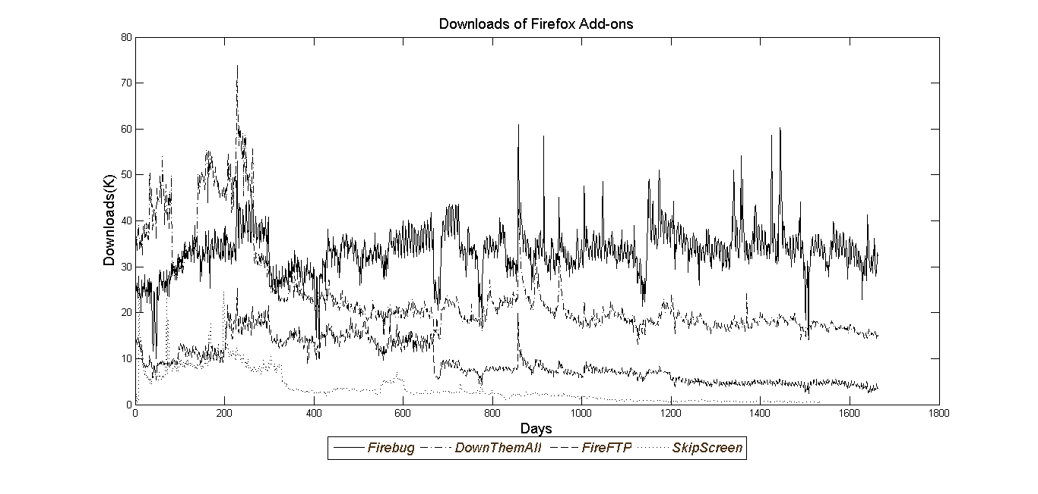

Figure Examples of Size of Usage Base for Firefox Add-ons

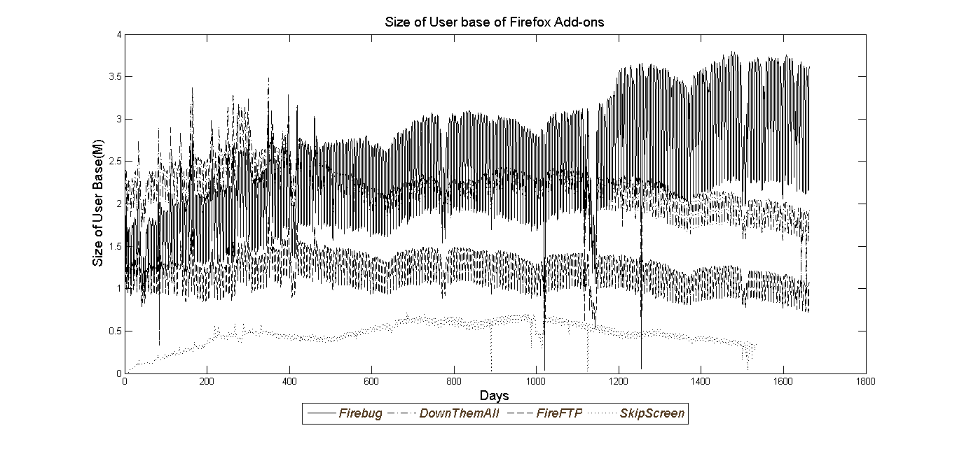

Figure Examples of Valence of Rating for Firefox Add-ons

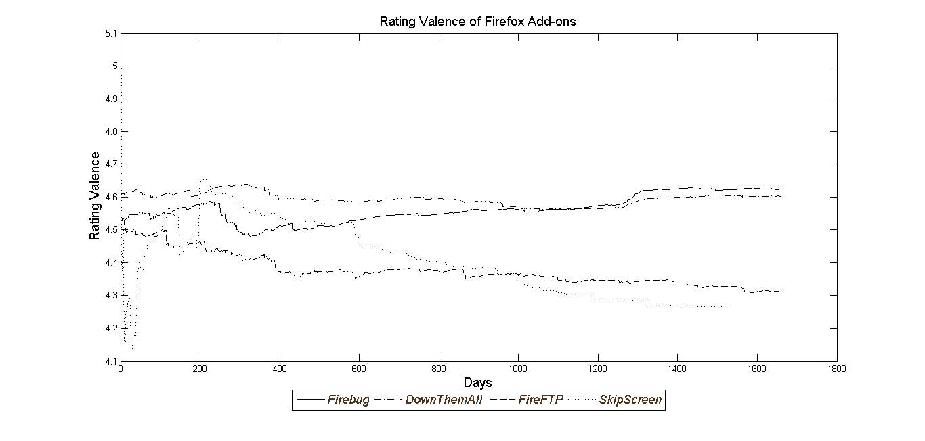

Figure Examples of Number of New Versions for Firefox Add-ons

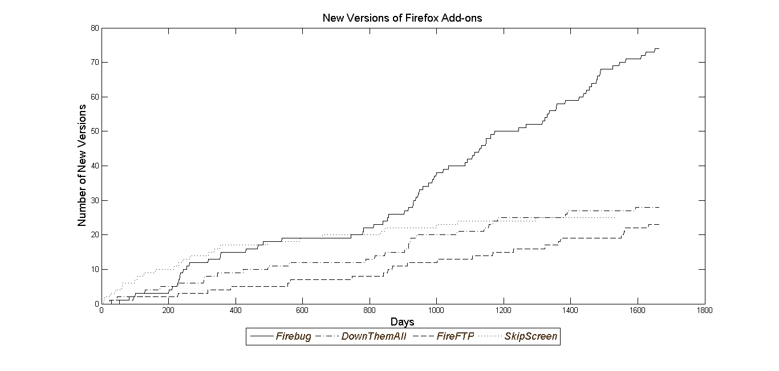

Table 3 Basic Statistics

|  |  |  |  |  |
| --- | --- | --- | --- | --- |
|  | Mean | SD | Min | Max |
| Downloads (K) | 7.641 | 18.502 | 11.79 | 283.44 |
| User Base Size (M) | 0.883 | 1.955 | 1.00E-06 | 16.97 |
| Rating Valence Mean | 4.275 | 0.499 | 1 | 5 |
| New Version of Product | 0.015 | 0.123 | 0 | 1 |
| Product Category Search | 38.753 | 17.566 | 0 | 100 |
| Share of Windows | 0.86 | 0.15 | 0.03 | 1 |
| Number of Reviews | 382.64 | 584.93 | 2 | 3686 |
| Variance of Rating | 1.46 | 0.76 | 0.48 | 4.2 |
| Size of Developer Team | 1.32 | 0.72 | 1 | 4 |
| Length of time series | 1321.9 | 456.6 | 260 | 1686 |

Table Model Comparison

|  |  |  |  |  |
| --- | --- | --- | --- | --- |
| Mode | Description | DIC (M) | Penalty Term  () (M) | Log Likelihood (M) |
| 1 | Static Model ( | 2,112.7 | 625.2 | 1,4865 |
| 2 | No Heterogeneity  ( | 12.9 | 4.6 | 8.3 |
| 3 | Unexplained Heterogeneity | 9.6 | 3.9 | 5.8 |
| 4 | Proposal Model | 9.6 | 3.9 | 5.8 |

Table Mean Elasticity Parameter Estimate in Static versus Dynamic Models

|  |  |  |  |  |  |
| --- | --- | --- | --- | --- | --- |
|  | |  | Static Model | Dynamic Model | Without heterogeneity |
| Carry Over | | 0 | 0.878 | 0.0047 |
| User Base Size | | 1.1229 | -0.307 | 0.1696 |
| Mean of Rating Valence | | -1.1549 | 0.047 | -0.2378 |
| Mean of Rating Square | | 0.4358 | 0.009 | -0.0064 |
| Product Category Search | | 2.0921 | 0.012 | 0.0651 |
| Version | | 0.0999 | 0.629 | -0.0056 |
|  | | 19.2227 | 0.109 | 422.0243 |
| Weekend Dummy() | | -69.7692 | -39.799 | 0.3155 |
|  | | 7.481 | 4.168 | 7.7308 |

Table Number of add-ons with significant effect in Static versus Dynamic Models

|  |  |  |  |  |
| --- | --- | --- | --- | --- |
|  | |  | Static Model | Dynamic Model |
| User Base Size | | 41 | 25 |
| Mean of Rating Valence | | 43 | 30 |
| Mean of Rating Square | | 42 | 29 |
| Product Category Search | | 15 | 18 |
| Version | | 45 | 36 |
|  | | 52 | 52 |
| Weekend Dummy() | | 52 | 52 |
|  | | 52 | 52 |

Figure Examples of one step ahead forecast versus actual demand

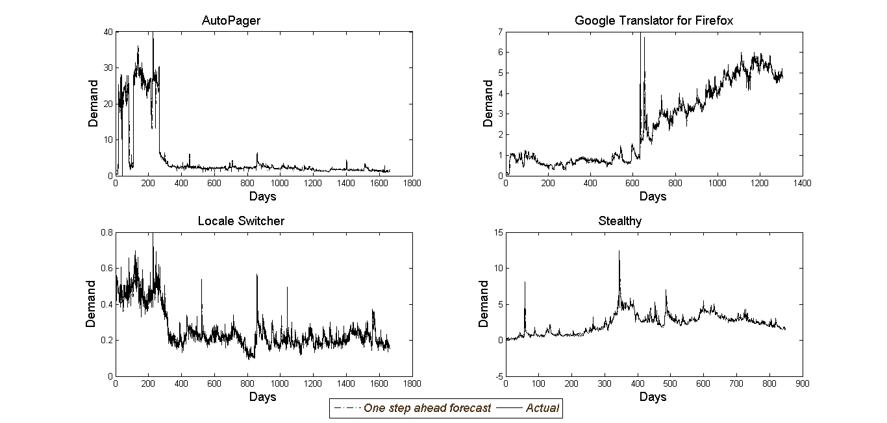

Table Examples of fit statistics

|  |  |  |
| --- | --- | --- |
| Examples of Add-on | Mean Absolute Deviation (MAD) | Mean Square Error (MSE) |
| Auto Pager | 0.522 | 2.413 |
| Local Switcher | 0.026 | 0.001 |
| Google Translator for Firefox | 0.325 | 0.340 |
| Stealty | 0.264 | 0.257 |

Figure Histogram of Latent Variable Elasticity across Supplementary Products

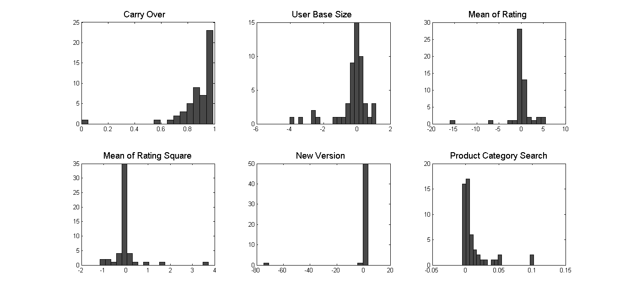

Table Mean Elasticity Parameter Estimate across Supplementary Products

|  |  |  |  |  |
| --- | --- | --- | --- | --- |
|  | Mean | SD | 2.5 % | 97.5 % |
| Carry Over | 0.878 | 0.158 | 0.835 | 0.921 |
| User Base Size | -0.307 | 1.064 | -0.596 | -0.018 |
| Mean of Rating Valence | 0.047 | 2.866 | -0.732 | 0.826 |
| Mean of Rating Square | 0.009 | 0.651 | -0.168 | 0.186 |
| Product Category Search | 0.012 | 0.023 | 0.006 | 0.018 |
| Version | 0.629 | 2.986 | -0.183 | 1.440 |
|  | 0.109 | 0.267 | 0.036 | 0.181 |
| Weekend Dummy() | -39.799 | 0.000 | -39.799 | -39.798 |
|  | 4.168 | 16.664 | -0.361 | 8.697 |

Table Significance of effect

|  |  |
| --- | --- |
|  | Number of Add-on’s |
| Carry Over | 52 |
| User Base Size | 25 |
| Mean of Rating Valence | 30 |
| Mean of Rating Square | 29 |
| Product Category Search | 18 |
| Version | 36 |
|  | 52 |
| Weekend Dummy() | 52 |
|  | 52 |

Table Parameter Heterogeneity

|  |  |  |  |  |  |
| --- | --- | --- | --- | --- | --- |
|  |  | Estimate | SD | 2.5 % | 97.5 % |
| Carry Over | Intercept | 0.239 | 0.107 | 0.062 | 0.412 |
|  | Share of Windows | 0.746 | 0.122 | 0.541 | 0.948 |
| User Base Size | Intercept | 0.402 | 0.400 | -0.270 | 1.047 |
|  | Variance of Rating | -0.482 | 0.248 | -0.889 | -0.109 |
| Mean of Rating Valence | Intercept | 1.989 | 0.939 | 0.416 | 3.506 |
|  | Author Team Size | -1.318 | 0.549 | -2.253 | -0.441 |
| Mean of Rating Square | Intercept | -0.426 | 0.201 | -0.752 | -0.076 |
|  | Author Team size | 0.291 | 0.120 | 0.085 | 0.486 |
| Product Category Search | Intercept | 0.004 | 0.008 | -0.009 | 0.018 |
|  | Number of Reviews | 0.000 | 0.000 | 0.000 | 0.000 |
|  |  | 0.017 | 0.007 | 0.010 | 0.030 |
|  |  | 1.378 | 0.540 | 0.710 | 2.410 |
|  |  | 9.151 | 3.461 | 4.801 | 15.525 |
|  |  | 0.465 | 0.162 | 0.253 | 0.775 |
|  |  | 0.003 | 0.001 | 0.002 | 0.004 |

Figure Negative Effect of User Base Size

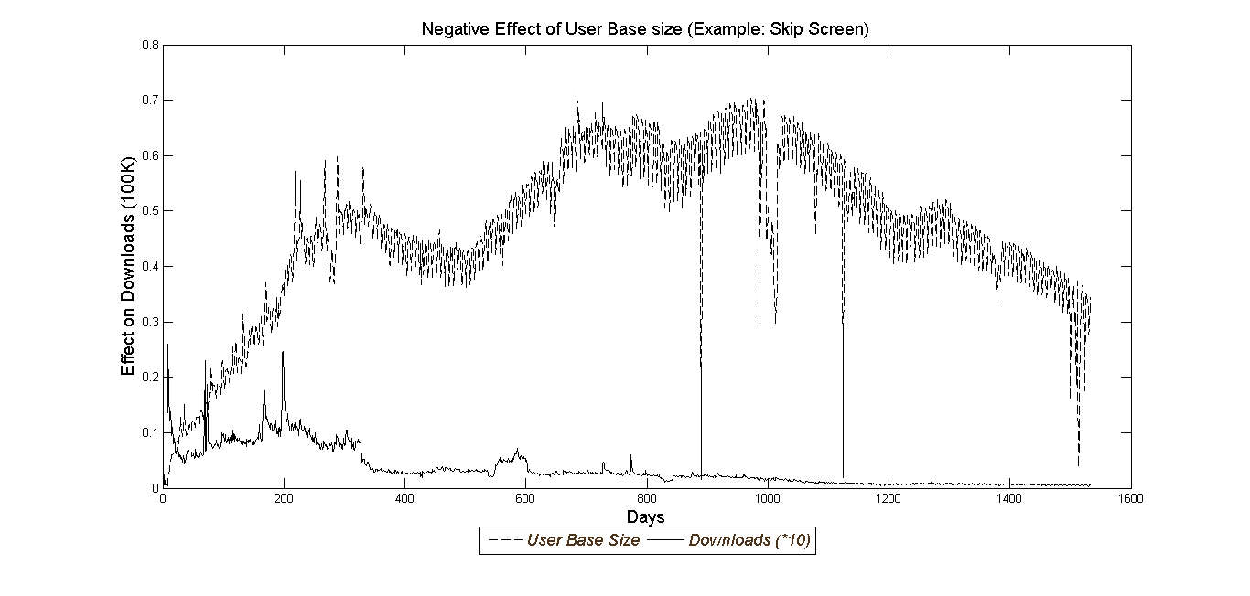

Figure Effectiveness of rating valence type 1 response example

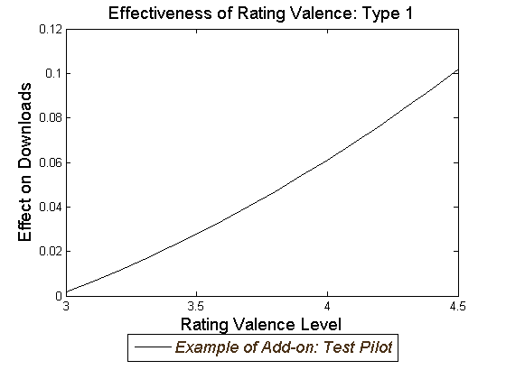

Figure Effectiveness of rating valence type 2 response examples

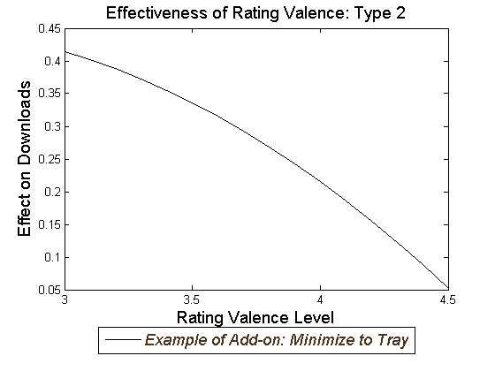

Figure Negative Effect of Average Rating Valence

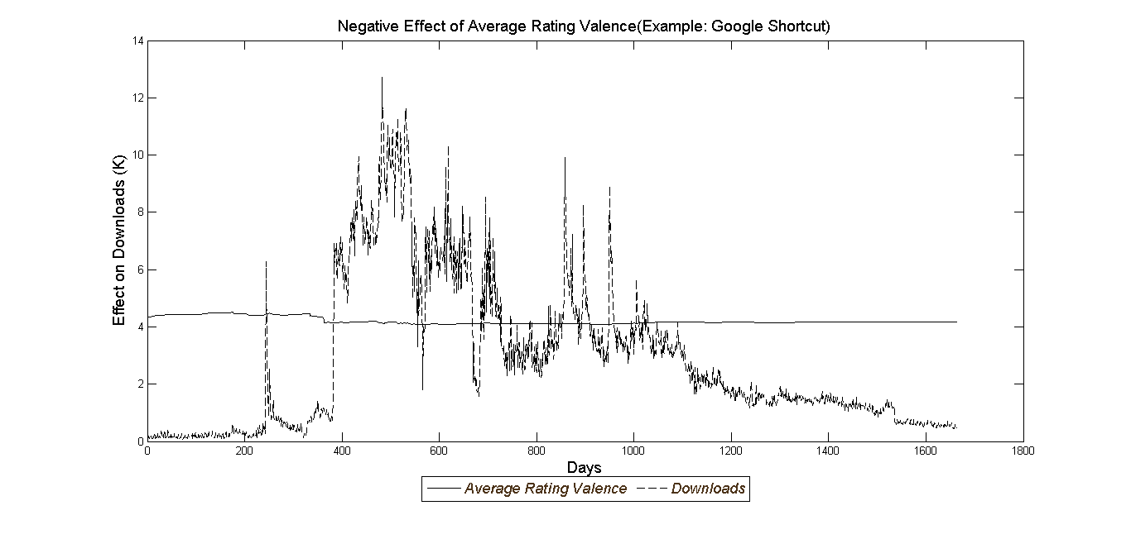

1. Add on is a complementary software that is added to Firefox browser to add new functionality to it.