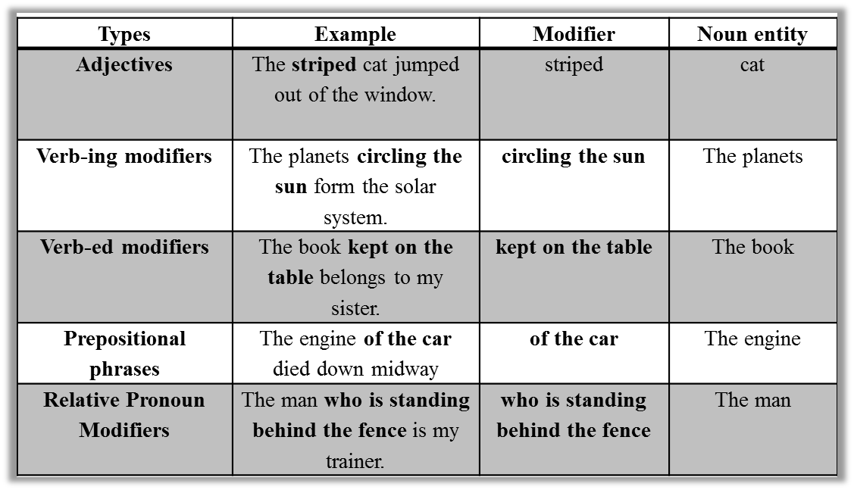

Commonly-tested grammar concepts:

SENTENCE STRUCTURE

COMPARISONS: Logical Comparison

SUBJECT-VERB AGREEMENT: Unusual Subject

VERB TENSE

MODIFIERS: Adjective can only modify nouns, Adverbs modify verbs, adjective, adverbs

PRONOUNS

PARALLELISM: Same Part of Speech

IDIOMATIC CONSTRUCTIONS

Choose:

-A clear construction over an awkward one. The awkward includes: redundancy, extra forms of verb (be), having been/being, Awkward Gerund Phrases, Awkward prepositional phrases, Unnecessary Pronouns

-A concise construction over a wordy one.

- An active construction over a passive one.

ADJECTIVE CLAUSE modifies noun/noun idea immediately before it.

PARTICIPIAL PHRASE (beginning of sentence) modifies the noun immediately after comma.

PARTICIPIAL PHRASE (set off by commas in sentence) modifies the subject of a previous clause.

APPOSITIVE- modifies noun/noun idea immediately before it.

NOUN + ASSOCIATED MODIFIERS can specify an idea (not one specific noun) described in a previous clause.

PREPOSITIONAL PHRASE modifies the noun immediately before it when not set off by commas.

When a “noun idea” is followed by an adjective clause, make sure that the verb agrees with the noun that is logically described.

|  |  |  |
| --- | --- | --- |
| Singular | Plural | Depends |
| Each*  Every  Everyone  Anyone  Someone  One  Nobody | Both  Few  Many | All  Most  Majority  Some |