class06 homework: writing functions

Meisha Khan

1/31/2020

## R Markdown

library(bio3d)

# Can you improve this code?

s1 <- read.pdb("4AKE") # kinase with drug

## Note: Accessing on-line PDB file

s2 <- read.pdb("1AKE") # kinase no drug

## Note: Accessing on-line PDB file  
## PDB has ALT records, taking A only, rm.alt=TRUE

s3 <- read.pdb("1E4Y") # kinase with drug

## Note: Accessing on-line PDB file

s1.chainA <- trim.pdb(s1, chain="A", elety="CA")  
s2.chainA <- trim.pdb(s2, chain="A", elety="CA")  
s3.chainA <- trim.pdb(s1, chain="A", elety="CA")  
s1.b <- s1.chainA$atom$b  
s2.b <- s2.chainA$atom$b  
s3.b <- s3.chainA$atom$b  
plotb3(s1.b, sse=s1.chainA, typ="l", ylab="Bfactor")

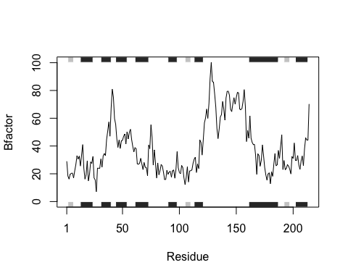

plotb3(s2.b, sse=s2.chainA, typ="l", ylab="Bfactor")

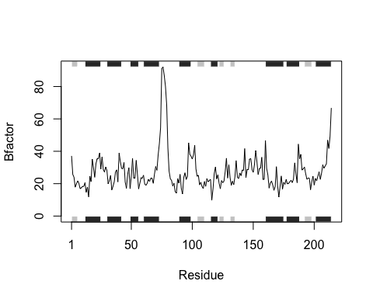

plotb3(s3.b, sse=s3.chainA, typ="l", ylab="Bfactor")



## overall goal of this code: *Create a small pdb object from large pdb files and isolate a subset of atoms

Inputs of this code include: - .pdb objects read via read.pdb() function and trimmed via trim.pdb() function - atom selections obtained after trimming are inputed into graphs

Output of this code include: - Collective ine graph of analyzed proteins

# main functions:

s1 <- read.pdb("4AKE")

## Note: Accessing on-line PDB file

## Warning in get.pdb(file, path = tempdir(), verbose = FALSE): /var/folders/dt/  
## 4ytc3pnn6wz_t86ybfkwfdlr0000gn/T//RtmpHRWNsx/4AKE.pdb exists. Skipping download

s1.chainA <- trim.pdb(s1, chain="A", elety="CA")  
s1.b <- s1.chainA$atom$b  
plotb3(s1.b, sse=s1.chainA, typ="l", ylab="Bfactor")



# simplify

file : s1 <- read.pdb(s1) trim: s1.chainA <- trim.pdb(s1, chain=“A”, elety=“CA”) chain: s1.b <- s1.chainA $atom$ b plot: plotb3(s1.b, sse=s1.chainA, typ=“l”, ylab=“Bfactor”)

#need to loop file for iterations to appear on one graph for (i in 1:length(protein[i])) plot(protein_analysis_plot) #code did not iterate inputs, could not figure it out :(

protein_analysis_plot <- function(file, trim, chain, plot) { s1 <- read.pdb(file) s1.chainA <- trim.pdb(s1, chain=“A”, elety=“CA”) s1.b <- s1.chainA $atom$ b plotb3(s1.b, sse=s1.chainA, typ=“l”, ylab=“Bfactor”) }

protein_analysis_plot <- function(s1) {  
 s1.chainA <- trim.pdb(s1, chain="A", elety="CA")  
 s1.b <- s1.chainA$atom$b  
 plotb3(s1.b, sse=s1.chainA, typ="l", ylab="Bfactor", col = rainbow(3))  
  
}  
s1 <- read.pdb("4AKE")

## Note: Accessing on-line PDB file

## Warning in get.pdb(file, path = tempdir(), verbose = FALSE): /var/folders/dt/  
## 4ytc3pnn6wz_t86ybfkwfdlr0000gn/T//RtmpHRWNsx/4AKE.pdb exists. Skipping download

protein_analysis_plot(s1)

