**Hidden Valley ESX Host - Specification and Installation**

2012-02-02

Michael Spence

**Audience:**

This specification and installation guide is intended for use by the APEagers System Engineer. It may be useful in part to Field Support, who may need references for the purpose of installation or maintenance. It is not intended for any other purpose.

**Preamble:**

This document summarizes the necessary setup requirements for the HVY-ESX server.

This document demonstrates the required connectivity to the network.

This document DOES NOT include the required setups for the VMs which are to live on this host.

**Topics of Discussion:**

1- System Specs

2- Disk Configuration

3- ESX Installation

4- RMM Configuration

5- Network Ports

**Topics in Detail:**

**1- System Specs**

[Insert Ocean Specs for this machine here]

**2- Disk Configuration**

Disk Array 1

2x 32GB SSD X25E

Disk Array 1

4x 1TB HDD 7200rpm

Virtual Disk 0

Raid 1 across Disk Array 1 for a total of 24GB

Virtual Disk 1

Raid 5 across Disk Array 2 for a total of 1.3TB

Virtual Disk 2

Raid 5 across Disk Array 2 for a total of 1.3TB

**3- ESX Installation**

General

ESX version: ESXi 4.1

ESX Licence: Standard CPU Licence

Root password: <is a!>.

Name of host as configured in DNS: hvy-esx1

Network address of Host: 10.52.0.101

Primary DNS: 10.1.1.43

Secondary DNS: 10.50.1.4

DNS Suffix: apeagers.com.au

Storage

ESX Host: hvy-esx host 24GB (Across Virtual Disk 0 only)

ESX Guest: hvy-vm prod 2.7TB (Across Virtual Disk 1 and Virtual Disk 2)

Networking

Virtual Switch VLAN 1 Nic0 and Nic2 to all VMs as default to LAN

Virtual Switch VLAN 666 Nic1 only to HVY-FW to WWW

**4- RMM Configuration**

Configured through BIOS under "Server Management" -> "Baseboard LAN configuration"

Under, "Intel RMM3 LAN configuration"

IP Address: 10.50.0.100

Under, "User configuration"

UserID = User3 configured to be:

U/N: issadmin

P/W: <is a>

Status: Enabled

**5- Network Ports**

The following diagram illustrates the positions of the network ports on the rear of the server.

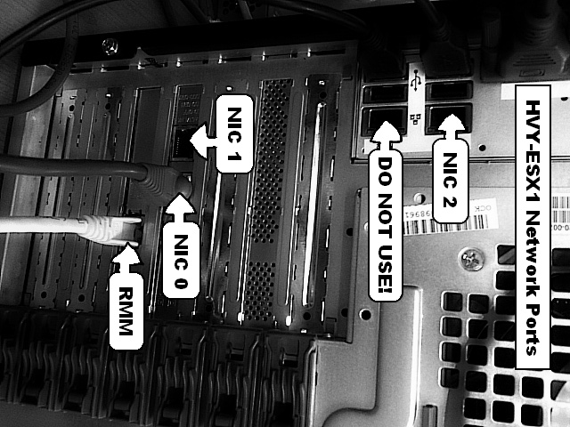

Nic0 and Nic2, which are components of different hardware, are to be used as redundant network connections to the local area network. Nic1 is the direct link to the internet at this location. The RMM interface should also be connected directly to the LAN..