**Parallel Programming Exercise 4– 8**

|  |  |
| --- | --- |
| **Author:** | 李明軒 ([b08505012@ntu.edu.tw](mailto:b08505012@ntu.edu.tw)) |
| **Student ID** | B08505012 |
| **Department** | Engineering Science and Ocean Engineering |

(If you and your team member contribute equally, you can use (co-first author), after each name.)

# Problem and Proposed Approach

(Brief your problem, and give your idea or concept of how you design your program.)

Problem:

Find how many time does two consecutive odd numbers are both primes.

Concept:

1. Distribute the number for processors and find prime numbers in them

2. Check if there are two consecutive prime number (locally)

3. Share the last prime number to adjacent processor to check if there are two consecutive prime numbers(globally)

4. The answer will be local result + global result

# Theoretical Analysis Model

(Try to give the time complexity of the algorithm, and analyze your program with iso-efficiency metrics)

n = 1,000,000

time complexity : Θ(n*ln(ln(n))/p)

To(overhead) : p $\frac{\sqrt{n}}{ln\sqrt{n}}\log^{p}$

T(n,1) : n*ln(ln(n))

Iso-efficiency: n*ln(ln(n))≧Cp $\frac{\sqrt{n}}{ln\sqrt{n}}\log^{p}$

# Performance Benchmark

(Give your idea or concept of how you design your program.) (寫在第一題)

Using the estimated time provided in the textbook.

Table . The execution time

|  |  |  |  |  |  |  |  |  |
| --- | --- | --- | --- | --- | --- | --- | --- | --- |
| Processors | 1 | 2 | 3 | 4 | 5 | 6 | 7 | 8 |
| Real execution time | 0.015740 | 0.008209 | 0.006225 | 0.005125 | 0.004104 | 0.002757 | 0.002401 | 0.002210 |
| Estimate execution time | 2.543 | 1.330 | 0.901 | 0.679 | 0.543 | 0.456 | 0.391 | 0.342 |
| Speedup | 1 | 1.912 | 2.822 | 3.7452 | 4.6832 | 5.5767 | 6.50383 | 7.43567 |
| Karp-flatt metrics | X | 0.046025 | 0.031538 | 0.0226768 | 0.016912 | 0.015181 | 0.012715 | 0.0108421 |

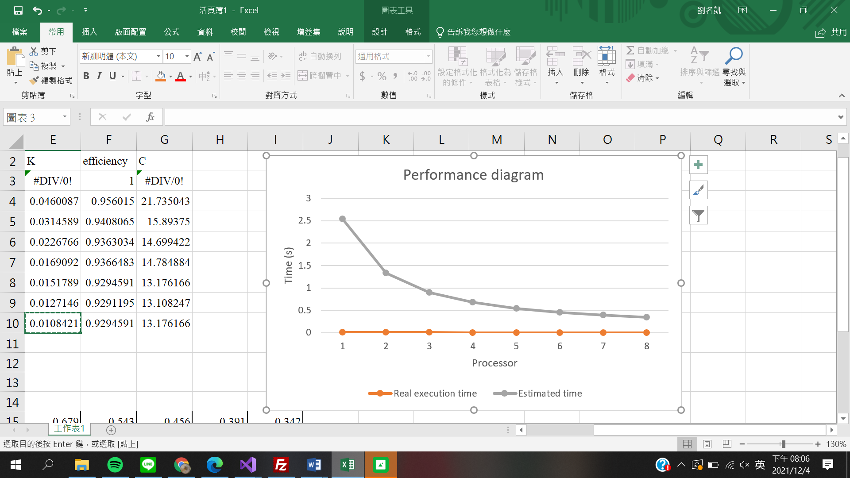

# Conclusion and Discussion

1. What is the speedup respect to the number of processors used?

: Speedup increase as the number of processor increase, because the time complexity depends on 1/p.

1. How can you improve your program further more
2. How does the communication and cache affect the performance of your program?

: Most time send on sieving and communication is needed in sieving process. However, if n is large, the communication time could be ignore.

1. How does the Karp-Flatt metrics and Iso-efficiency metrics reveal?

: e decrease as the number of processor increase. We can also notice that estimated execution time decrease linearly with the number of processor. All of the above indicates that a large fraction of this program can be parallelized.

**Appendix(optional):**

