**Parallel Programming Exercise 5 – 11**

|  |  |
| --- | --- |
| **Author:** | 李明軒 ([b08505012@ntu.edu.tw](mailto:b08505012@ntu.edu.tw)) |
| **Student ID** | B08505012 |
| **Department** | Engineering Science and Ocean Engineering |

# Problem and Proposed Approach

(Brief your problem, and give your idea or concept of how you design your program.)

Problem:

Write a parallel program that take n and precision as input. Calculate nth harmonic progression with the precision.

Concept:

Distribute the data and calculate locally. Last, add up those local value and we will get the answer. I have no idea how to improve the precision.

# Theoretical Analysis Model

(Try to give the time complexity of the algorithm, and analyze your program with iso-efficiency metrics)

time complexity: Θ(logp+n/p)

Iso-efficiency: n>Cplogp

T(n,1)= Θ(n), To(n,p)=pk=Θ(plogp)

M(n)=n, M(Cplogp)/p=Clogp

# Performance Benchmark

(Give your idea or concept of how you design your program.)

Estimate execution time : λ(logp)+χ(n/p)

λ: 0.000015, n = 7

χ: 0.0000004

Table . The execution time

|  |  |  |  |  |  |  |  |  |
| --- | --- | --- | --- | --- | --- | --- | --- | --- |
| Processors | 1 | 2 | 3 | 4 | 5 | 6 | 7 | 8 |
| Real execution time | 0.016255 | 0.008010 | 0.006172 | 0.004784 | 0.004051 | 0.002740 | 0.002340 | 0.002075 |
| Estimate execution time | 0.4 | 0.20001 | 0.133350 | 0.100021 | 0.080024 | 0.066693 | 0.057172 | 0.050031 |
| Speedup | 1 | 1.999 | 2.999 | 3.999 | 4.9985 | 5.9979 | 6.9964 | 7.995 |
| Karp-flatt metrics | x | 0.0005 | 0.000167 | 0.000083 | 0.000075 | 0.000070 | 0.000086 | 0.000089 |

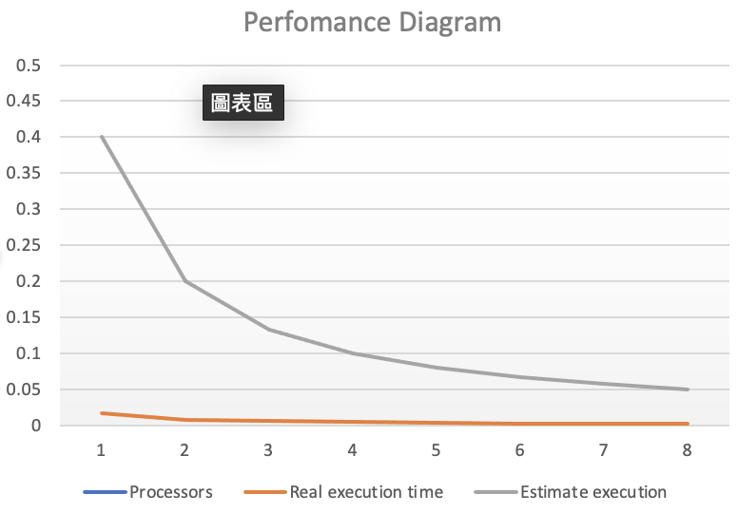

# Conclusion and Discussion

1. What is the speedup respect to the number of processors used?

: As number of processor increase, speedup increase too. Because n is large,χ(n/p) dominates the execution time. Therefore, the more processor, the quicker the program.

1. How can you improve your program further more

: Using long double to store the number is not enough for 100 precision. I have heard a method is to store it by array. However, I don`t have time to implement it.

1. How does the communication and cache affect the performance of your program?

: In this program, communication time is neglectable, since computation time is much longer. So the communication doesn’t affect the execution time.

1. How does the Karp-Flatt metrics and Iso-efficiency metrics reveal?

: e decreased when number of processor increase. However, it’s so small that it doesn’t limits the speedup.

**Appendix(optional):**

