Perforce(1) - Modify your workspace please
Edit your workspace, go to the advanced tab
Especially the revert unchanged files

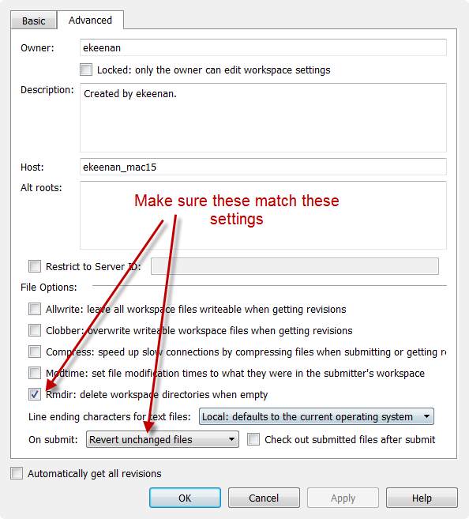

Perforce(2) - Enable logging
Go to Edit tab, choose preferences

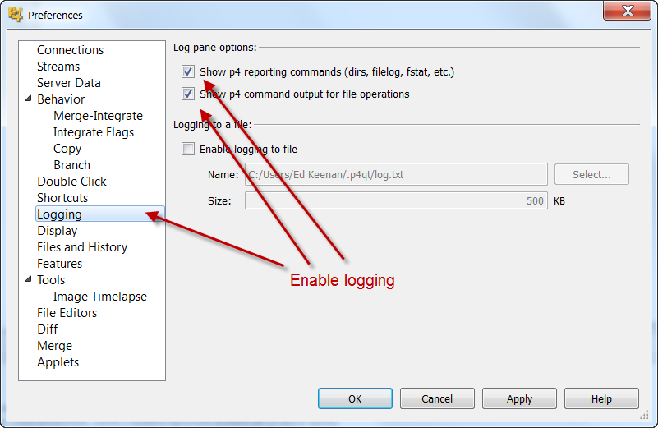

Perforce(3) - Etiquette - Deleting from Common (no-nay-never)
Do not check out or delete items in common folder. We really shouldn't be deleting things from the common directory because it's there for us to show useful ideas or look for help and problems.

Do not delete from common
- If you don't want common, do not get that directory
- If you need to remove it from the workspace not a delete
  - Right click on common, then choose remove from workspace

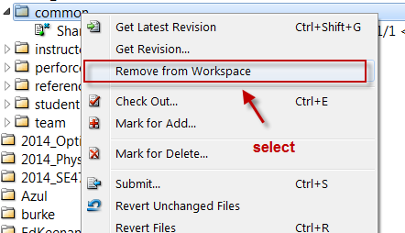

Perforce(4) - Tutorial Videos (by perforce)
https://www.youtube.com/watch?v=CtKkVDCJ0wo&list=PLH3pq2J85xsPlNfrmz8BgFuIzf3_k9pwY&index=12

search youtube for perforce files
Look at the ones made by perforce first.

Perforce(5) - How to verify your Perforce files are checked in correctly
Follow this process,

Preconditioning
- Build and run everything on your local machine.
- Check in everything into perforce
  - (except for generated files)
Verification
- In your local directory rename your directory
  - For example /PA1 → /PA1_Safety
- Force a get
  - Next go to perforce Depot tab
  - Get Revision on the directory
  - Click Force Operation.
- The code comes down again in a new /PA1 directory
- Build that directory without any modifications
  - No check outs
  - No deletions
  - No changes to any files
  - Leave everything as is.
- Build and Run the project if Successful
  - All done
  - Go to Cleanup
- Build and Run the project if Not Successful
  - Look at your safety copy and fix
  - May require adding or deleting files to perforce
  - Repeat the whole process again
Clean up
- Once everything is done and working
  - Delete /PA1_safety
    - do not check that into perforce

Perforce(6) - Checking in extra data - lowers your grade
Programming 101 - rules

DO NOT submit any self generated data/code/files
- Verify that only MINIMUM files are submitted
  - No - *.pdb, *.suo, *.sdf, *.user, *.obj, *.exe, *.log, *.pdb
- Anything that is generated by the compiler should not be included
  - No - /obj, /bin, /.vs, /Debug, /Release directories
  - Make sure what’s checked in works!
- Typical files project files that are required
  - *.sln, *.csproj,
  - *.cs
  - App.config
  - AssemblyInfo.cs
Start a discussion
- Create a CleanMe.bat to delete before you add to perforce
- Start a thread about how to remove these files

Perforce(7) - Several students are making these criticial mistakes (Please review)

There are 2 modes for perforce.

Mode A)
- Adding a file the first time to Perforce (its never been there before)
Mode B)
- Modifying the file (changing the code)
Mode A:

This is the ONLY time you should be on the workspace tab
- Mark for Add
- the submit individual files,
  - not directories
- Once the file is added, NEVER use the workspace tab again
Mode B:

You should stay in Depot Tab for the following operations not the workspace tab
You will do these operations repeatedly
- Check Out -> Edit -> Save -> Submit
- Check Out -> Edit -> Save -> Submit
NEVER use add, only the Check Out and Submit in perforce

Problems
- Several of you are adding too many files
- Several are Adding files that are already Checked Out (causing a lock)
If you have a Lock
- Go to the Changelist - select the files individually (right click -> unlock)
To UNDO a check out
- Revert the changelist

Perforce(8) - Reference directory is yours

DO NOT copy that stuff into your student directory.

You already have access to the reference directory

Stuff you should keep in your student directory
- Milestone1
- Sandbox - experiments
- mini coding examples

I can't say this enough - DO NOT copy stuff in reference directory into the student directory
You do not need the lectures, sample code, videos, etc...
- You have it in another directory its called reference

Perforce(9) - Do not copy Videos or Lectures into student directory
PLEASE
- Never copy videos or lectures into your student directory.
- You already have access, its read-only.
- Leave it in your Reference directory.

NO need to copy it to your student directory.

Only place code in student directory

