Luke Mayo
Homework 3

1)$$mod arith (x-y)|(x^{n}-y^{n}) \\ x^{n}≡y^{n} mod \left(x-y\right) \\ to prove this we need to find a number a such that \\ y^{n}=a\left(x-y\right)+0 \\ \frac{y^{n}}{x^{-1}-y^{n-1}}=\left(x-y\right) \\ x-y=(x-y)$$

2)
a)
$$reflexive: R∩S can only be reflexive if they are the same \\ symmetric:S∩R is the same as R∩S \\ transitive:R∩S∩T→R∩T works if R and T are the same$$
b)
$$R∪S is not an equivalence relation because it is not transitive.$$
$$R∪T cannot be reconciled to R∪T, because$$
$$S may have unique elements that R and T do not.$$
c)
$$nR∩Sm→6|(n-m)$$
d)
$$The number of equivalence classes for , lets say p, \\ 0<p<n+m \\ given that R and S must be the same, p=n+m.$$

3)
$$reflexive:\left(a,b\right)R_{1,1}\left(a,b\right)→ 1a+1b=1a+1b$$
$$symmetric:\left(c,d\right)R_{1,1}\left(a,b\right)→c+b=d+a \\ transitive: \left(a,b\right)R_{1,1}\left(c,d\right)→\left(c,d\right)R_{1,1}\left(e,f\right) \\ a+d=c+b, \\ c+f=d+e, \\ then, if we subtract… \\ a-b=c-d, \\ c-d=e-f \\ \left(a,b\right)R_{1,1}\left(e,f\right)→a+f=b+e, \\ a-b=e-f$$

b)$$\left(1,0\right)R_{1,1}\left(c,d\right)→1+d=c \\ [c-d]$$

c)
$$To find the equivalence classes of R_{1,1}, we would have to know the bounds of the \\ sets we are relating. Given that we are relating to the set of all integers, there are \\ infinitely many equivalence classes.$$
d)
$$reflexive: na+md=nc+mb \\ →na+md=na+md \\ symmetric: nc+mb=na+md \\ transitive:na+md=nc+mb \\ →nc+mf=ne+md \\ →na-mb=nc-md \\ →nc-md= ne-mf \\ →na-mb=ne-mf$$
e)
$$\left(1,0\right)R_{n,m}\left(c,d\right)→n+md=nc \\ [\frac{md}{n}+c]$$
f)
$The equivalence class appears to be the x component, the n of R_{n,m}.$
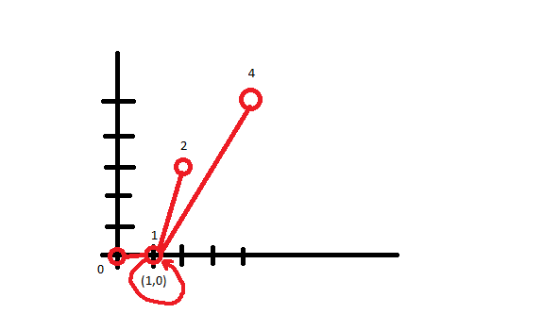

4)
a)
$$reflexivity:∃a walk of even length connecting v to v. Due to definition of even, 0 is even. \\ symmetric:∃a walk of even length connecting w to v. \\ Undirected graphs are bidirectional, so a walk of even length can be made backwards. \\ transitive:vTw→∃a walk of even length connecting v to w. \\ wTx→∃a walk of even length connecting w to x. \\ vTx→given both lengths are even, and since multiples of an even number are even \\ and since the path can be made from v to w and from w to x, \\ ∃a walk of even length connecting v to x.$$
b)
$$In a complete bipartite graph such as K_{n,m}, \\ given a and b s.t. 0<a<n and 0<b<m, the relation \\ a,b∈K_{n.m}, holds that every node is connected to two other nodes$$
c) Any cyclic graph with an even number of vertices is a bipartite graph, having two equivalence classes.
d) Each node is bidirectional, therefore for two vertices a and b, a is related to b and b is related to a.

5)
$$Using Fermat^{'}s Little Theoem \\ 19|({7777}^{4994}+{44444}^{9889}) \\ {\left[77777\right]}^{4994}+{\left[44444\right]}^{9889} \\ \frac{77777}{19}=4093*19+10 \\ remainder is 10 \\ \frac{44444}{19}=2339*19+3 \\ remainder is 3 \\ {\left[10\right]}^{4994}+{\left[3\right]}^{9889} \\ and then, \\ {10}^{18}≡1 mod 19 \\ 3^{18}≡1 mod 19 \\ 4994 mod 18=8 \\ 9889 mod 18=7 \\ 19|({10}^{8}+3^{7}) \\ 19|(100,000,000+2187)$$

6)$$we are looking for a number such that 137a≡1 mod 237 \\ 237|\left(137a-1\right) \\ or, for some int b 137a-237b=1 \\ 237=1 mod 100 \\ 237=137*1+100 \\ 137=100*1+37 \\ 100=37*2+ 26 \\ 37=26*1+11 \\ 26=11*2+4 \\ 11=4*2+3 \\ 4=3*1+1 \\ These are the steps of the euclidian algorithm, \\ rearranging gives us this: \\ 1=4-3*1 \\ 3=11-4*2 \\ 4=26-11*2 \\ 11=37-26*1 \\ 26=100-37*2 \\ 37=137-100*1 \\ 100=237-137*1 \\ and we can substitute them into each other like this: \\ 1=4-\left(11-\left(4*2\right)\right)*1 \\ 1=3\left(4\right)-\left(11\right) \\ 1=3\left(26-\left(11*2\right)\right)-11 \\ 1=3\left(26\right)-7\left(11\right) \\ 1=3\left(26\right)-7\left(37-26\right) \\ 1=10\left(26\right)-7\left(37\right) \\ 1=10\left(100-37*2\right)-7\left(37\right) \\ 1=10\left(100\right)-27\left(37\right) \\ 1=10\left(100\right)-27\left(137-100\right) \\ 1=37\left(100\right)-27\left(137\right) \\ 1=37\left(237-137\right)-27\left(137\right) \\ 1=37\left(237\right)-64\left(137\right) \\ -64 is our answer. {Let}^{'}s make it positive: \\ 237-64=173$$b)
$$k=37*173 \% 237 \\ k=2$$

