WEEK 4 ASSIGNMENT
Data Management — SACCO App
Student: Meitaya Verizon
GitHub: https://github.com/meitayaverizon892-create/sacco-app
Topic: Member Record Management (CRUD with SQLite)

Feature Implemented
• SQLite database (sqflite) to store SACCO members permanently
• Create — Add new member form
• Read — Members list loaded from database
• Update — Tap a member to edit details
• Delete — Swipe a member to remove
• Search — Live search by member name

Screenshots

Members List (Empty State)

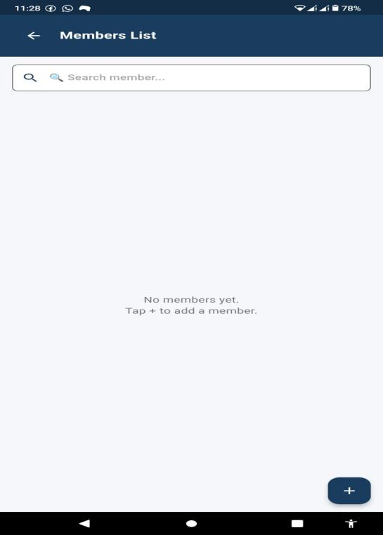

2. Add Member Form

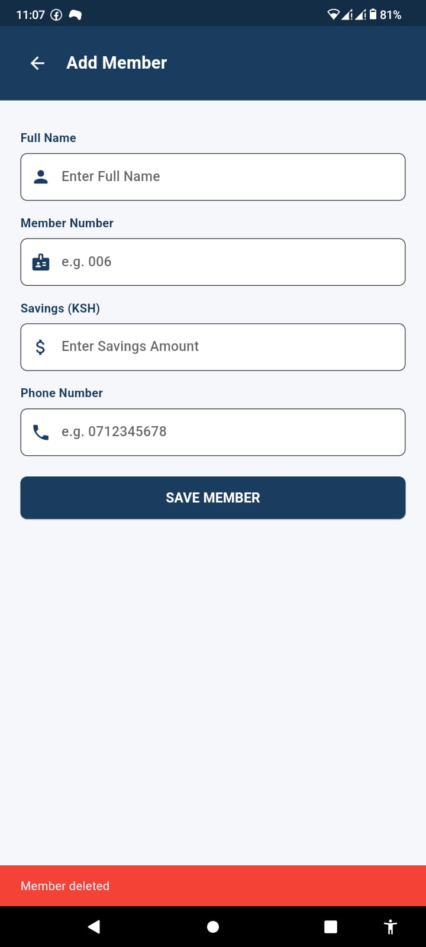

Members List (With Members)

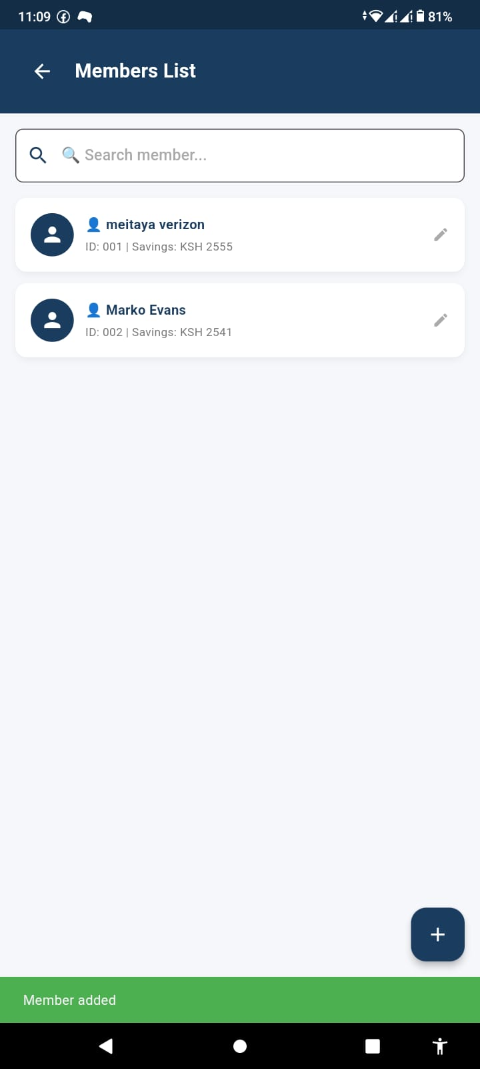

Edit Member
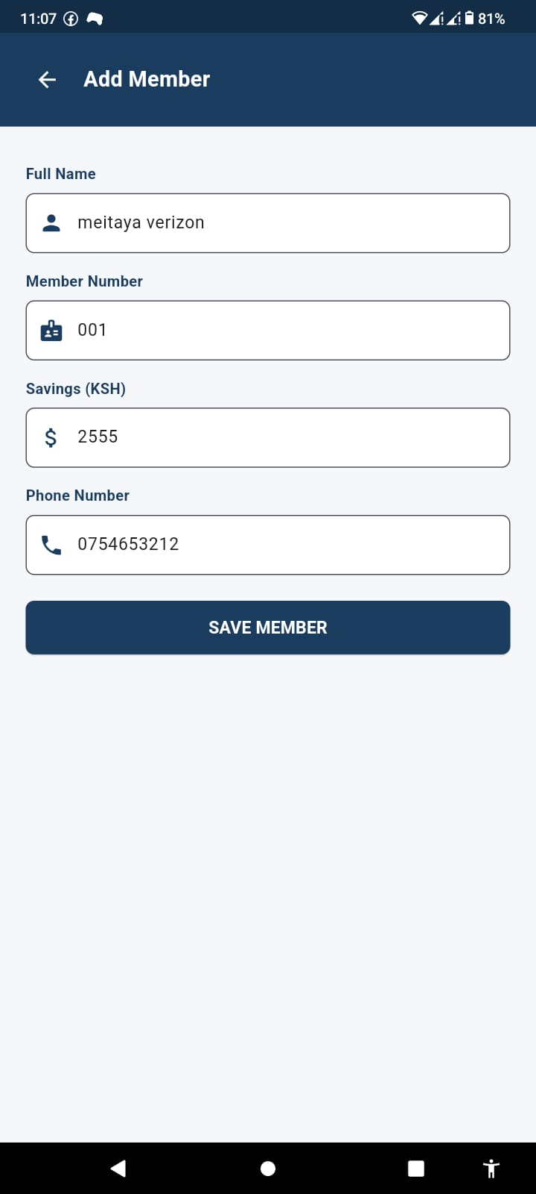

Delete Member (Swipe)


6. Search Functionality
