MOUNT KENYA UNIVERSITY
School of Computing and Informatics
Bachelor of Information Technology

MOBILE APPLICATION DEVELOPMENT
Week 1 Assignment Report
Introduction to Mobile Development & Environment Setup

Student Name | Meitaya Verizon
Course | Mobile Application Development
Assignment | Week 1 — Environment Setup & First Flutter App
Institution | Mount Kenya University
Date | June 2026
GitHub Repository | github.com/meitayaverizon892-create/sacco-app
Branch | week1-assignment

Task 1 — Development Tools Installation
All required development tools were successfully installed and configured on a Windows machine. The following screenshots provide evidence of each tool's installation.

1.1 Flutter SDK — flutter doctor Output
The flutter doctor command was run to verify the complete Flutter environment. All critical checks passed with no errors.

Screenshot 1 — flutter doctor
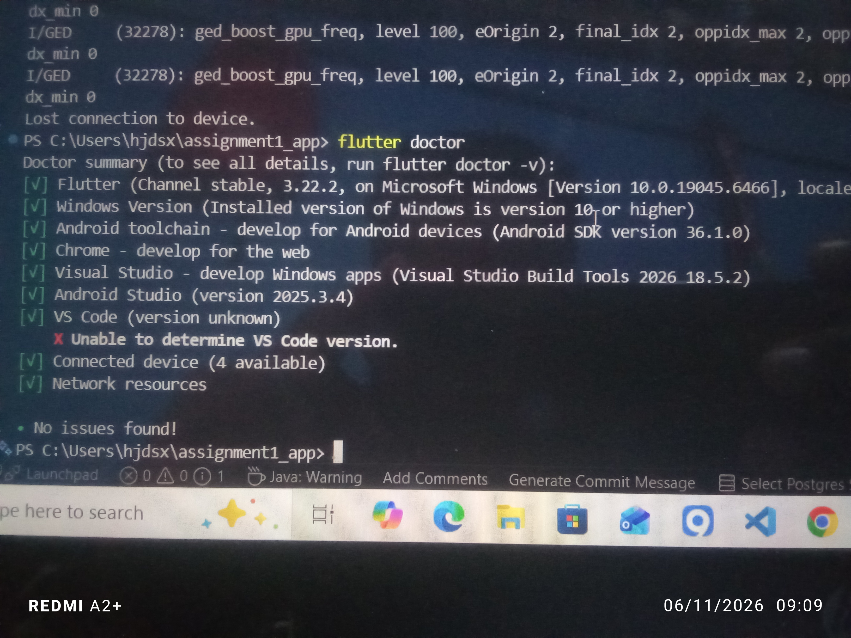

1.2 VS CODE
I used vs code that was already installed months ago

1.3 VS Code with Flutter Extension
Visual Studio Code was set up as the primary code editor with the Flutter and Dart extensions installed.

Screenshot 3 — VS Code Flutter Extension
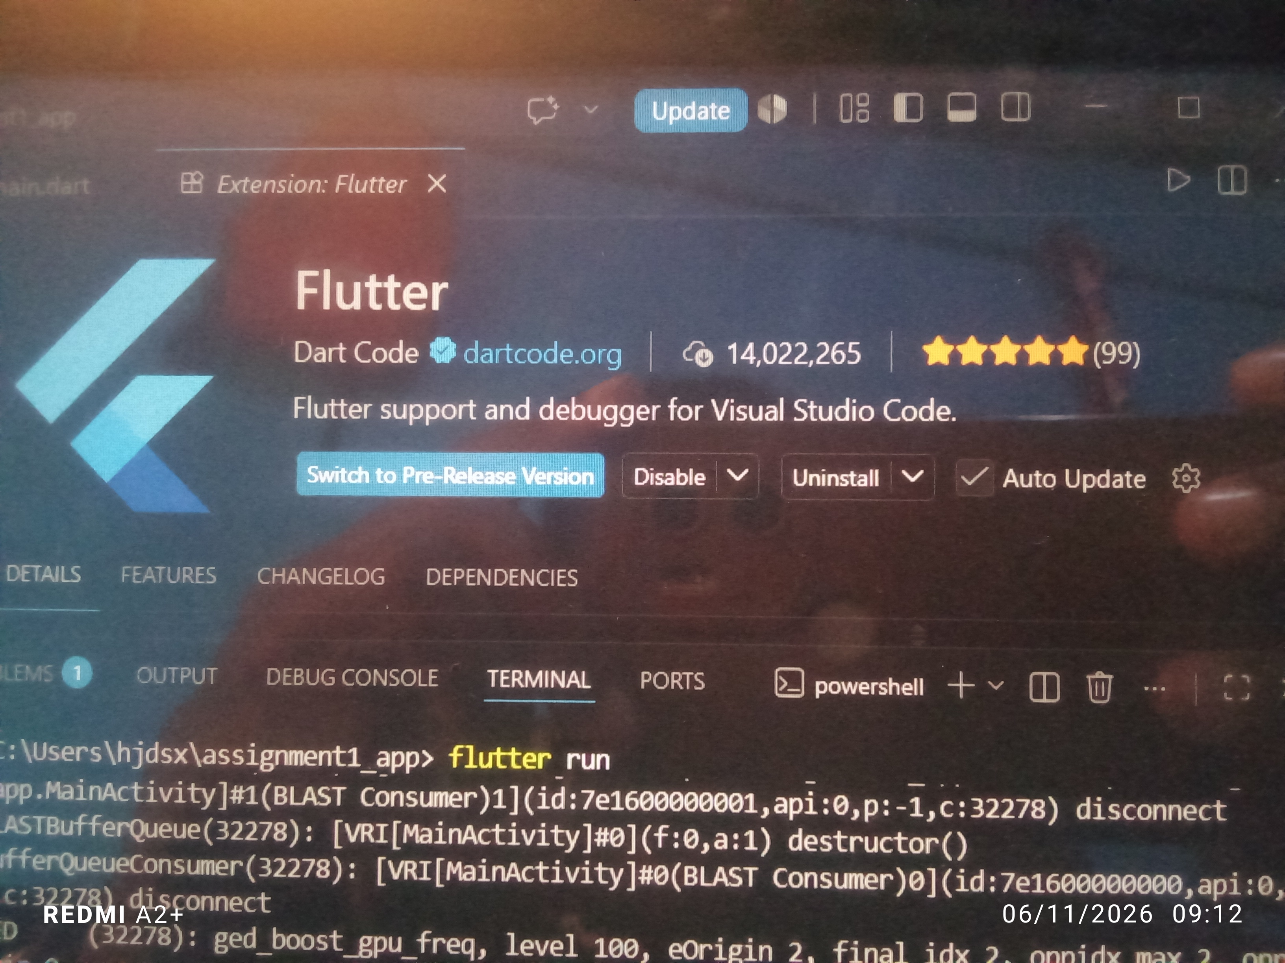NSHOT HERE ]

Task 2 — Flutter App Creation
A new Flutter project was created using the flutter create command and successfully launched on a connected Android device.

2.1 App Running on Device
The application was run using flutter run and confirmed working on a physical Android device via USB debugging.

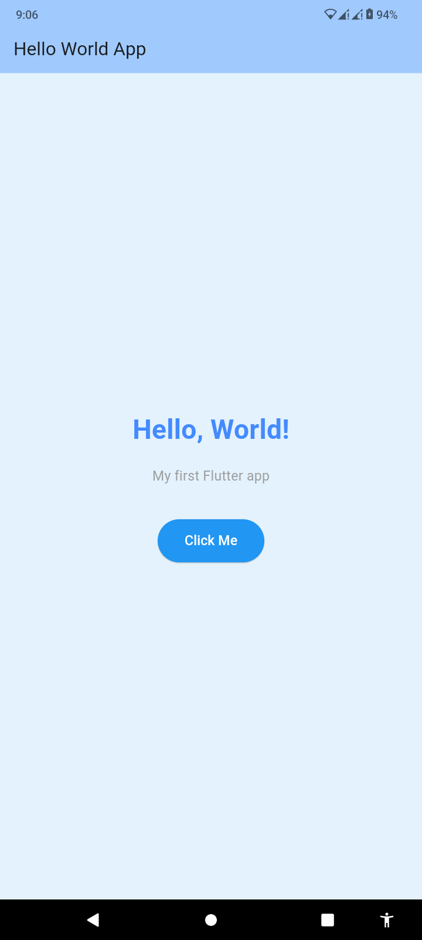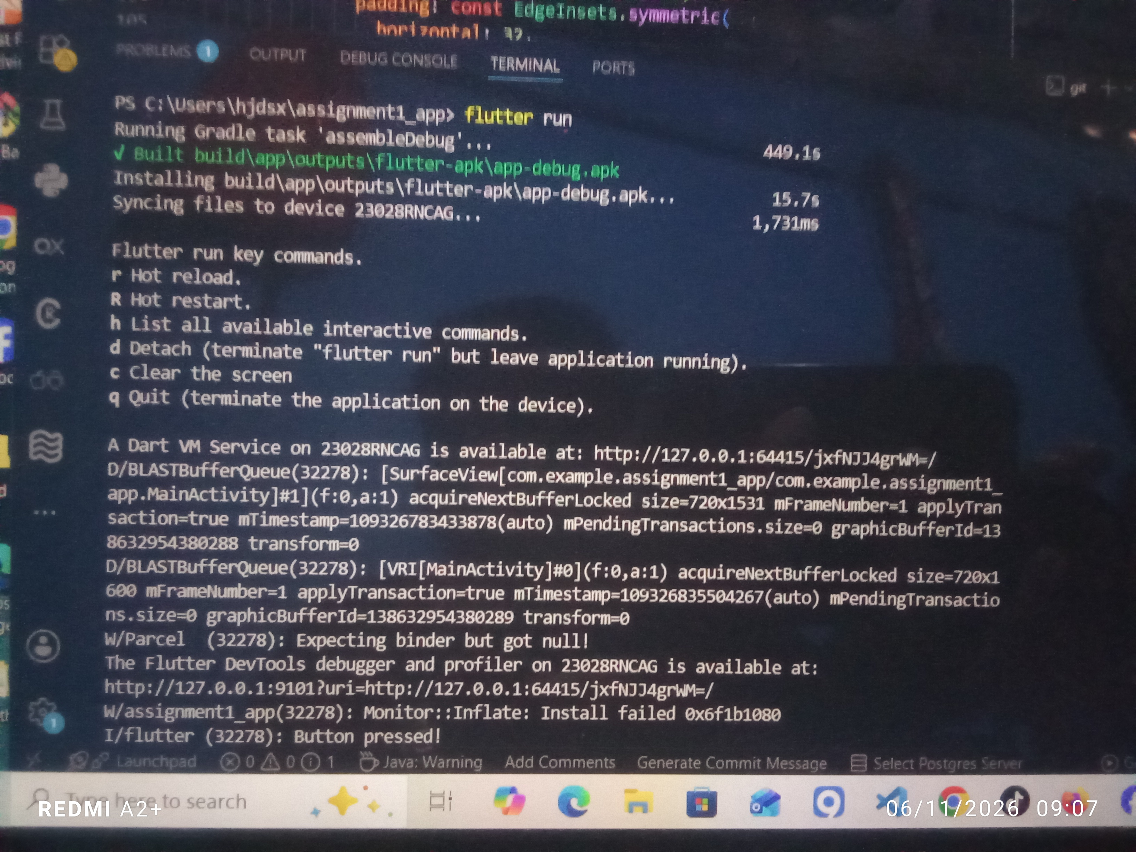ENSHOT HERE ]

2.2 Terminal — Successful Build
The terminal output confirmed a successful debug build and app launch with no critical errors.



Task 3 — App Title Changed
The default app title was changed from 'Flutter Demo' to 'Hello World App' by modifying the title property inside the MaterialApp widget in lib/main.dart.

[ INSERT SCREENSHOT

Task 4 — Background Color Changed
The screen background color was changed by setting the backgroundColor property on the Scaffold widget. A light blue color (Colors.blue[50]) was applied to give the app a clean, professional appearance.

Task 5 — Font Size Changed
The font size of the main text widget was modified using the TextStyle class. The font size was set to 32, with bold weight and a blue accent color applied for visual emphasis.


Task 6 — Button Added
An ElevatedButton widget was added below the text inside the Column widget. When tapped, the button executes an onPressed callback that prints a message to the debug console, demonstrating basic interactivity.

Screenshot 10 — Button Pressed Output
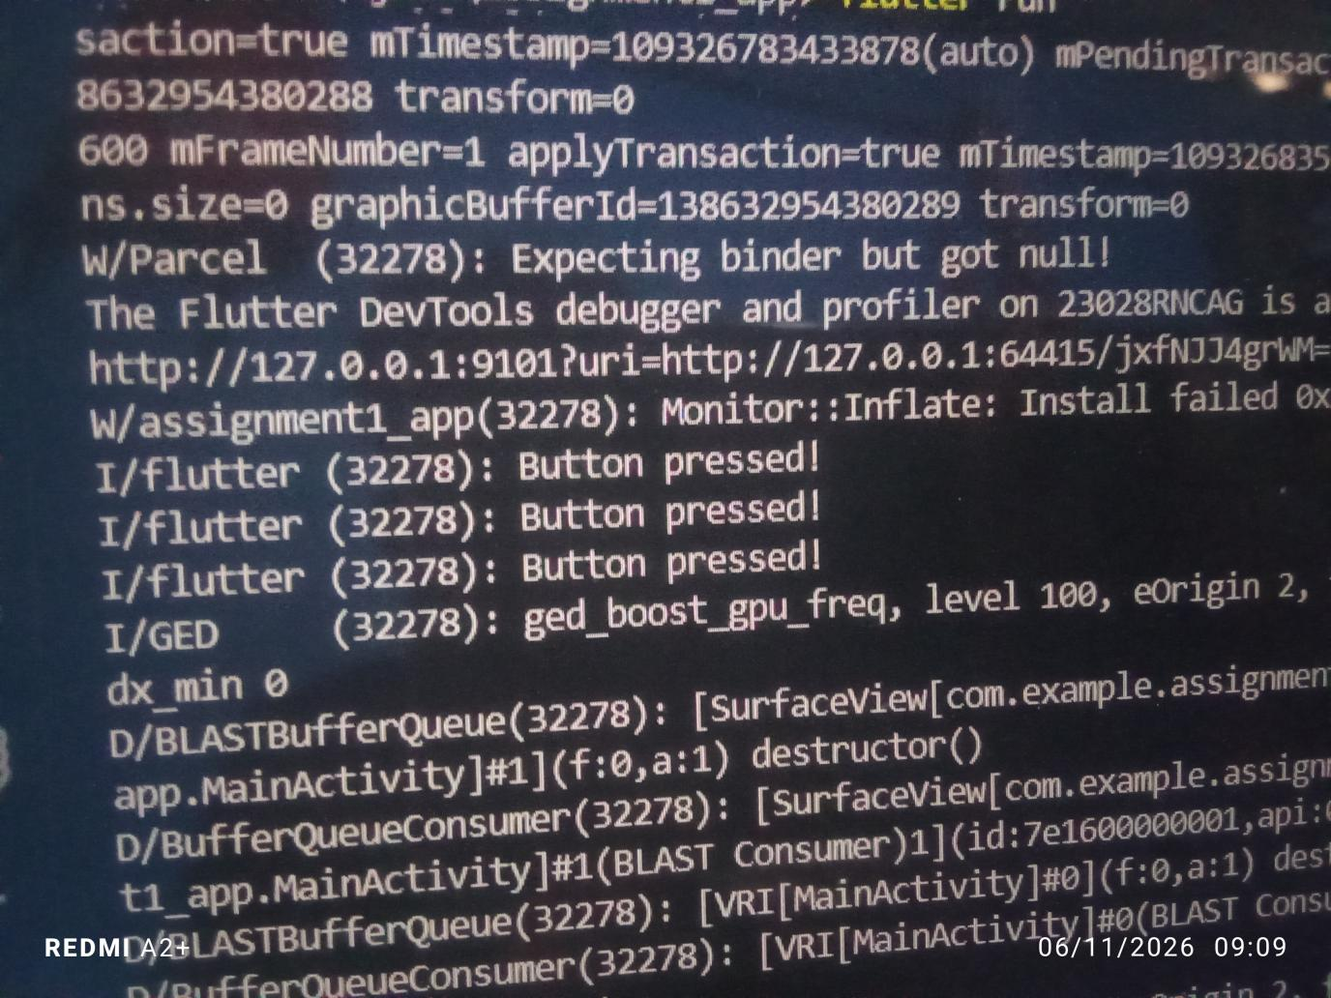

Task 7 — Source Code (main.dart)
The complete source code is available on GitHub at the repository and branch listed on the cover page. A screenshot of the main.dart file open in VS Code is provided below for reference.

https://github.com/meitayaverizon892-create/sacco-app/tree/week1-assignment

Conclusion
All six assignment tasks were completed successfully. The development environment was set up on a Windows machine with Flutter SDK, Android Studio, and VS Code. A Flutter application was created, modified, and run on a physical Android device. The application demonstrates the core Flutter widget architecture including MaterialApp, Scaffold, Column, Text, and ElevatedButton.

The source code has been pushed to GitHub on the week1-assignment branch and is available for review at:

https://github.com/meitayaverizon892-create/sacco-app/tree/week1-assignment

