WEEK 6 ASSIGNMENT
Networking Connection Screen — SACCO App
Student: Meitaya Verizon
GitHub: https://github.com/meitayaverizon892-create/sacco-app

1. Networking Connection Screen
A dedicated screen was added to the SACCO App that displays real-time network connectivity status (WiFi, Mobile Data, or No Connection), and allows the user to test live API connectivity.

Screenshot 1: Connected Status

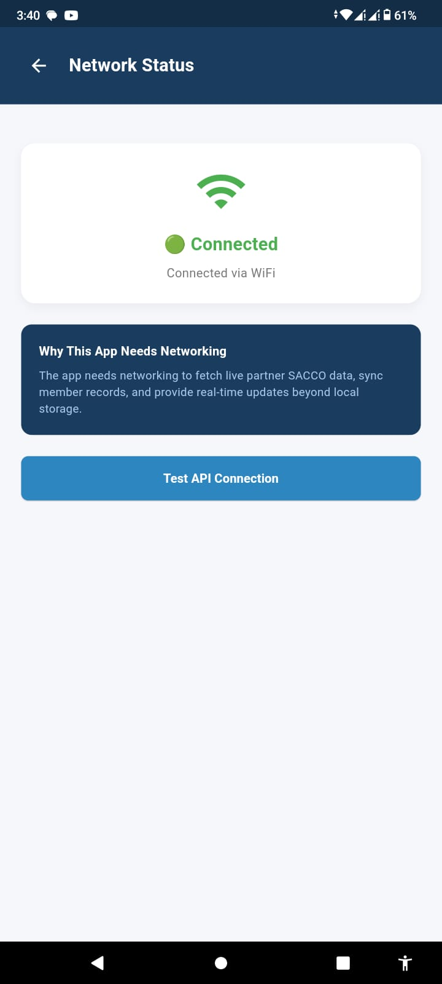

Screenshot 2: No Internet Connection

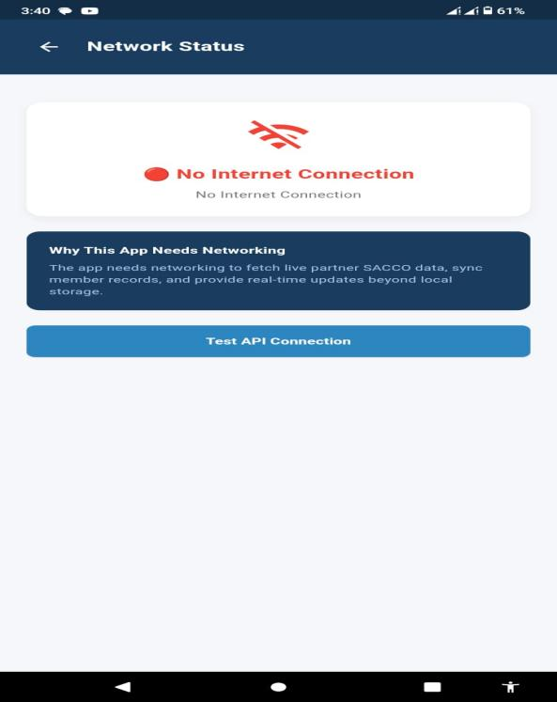

Screenshot 3: API Test - Success

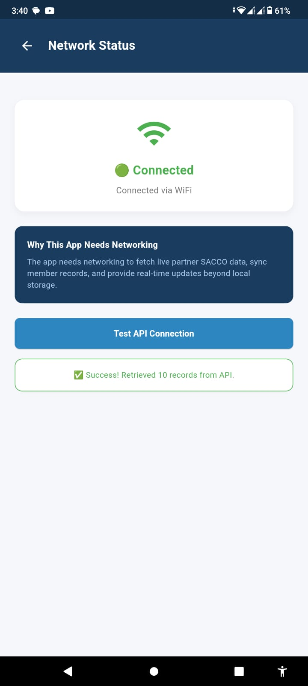

Screenshot 4: API Test - Failed (No Internet)

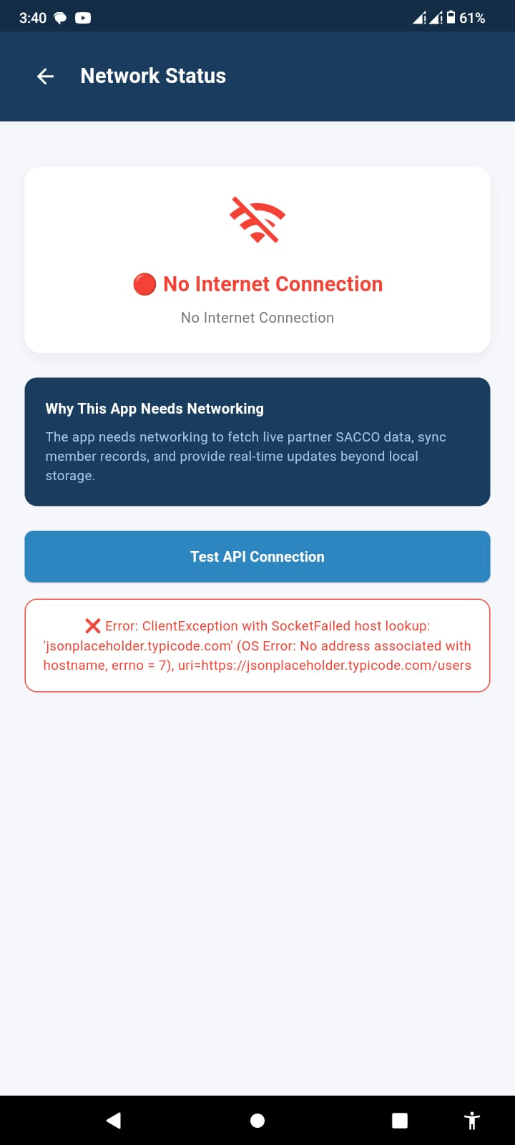

2. Why My App Requires Networking (Under 20 Words)
"The app needs networking to fetch live partner SACCO data, sync member records, and provide real-time updates beyond local storage."
(Word count: 18 words)

3. APIs and Asynchronous Operations
APIs (Application Programming Interfaces) allow the SACCO App to communicate with external servers and retrieve data such as partner SACCO member records. The app sends an HTTP GET request to a REST API endpoint, which returns data in JSON format.
Asynchronous operations (implemented using Dart's async and await keywords) allow these network requests to run in the background without freezing the user interface. While waiting for the server's response, the app displays a loading indicator. Once data arrives, the UI updates automatically. If the request fails (due to no internet, timeout, or server error), the app catches the error and displays a friendly message with a retry option, rather than crashing.
This ensures the SACCO App remains smooth, responsive, and reliable even on slow or unstable network connections.

