MOUNT KENYA UNIVERSITY
School of Computing and Informatics
Bachelor of Information Technology (BIT)
BIT 4107: MOBILE APPLICATION DEVELOPMENT
ENHANCED PROFESSIONAL STUDENT LOGBOOK
Student Name | Meitaya Verizon
Admission Number | BIT/2024/60987
Programme | Bachelor of Information Technology (BIT)
Academic Year | Year 3, Semester 2
Lecturer | Mr. Nyoro
Phone Number | 0759054330
GitHub Repository | https://github.com/meitayaverizon892-create/sacco-app

Table of Contents
Week 1: Introduction to Mobile Application Development
Week 2: Mobile UI Design & Flutter Basics
Week 3: User Interface (UI) Development
Week 4: Data Management (Local Storage with SQLite)
Week 5: Networking (REST API Integration)
Week 6: Networking Connection Screen & API Concepts
Week 7: CAT 1 Evaluation & Project Review

Instructions
This logbook documents weekly learning activities, practical exercises, skills acquired, challenges encountered, solutions applied and reflections. All sections must be completed every week. Screenshots/evidence must be attached for each practical activity.

WEEK 1: INTRODUCTION TO MOBILE APPLICATION DEVELOPMENT
Week | Week 1
Topic | Introduction to Mobile Application Development
Learning Objectives | Define mobile application development  Identify types of mobile applications  Describe mobile development platforms  Outline the mobile app development lifecycle
Practical Activities | Researched mobile app platforms (Android, iOS, Flutter, React Native)  Reviewed the mobile development lifecycle  Set up development environment
Tools / Software Used | VS Code, Android Studio, Browser
Screenshots / Evidence | Yes
Screenshot 1: Development environment setup

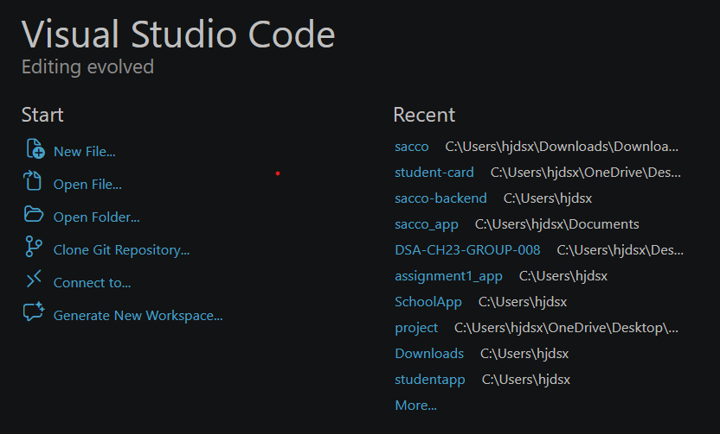
Screenshot 2: Mobile app types research
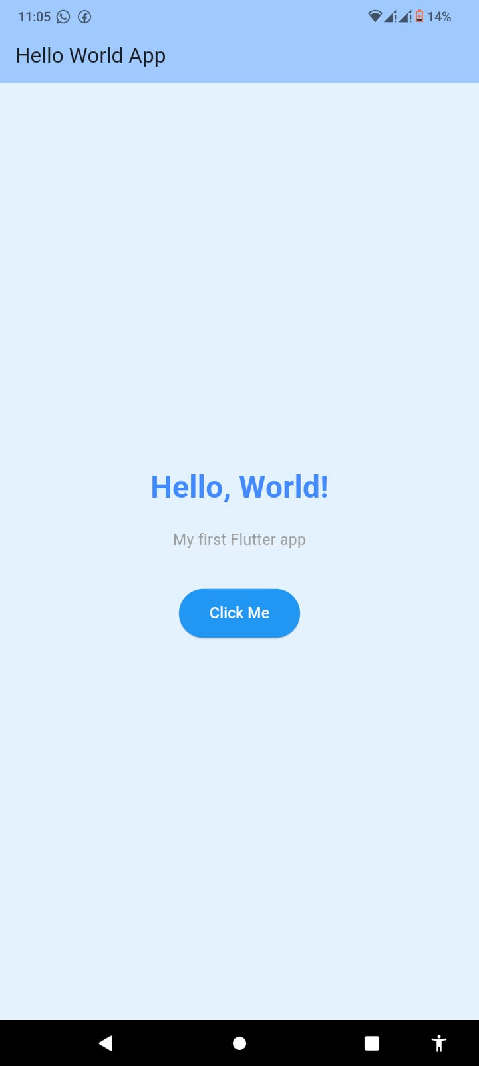

Personal Reflection | This week introduced me to mobile app development concepts. I learned the difference between native, hybrid and cross-platform apps and identified Flutter as our main tool.
Lecturer Remarks
Lecturer Signature

WEEK 2: MOBILE UI DESIGN & FLUTTER BASICS
Week | Week 2
Topic | Mobile UI Design & Flutter Basics
Learning Objectives | Set up Flutter development environment  Understand Flutter widgets  Build a basic Flutter UI  Run a Flutter app on emulator/device
Practical Activities | Installed Flutter SDK and set up VS Code  Built a basic Flutter app with widgets  Created a Mini Student Management App using React Native, Spring Boot and PostgreSQL
Tools / Software Used | Flutter, VS Code, Android Studio, React Native, Expo
Screenshots / Evidence | Yes
Screenshot 1: Flutter installation and setup
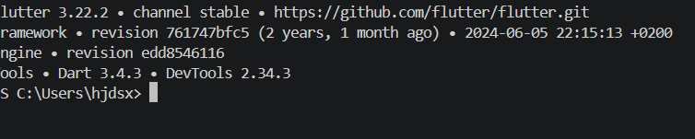
Screenshot 2: Basic Flutter app running on device/emulato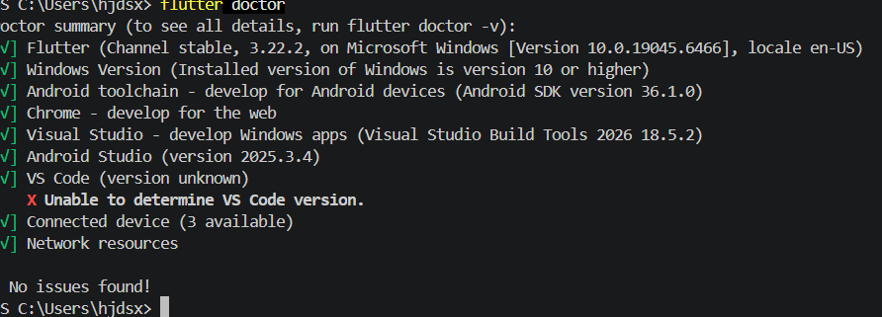
Personal Reflection | Setting up Flutter was challenging but rewarding. I built my first Flutter app and understood how widgets form the building blocks of every Flutter UI.
Lecturer Remarks
Lecturer Signature

WEEK 3: USER INTERFACE (UI) DEVELOPMENT
Week | Week 3
Topic | User Interface (UI) Development
Learning Objectives | Design app wireframes using Figma  Apply color schemes and typography  Convert Figma designs to Flutter code  Implement navigation between screens  Test app on real Android device
Practical Activities | Designed 5 screens in Figma: Splash, Login, Dashboard, Members List, Apply for Loan  Converted Figma designs to Flutter code  Implemented screen navigation using Navigator  Added animations (fade, scale, slide transitions)  Added form validation with Snackbar alerts  Tested on Android 13 device
Tools / Software Used | Figma, Flutter, VS Code, Android Studio, GitHub
Screenshots / Evidence | Yes
Screenshot 1: Figma wireframes (5 screens)
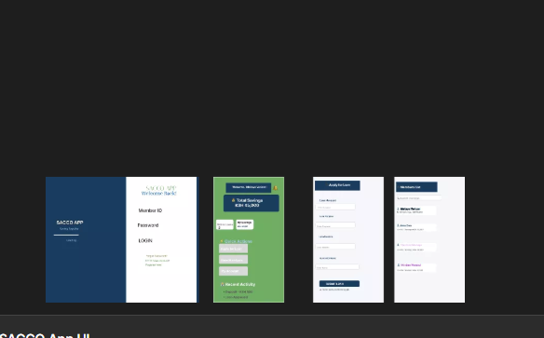
Screenshot 2: Splash Screen with animation
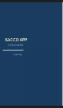
Screenshot 3: Login Screen with validation

Screenshot 4: Dashboard

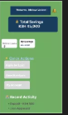
Screenshot 5: Members List

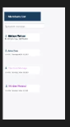
Screenshot 6: Apply for Loan form

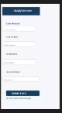
Personal Reflection | This week I built a complete SACCO App UI from design to code. Figma helped visualize screens before coding. Flutter animations made the app feel professional and smooth.
Lecturer Remarks

WEEK 4: DATA MANAGEMENT (LOCAL STORAGE WITH SQLITE)
Week | Week 4
Topic | Data Management (Local Storage with SQLite)
Learning Objectives | Explain data management in mobile applications  Implement local storage using SQLite  Perform CRUD operations on a database  Design a data-driven mobile application
Practical Activities | Added sqflite package to Flutter project  Created Member model class  Built DBHelper class with CRUD functions  Updated Members Screen to load from SQLite database  Created Add/Edit Member form screen  Implemented swipe-to-delete functionality  Made search bar functional with live filtering  Tested data persistence on Android device
Tools / Software Used | Flutter, sqflite package, VS Code, Android device
Screenshots / Evidence | Yes
Screenshot 1: Empty members list
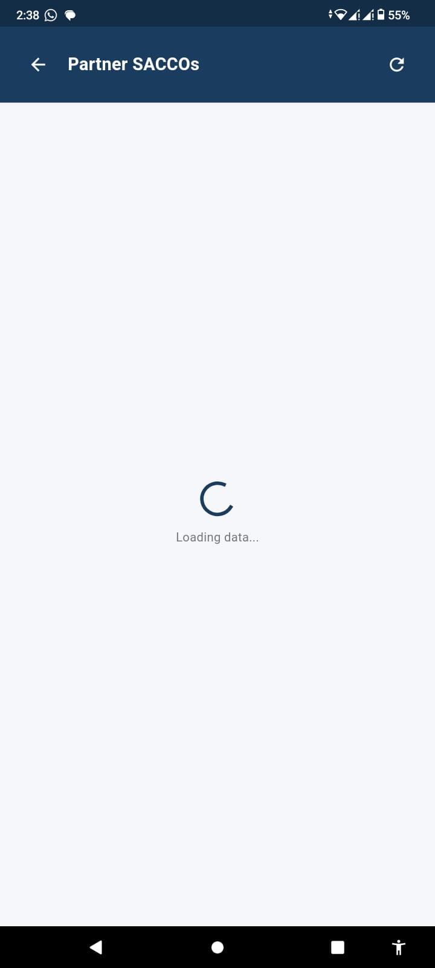
Screenshot 2: Add Member form

Screenshot 3: Members list with saved members

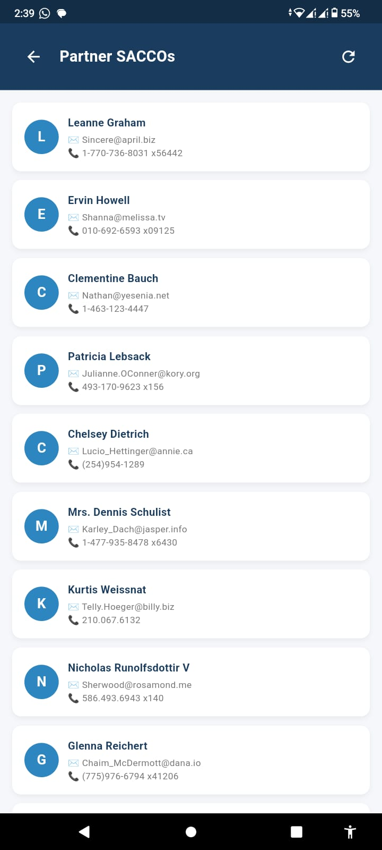

Screenshot 4: Edit Member screen
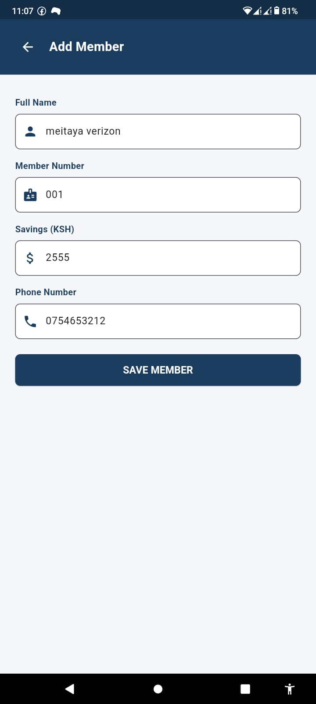
Screenshot 5: Swipe to delete in action
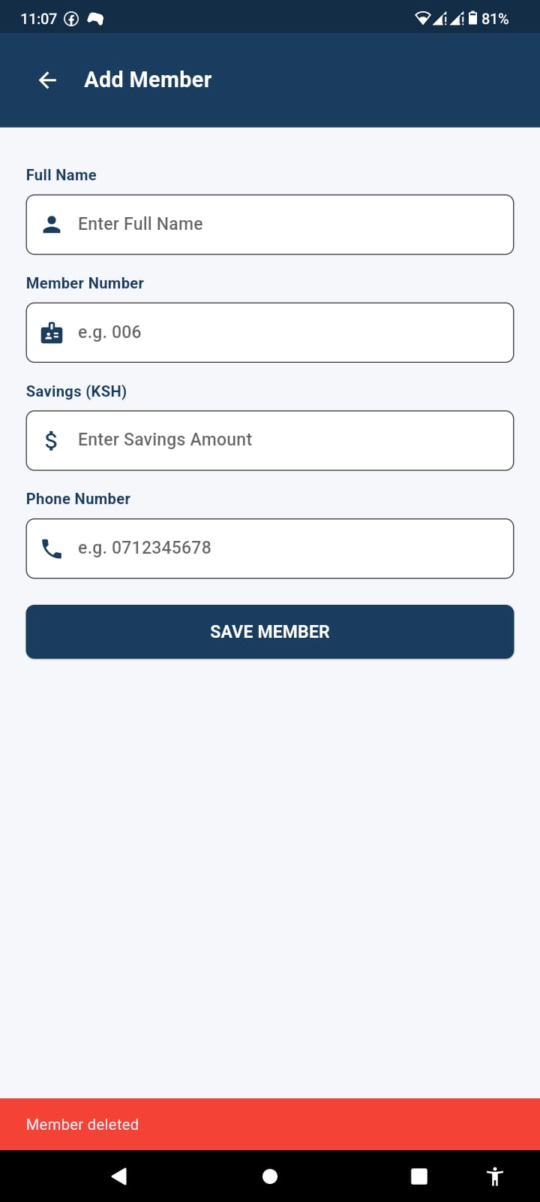
Screenshot 6: Search functionality working

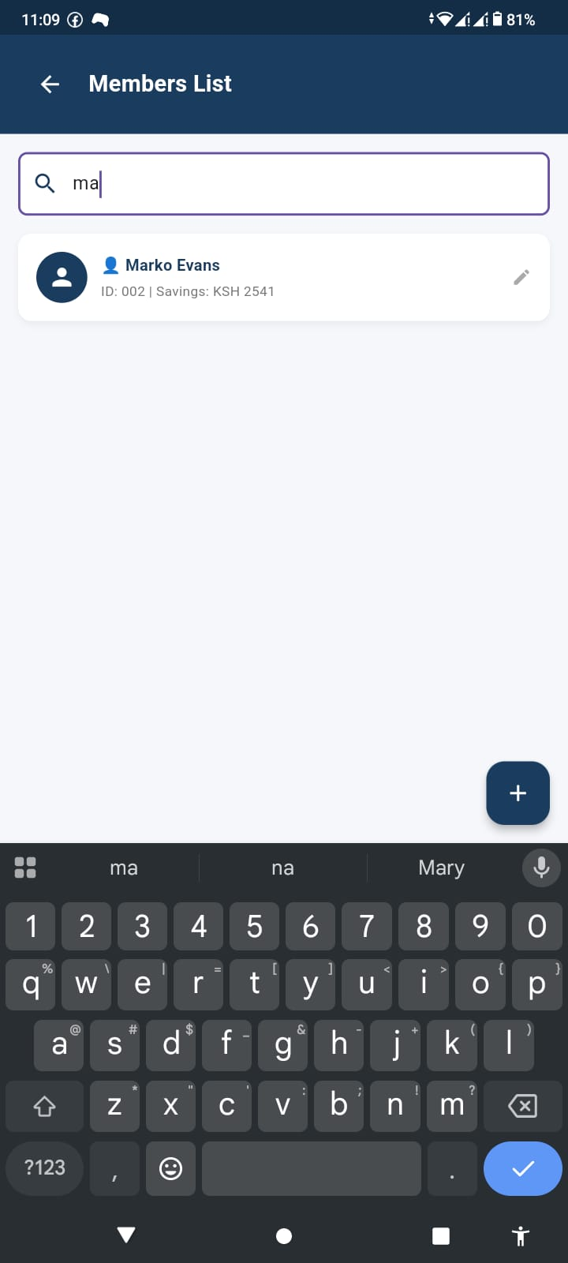

Personal Reflection | Week 4 taught me how to store data permanently using SQLite. CRUD operations make the app dynamic. Data now persists even after closing the app, making it feel real.
Lecturer Remarks
Lecturer Signature

WEEK 5: NETWORKING (REST API INTEGRATION)
Week | Week 5
Topic | Networking (REST API Integration)
Learning Objectives | Explain networking concepts in mobile apps  Understand APIs and web services  Make HTTP GET requests  Handle responses asynchronously  Consume a REST API and display data
Practical Activities | Added http package to Flutter project  Created OnlineMember model with fromJson() method  Built ApiService class to handle GET requests  Created Online Members screen displaying API data  Added loading indicator and error handling  Implemented retry functionality for failed requests  Added Partner SACCOs button on Dashboard  Tested with real internet on Android device
Tools / Software Used | Flutter, http package, JSONPlaceholder API, VS Code, Android device
Screenshots / Evidence | Yes
Screenshot 1: Dashboard with Partner SACCOs button

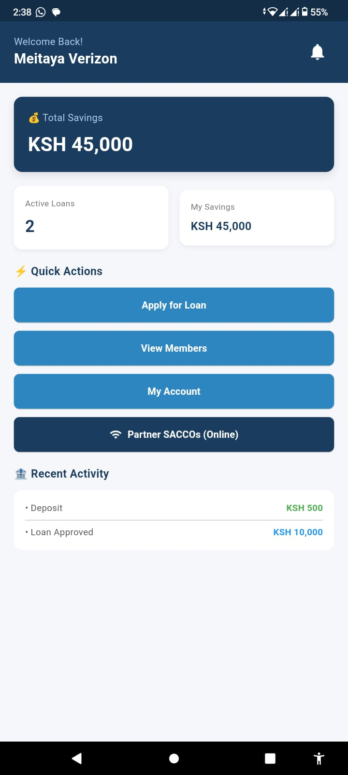

Screenshot 2: Loading state (spinner)



Screenshot 3: Members loaded from API
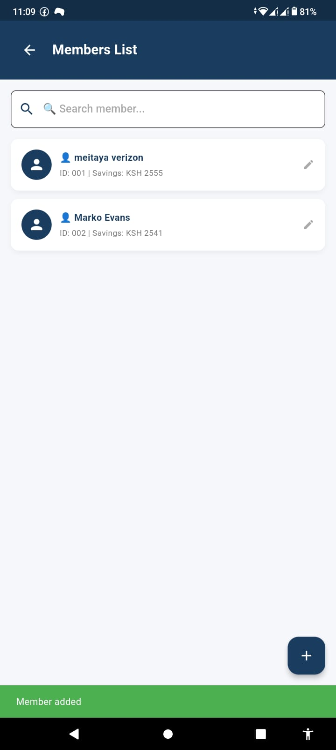
Screenshot 4: Error state - no internet

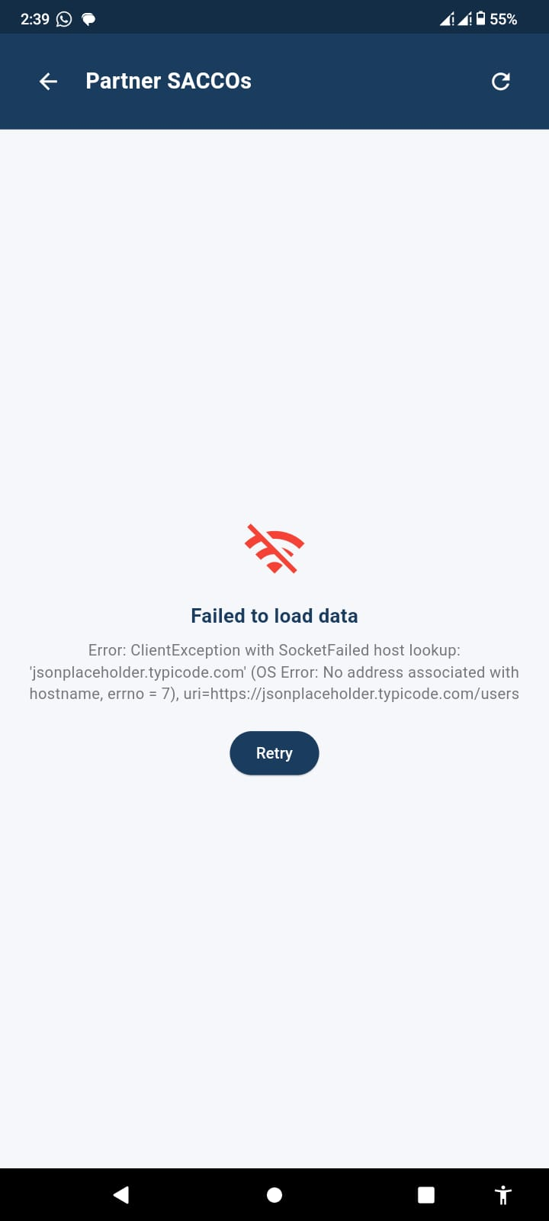

Screenshot 5: Retry button working

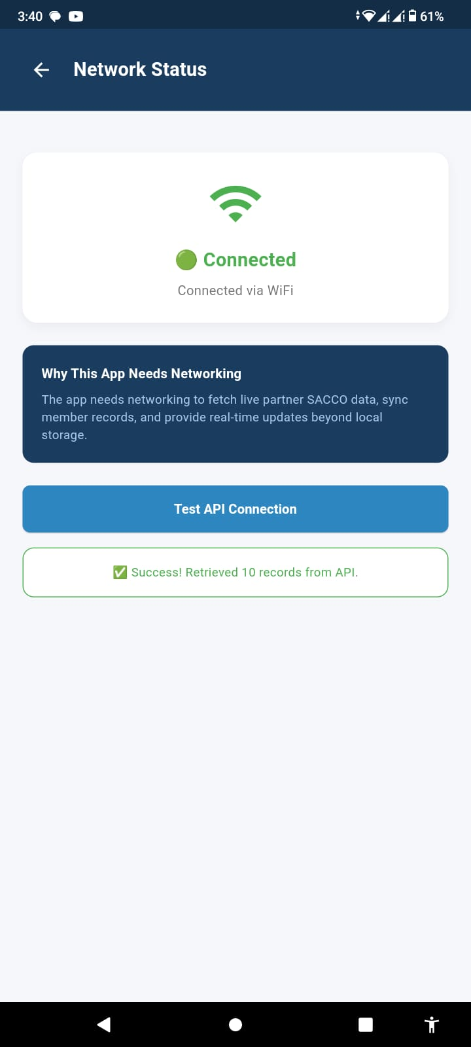

Personal Reflection | Networking brought the app to life by connecting it to real internet data. async/await made requests smooth without freezing the UI. Error handling improved app reliability.
Lecturer Remarks
Lecturer Signature

WEEK 6: NETWORKING CONNECTION SCREEN & API CONCEPTS
Week | Week 6
Topic | Networking Connection Screen & API Concepts
Learning Objectives | Build a real-time network connection status screen  Explain why the app requires networking  Demonstrate API and async operations  Handle online/offline states dynamically
Practical Activities | Added connectivity_plus package  Built Network Status Screen showing WiFi/Mobile/No Connection in real-time  Implemented live connection state listener (auto-updates when WiFi toggled)  Added Test API Connection button with live results  Added Network Status button on Dashboard  Documented why app requires networking (under 20 words)  Wrote explanation of APIs and async operations
Tools / Software Used | Flutter, connectivity_plus package, VS Code, Android device
Screenshots / Evidence | Yes
Screenshot 1: Network Status screen - Connected (green)



Screenshot 2: Network Status screen - No Internet (red)

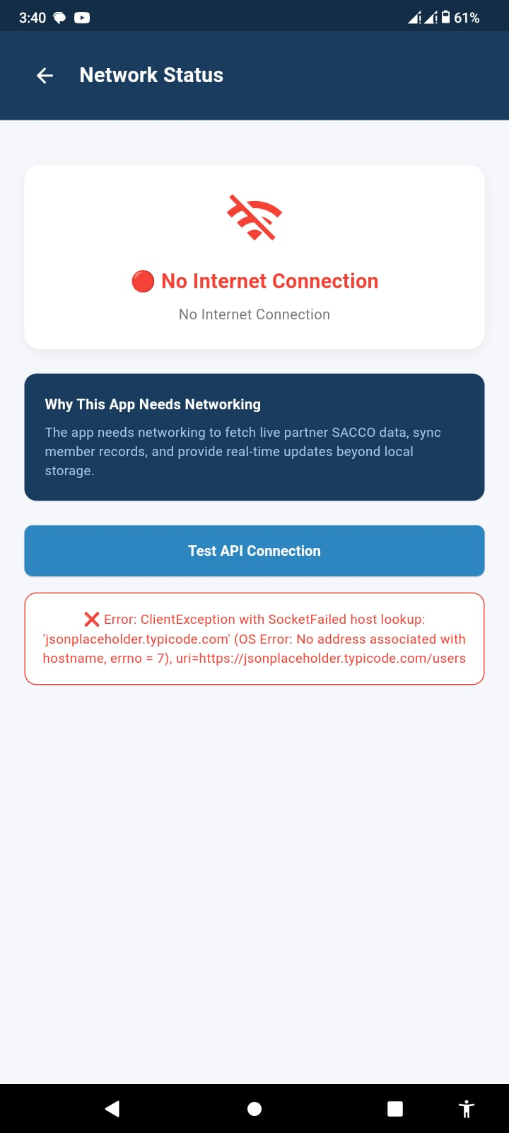

Screenshot 3: API Test - Success message



Screenshot 4: API Test - Failed message (no internet)



Personal Reflection | This week I built a real-time network monitor. Seeing the screen automatically switch between connected and offline states was impressive. Error handling and retry logic made the app robust.
Lecturer Remarks
Lecturer Signature

WEEK 7: CAT 1 EVALUATION & PROJECT REVIEW
Week | Week 7
Topic | CAT 1 Evaluation & Project Review
Learning Objectives | Integrate all concepts from Weeks 1-5  Demonstrate complete mobile application  Apply UI design, navigation, local storage, and networking  Submit technical documentation and source code
Practical Activities | Reviewed complete SACCO App covering all weekly concepts  Verified all 5 screens work correctly  Confirmed SQLite CRUD operations function properly  Tested REST API integration with error handling  Pushed all source code and reports to GitHub  Prepared technical documentation (Week 3-6 reports)  Demonstrated app functionality on real Android device
Tools / Software Used | Flutter, SQLite, REST API, Figma, GitHub, VS Code, Android device
Screenshots / Evidence | Yes
Screenshot 1: Complete app running on Android phone

App is completed and is running omn m phone
Screenshot 2: GitHub repository showing all weeks
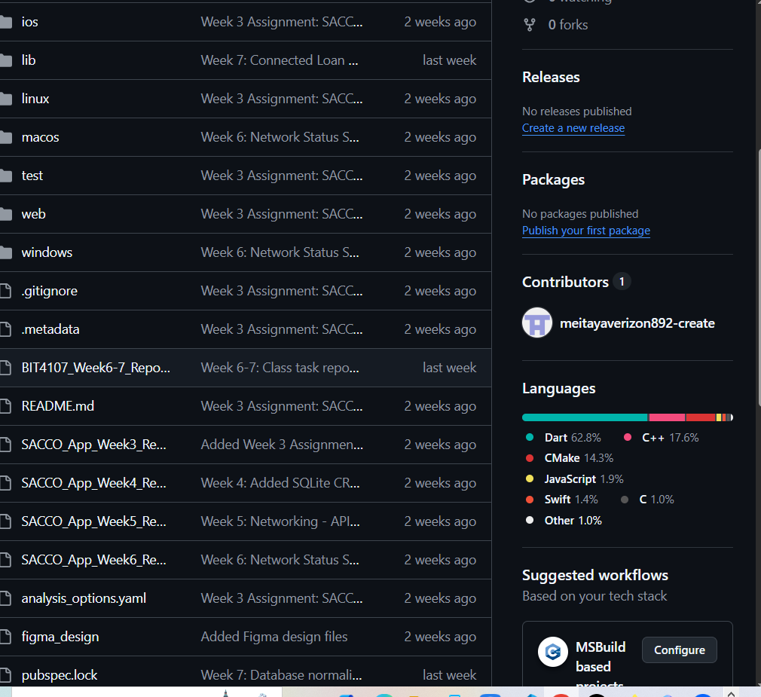
Screenshot 3: All 5 screens demonstration



Screenshot 5: API data loading successfully



Personal Reflection | The CAT brought together everything I learned. My SACCO App now has UI, navigation, local storage, networking and error handling. GitHub submissions show my full learning journey.
Lecturer Remarks
Lecturer Signature

