WEEK 5 ASSIGNMENT
Networking — SACCO App
Student: Meitaya Verizon
GitHub: https://github.com/meitayaverizon892-create/sacco-app
Topic: Mobile API Consumer (REST API + JSON)

Feature Implemented
• HTTP package used to consume a public REST API
• API: https://jsonplaceholder.typicode.com/users
• GET request to retrieve records
• JSON response parsed into Dart objects
• Asynchronous processing (async/await)
• Loading indicator while fetching
• Error handling (404, 500, timeout, no internet)
• Retry button on failure + Refresh button

Screenshots

Dashboard Partner SACCOs Button

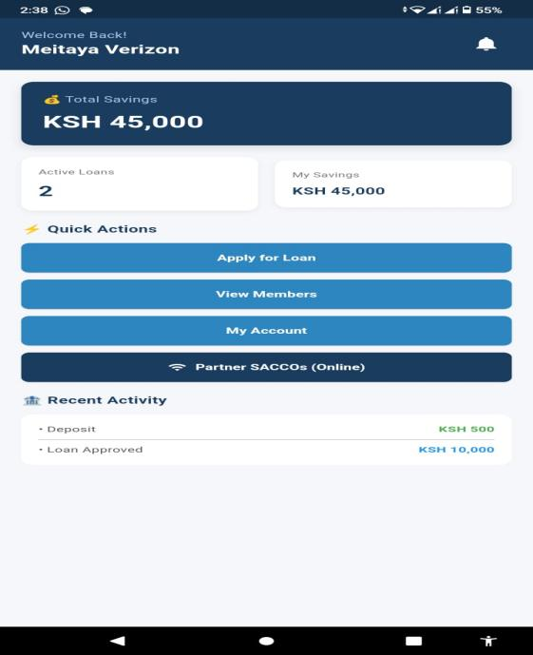

Loading State

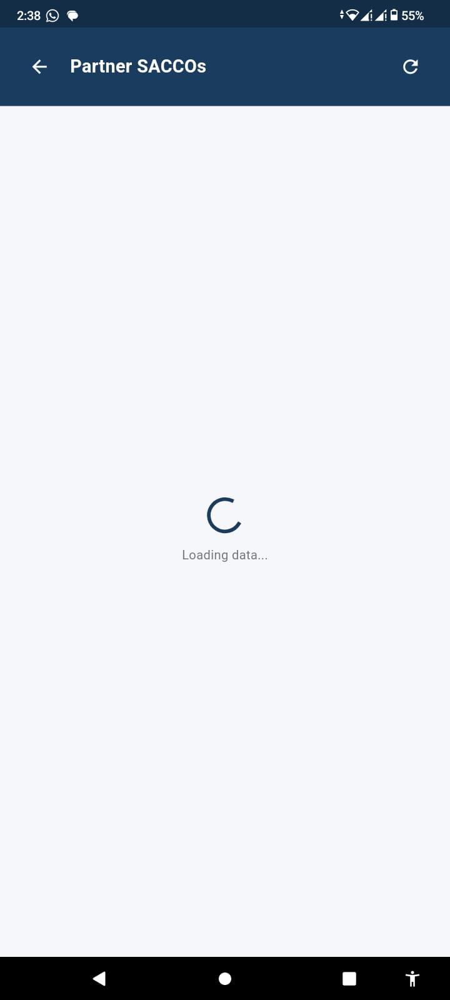

Members Loaded From API

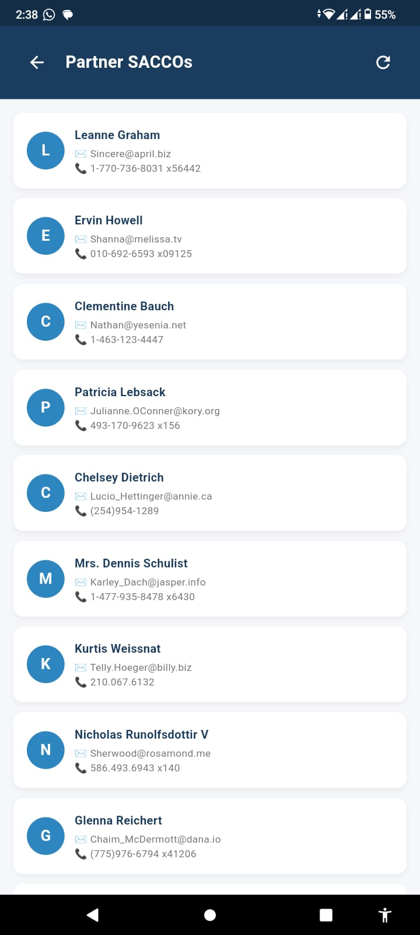

Error State (No Internet) + Retry

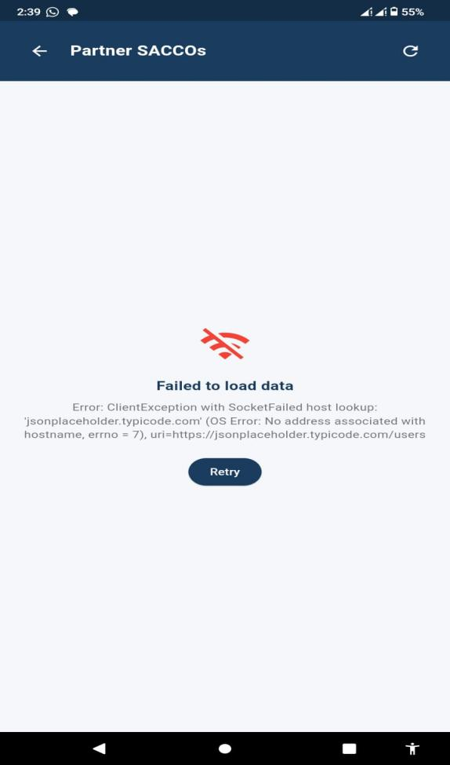

Refresh Working

