**EXPERIMENT 10**

**AIM:** Interfacing of 8051 Microcontroller with LEDs and Seven segment display.

**THEORY:**

**8085 Microcontroller:**

Digit pattern of a seven segment LED display is simply the different logic combinations of its terminals ‘a’ to ‘h’ to display different digits and characters. For example, if you want to display the digit 3 on seven segment then you need to glow the segments a, b, c, d and g, having a binary pattern: 3 → 1 1 1 1 0 0 1, in hexadecimal converts to 0x79. The table below, demonstrates the Hex decimal values that we need to send to the Display from PORT selected.

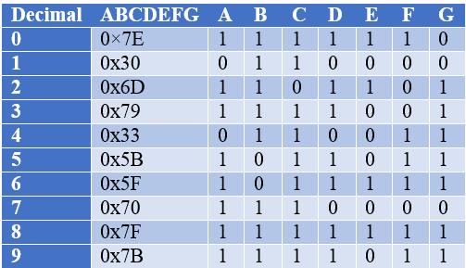

**Applications**

* Seven segments are widely used in digital clocks to display the time.
* These are used in electronic meters for displaying the numerical information.
* Used in Instrument panels.
* Used in digital readout displays.

**Limitations**

* The complexity is increased to display large information.
* It is not possible to display the symbols on seven segment.

**CODE:** To display the last bits of the SAP ID (4190068 → 3FEF74)

MOV P0,#79h

MOV P0,#47h

MOV P0,#4Fh

MOV P0,#47h

MOV P0,#70h

MOV P0,#33h

**OUTPUT:**

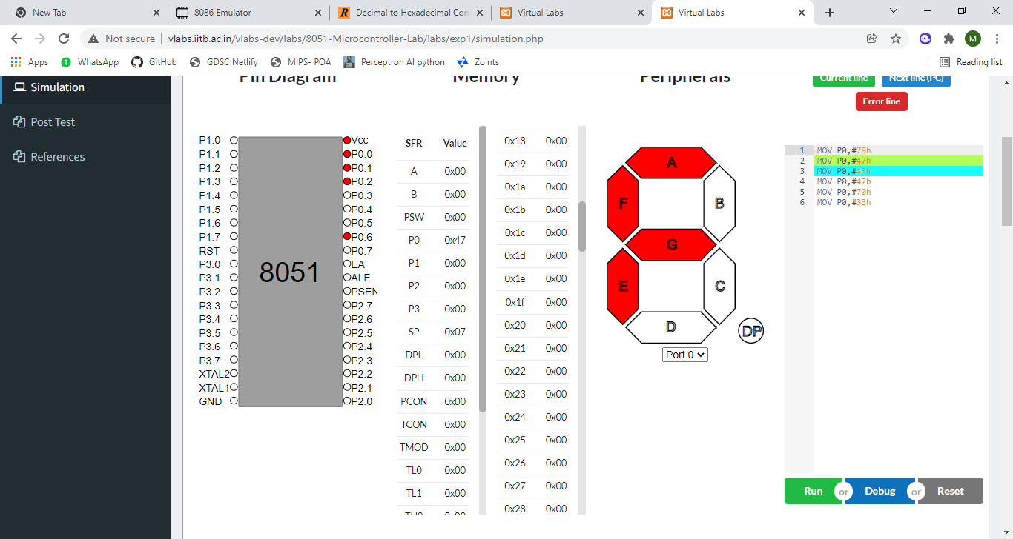

**CONCLUSION:**

In this experiment, I learnt interfacing 7 segment display with 8051 microcontroller. The 7 segment display have 7 segments a, b, c, d, e, f, g and the respective segments need to be lit in order to display a digit. Each digit has it’s own pattern for example, 3 → 1 1 1 1 0 0 1, in hexadecimal converts to 0x79. Thus, in the microcontroller we feed 79H to the port and the number is displayed. In this experiment I displayed the hex value of the last bits of my SAP ID (4190068 → 3FEF74)