EXPERIMENT NO. 07

Aim: To perform various OLAP operations such as slice, dice, drilldown, rollup, pivot

AIM: Perform OLAP operations such as Roll up, Drill down, Slice and Dice, Pivot on Datawarehouse.
Theory:
OLAP is an acronym for On Line Analytical Processing. Online Analytical Processing: An OLAP system manages large amount of historical data, provides Facilities for summarization and aggregation, and stores and manages information at different levels of granularity.
OLAP operations:
Slice: A slice is a subset of a multi-dimensional array corresponding to a single value for one or more members of the dimensions not in the subset.
Dice: The dice operation is a slice on more than two dimensions of a data cube (or more than two consecutive slices).
Drill Down/Up: Drilling down or up is a specific analytical technique whereby the user navigates among levels of data ranging from the most summarized (up) to the most detailed (down).
Roll-up: A roll-up involves computing all of the data relationships for one or more dimensions. To do this, a computational relationship or formula might be defined.
Pivot: To change the dimensional orientation of a report or page display.

EXERCISE 1
Consider a data Warehouse for a hospital, where there are three dimensions:
- Doctor
- Patient
- Time
With two measures
- Count
- Charge
Where Charge is the fee that the Doctor charges a patient for a visit.
Using the above example describe the following operations:
- Slice
- Dice
- Roll Up
- Drill Down
- Pivot
NOTE: Assume data according to the dimensions and measures and explore individual task diagrammatically.

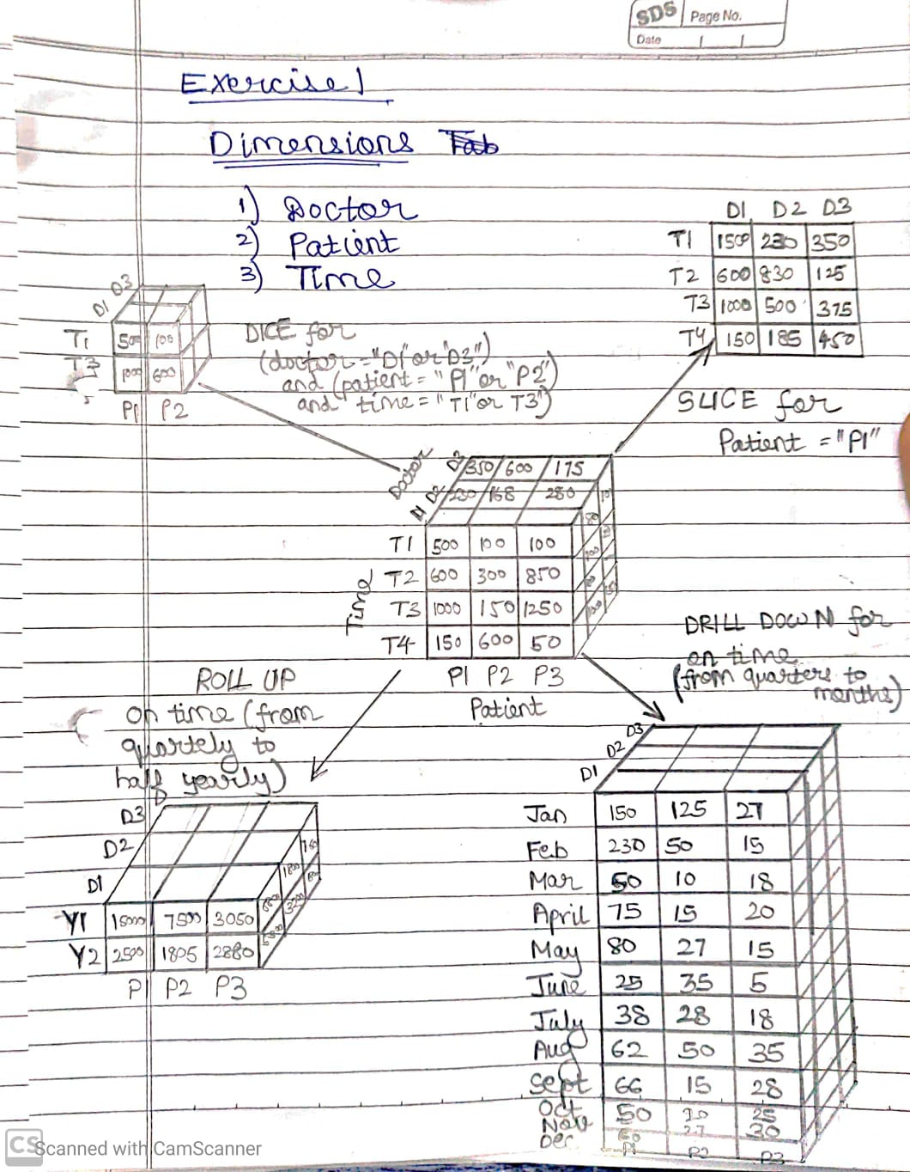

EXERCISE 2

To create Pivot of Table using MS Excel
Follow these steps …
- Start with M.S Excel.
- In excel sheet create 4 columns PRODUCT, ORIGIN, DAY OF SALE, SOLD UNITS (FACT COLUMN).
- Insert around fifty rows of data.
- Save the table data.
- Go to Insert Tab-> click on Pivot Table-> New work sheet-> Ok.
- Right side you will find pivot table fields.
It contains all columns of our table that we created.
Select product in rows,
Days in column,
Unit sold in ∑ values.
Later apply filter using Origin.
Also we can flip the rows & columns or combine together as rows only to see different views of same data.

OUTPUT: PIVOT TABLE

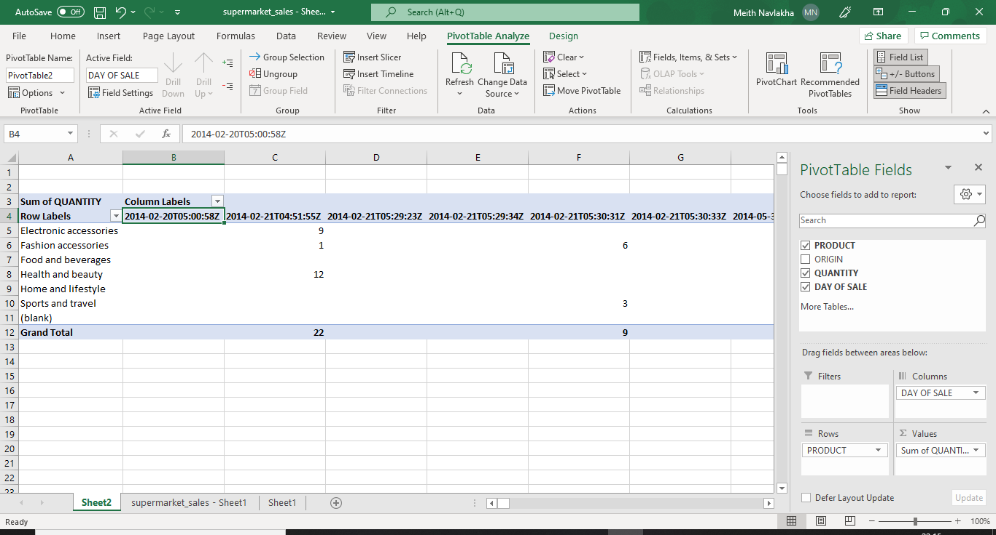

Filter by Origin
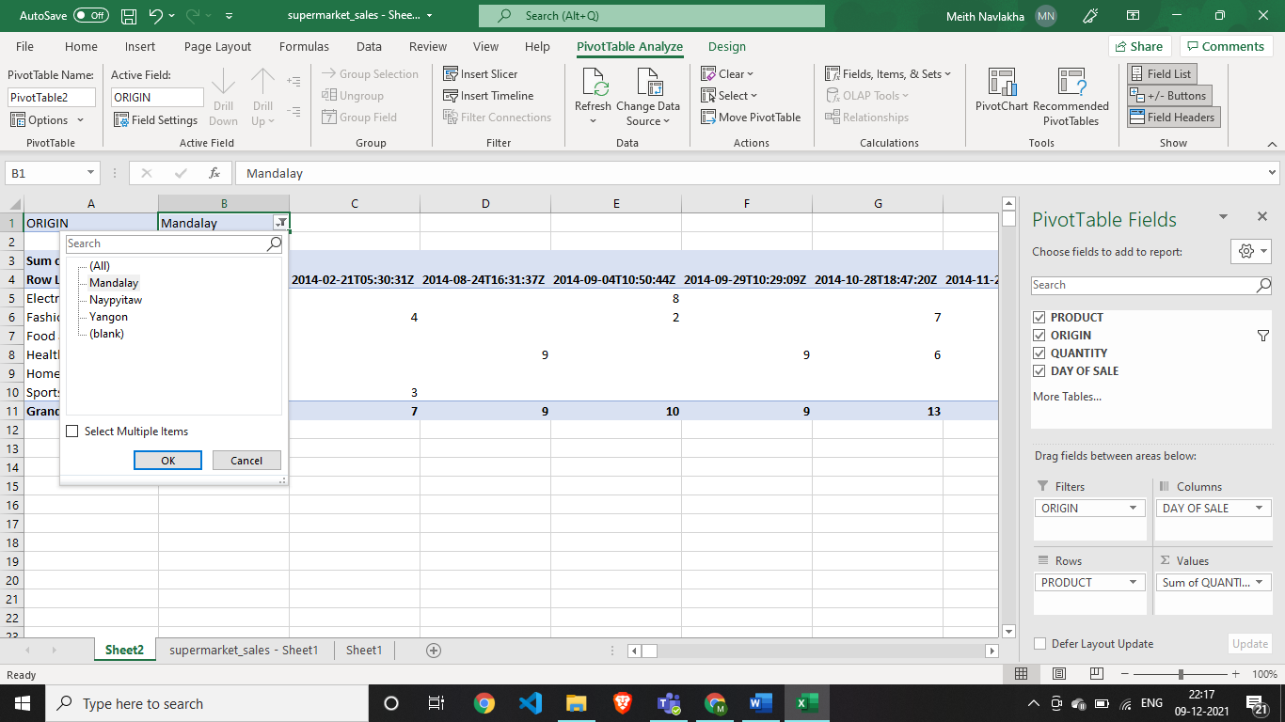

After Applying Filter by origin
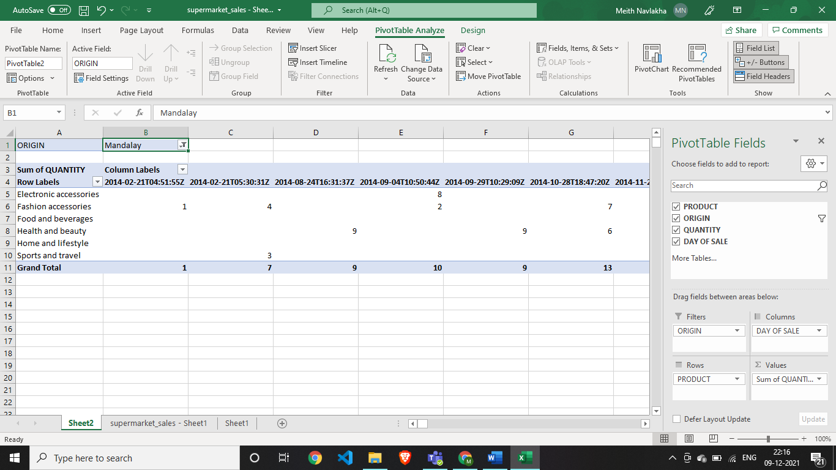

Products and Day of Sales on the rows with summation over Quantity sold along with filter by Origin.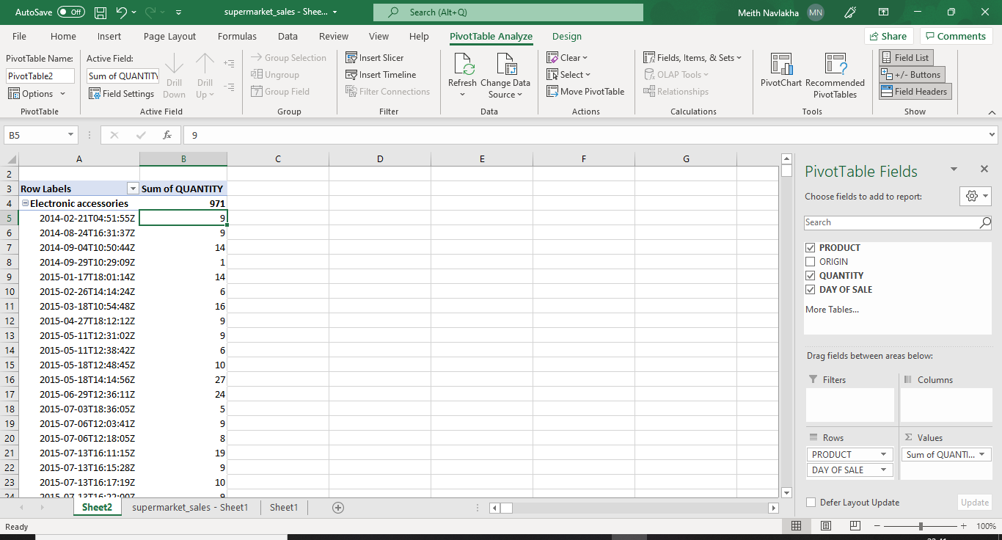

Distribution of products sold by category with respect to the origin place.

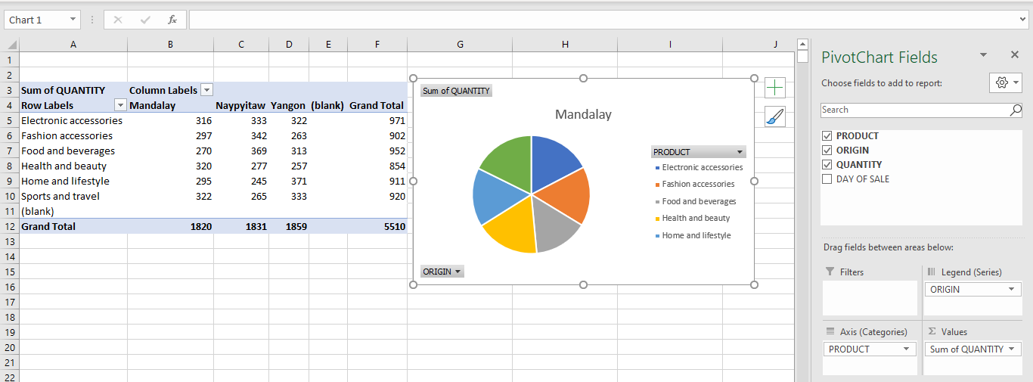
The above table summarizes the number of units sold by a particular category at different locations as well as the total sales for that category. It also gives insights about the category of the products which are most sold in the particular location. Pie chart for the sales distribution in Mandalay is also being displayed.

CONCLUSION:
In this experiment, I designed the data warehouse for a Hospital and performed OLAP operations such as Roll up by aggregating the quarterly time to yearly, Drill down by expanding to a more granular level i.e. months, Slicing the warehouse with respect to the patient (P1) and Dice operation on the warehouse. In the 2nd exercise I implemented Pivot on M.S Excel on the data warehouse. Through the experiment, I learnt the methods of data visualizing and analysis, how a data warehouse can be expanded or aggregated with respect to different fields and from that, strategic decisions can be formulated.

