**Recommendations for change to the game engine**

**1.Add the method to check if a location contains a specific item in the location class**

**Reason:** The current location class contain a method “getItems” which return a list of items in a location instance. Whenever the program needs to check if there is a specific item in a location, the program needs to call the get item method write code to loop through the returned item list. This will lead to unnecessarily repetition of code.

Adding this method could help to simplify the code as the program only needs to call this method to check if a specific item is in the location.

**2. Add method to check the current map that the actors are in**

**Reason:** It isvery difficult to trace which map is the player (or actor) in with the current engine code. (Unless the ground types of different maps are totally different, so that the current map can be determined by checking the ground type of the player(actor)’s location.)

One of the approaches could be modifying the **location** class, merging it with the **gamemap** class to create a (x, y, z) coordinate system where z represents the map.

**3. modified the code in the world class**

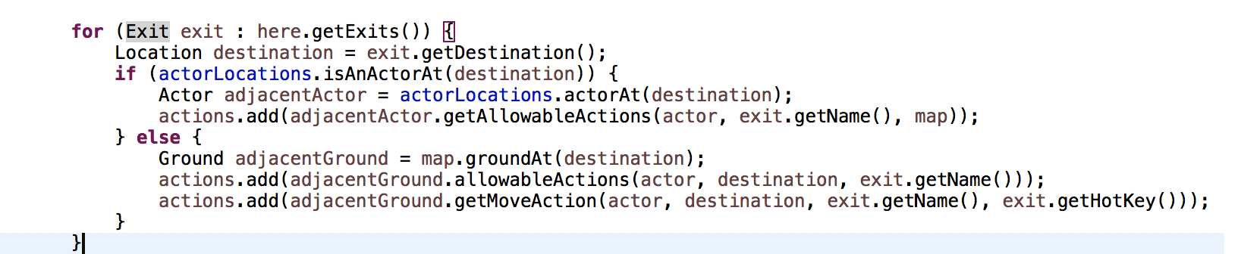

**Reason:** Currently the allowable actions of a ground will be triggered once the actor is in the adjacent grounds of that ground. This should be modified because for some special grounds; the allowable actions might only design to be triggered when the actor enters into those grounds.

One way to solve this problem is to create two types of ground. One type is the one that in the current engine code which its allowable actions could be triggered when the actor is around it. The other type is the one that its allowable actions could only be triggered when the actor is in that ground.

Then, add code to the **processActorTurn** method in the world class to check if the actor is inside the second ground types and determined if the allowable actions of those grounds should be added to the **‘actions’** array.