Name:
Student ID:

Template for assignments, final project and reports. Replace this by the title

Due: April 12 2021 (replace by the due date of assignment/report etc).
Returned: April XX, 2020 (replace as necessary)

Instructions:

- For reports/assignments, modify the title & section titles as necessary.
- 12pt font for text. Do not change the font, line spacing or margins.
- Submission must be done the following way:
  - Electronically as a PDF file at the course website (OWL).
  - Name the file using this pattern: Assignment_number_lastname_id.pdf, Replace number by assignment number, lastname by your last name and id by student id.
  - In your Dropbox at OWL, create a folder called Assignments and deposit the file there.
- Titles and subtitles should be sequentially numbered and in bold type face.
- Remember: You know what you have done, but you must be able to communicate what you have done to the readers. You must provide enough details such that the reader will be able to reproduce your results if he/she wishes to do so.
- You must provide an introduction that puts your study/report in general context.
- Figures: Use different line types and thick enough lines. Axis labels must be large enough and include units when necessary. Captions must always be provided and they must state clearly what the picture intends communicate.
- You must put the results you discuss in the proper context.
- You must provide a discussion and interpretation / conclusions as a separate section.
- Citations to other works and sources must be provided following good scientific practice. The citations must be format in a consistent manner with the title, author list, abbreviated journal name, volume, page range and year as follows:
Design of Supermaterials, A. Author, B. Author, J. Inter. Res., 10, 118-120 (2019). You may also add the DOI number but that is optional
- Note: Clarity and format are part of the evaluation.
- Any possible analysis code(s) (if applicable), must be uploaded at OWL with this report.

The next pages provide the template you must use. When submitting, remove the text under Instructions (gives you a clean cover page).

1. Introduction
- You must provide an introduction that puts your study in general context.
- The text should be at the level of an advanced undergraduate student
- Provide references to original works.

2. Methods and methodology
- You know what you have done, but you must be able to communicate that to the readers. You must provide enough details such that the reader will be able to reproduce you results if he/she wishes to do so.
- Equations must be clearly typed and all variables must be explained.

, ( 1)
where is force, ...

3. Results
- Describe results and analyses in detail
- Figures: Use different line types and thick enough lines. Axis labels must be large enough and include units when necessary. Captions must always be provided and the must state clearly what the picture intends communicate.
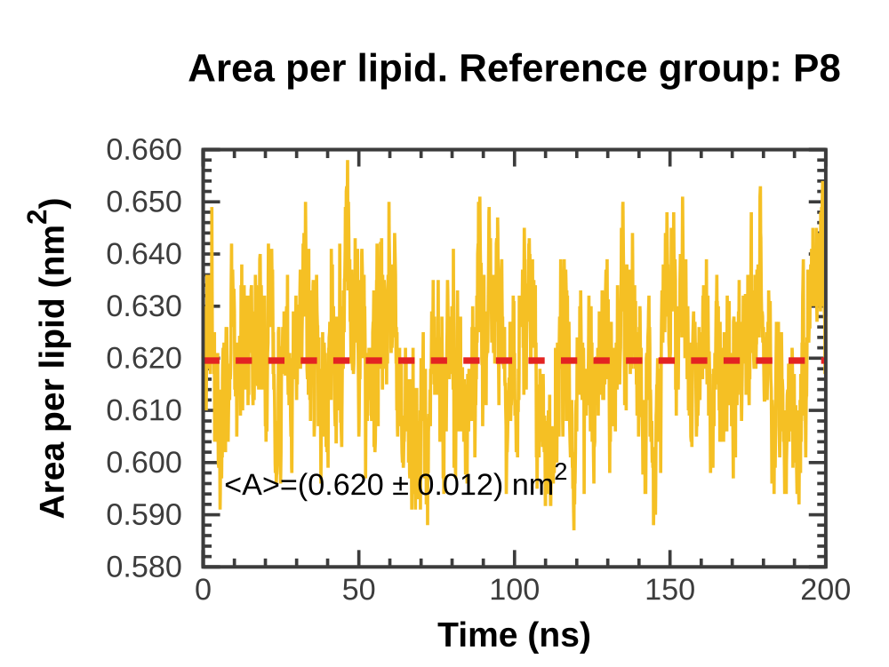
Figure 1: The caption must include a self-contained explanation of the figure and what the reader should pay attention to. Axes must be clearly labelled with large enough fonts. Units must be provided. Use thick enough lines and symbols.
- You must put the results your discuss in the proper context.

4. Discussion and conclusions
- You must provide a discussion and interpretation / conclusions as a separate section.

References
- Use the format below for references.

[1] Design of Supermaterials, A. Author, B. Author, J. Inter. Res., 10, 118-120 (2019).
[2] Design of even superer materials, A. Author, B. Author, Appl. Mat. Lett., 120, 2118-2120 (2019).

