Guide to Artifact Cleaning of the EMG

Introduction
This guide will give a brief overview of the say the EMG scanning artifact (with an i!) could be cleaned. Firstly it will state the kinds of artifact that are generated in a scanner setting, with ways to correct for them using the method from literature by R. Niazy's “FMRIB plug-in for EEGLAB, provided by the University of Oxford Centre for Functional MRI of the Brain (FMRIB)”.
(Aside: Because the correction procedures are actually for EEG measurements, and not for EMG, some minor changes are used in the EMG correction procedure which I hope will work better for EMG. One such change is that you'd want your correction procedure to be as adaptable as possible, to correct for movement related artifacts. One future direction is to further improve the usability of the EMG signal by wavelet analysis, but for now it is not used here.)
As an example, the procedure is explained by correcting the EMG (stored in emg.mat) of PP 9901 in the Tremor study, taken during the tremor2 task, but it could be used on any other EMG. How to obtain an emg.mat from the raw data files from the acquisition computer is discussed elsewhere in a guide “how to convert your data from raw files into files that you need”. I will assume that the conversion worked, and that the file emg.mat is in the directory:

X:/Onderzoek/fMRI/Tremor/pp/9901/tremor2/emg/emg.mat

Other useful files are as always the parameters file:
X:/Onderzoek/fMRI/Tremor/pp/9901/tremor2/parameters
The block design matrix “.mat” file:
X:/Onderzoek/fMRI/Tremor/pp/9901/tremor2/regressor/block.mat

Artifact – where do they come from?
Basically the artefact has two major components:
- Artefact from moving wires in the 3 Tesla field (the greater the velocity of the wires, the bigger the artefact – 0 velocity gives 0 artefact). This is easiest to remove by simply using a filter to “manipulate away” these movement artefacts.
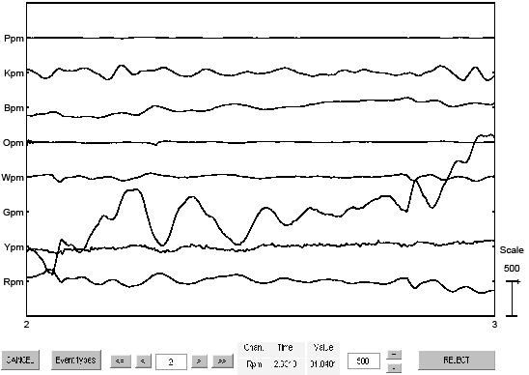
fig1 – see the slowly varying drft in the Green (Gpm) derivation; this is most probably due movement-induced 3T field on the wires.

- Artefact from the EPI sequence used by the scanner to record images. (this artefact originates from the fast-changing 10 mTesla field. Although this second field -used to measure the slices- is relatively small, it changes so fast the artefact on EMG is still huge. The artefact is solely dependent not on the velocity of the wires inside the magnetic field, but rather on the positioning of the wires. But of course, the positioning of the wires depend on movements of the subject, so this sub-division is probably only interesting to physicists.
There are TWO types of artifact from the sequence:
  - Volume artifact, once every TR (2.9 secs)
  - Slice artifact; once every slice (~60 msec)
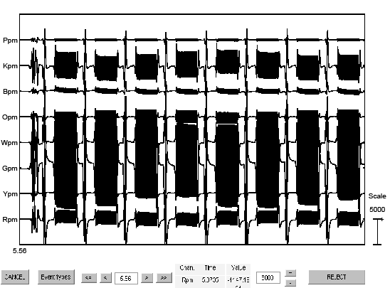
fig2 – you see in the beginning the volume artifact, and after that the slice artifact, both of which need correction. Some channels are more affected than others.

Correction Procedure
The following steps describe how to process the EMG in MATLAB
- Press the emg-fMRI button (if not already done so), go to the approprate folder, and load the emg data.
>> cd X:\Onderzoek\fMRI\Tremor\pp\9901\tremor2\emg
>> load emg.mat
>> eeglab redraw
Inspect with eeglab -> plot -> Plot channel spectra and maps (could be skipped...)
Wire colors are denoted by a letter;
  - P =Purple
  - K=blacK
  - B=Blue (can't use for black...)
  - O=Orange
  - W=White wire
  - G=Green
  - Y=Yellow
  - R=Red
With the p for 'plus', m for 'minus', meaning monopolar derivations, and 'pm' for plus-minus, meaning bipolar derivations. You'd want to measure muscles with bipolar derivations, so the first thing to do (aside: actually the exact , or 'best' way to do things is a subject of a lot of discussion). Gpm means a bipolar derivation of the green wire; Rp is the monopolar derivation of one of the red wires.
These data are 4 times a bipolar and 8 times a monopolar derivation. I made a function to firstly make the bipolar derivations
>> EEG=emg_make_bipolar(EEG);
Inspect it again, and notice that you now only have 8 channels.
- When inspecting the data, rescale the data in the box with the + and – by filling in a value of 20000 (20 mVolts). The next thing is to inspect the data to assess which one has the biggest artefact. Take a note of the channel which has a big artefact in it. (2 has a reasonable artifact!)
>> channel=2;
(if the channel with the biggest artefact is Ppm, or 4 if it is Opm)
Now, add slice-triggers inside your data. These slice-triggers are used as a marker by the artefact correction algorithm in literature. I make a function to do just that:
>> EEG=emg_add_slicetriggers(EEG,channel);
You will see output with a time in 'samples' (118.3 probably) If the values don't change (much!) this procedure works.
- The next step... is the high-pass filter the data. With this procedure the first artefact (descrived above) from the 3T field are somewhat attenuated. Every frequency lower than 25 will become less:
First make the filter in matlab:
>> [b a]=butter(5,25/(EEG.srate/2),'high');
Inspect frequency plot (not needed for now – you see declining power at <25 Hz.)
>> freqz(b,a,EEG.srate/2,EEG.srate);
Then apply the filter to the EMG:
>> d=EEG.data';
>> df=filtfilt(b,a,d);
>> df=df(1:EEG.pnts,:);
>> EEG.data=df';
If all is well you shouldn't have any error-messages, and no motion artifacts.
Now, inspect the data again with plot->channel data (scroll), to see if it actually worked. You should also see green lines with 's' above it – this means that evens have been added.
- Now comes the hardest part, namely to remove the slice and volume artifacts with the toolbox. Since these artifacts have such weird shapes, you cannot simply filter them away with a normal filter, but you must use average artifact templates to have some degree of succes to cleaning your signal.
Firstly go Tools -> FMRIB Tools -> FASTR: Remove .... (the first option)
Then the numbers inside the boxes should be:
  - Low-pass filter cutoff ... = 0
  - Interpolation ... = 10
  - Averaging window length = 10 (!)
  - Artifact-timing event: Slice, and in the box after that, 's'
  - Adaptive Noise Cancellation (not activated)
  - Correct for missing triggers (also not activated)
  - Advaned Options – click it, then:
    - Relative trigger location: 0.07 (not 0.03!)
    - Number of residuals: auto
Then press OK, and if all is well, the program should work. This takes a rather long time (ie; enough for a coffee break; approx. 10 minutes). In the unfortunate event of an error message, I get this sometimes as well. As of yet I haven't found a solution so will therefore have to spit through the program to find out where this error message comes from. It's probably a bug in the program. But it works most of the time.
[It also gives an error message here... I'll have to go through the procedure...]
- The next step then is to remove the Volume artifact.
Go to Tools -> FMRIB Tools -> FASTR: Remove .... (the first option)
Then the numbers inside the boxes should be:
  - Low-pass filter cutoff ... = 0
  - Interpolation ... = 10
  - Averaging window length = 10 (!)
  - Artifact-timing event: Volume, and in the box after that, '65535', or 'V' (only 1 possible)
  - Adaptive Noise Cancellation (not activated)
  - Correct for missing triggers (also not activated)
  - Advaned Options – click it, then:
    - Relative trigger location: 0.03 (leave it at that)
    - Number of residuals: auto
(aside: no, I did not mis-spell advanced... If Niazy says these options are called 'advaned', then there must be a reason so advanced that there's nothing we can do than to just copy the term!)

- The next step is to apply a frequency band-pass filter to the EMG. Lots of artifact components have a higher frequency than the frequency of the EMG and is disturbing your signal... so filter them away, like this:
>> EEG=emg_filter_bandpass(EEG,20,250);

Conclusion
In principle, we're now done. The corrected EMG can be now be inspected and is ready to do further analyses, or model extraction, from. It may or may not look actually useful on visual inspection. One useful further step which almost always needs to be taken is to low-pass filter (again) and rectify the signal to look for discharge envelope rates. (see the paper from Myers: Rectification and non-linear pre-processing of EMG signals for cortico-muscular analysis, Journal of Neuroscience Methods, 124).

