Research group |  | Participant |  | Video: voluntary |  | Video: no myoclonus |  | Video: myoclonus
 |  |  |  | movement |  | EMG: burst |  | EMG: no burst
 |  |  |  | EMG: burst
Genetic negative |  | 1 |  | 4 |  | 11 |  | 4
M-D patients |  | 3 |  | 3 |  | 7 |  | 14

Table 3: Differences between video and EMG recording.

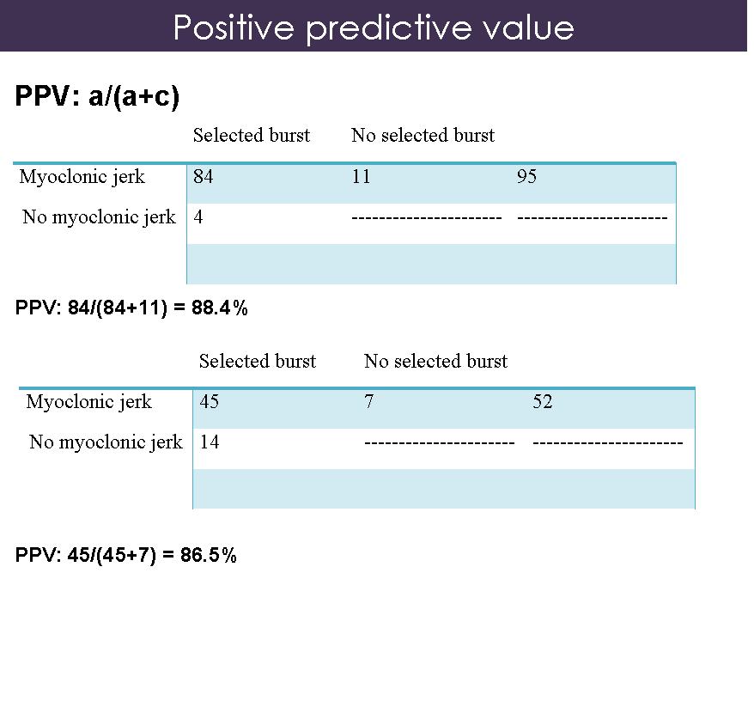
Assuming that the video recordings allow to accurately detect the myoclonic jerks during fMRI scanning we calculated the positive predictive value of the EMG in detecting myoclonic jerks. In the two genetic negative M-D patients this percentage was respectively 88.4 percent and 86.5 percent. Both the false positive selected bursts and the false negatives discovered by video recordings meant discrepancy that is accepted in this study.
Another method to check EMG accuracy was the comparison of bursts selected in the EMG in healthy control subjects and bursts selected in the M-D patients. We did not detect differences between the selected bursts of the group of genetic positive and genetic negative M-D patients and the selected bursts of the group of the healthy control subjects

 | Mean; average number of bursts (rounded) | Range; minimum and maximum number of bursts
Genetic positive M-D patients | 43 | 32-60
Genetic negative M-D patients | 64 | 51-95
Healthy control subjects | 17 | 5-29

