PROJECT PROPOSAL
CareLink
Every patient record, even when the internet is not there.

An offline-first, peer-to-peer patient records app for rural clinics and outreach camps (Android)

Course | Mobile Application Development
Platform | Android (Kotlin, Jetpack Compose)
Presented by | Kirabira Mohammad Elias  Makabugo J.Shafic  Kaddu Suudi
Date | October 2026

1. Problem Statement
In rural clinics and outreach camps, internet access is slow, intermittent, or absent. Most digital record systems assume a constant connection, so health workers fall back on paper. Paper records are easily lost, duplicated, or delayed, and they rarely reach the central database in time to support follow-up care, referrals, or reporting.
Going digital does not remove the problem by itself. Where devices can exchange data, two workers may edit the same patient record while offline. Existing tools usually resolve such clashes silently, most often with “last write wins”, so one worker’s clinical entry can vanish without anyone noticing. In healthcare, a silently lost allergy, dose, or follow-up date is a patient-safety risk, not a minor bug.
The gap: apps that are offline-first exist, but few let nearby devices sync directly with each other, and fewer still detect and surface conflicting edits instead of hiding them. CareLink targets exactly that combination.

Who is affected
User | Situation | What they need
Community health worker (CHW) | Walks to villages and camps; no signal; one phone | Register patients and log visits quickly, never lose data
Clinic nurse | Shared clinic with one or two devices; internet is rare | See the patient’s latest history, even if a colleague saw them elsewhere
Supervisor / records officer | Needs consolidated data for reporting | A trustworthy central database and a way to resolve flagged conflicts

2. Aim and Objectives
Aim. To design, build and evaluate an Android app that works fully offline, shares patient records directly between nearby devices, detects conflicting edits instead of hiding them, and syncs to a central server whenever any device gets internet.

Objectives
# | Objective | How it will be verified
O1 | Build an offline-first app with a local encrypted database (SQLCipher) for patient and visit records. | App runs in airplane mode; database file is unreadable without the key.
O2 | Implement automatic peer discovery (BLE) and data exchange (Wi-Fi Direct, Bluetooth fallback). | Two to five devices discover each other and exchange records without user setup beyond a one-time pairing.
O3 | Implement and compare three conflict-resolution strategies for concurrent edits. | Same test scripts replayed under each strategy; results tabulated.
O4 | Build a cloud sync layer that uploads accumulated data whenever any device goes online. | Records created offline appear in the cloud database exactly once after reconnect.
O5 | Measure the battery and performance cost of continuous peer discovery. | Battery drain per hour measured at several scan intervals on physical devices.

3. Research Questions and Hypotheses
Research question | Hypothesis
RQ1. Which conflict-resolution strategy preserves the most data accuracy with the least overhead? | H1. Vector clocks with flagged conflicts will lose no concurrent edits, whereas last-write-wins will silently discard some, at a small storage and sync-time cost.
RQ2. How much battery does continuous peer discovery use, and how does scan interval affect it? | H2. Duty-cycled scanning (for example 10 s scan every 60 s) will cut discovery battery drain substantially compared with continuous scanning, while only modestly increasing the time to find a peer.

4. Requirements

Functional requirements
- FR1 Secure login with worker PIN or biometrics; each edit records who made it.
- FR2 Register, search, view and edit patients; record visits (complaint, vitals, diagnosis, treatment, follow-up date).
- FR3 Discover nearby CareLink devices automatically and show sync status (peers found, last sync, records pending).
- FR4 Exchange only changed records (delta sync) with trusted peers.
- FR5 Detect concurrent edits, keep both versions, and show a conflict-review screen to resolve them.
- FR6 Upload pending records to the cloud automatically when internet is available; safe to retry.
- FR7 Supervisor view of consolidated records and unresolved conflicts.

Non-functional requirements
Quality | Requirement
Offline | Every user-facing feature except cloud upload works with no network.
Security | Encrypted at rest (SQLCipher, key in Android Keystore); encrypted and authenticated peer channel; HTTPS to cloud.
Integrity | No silent data loss: a concurrent edit is either merged safely or flagged. Re-sending a record never creates a duplicate.
Performance | Target: sync 100 changed records between two devices in under 10 seconds.
Battery | Target: discovery overhead measured and a recommended scan setting published.
Usability | Registering a patient in under one minute; large touch targets and simple language for low-training users.

5. Proposed Solution
CareLink treats every phone as a full copy of the clinic’s data. Phones sync with each other whenever they meet, and any phone that reaches the internet uploads everyone’s accumulated changes, so one lucky connection carries the whole group’s data to the cloud.

Technology choices
Layer | Choice | Why
App | Native Android: Kotlin, Jetpack Compose, MVVM | Direct, reliable access to BLE, Wi-Fi Direct and foreground services. Flutter plugins for these are less mature.
Local database | Room over SQLCipher | Encrypted SQLite with type-safe queries; migrations; works offline.
Peer discovery | Bluetooth Low Energy advertising and scanning | Low power; lets devices notice each other cheaply.
Peer transfer | Wi-Fi Direct (Bluetooth Classic fallback) | Higher throughput for bulk record transfer; fallback for devices with poor Wi-Fi Direct support.
Background work | Foreground service (sync) and WorkManager (cloud upload) | Survives screen-off; upload runs as soon as network constraint is met.
Cloud | FastAPI REST + PostgreSQL | Simple, quick to build; JSONB suits version payloads.

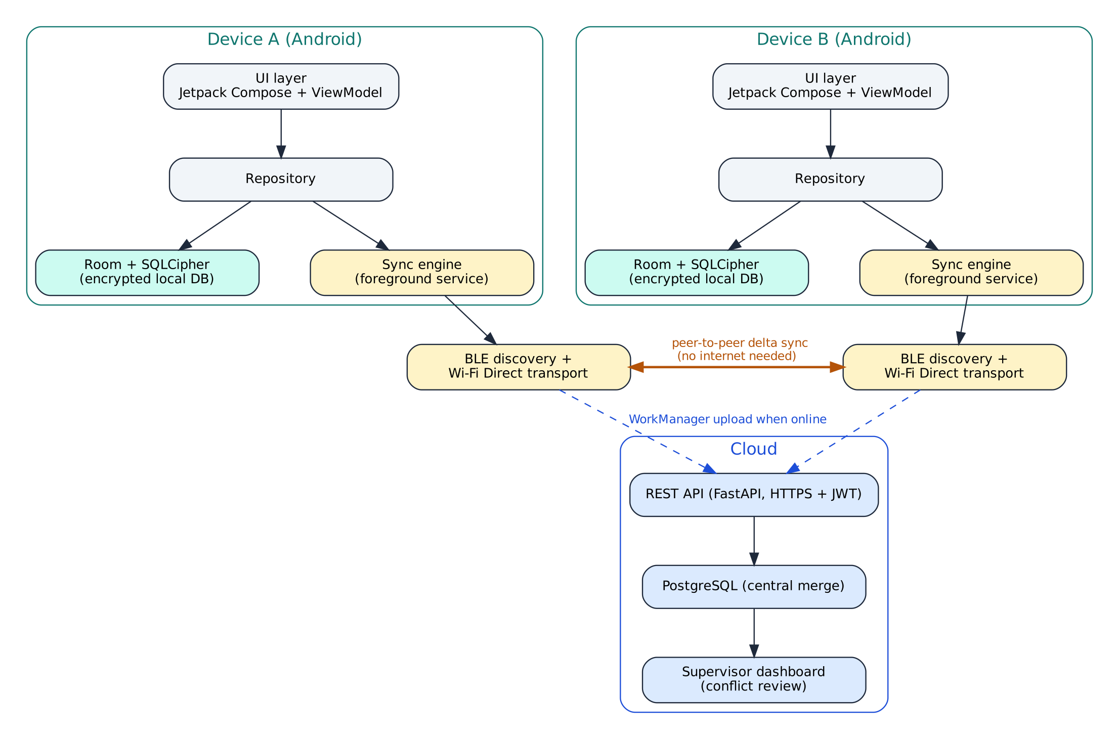
Figure 1. System architecture: devices sync peer-to-peer offline and upload to the cloud when online.

How a sync works
Each device keeps an append-only history of record versions. When two devices meet they compare compact clock summaries, send each other only what the other has not seen, and flag any record that was changed on both sides independently.
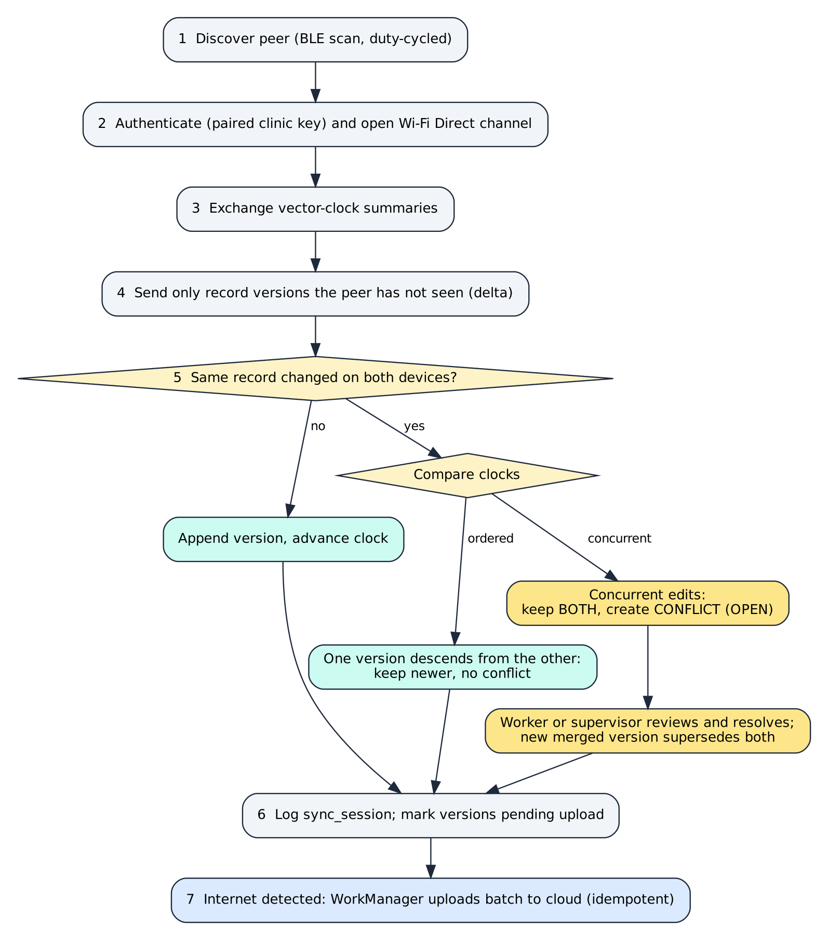
Figure 2. Sync and conflict-handling flow, from discovery to cloud upload.

Planned screens
Screen | Purpose
Login / PIN | Identify the health worker; unlock the encrypted database.
Patient list and search | Fast lookup by name, village or phone; offline.
Patient detail and visit form | View history, add a visit, edit demographics.
Sync status | Nearby peers, last sync time, pending records, internet/cloud status.
Conflict review | Side-by-side comparison of two versions with “keep A / keep B / merge”.
Settings | Scan interval, pairing (QR code), language, data export.

6. Data Design (ER Diagrams)
Four ER diagrams describe the system: the conceptual model, the on-device database, the cloud database, and the evaluation data collected during experiments. They use crow’s-foot notation.
Key. PK = primary key, FK (italic) = foreign key. Teal headers are core clinical entities, amber headers are sync and conflict entities (the novel part of CareLink), blue headers are supporting entities. Line ends show cardinality: a double bar is exactly one, a circle with a crow’s foot is zero or many, a bar with a crow’s foot is one or many.

6.1 Conceptual ER diagram
A clinic employs health workers and registers patients. Workers record visits. Every change to a patient or visit becomes an immutable RECORD_VERSION authored on a DEVICE; if two versions are concurrent, a CONFLICT links them. SYNC_SESSION captures each peer exchange.
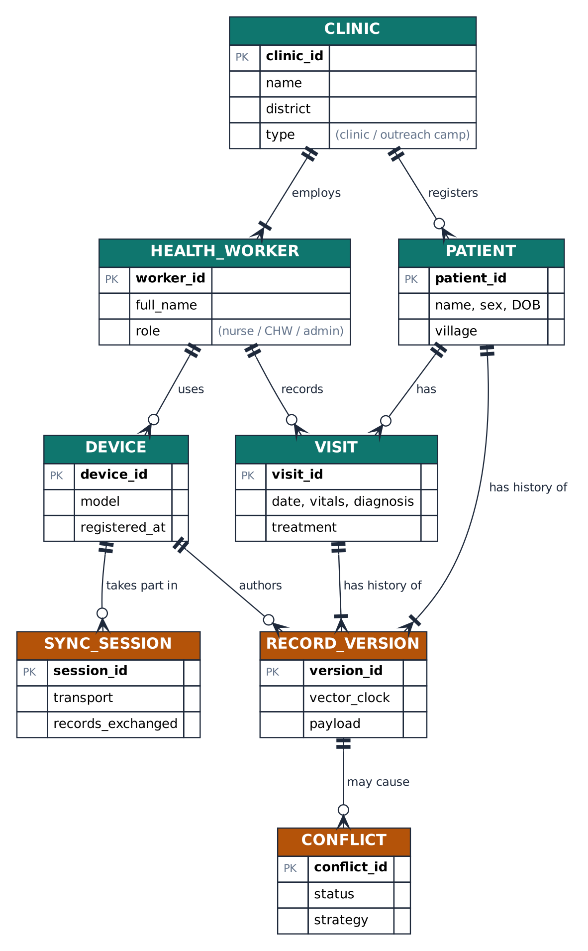
Figure 3. Conceptual ER diagram.

6.2 On-device database (SQLite with SQLCipher)
Patients and visits hold the current state; record_version keeps the full history with a vector clock and a hybrid logical clock (HLC) timestamp. Because rows are never overwritten, a conflict can always be reconstructed and reviewed.
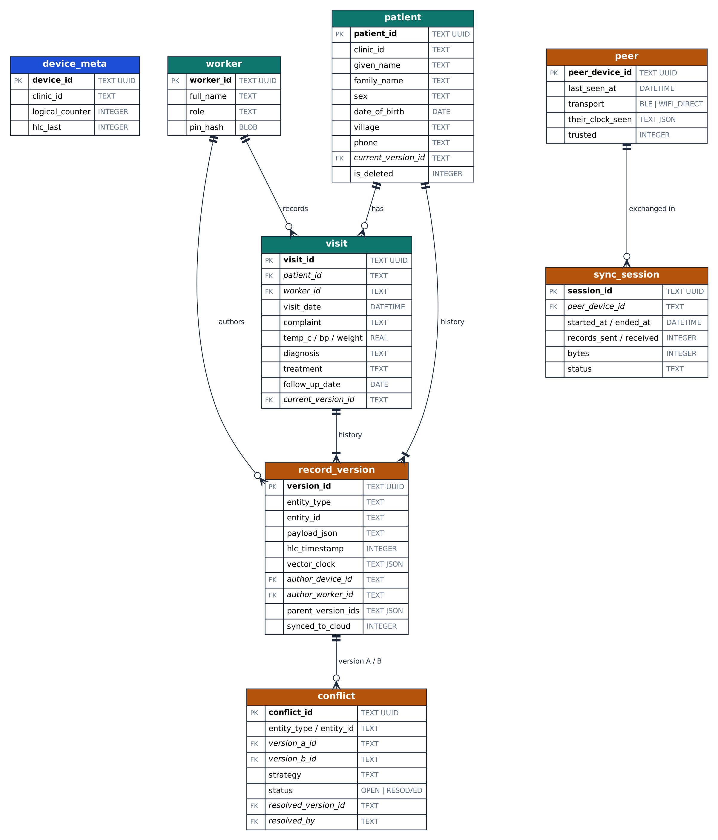
Figure 4. Logical ER diagram of the on-device database. device_meta is a one-row table storing this device’s identity and clock counters.

6.3 Cloud database (PostgreSQL)
The cloud schema mirrors the device schema and adds upload_batch (for idempotent, auditable uploads), health_worker/device ownership, an audit log, and merged_into_id on patient to support de-duplicating the same person registered on two devices.
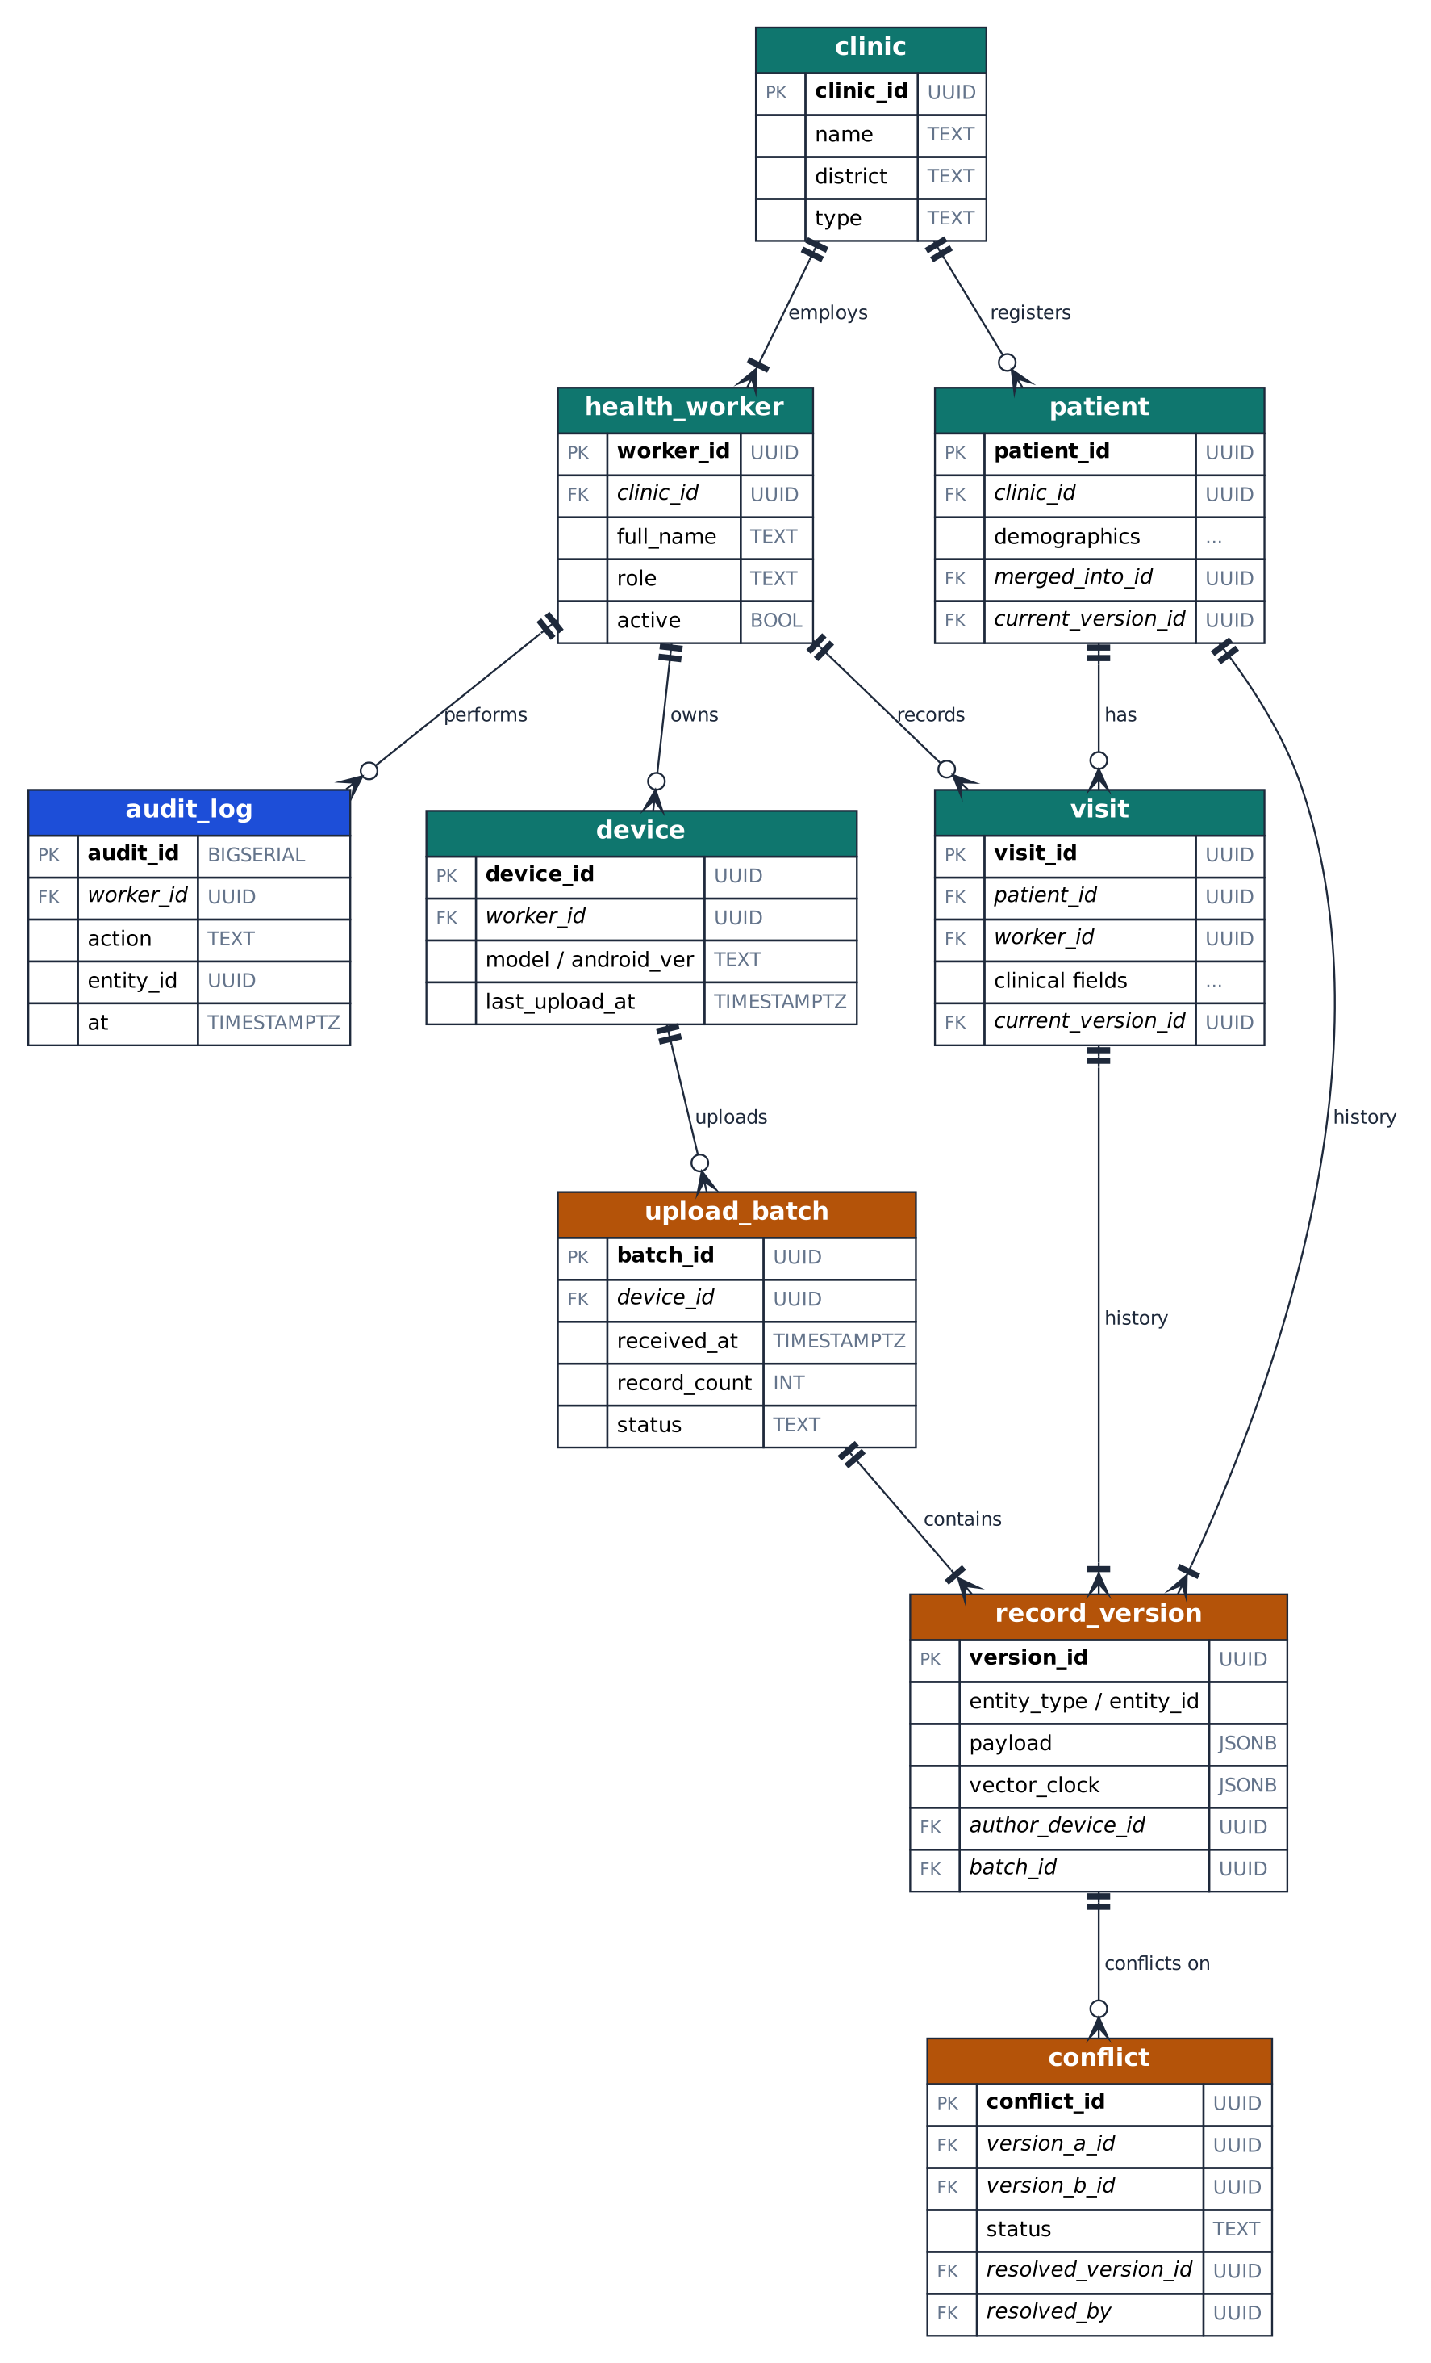
Figure 5. Logical ER diagram of the cloud database.

6.4 Evaluation data model
Experiment results are stored in a small structured model so every table in the final report can be regenerated from raw measurements.
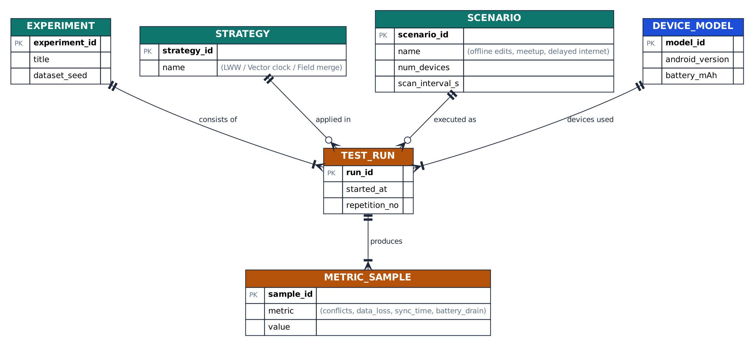
Figure 6. ER diagram for experiment and metric data.

Key design decisions
- UUIDs as primary keys. Offline devices cannot coordinate auto-increment IDs; UUIDs let any device create records without collisions.
- Append-only versions. Edits create new versions rather than overwrite, so concurrent edits are never destroyed before a strategy decides what to do.
- Idempotent upload. Every version has a unique ID, so a retried upload cannot create duplicates.
- Soft delete. Deletions are flagged and synced like any other change.
- Duplicate patients. The same person may be registered on two devices. Cloud-side matching (name, date of birth, village, phone) proposes merges via merged_into_id for supervisor approval.

7. Conflict-Resolution Strategies Under Comparison
Strategy | How it decides | Strengths | Weaknesses
S1 Last-write-wins (HLC timestamps) | Newest timestamp survives; the other is discarded | Simplest; no user effort; baseline | Silently loses concurrent edits; depends on clock quality
S2 Vector clocks + flagged conflict | Detects true concurrency; keeps both versions; asks a human | No silent loss; auditable | Needs a review step; clock metadata grows with device count
S3 Field-level merge + flag overlaps | Merges edits to different fields automatically; flags only same-field clashes | Fewer manual reviews | More complex; needs per-field versioning

S1 is the baseline most apps use; S2 is the safety-first design; S3 tests whether finer granularity reduces the review burden.

8. Security, Privacy and Ethics
- Encryption at rest. SQLCipher database; key protected by the Android Keystore and unlocked by worker PIN or biometrics.
- Trusted peers only. Devices pair once (for example by scanning a QR code carrying a clinic key); all peer traffic is authenticated and encrypted, and unknown devices are ignored.
- Cloud. HTTPS, token-based authentication, role-based access, audit log of reads and edits.
- Legal context. Health data is sensitive personal data; a real deployment would need to comply with local law such as Uganda’s Data Protection and Privacy Act, 2019.
- Ethics of testing. All experiments use synthetic patient data. No real patient information is used in development or demos.

9. Methodology and Evaluation Plan

Approach
- Review related work: vector clocks, hybrid logical clocks, CRDTs, delay-tolerant networking, local-first software.
- Design the architecture and data model (Section 6).
- Develop the prototype iteratively in Android, with unit tests on the sync and conflict logic before any device testing.
- Test on 3 to 5 physical Android devices using scripted scenarios.
- Compare strategies and scan intervals using the metrics below.

Test scenarios
Scenario | What happens | Tests
A Offline edits | Two devices edit the same patient while apart, then meet | Conflict detection; data loss under S1 vs S2 vs S3
B Chain of meetups | A meets B, B meets C, C meets A, in varying order | Convergence: do all devices end up identical?
C Delayed internet | Only one device gets internet after hours offline | Cloud receives everyone’s data exactly once
D Scan interval sweep | Continuous, 10 s, 30 s and 60 s scan intervals over a fixed period | Battery drain and discovery latency

Metrics
Metric | Definition
Conflict count | Concurrent edits detected per scenario run
Data-loss rate | Concurrent edits whose content is missing from the final record, divided by total concurrent edits
Convergence | Whether all devices hold identical data after the final sync
Sync time | Seconds to sync N changed records (N = 10, 100, 500)
Storage overhead | Extra bytes per record from version history and clocks
Battery drain | Percentage of battery per hour (and estimated mAh) at each scan interval, measured with Android battery stats

Each scenario is repeated at least five times per configuration, and results are reported as mean and range. Dataset: about 500 synthetic patients and 2,000 visits, generated from a fixed seed so runs are reproducible.

Success criteria (targets to be validated)
- All devices converge in 100% of scenario B runs.
- Zero silent data loss under S2 and S3 in scenario A.
- Cloud upload creates no duplicates in scenario C.
- A recommended scan interval is identified with measured battery cost.

10. Work Plan
Weeks | Activity | Deliverable
1–2 | Literature review; requirements; UI sketches | Review notes, requirements list
3–4 | Local app: login, patient and visit CRUD, SQLCipher | Offline single-device app
5–7 | Version history, clocks, BLE discovery, Wi-Fi Direct sync | Two-device peer sync
8–9 | Conflict strategies S1–S3; conflict-review screen | Strategy comparison harness
10 | Cloud API, WorkManager upload, supervisor view | End-to-end sync to cloud
11–12 | Experiments on 3–5 devices; data collection | Raw measurements
13 | Analysis; fixes; demo rehearsal | Results and charts
14 | Final report and presentation | Report, demo, source code

11. Risks and Mitigation
Risk | Likelihood / impact | Mitigation
Wi-Fi Direct and Bluetooth behave differently across Android versions | High / High | Fix a tested device list; keep Bluetooth fallback; log failures per model
Android background limits stop discovery | Medium / High | Foreground service with a visible notification; test battery-optimisation exemptions
Device clocks are wrong, breaking last-write-wins | Medium / Medium | Use hybrid logical clocks; report clock skew as a finding
Too few physical devices | Medium / Medium | Borrow devices; use emulator pairs for logic tests only
Scope too large for the time | Medium / Medium | S3 and the supervisor dashboard are stretch goals; core is S1, S2 and peer sync

12. Scope and Limitations
- Android only, since iOS restricts background networking.
- Bluetooth and Wi-Fi Direct behaviour varies across Android versions, so the app is tested on specific devices.
- Live demos need physical devices close together.
- A research prototype with synthetic data, not a certified clinical system; no integration with national health systems (for example DHIS2) in this phase.

13. Expected Outcomes and Contribution
- A working prototype demonstrating offline use, peer sync, conflict handling and cloud sync.
- A measured comparison of conflict-resolution strategies on data loss, overhead and review burden.
- Battery-cost measurements and a recommended scan setting for continuous discovery.
- A reusable, documented data model and sync design for offline health-record apps.

Why it matters
Patients in low-connectivity areas should not receive worse continuity of care because their clinic lacks a signal. CareLink shows that reliable, safe record sharing can be built on the phones health workers already carry.

References
- Lamport, L. (1978). Time, clocks, and the ordering of events in a distributed system. Communications of the ACM, 21(7), 558–565.
- Fidge, C. J. (1988). Timestamps in message-passing systems that preserve the partial ordering. Proc. 11th Australian Computer Science Conference.
- Mattern, F. (1989). Virtual time and global states of distributed systems. Proc. Workshop on Parallel and Distributed Algorithms.
- Kulkarni, S. S., Demirbas, M., Madappa, D., Avva, B., & Leone, M. (2014). Logical physical clocks (hybrid logical clocks). OPODIS 2014.
- Shapiro, M., Preguiça, N., Baquero, C., & Zawirski, M. (2011). Conflict-free replicated data types. SSS 2011.
- Fall, K. (2003). A delay-tolerant network architecture for challenged internets. ACM SIGCOMM 2003.
- Kleppmann, M., Wiggins, A., van Hardenberg, P., & McGranaghan, M. (2019). Local-first software: you own your data, in spite of the cloud. Onward! 2019.
- Republic of Uganda (2019). Data Protection and Privacy Act, 2019.

