**Business Requirement Definition**

**BRD**

**BRD Daily Deduction GRAB - Reporting**

**COPYRIGHT NOTICE**

**Document of Information Technology Directorate**

**Copyright © (2020) by Adira Finance**

All rights reserved. This material is confidential and proprietary to PT. Adira Dinamika Multi Finance Tbk. And no part of this material should be reproduced, published in any form by any means, electronic or mechanical including photocopy or any information storage or retrieval system nor should the material be disclosed to any party without the express written authorization of PT. Adira Dinamika Multi Finance Tbk.

# REVISION HISTORY

|  |  |  |  |  |
| --- | --- | --- | --- | --- |
| Revision No. | Revision Date | Author | Sections Changed & Page # | Descriptions |
| 0r0 | 05-10-2021 | Charlene |  | Pembuatan BRD |
| 0r1 | 08-10-2021 | Rionaldy Christanto | I.C & Hal. 6 | Scoring BRD |

# APPROVAL – Business Process

|  |  |  |  |  |
| --- | --- | --- | --- | --- |
| **Area** | **Name** | **Comments** | **Signature** | **Date** |
| **Process Owner** | Gita Amanda W. |  |  |  |
| **Module Owner** | Geovanny Jemmie K. |  |  |  |
| **Key User/User Representative** | Charlene |  |  |  |
| **Key User/User Representative** | Ricky Kurniawan |  |  |  |
| **Key User/User Representative** | Melia Indarti |  |  |  |
| **Key User/User Representative** | Fernando Hutasoit |  |  |  |
| **Key User/User Representative** | Rionaldy Christanto |  |  |  |
| **Risk Management** | Achmad Komara |  |  |  |

# 

# APPROVAL – IT

|  |  |  |  |  |
| --- | --- | --- | --- | --- |
| **Area** | **Name** | **Comments** | **Signature** | **Date** |
| **Head of Development Dept** | Wienny Chiuniardi |  |  |  |
| **Head of Development Dept** | Tri Yuniarto M. |  |  |  |
| **IT System Analyst** | Wawan Kurniadi |  |  |  |
| **IT System Analyst** | Dede Kurniawan |  |  |  |
| **IT Programmer** |  |  |  |  |
| **Head of Infrastructure**  **Dept** |  |  |  |  |
| **DBA\*** |  |  |  |  |
| **IT Security\*** |  |  |  |  |
| **IT PMO** |  |  |  |  |
| **IT Integration** |  |  |  |  |
| **IT Operation** |  |  |  |  |

*\* Jika terkait dengan Security dan atau Database*

**Table of Contents**

REVISION HISTORY 2

APPROVAL – Business Process 3

APPROVAL – IT 4

I. Global 6

A. Latar Belakang / Background 6

B. Kebutuhan Global System / Global Requirement 6

C. Tingkat Kebutuhan Bisnis / Business Priority 6

D. Beban & Keuntungan / Cost & Benefit 6

E. Resiko / Risk 6

II. Detail 7

A. Spesifikasi Kebutuhan Bisnis / Functional Requirement of Business Specification 7

B. Proses Sebelumnya / Current Process 8

C. Proses yang diharapkan / Modified Process 8

D. Hubungan dengan Proses Bisnis Divisi Lain/Relation with Other Division Business Process 8

III. Draft SOP 8

IV. Draft BCP 8

V. User Design 8

A. Desain User Interface /Design Graphic User Interface (GUI) 8

B. Desain Laporan / Design Report 8

C. Desain Perencanaan Sistem / Design Schedule System 9

D. Desain Matriks User / Design User Matrix 9

E. Jadwal Kebutuhan User / Schedule Requirement – Target Go Live! 9

VI. Detail Revision History 10

|  |
| --- |
| Global |

## Latar Belakang / Background

# Adanya kebutuhan scheduler penarikan dan pengiriman report data angsuran ke partner Digital berdasarkan no PK customer.

## Kebutuhan Global System / Global Requirement

### Setiap kontrak customer yang dihasilkan dari program kerja sama antara Grab dan Adira, akan diwajibkan untuk daily deduction. Proses daily deduction ini akan dilakukan oleh Grab setiap harinya lalu akan melimpahkan hasil daily deduction tersebut kepada Adira langsung ke masing-masing Virtual Account customer yang terdaftar di Adira.

## Tingkat Kebutuhan Bisnis / Business Priority

User : High Priority

Priority User-Rep : Medium

Skoring User-Rep : 

## Beban & Keuntungan / Cost & Benefit

#### Beban / Cost

##### Beban Operasional / Cost Operational

##### Beban IT / Cost IT (IT Cost Management)

#### Keuntungan / Benefit

* + Reporting Leads & PPD lebih mudah didapat
  + Mempercepat proses penarikan dan pengiriman data angsuran customer.
  + Mempermudah proses monitoring data oleh tim MIS Durable dan Business Durable

## Resiko / Risk* *(jika diperlukan – Diisi oleh Risk Management)*

|  |
| --- |
| Detail |

## Spesifikasi Kebutuhan Bisnis / Functional Requirement of Business Specification

### Scheduler penarikan dan pengiriman data angsuran dari Adira ke Grab setiap tanggal 20 dengan scenario sebagai berikut:

* Product Matrix : 0000P - Durable Reguler AORO

0000O - Durable Reguler New

Sumber Order : 004 - Digital Channel

Program Tag : 0009S - Grab Durable

Sales Through : 95 - Merchant Quantum

APPL Tag : 81010017 - Grab Durable

### PK yang PPD di tanggal 1-19 September akan jatuh tempo di 5 November.

### PK yang PPD di tanggal 20 September – 19 Oktober akan jatuh tempo di 5 Desember.

1. Pengirim email : [tri.aagustina@adira.co.id](mailto:tri.aagustina@adira.co.id)
2. Penerima email : [af.db.digitaldurable@adira.co.id](mailto:af.db.digitaldurable@adira.co.id) ; [af.coll.mis@adira.co.id](mailto:af.coll.mis@adira.co.id) ; [ricky.kurniawan@adira.co.id](mailto:ricky.kurniawan@adira.co.id) ; [geovanny.kusuma@adira.co.id](mailto:geovanny.kusuma@adira.co.id) ; [charlene.charlene@adira.co.id](mailto:charlene.charlene@adira.co.id) ; [fernando.hutasoit@adira.co.id](mailto:fernando.hutasoit@adira.co.id) ; [fenky.tania@grabtaxi.com](mailto:fenky.tania@grabtaxi.com); [ops.id.benefits.partners@grabtaxi.com](mailto:ops.id.benefits.partners@grabtaxi.com) ; [toar.sapada@grabtaxi.com](mailto:toar.sapada@grabtaxi.com) ; [santi@grabtaxi.com](mailto:santi@grabtaxi.com) ; [ftt.vicky.philiana@grabtaxi.com](mailto:ftt.vicky.philiana@grabtaxi.com) ; [igel.zibriel@grabtaxi.com](mailto:igel.zibriel@grabtaxi.com)
3. Attachment email : Report Data Angsuran Program Grab Durable
4. Subject e-mail : Report Data Angsuran Daily Deduction Grab
5. Wording untuk badan e-mail:

**Dear All,**

**Sehubungan dengan Project Grab Durable, berikut terlampir Report Data Angsuran Driver. Mohon dapat di cek kembali. Terima kasih atas kerja samanya.**

**Regards,**

**Adira Finance**

1. Format Report:

|  |  |  |  |  |  |
| --- | --- | --- | --- | --- | --- |
| **Contract No** | **Name** | **Installment Amount** | **VA Number** | **Angsuran Ke** | **Tgl JT** |
| 010119102953 | RUDY | 570.000 | 7755010119102953 | 1 | 05/11/21 |
| 010119102954 | HERU | 600.000 | 7755010119102954 | 1 | 05/11/21 |

1. Password File : GrabDurable2021

### Penambahan report Data Angsuran di Ad1Report untuk proses monitoring di tim MIS Durable dan tim Business Durable

## Proses Sebelumnya / Current Process

1. Belum ada untuk pengiriman data Grab.
2. Belum ada report Data Angsuran di Ad1Report.

## Proses yang diharapkan / Modified Process

### Adanya proses pengiriman data Angsuran Gran Durable dari Adira ke Grab.

### Tersedianya report data Angsuran di Ad1Report untuk keperluan monitoring.

## Hubungan dengan Proses Bisnis Divisi Lain / Relation with Other Division Business Process

|  |
| --- |
| Draft SOP |

|  |
| --- |
| Draft BCP |

Jika server tiba-tiba down maka proses akan menunggu sampai server pulih kembali

|  |
| --- |
| User Design |

## Desain User Interface /Design Graphic User Interface (GUI)

Nama Report: Laporan Daily Deduction Grab Durable

Periode : Tanggal PPD

Group Objek : 003 – Durable

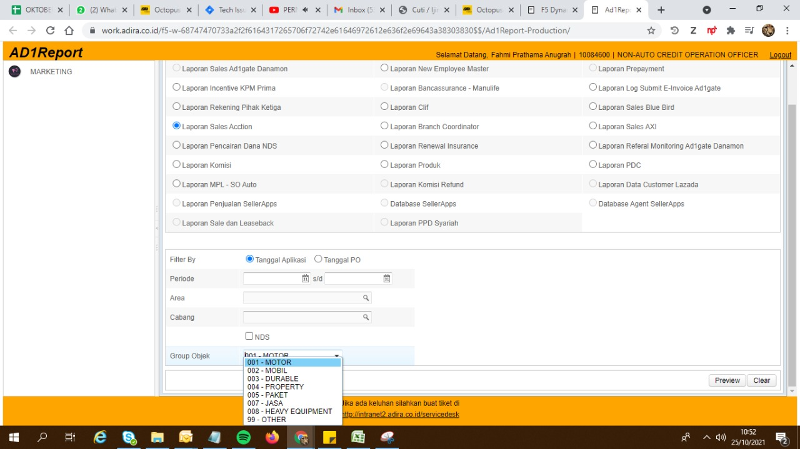

**Laporan Daily Deduction Grab Durable**

## Desain Laporan / Design Report

### Report Data Angsuran Grab Durable



## Desain Perencanaan Sistem / Design Schedule System

Scheduler penarikan dan pengiriman data angsuran dari Adira ke Grab setiap tanggal 20.

## Desain Matriks User / Design User Matrix

|  |  |  |  |  |
| --- | --- | --- | --- | --- |
| Report | Aplikasi | PIC | User | Akses |
| Laporan Daily Deduction Grab Durable | Ad1Report | Credit Operation | Wildan Fauzi / 10066892 | Download |
| Credit Operation | Fahmi Prathama A. / 10084600 |
| Credit Operation | Tri Ayu Agustina / 10078273 |
| BusDev Durable | Ricky Kurniawan / 10088468 |
| BusDev Durable | Geovanny Jemmie K. / 10086631 |
| Strategic Planning | Charlene / 10084714 |
| Durable MIS | Fernando / 10079690 |
| Durable MIS | Melia Indarti / 10079688 |

## Jadwal Kebutuhan User / Schedule Requirement – Target Go Live!

Desember 2021

|  |
| --- |
| Detail Revision History |

|  |  |
| --- | --- |
| **Not Applicable** | *Tuliskan N/A jika dalam project ini tidak terdapat hal yang dimaksud* |