* [Docs](https://coding-bootcamp-fsf-prework.readthedocs-hosted.com/en/latest/) »

* Prepare to Code! Prework Curriculum

**Prepare to Code! Prework Curriculum**

*"Give me six hours to chop down a tree, and I will spend the first four sharpening the axe." –– Abraham Lincoln*

**Welcome**

Congratulations on your acceptance to the Full Stack Flex Boot Camp!

You are about to embark on a transformational journey that will dramatically improve your skill set. At times, it will be challenging, frustrating, and even bewildering, but trust us; it *will* be worth it in the end.

This program's curriculum is not easy. You will be exposed to new ideas at breakneck speeds and challenged to complete difficult exercises. Be prepared to push yourself and to be pushed.

That said, remember every one of us, behind the scenes, is rooting for you. You were accepted into this program because we believe in your potential to succeed. You will have excellent instructors, dedicated teacher assistants, an extremely rich curriculum, and supportive peers to nudge you forward. If you put in the time and effort, we're confident you will find the success you're looking for.

**The Importance of Prework**

Because of the challenging nature of this program, we want you to come ready to sprint on Day 1. To help prepare you, we've created these modules to be completed before your first day. The prework will provide you with the preliminary skills and information you'll need to begin the course. It will also give you a glimpse of what's to come.

We recommend reading the sections in sequential order, as each section builds on the other. You should also complete all assignments, some of which will be fairly challenging and require outside research.

As you work through the readings and assignments, don't be discouraged if some of them give you trouble. Just focus on doing your best.

Good luck, have fun, and get pumped! You are in for an amazing ride.

**Prework Table of Contents**

[**Module 1: Get Started**](https://coding-bootcamp-fsf-prework.readthedocs-hosted.com/en/latest/modules/chapter1/)

Your Info

* Required

Email address *

Name *



Why are you taking this course? *



SUBMIT

Never submit passwords through Google Forms.

Congratulations! You have already made big strides toward your desired career in web development. Your first step was signing up for the boot camp. The second step will be completing this prework.

The boot camp will present many challenges. This prework, which contains 14 modules, is designed to provide the information and guidance you need to succeed in the first few weeks of the course. We recommend reading the modules in order, but you can complete the activities and assignments in any order you choose.

The time and effort required to complete this prework will give you a taste of the challenges to come. Just remember that perfection isn't everything. Give each of these modules your all and submit whatever you create. You'll have the rest of the course to smooth out the edges.

Good luck!

**Required Equipment**

Being successful in this course begins with the right equipment. Below are the equipment requirements for this course. **Note:** If you are unable to meet these requirements, please contact your Student Success Manager.

**Taking an in-person class?**

Laptop (Mac or Windows) with 8 GB RAM and 64-bit dual-core processor

**Note:** You cannot use Linux in this course.

**Taking an online class?**

* Laptop (Mac or Windows) with 8 GB RAM and 64-bit dual-core processor

**Note:** Linux is not allowed.

* Monitor compatible with laptop
* Webcam
* Microphone
* Headphones
* High-speed internet connection (minimum speed requirements: download 25 Mbps, upload 5 Mbps)

**How to Submit Prework Assignments**

You will submit your completed assignments on [Bootcamp Spot](https://www.bootcampspot.com/login), which you'll be given access to after you enroll in the course. Follow these steps to submit your assignments.

1. Create a local folder on your computer titled PREWORK_{INITIALS}, e.g., PREWORK_AFH.

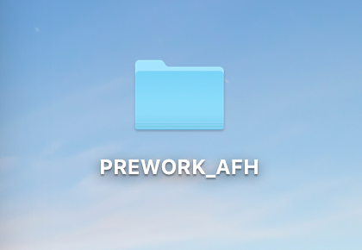

1. Create a subfolder for each module so that your folder looks something like this:

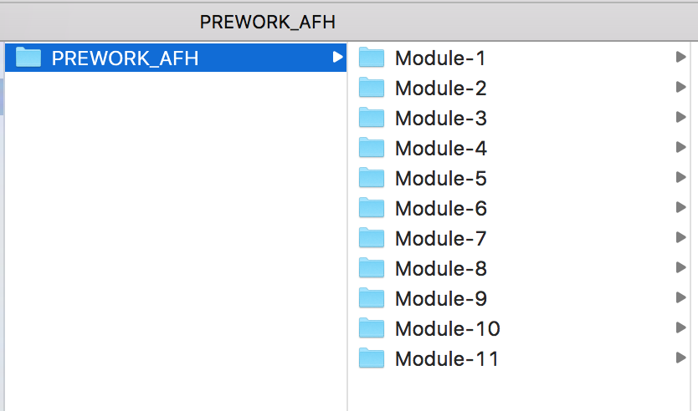

1. When you complete an assignment, save your solution in the appropriate subfolder. In some cases, you may need to copy multiple files into the subfolder.
2. Create a [Google Drive](https://www.google.com/drive/) account if you don't already have one.
3. Select **New > Folder upload** to upload your local folder to Google Drive. **Note:** This can be done after you have completed all prework assignments.

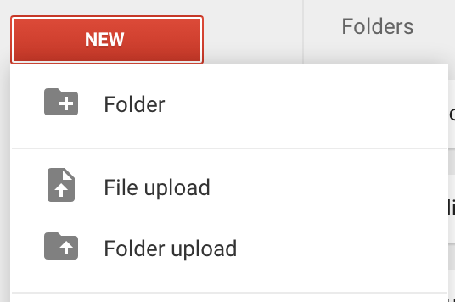

1. Right-click the folder and change the sharing settings to **Anyone with the link can edit.**

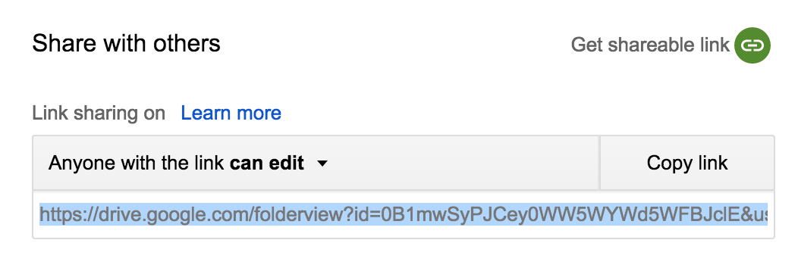

1. Copy the folder link.
2. Log in to Bootcamp Spot and find the prework assignment associated with your class.
3. Click on the assignment and paste the Google Drive link.

And that's it! You're ready for Module 2! [Next](https://coding-bootcamp-fsf-prework.readthedocs-hosted.com/en/latest/modules/chapter2/)

Coding Boot Camp © 2018. All Rights Reserved.

Built with [MkDocs](http://www.mkdocs.org/) using a [theme](https://github.com/snide/sphinx_rtd_theme) provided by [Read the Docs](https://readthedocs.org/).

[Next »](https://coding-bootcamp-fsf-prework.readthedocs-hosted.com/en/latest/modules/chapter2/)

  v: latest

Prepare to be prepared! We'll discuss a few prework logistics, including how to submit assignments and computer requirements for this course.

[**Module 2: Install Your Tools**](https://coding-bootcamp-fsf-prework.readthedocs-hosted.com/en/latest/modules/chapter2/)

Get your computer ready for boot camp battle! Tools, installers, and readmes abound in this module.

[**Module 3: Deploy Today!**](https://coding-bootcamp-fsf-prework.readthedocs-hosted.com/en/latest/modules/chapter3/)

Get your computer ready for boot camp battle! Tools, installers, and readmes abound in this module.

[**Module 4: HTML Basics**](https://coding-bootcamp-fsf-prework.readthedocs-hosted.com/en/latest/modules/chapter4/)

Time to finally code! Get a head start on the first day of class in this module.

[**Module 5: CSS Basics**](https://coding-bootcamp-fsf-prework.readthedocs-hosted.com/en/latest/modules/chapter5/)

Style up your simple HTML with CSS, and further your head start in the course with this module.

[**Module 6: JavaScript Basics**](https://coding-bootcamp-fsf-prework.readthedocs-hosted.com/en/latest/modules/chapter6/)

Keep diving into the good stuff in this module, which will give you a preliminary dose of JavaScript.

[**Module 7: Programming Logic Basics**](https://coding-bootcamp-fsf-prework.readthedocs-hosted.com/en/latest/modules/chapter7/)

Code is complicated, but life doesn't have to be. Pseudocode your way to clarity with this module.

[**Module 8: Debugging Basics**](https://coding-bootcamp-fsf-prework.readthedocs-hosted.com/en/latest/modules/chapter8/)

You'll find yourself needing to debug issues many a time in this course (not to mention your career as a web developer). Prepare your strategy in this module.

[**Module 9: What Is Web Developer?**](https://coding-bootcamp-fsf-prework.readthedocs-hosted.com/en/latest/modules/chapter9/)

Get answers to your most basic questions about what it means to be a web developer.

[**Module 10: How To Succeed In This Course**](https://coding-bootcamp-fsf-prework.readthedocs-hosted.com/en/latest/modules/chapter10/)

This boot camp won't be easy. Set the right attitude and expectations with our tips.

[**Module 11: Becoming Employable**](https://coding-bootcamp-fsf-prework.readthedocs-hosted.com/en/latest/modules/chapter11/)

Start thinking about the job search in this module, which provides tips for prepping your professional online persona and networking.

[**Module 12: Type Like a Pro**](https://coding-bootcamp-fsf-prework.readthedocs-hosted.com/en/latest/modules/chapter12/)

Every line of code begins on the keyboard, and so should you! Practice your typing skills with this module.

[**Module 13: Whiteboarding Interview Prep**](https://www.gitbook.com/read/book/the-coding-bootcamp/whiteboarding-algorithms-and-interview-questions?key=technicalInterview)

Think you're ready to prepare for your technical interview? Head here!

[**Module 14: What's Next?**](https://coding-bootcamp-fsf-prework.readthedocs-hosted.com/en/latest/modules/chapter14/)

Looking for more practice? Check out our recommendations in this module.

Coding Boot Camp © 2018. All Rights Reserved.

Built with [MkDocs](http://www.mkdocs.org/) using a [theme](https://github.com/snide/sphinx_rtd_theme) provided by [Read the Docs](https://readthedocs.org/).

  v: latest