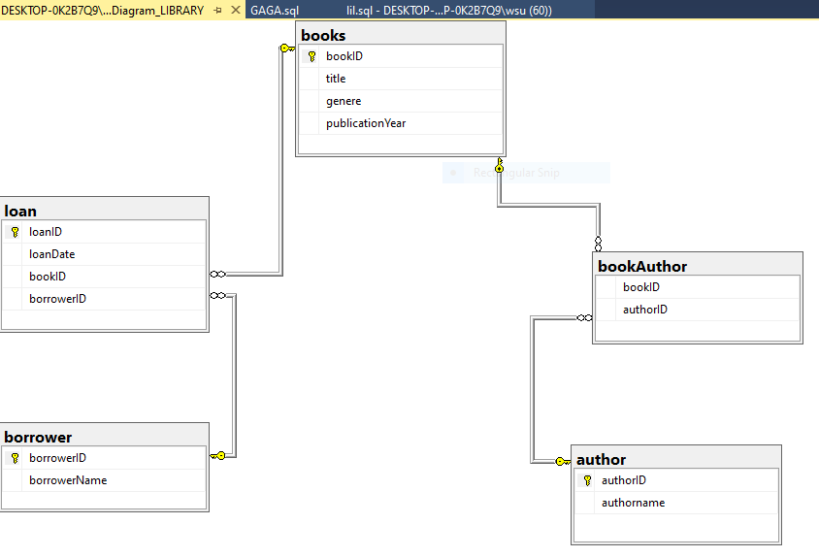

1,select all books in the catalog

select*from books;

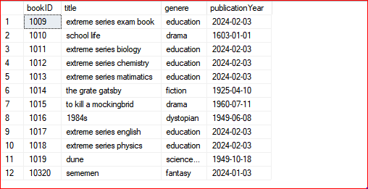

G
2,select all books of a specific genere
select*from books WHERE genere='drama';

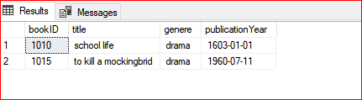

3,select all distinct geners in the catalog
select distinct genere from books;

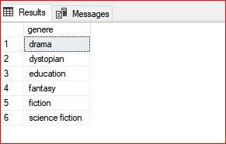

4,select the total number of books in the catalog
select count(*)from books;

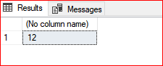

5,select the book title and the authors name
select B.title, A.authorname
from books B
JOIN bookAuthor BA ON B.bookID=BA.bookID
JOIN author A ON BA.authorID=A.authorID;

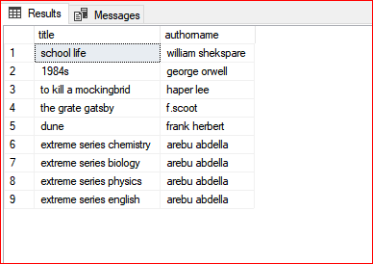

6 select only authers who have written more than 1 book
select A.authorname
from author A
join bookAuthor BA ON A.authorID = BA.authorID
GROUP BY A.authorname
having count (BA.bookID)>1;

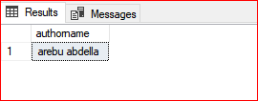

7 select each borrowers name along with the books they have borrowed
SELECT bor.borrowerName , B.title
from borrower Bor
join loan L ON Bor.borrowerID=L.borrowerID
JOIN books B ON L.bookID=B.bookID;

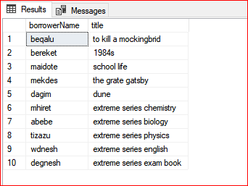

8 select all borrowers along with the number of books they have borrowed
(including borrowers with no loan).
select bor.borrowerName ,
count (L.bookID) AS NumberOfBooksBorrowed
from borrower Bor
left join loan L ON Bor.borrowerID=L.borrowerID
GROUP BY Bor.borrowerName;

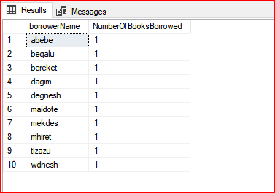

9 select all books published in a specific year
select * from books WHERE publicationYear ='2024-02-03';

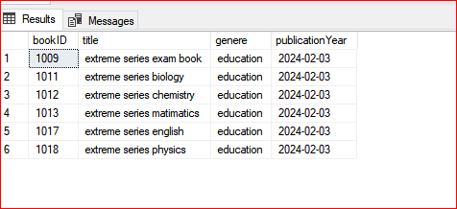

10 select all books borrowed in the last month
select B.title
from books B
join loan L ON B.bookID=L.bookID
WHERE L.loanDate>='05-04-2025';

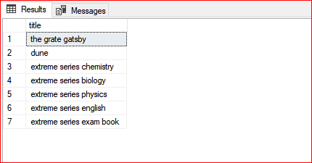

11 add a new book to the catalog
insert into books (bookID, title,genere, publicationYear) values (10320,'sememen','fantasy','2024-01-03' );

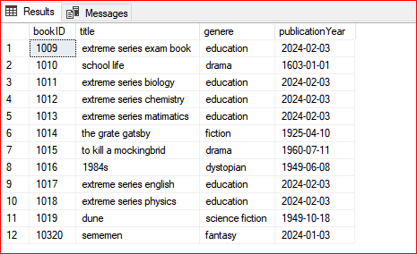

12 add a new Auther to the catalog
insert into author (authorID,authorname) values (7783,'Isaac Asimov');

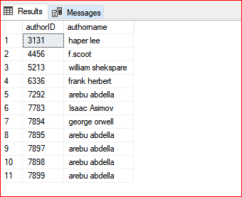

13 update the title of a book
update books
set title ='school life'
where bookID=1010;

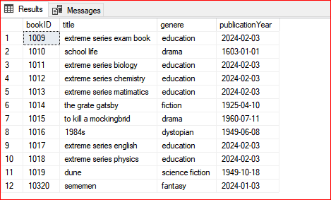

14 delete a book from the catalog
delete from books WHERE bookID=1013;

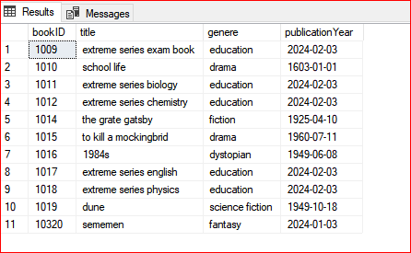

15 find the most popular book (the book borrowed the most times)
select B.title, count(L.bookID)
AS borrowcount
from books B
JOIN loan L ON B.bookID=L.bookID
GROUP BY B.title
ORDER BY borrowcount DESC;

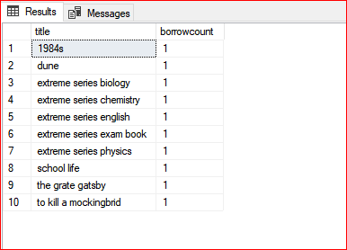

IMPLEMENTATION

create database library
use library
create table books(
bookID int primary key,
title varchar(50),
genere varchar(50),
publicationYear varchar(50),
);
create table author(
authorID int primary key,
authorname varchar(45)
);
create table borrower(
borrowerID int primary key,
borrowerName varchar(50)
);
create table loan(
loanID int primary key ,
loanDate varchar(50),
bookID int ,
borrowerID int,
foreign key (bookID) references books (bookID),
foreign key (borrowerID ) references borrower(borrowerID)
);
create table bookAuthor(
bookID int ,
authorID int ,
foreign key (bookID) references books(bookID),
foreign key (authorID ) references author(authorID)
);
select *from books
select * from author
select *from borrower
select *from loan
select *from bookAuthor

select * from books
insert into books values (1010,'hamlet','drama','1603-01-01')
insert into books values (1016,'1984s','dystopian','1949-06-08');
insert into books values (1015,'to kill a mockingbrid','drama','1960-07-11');
insert into books values (1014,'the grate gatsby','fiction','1925-04-10')
insert into books values (1019,'dune','science fiction','1949-10-18');
insert into books values (1013,'extreme series matimatics','education','2024-02-03');
insert into books values (1012,'extreme series chemistry','education','2024-02-03');
insert into books values (1011,'extreme series biology','education','2024-02-03');
insert into books values (1018,'extreme series physics','education','2024-02-03');
insert into books values (1017,'extreme series english','education','2024-02-03');
insert into books values (1009,'extreme series exam book','education','2024-02-03');

select*from author

insert into author values(5213,'william shekspare');
insert into author values(7894,'george orwell');
insert into author values(3131,'haper lee');
insert into author values(4456,'f.scoot');
insert into author values(6336,'frank herbert');
insert into author values(7899,'arebu abdella');
insert into author values(7898,'arebu abdella');
insert into author values(7897,'arebu abdella');
insert into author values(7895,'arebu abdella');
insert into author values(7292,'arebu abdella');

select *from borrower

insert into borrower values (91947,'maidote');
insert into borrower values(93801,'bereket');
insert into borrower values(92553,'beqalu');
insert into borrower values(91975,'mekdes');
insert into borrower values(91970,'dagim');
insert into borrower values (90509,'mhiret');
insert into borrower values (90511,'abebe');
insert into borrower values (90542,'tizazu');
insert into borrower values (90455,'wdnesh');
insert into borrower values (92328,'degnesh');

select *from loan

insert into loan values (0044,'01-02-2025',1010,91947);
insert into loan values(0033,'02-01-2025',1016,93801);
insert into loan values(0022,'03-02-2025',1015,92553);
insert into loan values(0066,'05-04-2025',1014,91975);
insert into loan values(0077,'11-01-2025',1019,91970);
insert into loan values(0088,'12-02-2025',1012,90509);
insert into loan values (0099,'13-02-2025',1011,90511);
insert into loan values (0101,'14-02-2025',1018,90542);
insert into loan values (0202,'15-02-2025',1017,90455);
insert into loan values (0303,'16-02-2025',1009,92328);

select*from bookAuthor
insert into bookAuthor values(1010,5213);
insert into bookAuthor values(1016,7894);
insert into bookAuthor values(1015,3131);
insert into bookAuthor values(1014,4456);
insert into bookAuthor values(1019,6336);
insert into bookAuthor values(1013,7898);
insert into bookAuthor values(1012,7898);
insert into bookAuthor values(1011,7898);
insert into bookAuthor values(1018,7898);
insert into bookAuthor values(1017,7898);

