Question #2

Pattern: Bridge Pattern

Why: In the question there are two types of displays for the products. Each of these displays can be implemented on a separate class. The application also needs product sorting functionality without changing the way they are displayed. If we need more functionalities as well, it is not the best idea always to modify implementation of these display classes to incorporate each functionality. So bridge class handle additional functionalities without changing the original display classes. So any time we need changes, all we change is the bridge class.

Structure:

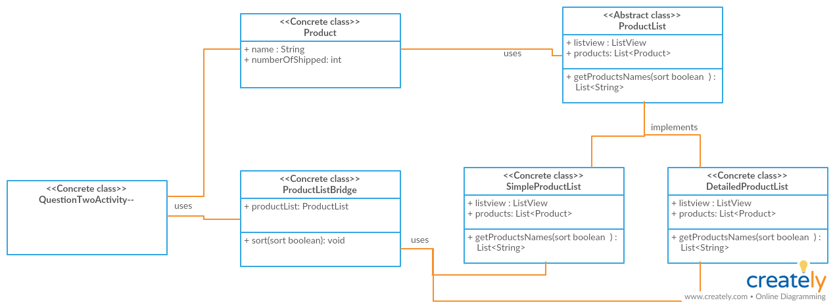

Question 4

Patterns:

* Composite Pattern
* Factory Pattern
* Template Method
* Singleton

Structure: (Next Page)

