Insights:

**Plot 1:**

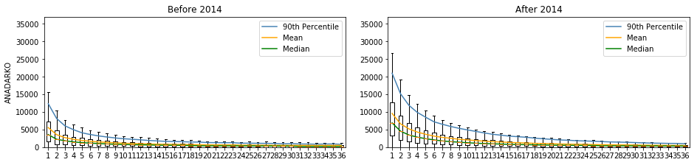  
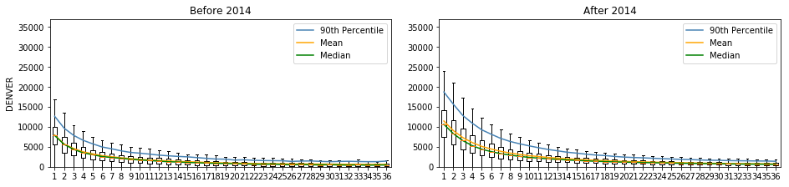  
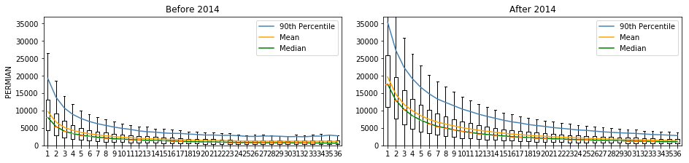  
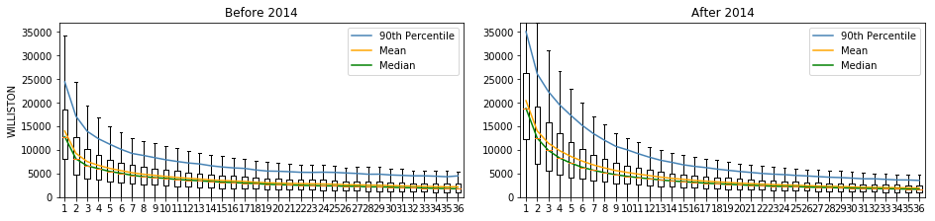

* The months at which the basins production attain a form of low production monotonic horizontal lines increased by a rough average of 11 months after applying the new drilling techniques in 2014.  
  **i.e.** around one year of higher levels of production is added to each basin with the new applied techniques.
* The production amount of wells in each basin acquires similar behavior resulting in close mean and median values.

**Plot 2:**

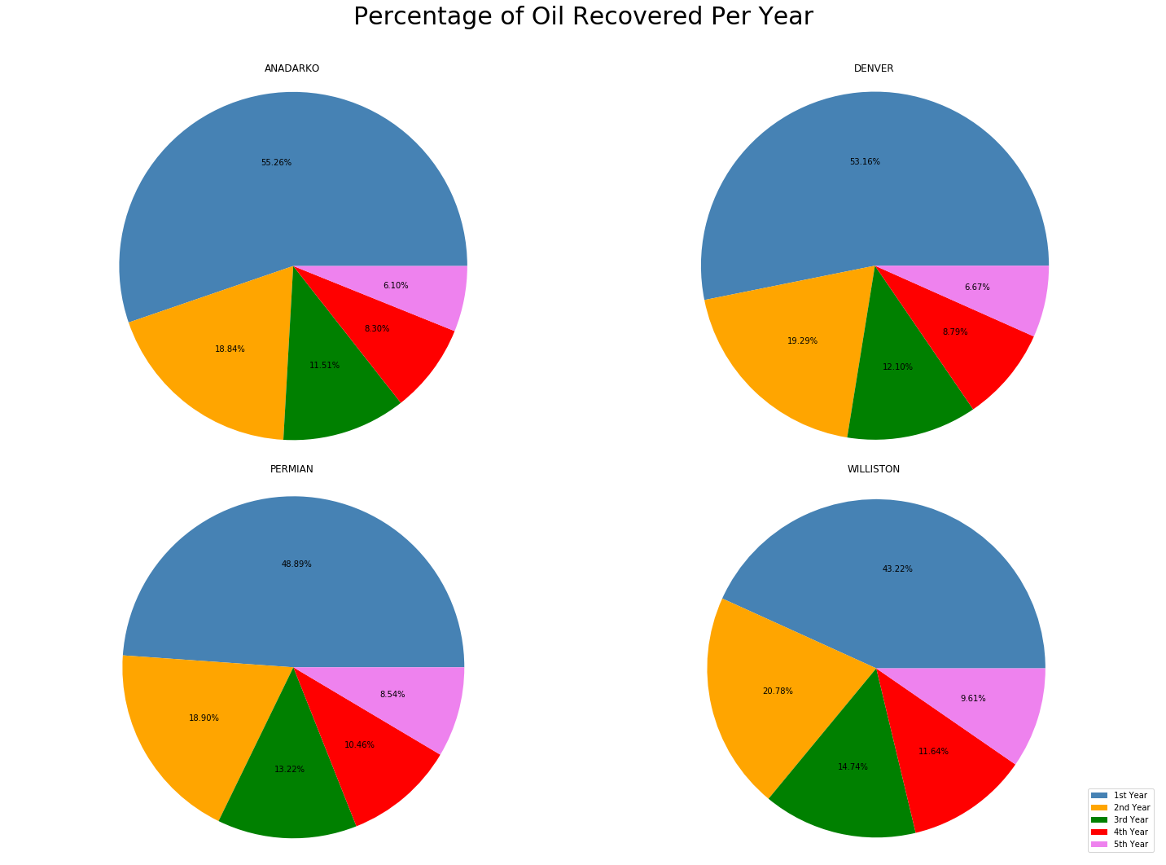

* With plot one taken into consideration, we can infer that basins starting with higher production volume in their peaks, decline with higher percentage rates than those starting with lower levels. **i.e.** peak production value is directly related to the production-declination percentage.

**Plot 3:**

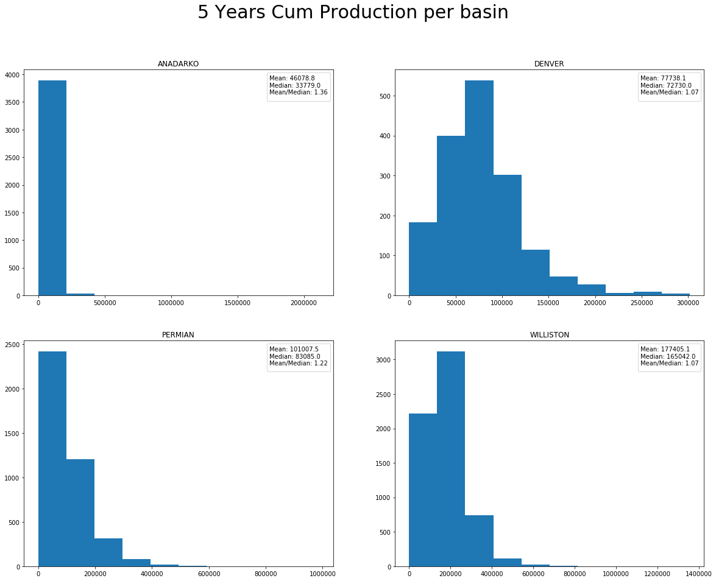

**Plot 4:**

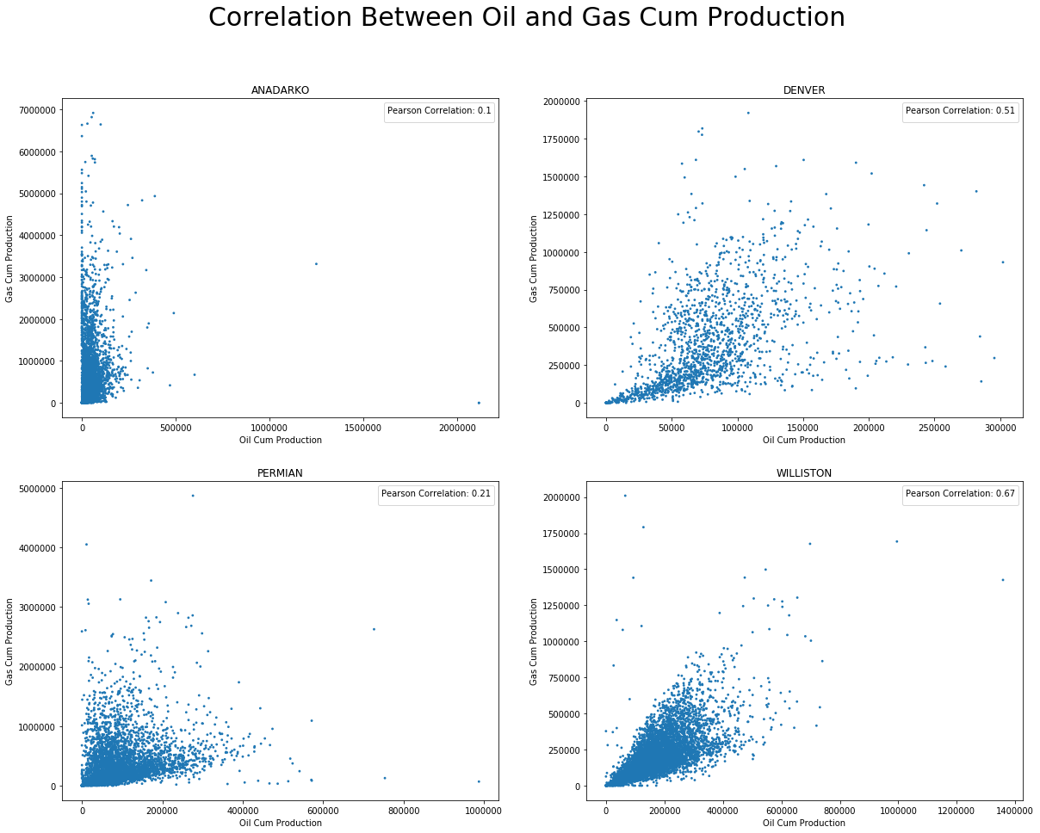

**Plot 5:**