**Changing verb biases within and across domains: Manner/Path and Action/Effect generalization**

Melissa Kline, Annelot de Rechteren van Hemert and Jesse Snedeker

A hallmark of human cognition is our ability to share thoughts with one another by converting conceptual representations into a linguistic format. How do we map different aspects of the world onto words? Events can be broken down into component conceptual parts: for example, *agent* (girl), *outcome* or what happens (crossing the floor), and *means* or how it happens (by dancing). Across languages, most verbs encode either the outcome or the means of an event, but not both (Talmy, 1985; Beavers, Levin & Tham, 2010; Kiparsky, 1997; Rappaport Hovav & Levin, 2010). These biases vary significantly across lanugages, with some showing marked *manner biases* and others *path biases;* these biases are established in children by age 4-5 (Maguire et al., 2010; Papafragou & Selimis, 2010).

Havasi, Shafto & Snedeker (2014) showed that for adults these biases are not fixed but malleable – when they learn several novel verbs in a row which turn out to have path meanings (*around*, *down*), they begin to guess that a novel word for an event that could be described as either running or ascending in fact refers to the path of motion. In addition to being flexible, these biases appear to be very abstract, even crossing between semantic fields which have very different meanings and syntactic instantiations. Geojo (2015) showed that once adults had learned a Path bias with a spatial/motion event category, their preferences were maintained for change-of-state scenes, which also have a distinction between means (the Action taken by the agent) and outcome (the Effect on the patient). The reverse was also true; adults generalized from a learned Action or Effect bias in the change-of-state domain to the corresponding perspective in motion scenes. To accomplish this requires some kind of very general representation of events that can account for *hitting* (action) being more like *running* (manner) than like *entering* (path).

|  |  |  |
| --- | --- | --- |
| Spatial events | Manner (running, skipping) | Path (ascending, entering) |
| Causal/change-of-state events | Action (hammering, hitting) | Effect (breaking, melting) |
| Proposed abstract categories | Means | Outcome |

Where do these representations come from? Although children do not show biases in linguistic tasks before age four, pre-linguistic infants are sensitive to a parallel, non-linguistic means/outcomes distinction (Phillips & Wellman, 2005; Woodward, 1998, Csibra & Gergely, 2007; Gergely, Bekkering, & Király 2002). It is possible that this early conceptual framework provides a foundation for the kinds of distinctions in meaning that matter for language. If this is the case, we might expect children to show both bias flexibility and bias generalization in the same way as adults. To test this hypothesis, we adapted the training task used in Havasi et al (2014) for children. Over a series of eight sequences, children were presented with a repeating learning sequence:

1. Bias phase: A word/event pairing is presented (e.g. crabwalk-into), then children choose between another event that maintained either the Means (crabwalk-around) or the Outcome (skip-into) of the initial scene.
2. Training phase: Children saw 3 additional events that maintained one aspect of the event (either Means or Outcome)
3. Re-test phase: Children saw another pair of events, one matching the learned event aspect and the other matching the non-trained aspect of the initial movie

Our key interest is not in the learning of individual verbs (3), but in the *biases* that children develop over the course of the session (measured at the Bias phase (1)). We are currently conducting two versions of the study, one in the Manner/Path domain and one in the Action/Event domain.

In the Manner/Path study (N=31), 4-6 year old children begin with a bias toward Manner meanings (matching the dominant pattern in English, but the two training conditions result in different patterns of biases for newly-presented verbs. Figure 1 shows the proportion of path meanings that children initially select after being exposed to a run of either Path or Manner verbs. Like adults, these biases seem to be flexible and able to be modified by experience[1].

In a second study we evaluate whether (a) children’s verb meaning biases are similarly malleable for another domain, change-of-state events and (b) whether these biases can extend between new domains, relying on a very abstract generalization of means of acting vs. goal or outcome of action. Initial evidence suggests that children are again able to learn biases relatively quickly; children begin to make markedly different kinds of guesses as they are exposed to a set of novel words referring to (e.g.) Action events (Figure 2).

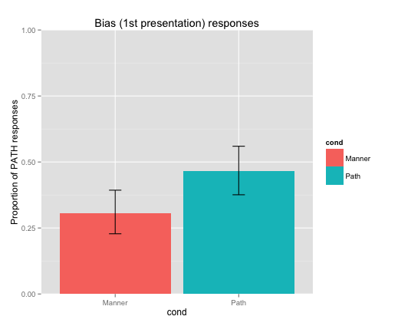

Figure 1 N=31, p = 0.079

To test crossover biases, the paradigm described above then continued with a series of eight Bias-only forced-choices for children to make, in the Manner/Path domain. While data collection is ongoing, we see a trend in the expected direction: after learning a series of change-of-state verbs referring to Action, children are somewhat more likely to guess that a new Motion event verb refers to the Manner (not the Path) of motion (Figure 3).

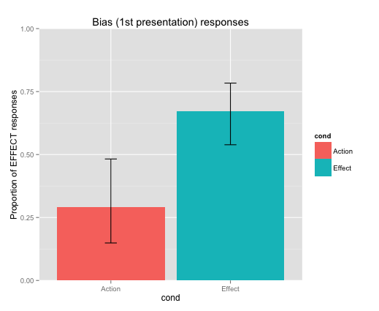

Figure 2 N = 12, p < 0.05

If this trend is robust, it would suggest that these effects are based on some deep and very abstract kinds of lexical semantics, meaning representations which maybe be closely tied to fundamental kinds of cognitive representations that are available for implicit inference to toddlers as young as 12 months.

In addition to knowing that children accommodate to the meaning patterns and verb distribution of their native language, it is now becoming possible and critical to ask how and in what form they gain access to these conceptual/semantic representations, especially given the converging findings from other areas of cognitive development. This line of work will establish the trajectory of children’s semantic expectations about basic verb/ sentence types and how they incorporate them into other conceptual models of the world.

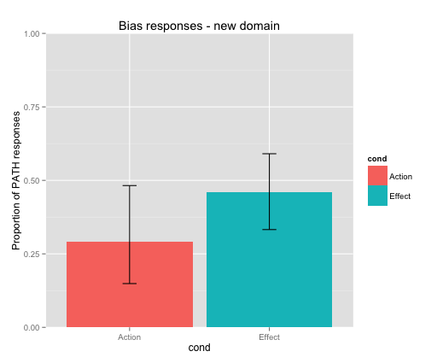

Figure 3 N=12, p > 0.10

1. All significance testing is performed by comparing a logistic regression mixed model with Condition as a fixed effect and individual subject random intercepts. P values reflect comparisons between this model and the model lacking the fixed effect of Condition.