**Initial Email**

To: bcs_subjects@mit.edu

Cc: bcs_study_pool@mit.edu

Subject: fMRI study ($60): 11/9, 11/11, or 11/13

Hello,

### PLEASE SEND REPLIES TO [your name] ([your email]@mit.edu) ###

### PLEASE MAKE SURE TO READ ALL THE QUALIFICATION REQUIREMENTS ###

We are conducting fMRI research about cortical areas involved in different cognitive processes. We are looking for individuals who would be willing to come in for a 2-hour fMRI scanning session during **one** of the following times:

**Mon 11/9**

10am - 12pm

12pm - 2pm

2pm - 4pm

4pm - 6pm

**Wed 11/11**

10am - 12pm

12pm - 2pm

2pm - 4pm

4pm - 6pm

**Fri 11/13**

12pm - 2pm

2pm - 4pm

4pm - 6pm

You will receive **$60** for your participation.

During the scan you need to lie still and look at briefly presented images or words, perform some task, and/or listen to auditory stimuli.

When you reply, you must include *ALL* of the information below, including a phone number where you can be reached, in order to be considered for participation in the study.

1. First and last name

2. Date of birth

3. Are you affiliated with MIT?  If so, how?

4. Phone number where you can be reached (ideally cell-phone).

5. Have you been scanned previously?

6. Which of these times could you make? Keep in mind that **you will need to arrive 15 minutes early** to your scheduled slot.

(a) Mon 11/9 10am - 12pm

(b) Mon 11/9 12pm - 2pm

(c) Mon 11/9 2pm - 4pm

(d) Mon 11/9 4pm - 6pm

(e) Wed 11/11 10am - 12pm

(f) Wed 11/11 12pm - 2pm

(g) Wed 11/11 2pm - 4pm

(h) Wed 11/11 4pm - 6pm

(i) Fri 11/13 12pm - 2pm

(j) Fri 11/13 2pm - 4pm

(k) Fri 11/13 4pm - 6pm

7. Do you fulfill all the requirements below? (please respond to each individual item)

(a) You are a native English speaker (bilinguals are ok);

(b) You are right-handed (I occasionally scan left-handers, so let me know if this is the only requirement you don't satisfy);

(c) You are between 18 and 30;

(d) You do not experience claustrophobia;

(e) You have no metal in your body, ***no metal piercing*** (dental fillings are OK);

(f) You have no color tattoos;

(g) You have normal or contact-corrected vision (NO GLASSES and no color contacts);

(h) You weigh under 200 lbs;

(i) You can lie on your back and keep VERY still for approximately 2 hours;

(j) You are normally awake and alert during the hours of the scan;

(k) You are not currently sick or recovering from being sick.

*** If you are eligible, we will contact you to schedule a slot during a time that works you. Please reply only if you are absolutely sure you can make the times you request.  Each scanning session costs us approximately $1,000, so if you do not make your appointment, or if you are late for your appointment, you should expect to not be contacted in the future about participating in fMRI studies in EvLab. ***

We often get many replies to these messages, so if we don't write back, it either means that we have already found someone, or that you are ineligible because of some studies you have participated in previously.  We apologize that we cannot reply back to everyone who we are unable to scan for a given session.

Thanks,

[your name]

Ev Fedorenko

McGovern Institute for Brain Research

M.I.T.

**Reply to a Potential Subject**

Hi [participant name],

I can confirm you for Mon 11/9 from 10am - 12pm. Does this work for you? You would need to arrive 15 minutes early.

Thanks,

[your name]

**Once the subject confirms**

Hi [participant name],

Thanks so much!

The scan will take place at MIT Building 46. The street address is 43 Vassar St, but you should enter through the Main St entrance, which says "McGovern Institute for Brain Research" (see the attached pictures). When you arrive, you can text me at [your number], email me, or just wait for us to come get you. Please arrive by **9:45am** so we can get everything set up for your scan at 10am on Monday **11/9**.

Thanks,

[your name]

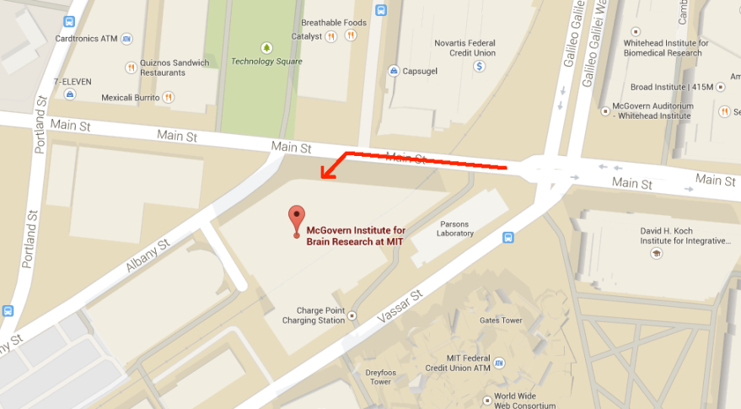

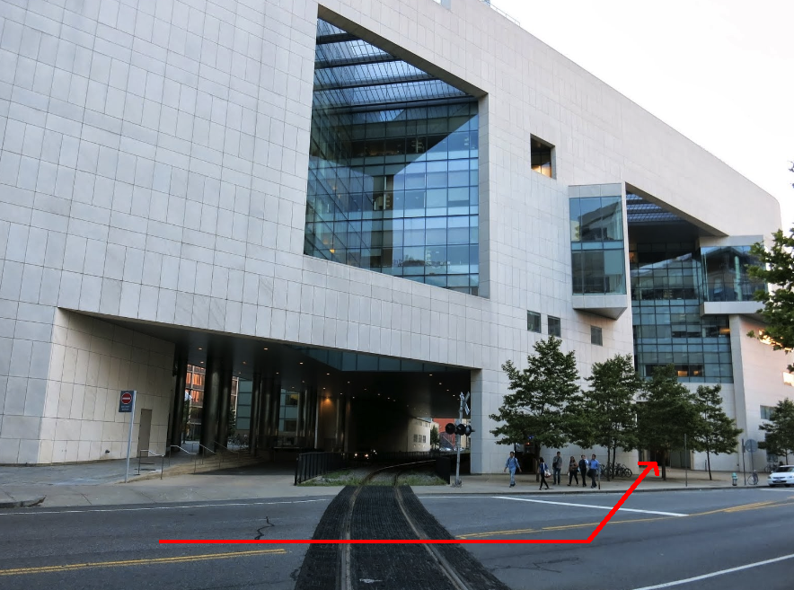

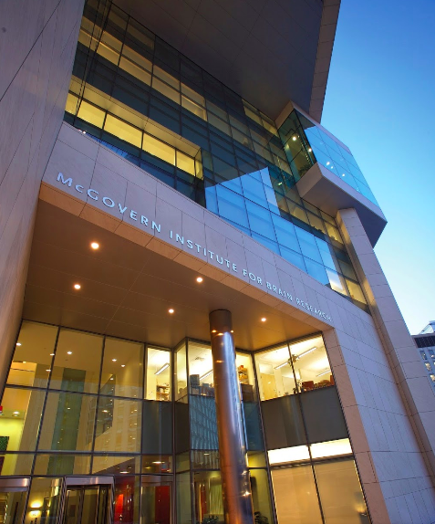

**Day before the scan**

Hi [participant name],

This is just a reminder that you are scheduled to come in tomorrow for an fMRI study at 10:45am. When you arrive, you can wait in the lobby and we’ll come get you, or you can email / call / text me ([your number])

See you then,

[your name]