Investigating a Drop in User Engagement:

Some of the causes of the drop can be as follows: -

* Holiday: Since Yammer is used as a work application, chances of users using it during holidays is low.
* Broken feature: It is possible that something in the application is broken and the use of the Yammer application is low.
* Broken tracking code: It’s possible that the code that logs events is, itself is broken and is not showing the correct usage.
* Interruption in internet services.
* Popular event.

Investigation

Daily Signups: Nothing has changed, high during the week and low in the weekend

SELECT DATE_TRUNC('day',created_at) AS day,

COUNT(*) AS all_users,

COUNT(CASE

WHEN activated_at IS NOT NULL THEN u.user_id

ELSE

NULL

END) AS activated_users

FROM tutorial.yammer_users u

WHERE created_at >= '2014-06-01'

AND created_at < '2014-09-01'

GROUP BY DATE_TRUNC('day',created_at)

ORDER BY DATE_TRUNC('day',created_at)

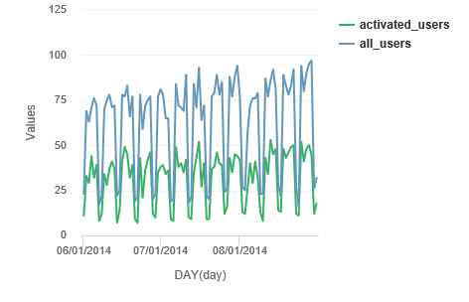

Since growth is normal, it’s possible that the dip in engagement is coming from existing users as opposed to new ones. One of the most effective ways to look at this is to cohort users based on when they signed up for the product.

Engagement by Age Use Cohort

SELECT DATE_TRUNC('week',z.occurred_at) AS "week",

AVG(z.age_at_event) AS "Average age during week",

COUNT(DISTINCT CASE WHEN z.user_age > 70 THEN z.user_id ELSE NULL END) AS "10+ weeks",

COUNT(DISTINCT CASE WHEN z.user_age < 70 AND z.user_age >= 63 THEN z.user_id ELSE NULL END) AS "9 weeks",

COUNT(DISTINCT CASE WHEN z.user_age < 63 AND z.user_age >= 56 THEN z.user_id ELSE NULL END) AS "8 weeks",

COUNT(DISTINCT CASE WHEN z.user_age < 56 AND z.user_age >= 49 THEN z.user_id ELSE NULL END) AS "7 weeks",

COUNT(DISTINCT CASE WHEN z.user_age < 49 AND z.user_age >= 42 THEN z.user_id ELSE NULL END) AS "6 weeks",

COUNT(DISTINCT CASE WHEN z.user_age < 42 AND z.user_age >= 35 THEN z.user_id ELSE NULL END) AS "5 weeks",

COUNT(DISTINCT CASE WHEN z.user_age < 35 AND z.user_age >= 28 THEN z.user_id ELSE NULL END) AS "4 weeks",

COUNT(DISTINCT CASE WHEN z.user_age < 28 AND z.user_age >= 21 THEN z.user_id ELSE NULL END) AS "3 weeks",

COUNT(DISTINCT CASE WHEN z.user_age < 21 AND z.user_age >= 14 THEN z.user_id ELSE NULL END) AS "2 weeks",

COUNT(DISTINCT CASE WHEN z.user_age < 14 AND z.user_age >= 7 THEN z.user_id ELSE NULL END) AS "1 week",

COUNT(DISTINCT CASE WHEN z.user_age < 7 THEN z.user_id ELSE NULL END) AS "Less than a week"

FROM (

SELECT e.occurred_at,

u.user_id,

DATE_TRUNC('week',u.activated_at) AS activation_week,

EXTRACT('day' FROM e.occurred_at - u.activated_at) AS age_at_event,

EXTRACT('day' FROM '2014-09-01'::TIMESTAMP - u.activated_at) AS user_age

FROM tutorial.yammer_users u

JOIN tutorial.yammer_events e

ON e.user_id = u.user_id

AND e.event_type = 'engagement'

AND e.event_name = 'login'

AND e.occurred_at >= '2014-05-01'

AND e.occurred_at < '2014-09-01'

WHERE u.activated_at IS NOT NULL

) z

group by 1

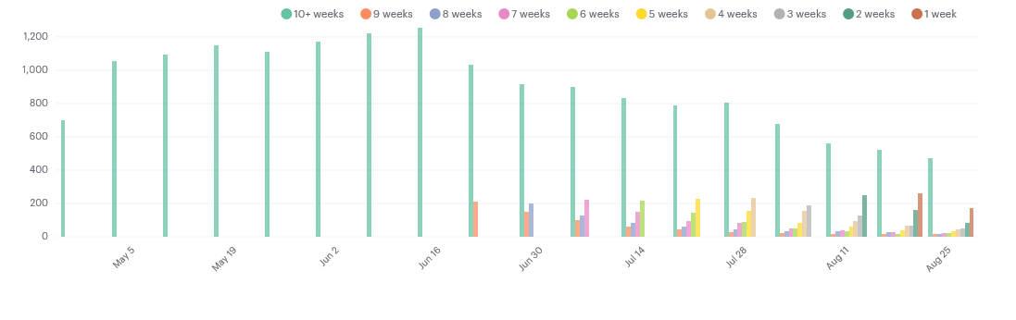

Seems like the dip is in old users.

Weekly Engagement By Device Type

SELECT DATE_TRUNC('week', occurred_at) AS week,

COUNT(DISTINCT e.user_id) AS weekly_active_users,

COUNT(DISTINCT CASE WHEN e.device IN ('macbook pro','lenovo thinkpad','macbook air','dell inspiron notebook',

'asus chromebook','dell inspiron desktop','acer aspire notebook','hp pavilion desktop','acer aspire desktop','mac mini')

THEN e.user_id ELSE NULL END) AS computer,

COUNT(DISTINCT CASE WHEN e.device IN ('iphone 5','samsung galaxy s4','nexus 5','iphone 5s','iphone 4s','nokia lumia 635',

'htc one','samsung galaxy note','amazon fire phone') THEN e.user_id ELSE NULL END) AS phone,

COUNT(DISTINCT CASE WHEN e.device IN ('ipad air','nexus 7','ipad mini','nexus 10','kindle fire','windows surface',

'samsumg galaxy tablet') THEN e.user_id ELSE NULL END) AS tablet

FROM tutorial.yammer_events e

WHERE e.event_type = 'engagement'

AND e.event_name = 'login'

GROUP BY 1

ORDER BY 1

LIMIT 100

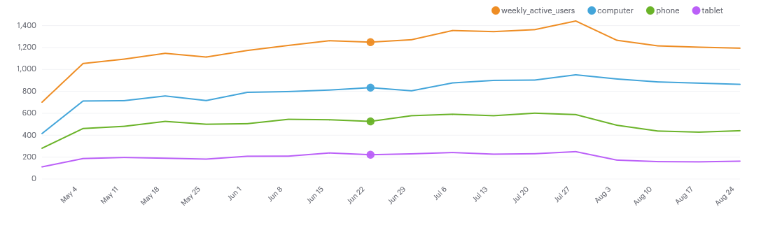

The above chart shows there’s a pretty steep drop in phone engagement rates. So it’s likely that there’s a problem with the mobile app related to long-time user retention. Since we know this problem relates to the retention of long-time users, it’s worth checking out whether the email has something to do with it.

Emails

SELECT DATE_TRUNC('week', occurred_at) AS week,

COUNT(CASE WHEN e.action = 'sent_weekly_digest' THEN e.user_id ELSE NULL END) AS weekly_emails,

COUNT(CASE WHEN e.action = 'sent_reengagement_email' THEN e.user_id ELSE NULL END) AS reengagement_emails,

COUNT(CASE WHEN e.action = 'email_open' THEN e.user_id ELSE NULL END) AS email_opens,

COUNT(CASE WHEN e.action = 'email_clickthrough' THEN e.user_id ELSE NULL END) AS email_clickthroughs

FROM tutorial.yammer_emails e

GROUP BY 1

ORDER BY 1

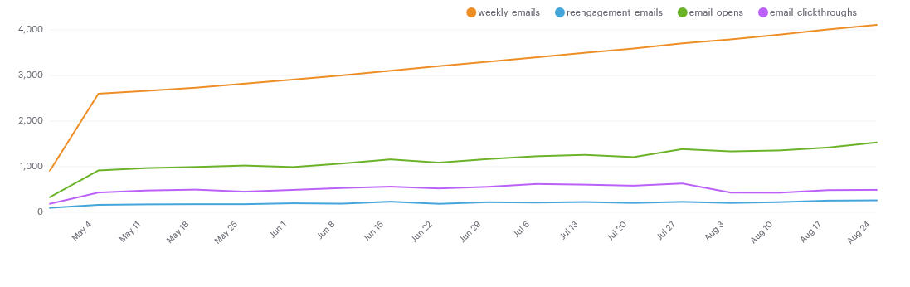

**Since, there is a dip in the reengagement emails, we need to look at the open rates of emails.**

SELECT week,

weekly_opens/CASE WHEN weekly_emails = 0 THEN 1 ELSE weekly_emails END::FLOAT AS weekly_open_rate,

weekly_ctr/CASE WHEN weekly_opens = 0 THEN 1 ELSE weekly_opens END::FLOAT AS weekly_ctr,

retain_opens/CASE WHEN retain_emails = 0 THEN 1 ELSE retain_emails END::FLOAT AS retain_open_rate,

retain_ctr/CASE WHEN retain_opens = 0 THEN 1 ELSE retain_opens END::FLOAT AS retain_ctr

FROM (

SELECT DATE_TRUNC('week',e1.occurred_at) AS week,

COUNT(CASE WHEN e1.action = 'sent_weekly_digest' THEN e1.user_id ELSE NULL END) AS weekly_emails,

COUNT(CASE WHEN e1.action = 'sent_weekly_digest' THEN e2.user_id ELSE NULL END) AS weekly_opens,

COUNT(CASE WHEN e1.action = 'sent_weekly_digest' THEN e3.user_id ELSE NULL END) AS weekly_ctr,

COUNT(CASE WHEN e1.action = 'sent_reengagement_email' THEN e1.user_id ELSE NULL END) AS retain_emails,

COUNT(CASE WHEN e1.action = 'sent_reengagement_email' THEN e2.user_id ELSE NULL END) AS retain_opens,

COUNT(CASE WHEN e1.action = 'sent_reengagement_email' THEN e3.user_id ELSE NULL END) AS retain_ctr

FROM tutorial.yammer_emails e1

LEFT JOIN tutorial.yammer_emails e2

ON e2.occurred_at >= e1.occurred_at

AND e2.occurred_at < e1.occurred_at + INTERVAL '5 MINUTE'

AND e2.user_id = e1.user_id

AND e2.action = 'email_open'

LEFT JOIN tutorial.yammer_emails e3

ON e3.occurred_at >= e2.occurred_at

AND e3.occurred_at < e2.occurred_at + INTERVAL '5 MINUTE'

AND e3.user_id = e2.user_id

AND e3.action = 'email_clickthrough'

WHERE e1.occurred_at >= '2014-06-01'

AND e1.occurred_at < '2014-09-01'

AND e1.action IN ('sent_weekly_digest','sent_reengagement_email')

GROUP BY 1

) a

ORDER BY 1

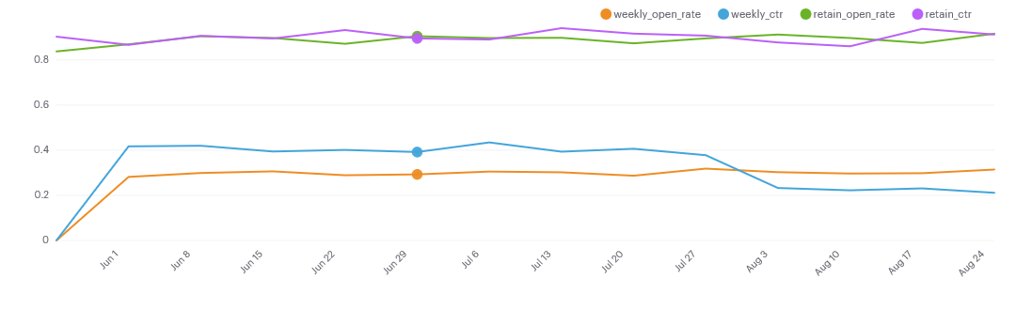

Conclusion: It appears that the problem has to do with mobile use and digest emails.