Notes on creation of subcatchments from DEM for CSI Campus.

June 24, 2023

Michael Kress, Ph. D., CSI CUNY

The map file used is: "C:\Zhanyang\SensorData\CompoundFlooding\VRVis\Transfer\NYC_DEM_Revised\NYCDEMRevised.mxd"

The directory for the gis files and work subdirectories is "C:\Zhanyang\SensorData\CompoundFlooding\CompoundFloodModel\DEMtoSubcatchment"

Also see the

This is a multistep process that starts with the DEM file. I used the tiles which Mehdi created for NYC. The tiles for the Campus were 50, 51, 66 and 67. In order to handle continuity across the times, the tiles were merged using the tool:  **Mosaic To New Raster** tool by navigating to **ArcToolbox** > **Data Management Tools** > **Raster** > **Raster Dataset**.

1. Insert the raster files.
2. Select the output location. This required making a geodatabase as a location to have the new raster placed in.
3. Specify a name and extension for the output.
4. Specify the pixel type.
5. Specify the number of bands.
6. Reference: <https://support.esri.com/en-us/knowledge-base/how-to-merge-multiple-raster-datasets-into-a-new-raster-000015258>

Note: Mehdi also merged the rasters and put the result on the drop bax at: https://www.dropbox.com/s/idthcdkt43trgob/Mosaiced.zip?dl=0

The merged raster was called CSIMergedTiles – and the source is: Data Type: File Geodatabase Raster Dataset, Database: C:\Zhanyang\SensorData\CompoundFlooding\CompoundFloodModel\DEMtoSubcatchment\CSITiles\CSITiles.gdb, Raster: CSITiles

Reference for the following is: https://www.youtube.com/watch?v=Ww4JVP4uZi4

The next steps used the toolbox SpacialAnalysisTools>hydrology>Fill followed by SpacialAnalysisTools>hydrology>FlowDirection followed by SpacialAnalysisTools>hydrology>FlowAccumulation

The next step was to create a Pour Point, Shape File, on an accumulation line followed by SpacialAnalysisTools>hydrology>SnapPourPoint.

The resulting snapped shape file is used in SpacialAnalysisTools>hydrology>Watershed with the accumulation raster to create a watershed (subcatchment) which has an outfall at the Pour Point.

The above was done for a number of outfalls until a reasonable amount of the campus was covered. The raster to polygon conversion tool ConversionTools>FromRaster>RasterToPolyline (an easy way to locate tools is to use the search tool which is located next to the Catalogue icon on the top line of the arcMap window.

The next step was to put the area in acres into the shape files containing the subcatchments. This was done by hand using the Open Attribute Table, Add Field (use defaults for a double number), Geometry Calculator, Area specify Acres(AC) as the output units.

Note: The next step is still being worked on:

The next step is to calculate the average slope of each subcatchment using the slope tool, spatialAnalyst>surface>slope. This creates a raster of slope values which need to be masked to the polygon of each subcatchment and get the statistic for the average value.

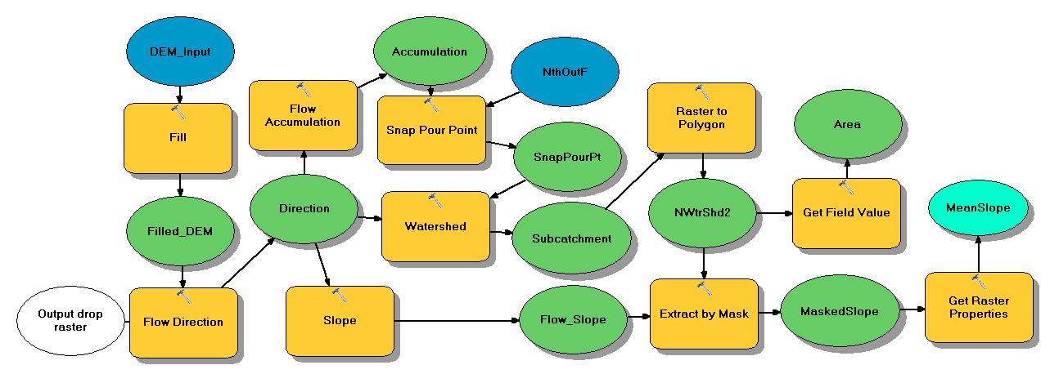

# -*- coding: utf-8 -*-

# ---------------------------------------------------------------------------

# DEMtoSubcatchment1.py

# Created on: 2023-06-24 12:50:34.00000

# (generated by ArcGIS/ModelBuilder)

# Description:

# ---------------------------------------------------------------------------

# Import arcpy module

import arcpy

# Load required toolboxes

arcpy.ImportToolbox("Model Functions")

# Local variables:

DEM_Input = "Mosaiced.img"

Filled_DEM = "C:\\Users\\M Kress\\OneDrive - csi.cuny.edu\\Documents\\ArcGIS\\Default.gdb\\Fill_img2"

Output_drop_raster = ""

Direction = "C:\\Users\\M Kress\\OneDrive - csi.cuny.edu\\Documents\\ArcGIS\\Default.gdb\\FlowDir_Fill2"

NthOutF = "NthOutF"

Accumulation = "C:\\Users\\M Kress\\OneDrive - csi.cuny.edu\\Documents\\ArcGIS\\Default.gdb\\FlowAcc_Flow2"

SnapPourPt = "C:\\Users\\M Kress\\OneDrive - csi.cuny.edu\\Documents\\ArcGIS\\Default.gdb\\SnapPou_shp8"

Subcatchment = "C:\\Users\\M Kress\\OneDrive - csi.cuny.edu\\Documents\\ArcGIS\\Default.gdb\\Watersh_Flow4"

NWtrShd2 = "C:\\Users\\M Kress\\OneDrive - csi.cuny.edu\\Documents\\ArcGIS\\Default.gdb\\NWtrShd2"

Area = NWtrShd2

Flow_Slope = "C:\\Users\\M Kress\\OneDrive - csi.cuny.edu\\Documents\\ArcGIS\\Default.gdb\\Slope_FlowDi1"

MaskedSlope = "C:\\Users\\M Kress\\OneDrive - csi.cuny.edu\\Documents\\ArcGIS\\Default.gdb\\Extract_Slop1"

MeanSlope = "18.0566748842181"

# Process: Fill

arcpy.gp.Fill_sa(DEM_Input, Filled_DEM, "")

# Process: Flow Direction

arcpy.gp.FlowDirection_sa(Filled_DEM, Direction, "NORMAL", Output_drop_raster, "D8")

# Process: Flow Accumulation

arcpy.gp.FlowAccumulation_sa(Direction, Accumulation, "", "FLOAT", "D8")

# Process: Snap Pour Point

arcpy.gp.SnapPourPoint_sa(NthOutF, Accumulation, SnapPourPt, "1", "Id")

# Process: Watershed

arcpy.gp.Watershed_sa(Direction, SnapPourPt, Subcatchment, "")

# Process: Raster to Polygon

tempEnvironment0 = arcpy.env.outputZFlag

arcpy.env.outputZFlag = "Disabled"

tempEnvironment1 = arcpy.env.outputMFlag

arcpy.env.outputMFlag = "Disabled"

arcpy.RasterToPolygon_conversion(Subcatchment, NWtrShd2, "SIMPLIFY", "Value", "SINGLE_OUTER_PART", "")

arcpy.env.outputZFlag = tempEnvironment0

arcpy.env.outputMFlag = tempEnvironment1

# Process: Get Field Value

arcpy.GetFieldValue_mb(NWtrShd2, "Shape_Area", "String", "0")

# Process: Slope

arcpy.gp.Slope_sa(Direction, Flow_Slope, "DEGREE", "1", "PLANAR", "METER")

# Process: Extract by Mask

arcpy.gp.ExtractByMask_sa(Flow_Slope, NWtrShd2, MaskedSlope)

# Process: Get Raster Properties

arcpy.GetRasterProperties_management(MaskedSlope, "MEAN", "")