**Experiment No. 5**

**A.I.M -:** Write a C program to find first of a given string.

Source Code-:

#include<stdio.h>

#include<conio.h>

void FIRST(char);

int count, n=0;

char prodn[10][10] , first[10];

void main()

{

int i, choice ;

char c,ch;

printf(“how many productions? :\n”);

scanf(“%d”,&count);

printf(“enter %d products with epsilon =$:\n”,count);

for(i=0;i<count;i++)

{

scanf(“%s %c “,prodn[i],&ch);

do

{

n=0;

printf(“element :\n”);

scanf(“%c”,&c);

FIRST(c) ;

Printf(“\n FIRST(%c) = {“,c);

for(i=0;i<n;i++)

{

printf(“%c”,first[i]);

printf(“}\n”);

printf(“press 1 to continue:”);

scanf(“%d %c”,& choice,&ch);

}

while(choice==1);

}

void FIRST(char c)

{

int j;

if( isupper(c) first[n++]==c)

for(j=0;j<count;j++)

{

if(prodn[j][2]==’$’)

first[n++]==’$’;

elseif(islower(prodn[j][2]) )

first[n++]=prodn[j][2];

else FIRST(prodn[j][2]);

}

}

}

Output- :

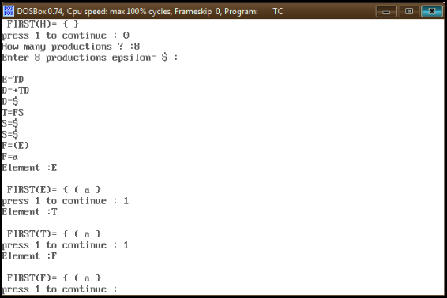

**Experiment No. 6**

**A.I.M-:** Write a program to find follow of a given string

Source Code -:

#include<stdio.h>

#include<conio.h>

int n,m=0,p,i=0,j=0;

char a[10][10], f[10] ;

void follow(char c);

void first (char c);

int main()

{

Int I,z;;

Char c,ch;

Printf(“enter the number of productions:”);

Scanf(“%d”,&n);

Printf(“\n enter the productions with epsilon &”,\n);

For(i=0;i<n;i++)

Scanf(“%s%c,a[i],&ch);

Do

{

m=0;

printf(“enter the element whose follow is to be found:”);

scanf(“%c”,&c);

follow(c);

printf(“follow(%c)={“,c);

for(i=0;i<m;i++)

printf(“%c”,f[i]);

printf(“}\n”);

printf(“do you want to continue? \n press 1 \n”);

scanf(“%d%c”,&z,&ch);

}

While(z==1)

}

Void follw(char c)

{

If(a[0][0]==c) f[m++]=’$’;

For(i=0;i<n;i++)

{

For(j=2;j<strlen(a[i]),j++)

{

If(a[i][j]==()

{

If(a[i][j+1]!=’\0’)

First(a[i][j+1]);

If(a[i][j+1]==’\0’ &&c !=[i][0])

Follow(a[i][0]);

}}

}}

void first(char c)

{

int k;

if(!(isupper(c)))f[m++]=c;

for(k=0;k<n;k++)

{

If(a[k][0]==c)

{

If(a[k][2]=’$’) follow(a[i][0]);

Else if(islower(a[k][2]))

F[m++]=a[k][2];

Else first(a[k][2]);

}

}

}

Output-:

