Experiment No.

A.I.M- Implement the C.R.C in c.

Source Code -:

#include <stdio.h>

#include <conio.h>

#include <string.h>

int main()

{

int i,j,keylen,msglen;

char input[100], key[30],temp[30],quot[100],rem[30],key1[30];

printf("Enter Data: ");

gets(input);

printf("Enter Key: ");

gets(key);

keylen=strlen(key);

msglen=strlen(input);

strcpy(key1,key);

for(i=0;i<keylen-1;i++)

{

input[msglen+i]='0';

}

for(i=0;i<keylen;i++)

temp[i]=input[i];

for(i=0;i<msglen;i++)

{

quot[i]=temp[0];

if(quot[i]=='0')

for(j=0;j<keylen;j++)

key[j]='0';

else

for(j=0;j<keylen;j++)

key[j]=key1[j];

for(j=keylen-1;j>0;j--)

{

if(temp[j]==key[j])

rem[j-1]='0';

else

rem[j-1]='1';

}

rem[keylen-1]=input[i+keylen];

strcpy(temp,rem);

}

strcpy(rem,temp);

printf("\nQuotient is ");

for(i=0;i<msglen;i++)

printf("%c",quot[i]);

printf("\nRemainder is ");

for(i=0;i<keylen-1;i++)

printf("%c",rem[i]);

printf("\nFinal data is: ");

for(i=0;i<msglen;i++)

printf("%c",input[i]);

for(i=0;i<keylen-1;i++)

printf("%c",rem[i]);

return 0;

}

Output -:

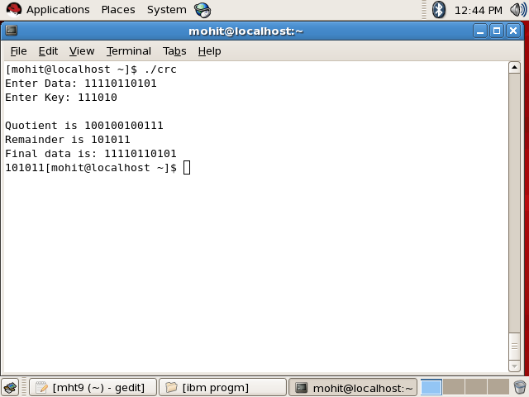

***Experiment no.***

***A.I.M-***  wap to sort a numbers using Heap Sort.

Source Code -:

#include<stdio.h>

#include<conio.h>

void maxheap(int [],int,int);

void buildmaxheap(int a[],int n)

{

int i;

for(i=n/2;i>=1;i--)

{

maxheap(a,i,n);

}

}

void maxheap(int a[],int i,int n)

{

int R,L,largest,t;

L=2*i;

R=2*i+1;

if((L<=n) && (a[L]>a[i]))

largest=L;

else

largest=i;

if((R<=n) && (a[i]>a[largest]))

largest=R;

if(largest!=i)

{

t=a[i];

a[i]=a[largest];

a[largest]=t;

maxheap(a,largest,n);

}

}

void heapsort(int a[],int n)

{

int i,temp;

buildmaxheap(a,n);

for(i=n;i>=2;i--)

{

temp=a[1];

a[1]=a[i];

a[i]=temp;

maxheap(a,1,i-1);

}

}

int main()

{

int a[50],i,n;

printf("Enter the size of array : ");

scanf("%d",&n);

printf("Enter the elements of array \n");

for(i=1;i<=n;i++)

{

scanf("%d",&a[i]);

}

heapsort(a,n);

printf("sorted array is \n");

for(i=1;i<=n;i++)

{

printf("%d\t",a[i]);

}

return 0;

}

***Output-:***

