***Experiment No. 8***

A.I.M - Write a shell program to find the sum of all the digits in a given 5 digit number.

*Source Code* -:

echo -n "Input no : "

read no

length=`expr length $no`

while [ $length -ne 0 ]

do

b=`expr substr $no $length 1`

ans=`expr $ans + $b`

length=`expr $length - 1`

done

echo "Sum of Digit is : $ans"

***Output-:***

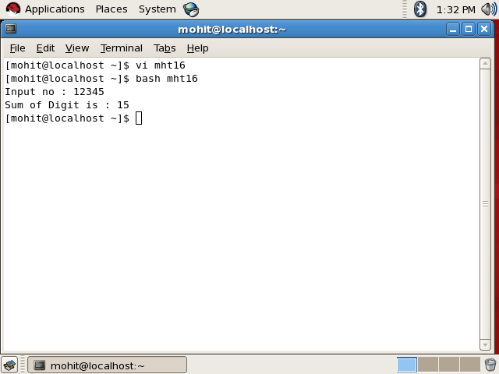

***Experiment No . 9***

***A.I.M -*** Write a shell script to find the sum, the average and the product of the four integers entered

Source Code-:

echo Enter four integers with space between

read a b c d

sum=`expr $a + $b + $c + $d`

avg=`expr $sum / 4`

dec=`expr $sum % 4`

dec=`expr \( $dec \* 1000 \) / 4`

product=`expr $a \* $b \* $c \* $d`

echo Sum=$sum

echo Average=$avg.$dec

echo Product=$product

***Output-:***

