*Bubble Sort Output -*

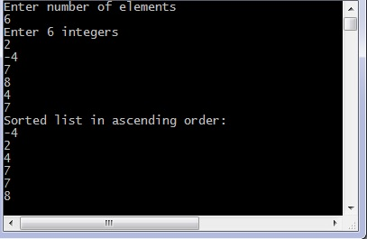

*Selection Sort Output -:*

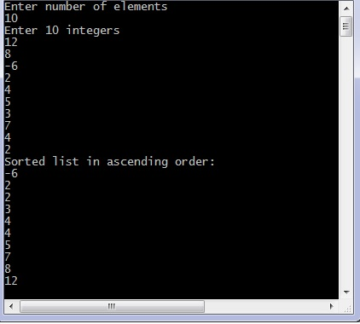

*Heap Sort Output -:*

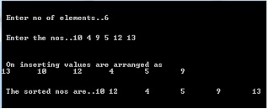

***Experimnet No. 1***

***Aim-*** Basic Linux command for Networking.

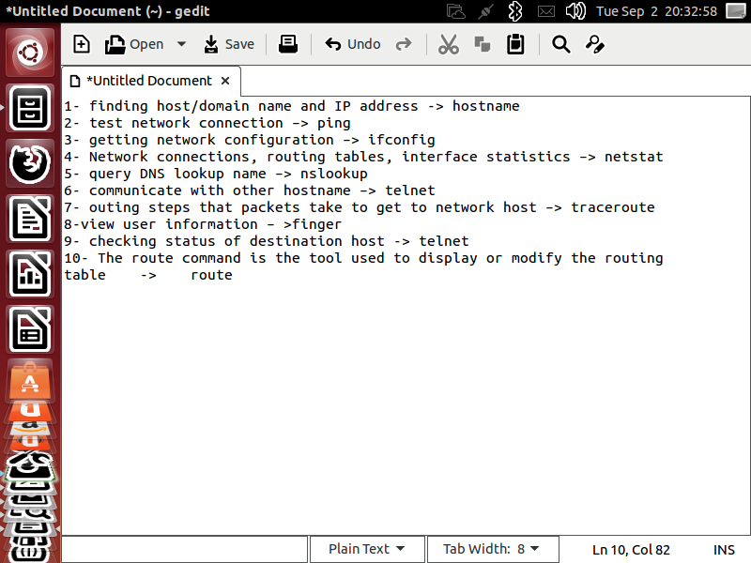

***Experiment No.2***

***Aim :-***  Wap for Bitstiffing in C using linux.

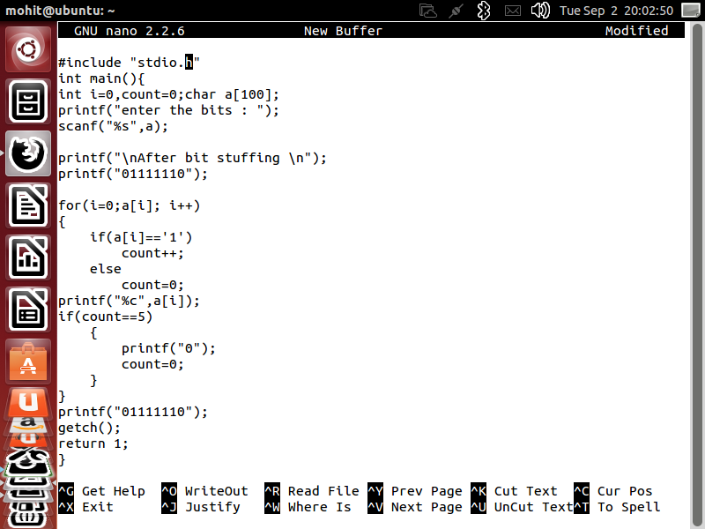

output -:

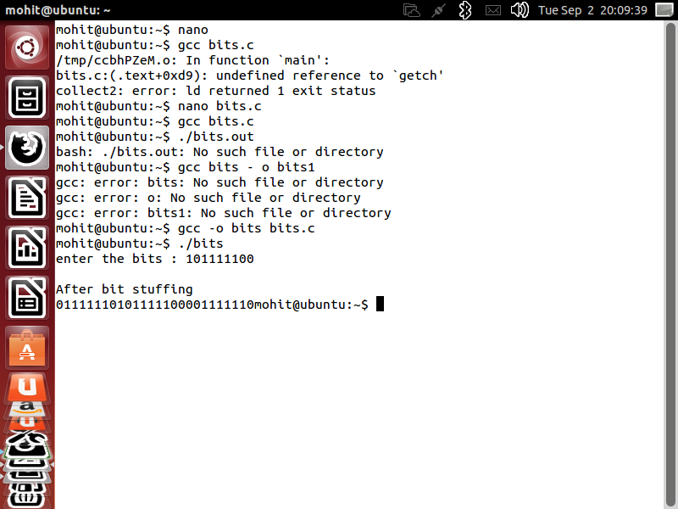

Experiment no.__

Aim- wap for merge sort in array ?

Source Code -:

#include<stdio.h>

#include<conio.h>

void merge(int [],int ,int ,int );

void part(int [],int ,int );

int main()

{

int arr[30];

int i,size;

printf("\n Merge sorting method\n");

printf("Enter total no. of elements : ");

scanf("%d",&size);

for(i=0; i<size; i++)

{

printf("Enter %d element : ",i+1);

scanf("%d",&arr[i]);

}

part(arr,0,size-1);

printf("\n Merge sorted elements \n");

for(i=0; i<size; i++)

printf("%d ",arr[i]);

getch();

return 0;

}

void part(int arr[],int min,int max)

{

int mid;

if(min<max)

{

mid=(min+max)/2;

part(arr,min,mid);

part(arr,mid+1,max);

merge(arr,min,mid,max);

}

}

void merge(int arr[],int min,int mid,int max)

{

int tmp[30];

int i,j,k,m;

j=min;

m=mid+1;

for(i=min; j<=mid && m<=max ; i++)

{

if(arr[j]<=arr[m])

{

tmp[i]=arr[j];

j++;

}

else

{

tmp[i]=arr[m];

m++;

}

}

if(j>mid)

{

for(k=m; k<=max; k++)

{

tmp[i]=arr[k];

i++;

}

}

else

{

for(k=j; k<=mid; k++)

{

tmp[i]=arr[k];

i++;

}

}

for(k=min; k<=max; k++)

arr[k]=tmp[k];

}

Output - Merge Sort.

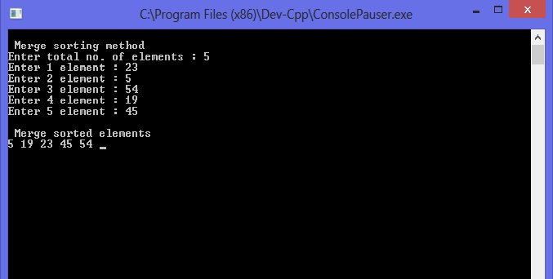

Experiment No.

A.I.M - Wap for a selection sort in c.

Source Code -:

#include <stdio.h>

int main()

{

int array[100], n, c, d, position, swap;

printf("Enter number of elements**\n**");

scanf("%d", &n);

printf("Enter %d integers**\n**", n);

for ( c = 0 ; c < n ; c++ )

scanf("%d", &array[c]);

for ( c = 0 ; c < ( n - 1 ) ; c++ )

{

position = c;

for ( d = c + 1 ; d < n ; d++ )

{

if ( array[position] > array[d] )

position = d;

}

if ( position != c )

{

swap = array[c];

array[c] = array[position];

array[position] = swap;

}

}

printf("Sorted list in ascending order:**\n**");

for ( c = 0 ; c < n ; c++ )

printf("%d**\n**", array[c]);

return 0;

}

Experiment No.

Aim- Wap for a bubble sort in c.

Source Code -:

#include <stdio.h>

int main()

{

int array[100], n, c, d, swap;

printf("Enter number of elements**\n**");

scanf("%d", &n);

printf("Enter %d integers**\n**", n);

for (c = 0; c < n; c++)

scanf("%d", &array[c]);

for (c = 0 ; c < ( n - 1 ); c++)

{

for (d = 0 ; d < n - c - 1; d++)

{

if (array[d] > array[d+1]) */* For decreasing order use < */*

{

swap = array[d];

array[d] = array[d+1];

array[d+1] = swap;

}

}

}

printf("Sorted list in ascending order:**\n**");

for ( c = 0 ; c < n ; c++ )

printf("%d**\n**", array[c]);

return 0;

}