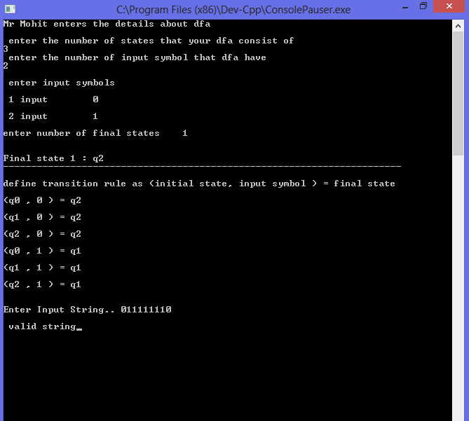

***Experiment no. ___***

***A.I.M*** - Write a program to check whether string is accepted by a dfa or not , take transition table as input by the user ?

***Source Code*** -

#include<stdio.h>

#include<conio.h>

int ninputs;

int chk(char,int );

int dfa[10][10];

char c[10], string[10];

int main()

{

int nstates, nfinals;

int f[10];

int i,j,s=0,final=0;

printf("Mr Mohit enters the details about dfa ");

printf("\n \n enter the number of states that your dfa consist of \n");

scanf("%d",&nstates);

printf(" enter the number of input symbol that dfa have \n");

scanf("%d",&ninputs);

printf("\n enter input symbols\t");

for(i=0; i<ninputs; i++)

{

printf("\n\n %d input\t", i+1);

printf("%c",c[i]=getch());

}

printf("\n\nenter number of final states\t");

scanf("%d",&nfinals);

for(i=0;i<nfinals;i++)

{

printf("\n\nFinal state %d : q",i+1);

scanf("%d",&f[i]);

}

printf("\n\ndefine transition rule as (initial state, input symbol ) = final state\n");

for(i=0; i<ninputs; i++)

{

for(j=0; j<nstates; j++)

{

printf("\n(q%d , %c ) = q",j,c[i]);

scanf("%d",&dfa[i][j]);

}

}

do

{

i=0;

printf("\n\nEnter Input String.. ");

scanf("%s",string);

while(string[i]!='\0')

if((s=chk(string[i++],s))<0)

break;

for(i=0 ;i<nfinals ;i++)

if(f[i] ==s )

final=1;

if(final==1)

printf("\n valid string");

else

printf("invalid string");

getch();

printf("\nDo you want to continue.? \n(y/n) ");

}

while(getch()=='y');

getch();

}

int chk(char b,int d)

{

int j;

for(j=0; j<ninputs; j++)

if(b==c[j])

return(dfa[d][j]);

return -1;

}