Mech3 Mission Editor

Version 0.5.8

This software is free for use and is not warranted or implied for any purpose or use. It is not guaranteed to work for any purpose. Usage of this program is an agreement that I am not liable for any damage that may occur from its use. Use this program at your own risk. Microsoft, Zipper Interactive, FASA and/or Activision does not support this program and will likely not give you support with Mech3 if you use this program. There aren't any guarantees for support or upgrades. I will update the program at my leisure and convenience.

Requirements:
Mechwarrior 3 is Required.
200Mhz Pentium or faster
Windows 95/98
32MB RAM
High Color Graphics (640x480x16-bit color 2MB video RAM minimum)
Hard Drive 4MB

The program is designed to allow you to edit existing Mech3 multi-player missions to allow you to create new missions. The program is not designed to create new 3D items in the program. The program is designed to let you alter multi-player mission properties only.

The program will attempt to detect your Mech3 working directory and start working from the proper directory. The program should start in the zbd directory. Multi-player missions in Mech3 are limited to the following files where ## is a one or two digit number:
c1\readermp##.zbd
c2\readermp##.zbd
c3\readermp##.zbd
c4\readermp##.zbd
c4b\readermp##.zbd
t1\\readermp##.zbd

You must select an existing editable mission for editing. The original set of multiplayer missions in Mech3 are not editable because the information in the readermp##.zbd file isn't complete. If you get the message "Built in Mission not available to edit!" then choose a different mission to edit.

Usage: When you open up a mission it will load up the map and display points and boundaries on the screen.

Graphical descriptions:
light blue points are startup points (where mechs are when the game begins)
blue lines are x and y axis
yellow line is the warning boundary that your going out of bounds
red line is the kill boundary.
green points are MFB locations.

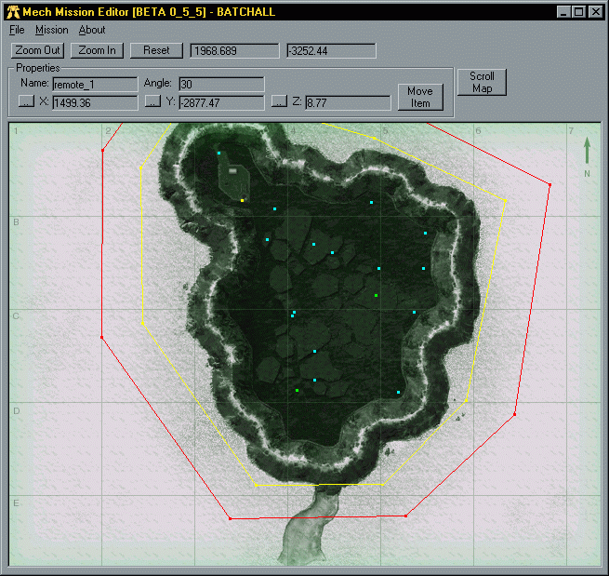
Every point in the file is represented in 3 dimensions X,Y,Z you must be careful not to ignore the Z value or you may be putting startup points inside of surface features or underground. Note also if you put the startup points outside of the boundaries they will cause the boundary event to happen upon spawn, ie (yellow warning or red kill).
Moving over start up points will display their properties in the properties frame, after which you can click mouse button down and drag to the new location. Alternatively, after the point is in the properties frame, you can click on the x ,y ,z coordinate buttons to adjust them by hand.

To move the map around you'll have to hit the Scroll Map button, after which you can click and drag the map around to see the rest of it. Click on the Done button when your finished moving the map around and ready to move points.

The environment menu choice will let you adjust environment variables in the mission. Under the environment settings its pretty much spelled out, the only thing is, we aren't certain of the maximum values for the properties, so your guess is as good as any. We notice however that RGB values are based on a 0-1 range so that .5 .5 .5 is gray.
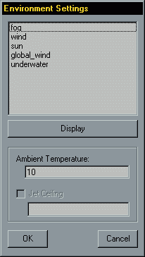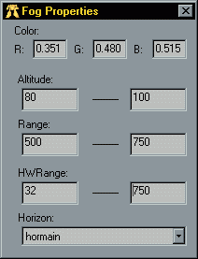
You will notice that in some missions not all of the environmental settings are available to edit. This is because the settings aren't in the particular mission and will default to the campaign setting. (C1,C2,C3,C4,C4B
,T1).
One simple feature is the Ambient Temperature, this appears to be the temperature in Centigrade. To alter the value just change it in the box and hit ok. The Jet Ceiling appears to be the setting to allow indoor ceiling limits (ie. hit the top of a cave) Altering this setting is usually not a real good idea.

Under the Fog properties Altitude has a minimum and maximum setting this appears to be the z value where fog begins and ends, altering this properly you can give the cloudy sky effect or fog just lingering below or above vision. The Range and HWRange settings influence the Density of the fog. The Horizon setting lets you change it from a typical sky scene (defaulted by the campaign) or black, often used in cave missions.

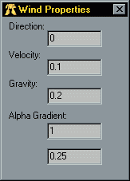The Wind properties appears to be the setting in degrees of the wind blowing where 0 is directly north and 180 is directly south. Velocity is wind speed in ft/sec. Gravity is unclear and untested as yet, it might be falling speed or possibly push speed. Alpha Gradient is also unclear.

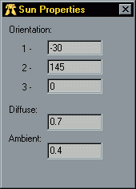Orientation appears to be in angles, the -30 is -30 from north and 145 appears to be 145 degrees off of the horizon. Diffuse and Ambient appear to be light settings for brightness and general lighting intensity.

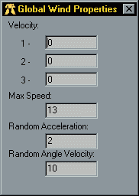Velocity of Wind appears to be in 3 values possibly angles as the sun settings above. Max Speed is the maximum gust of wind. Random Acceleration is the randomness of how the gusts come and the angle velocity is the angle randomness from which direction.

These properties are much like the fog settings. Please review the settings for fog for details.
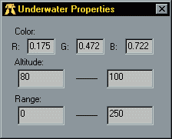

Environmental settings aren't set until you hit the OK button on the main property selection dialog. If you hit cancel on the main property selection dialog all settings that you changed in the individual environment settings will not be valid.

Mission Naming Rules: Mission Filenames need to be carefully selected. If you have a mission with a name say "RedSmog" and you saved it as readermp88.zbd and someone
else has one they names "RedSmog" and they saved theirs as readermp12.zbd they won't
work when you try to launch the game in multiplayer.

To get the missions to work for everyone these rules must be followed:
- They must be named the same on all machine using it. (ie. readermp99.zbd)
- They must be in the same directory name (ie. zbd/c3)
- They must all have the same mission name. (ie. RedSmog)
- The mission number readermp##.zbd has to be two digits it doesn't like 3 digits.

Change log from 0.5.5 to 0.5.8
Bug fixes that clobber the file after editing a while. Found the bug after some searching. This should fix quite a bit of the bad missions problem that was going around.

Change log from 0.5.4 to 0.5.5
Allow MFB menu item added - This will let you turn MFBs on or off in a mission (if the mission already has this option.) Some missions don't have the flag to turn it off and on.
Move Boundary Points - This will now let you move the boundary points around just like the startup points.

Change log from 0.5.3 to 0.5.4:
Highlight selected node points - This should help keep from confusing what you might have selected, it turns the selected point yellow so you know which point on the screen the properties is displaying information about.
MFB Points - You can now drag MFB points around like regular startup points. The MFB points will be colored Green.
Caption - I changed the caption to reflect the real version number and not some arbitrary number I thought up so you can keep track of the real beta build numbers.

Change log from 0.5.1 to 0.5.3:
Bitmap Image is now 15-bit instead of 32-bit - should speed up refreshes and use less memory now.
Embedded Properties into main window - this is more intuitive, you don't have to worry about displaying it because it's always there and you don't have to worry about it being on top.
User Interface Change - Due to major confusion on how to operate the program it seemed a better design to let you click and drag points first instead of scrolling the map. So you now can click on points and move them and use a button to activate scrolling of the map.

On the To Do list:
✓Move Boundary points.
Move entire boundaries.
Move entire points & boundaries.
✓MFB Move
✓MFB enable/disable
MFB enable/disable (Add to mission)
Mission Syncing on Launch (anti-cheat)
Rotate start up points for Z - testing

Wish list:
Detect Z values automatically.
Display Map in 3D.

Any bugs, e-mail me.
VMaxx
vmaxx@tisd.net

