Introduction
PROBA-V is an earth observation satellite designed to map land cover and vegetation growth across the entire globe. It was launched on the 6th of May 2013 into a sun-synchronous orbit. It's payload sensors allow for an almost global coverage (90%) per day, providing 300m resolution images(LR). PROBA-V also provides 100m "high resolution" images (HR), but at a lower frequency, of roughly every 5 days (dependent on the location).
The goal of this article is to construct such high-resolution images by using more frequent low-resolution images. This process is known as Multi-image Super-resolution.
PROBA-V takes multiple images from the same patch, but originate from successive revisits over longer periods of time. Thus, PROBA-Vs products represent a convenient way to explore super-resolution in a relevant setting. The images provided are not artificially degraded, but are real images recorded from the very same scene, just at different resolutions and different times. Any improvements on this data-set might be transferable to larger collections of remote sensing data without the need to deploy more expensive sensors or satellites, as resolution enhancement can happen post-acquisition.
Data
The data is collected satellite data from the PROBA-V mission 74 regions around the globe at different points in time. The data is composed of radiometrically and geometrically corrected Top-Of-Atmosphere (TOA) reflectances for the RED and NIR spectral bands at 300m and 100m resolution in Plate Carrée projection. The 300m resolution (LR) data is delivered as 128x128 grey-scale pixel images, the 100m resolution (HR) data as 384x384 grey-scale pixel images.
Each image comes with a quality map, indicating which pixels in the image are concealed (i.e. clouds, cloud shadows, ice, water, missing, etc) and which should be considered clear. Each data-point consists of exactly one hight-resolution image and several low-resolution images from the same scene. In total, the dataset contains 1450 scenes, which are split into 1160 scenes for training and 290 scenes for testing. On average, each scene comes with 19 different low resolution images and always with at least 9.
Metric
To compare the quality of each super-resolution method, a modifier clear Peak Signal to Noise Ratio is used. To calculate the score, we calculate the bias of the brightness which is the mean difference between the cropped HR images and cropped submitted image SR. This bias is used to calculate the corrected clear mean square error of the SR and HR images. After that we calculate the clear Peak Signal to Noise Ratio and deduce the score which is the baseline cPSNR devided by the cPSNR. (see https://kelvins.esa.int/proba-v-super-resolution/scoring/ for all equations)
Approaches
Many approaches where used to solve the multi-image super-resolution (MISR)
1- Bicubic transformation
we construct the high-resolution image by aggregating low-resolution images pixel wise. The functions used are mean, median and mode. We aggregate only clear pixels by using the quality map of each image. After that, we applied the bicubic transformation. This method was worst than the baseline upscaling method used in this competition.
2- SRCNN
we implemented the SRCNN from Chao Dong et al (2015) article. It is a deep convolutional network that learns an end-to-end mapping between the LR images and HR images. This model takes the upscaled LR images as input and outputs a SR image. The model that we used has the following architecture:
- a Conv2D with 32 filters, 9x9 kernel, ReLU activation function
- a Conv2D with 32 filters, 3x3 kernel, ReLU activation function
- a Conv2D with 64 filters, 3x3 kernel, ReLU activation function
- a Conv2D with 128 filters, 3x3 kernel, ReLU activation function
- a Conv2D with 64 filters, 3x3 kernel, ReLU activation function
- a Conv2D with 32 filters, 5x5 kernel, ReLU activation function
- a Conv2D with 1 filter, 5x5 kernel, Sigmoid activation function
The LR images were upscaled using the baseline upscaling function which average images with maximum clarity and uses bicubic interpolation.
To train this model, we used the PSNR as a loss function and Adam optimizer with learning rate of 0.001 and beta_1 of 0.9.
We trained the model for 300 epochs

The SRCNN takes as input the upscaled image, which increases the computational cost which made it very slow specially since it was trained on CPU ( I don’t have a gpu) and to have acceptable result, it should be trained for a big number of epochs.
To address this problem, we applied the FSRCNN
3- FSRCNN
FSRCNN stands for Fast Super Resolution Convolutional Neural Network. It’s objective is resorting quality and increasing speed. Fig 1 showes the network structure of SRCNN and FSRCNN. The main advantages of FSRCNN over SRCNN are as fellow:
- using deconvolution layer at the end of the network instead of the bicubic transformation
- learning the mapping directly from the low-resolution image which decrease the computational cost
- using smaller kernel sizes and more mapping layers
- shrinking the input feature dimension before mapping
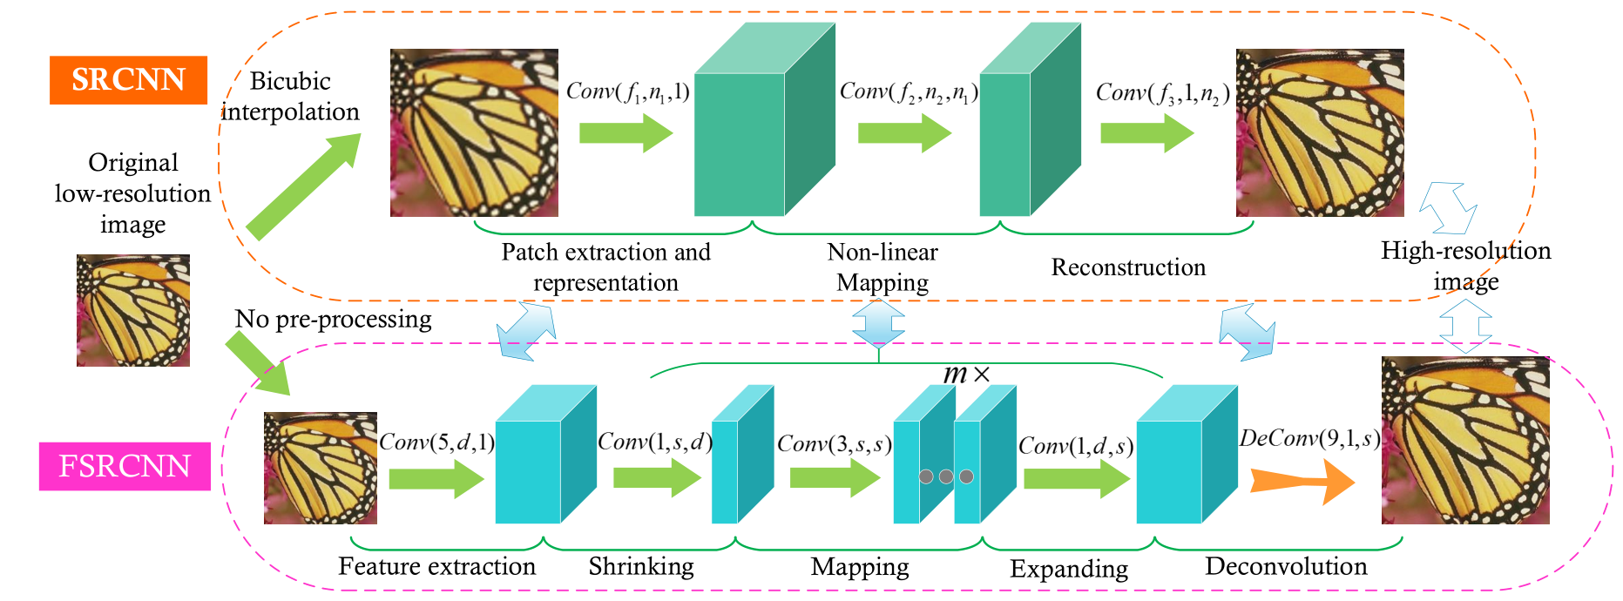
since FSRCNN is used for single image super-resolution, we used two approaches to combine the different pictures. First approach is to aggregate all LR images using the median of each pixel so to end up with a (128,128,1) input image. The second approach is to use concatenate the 9 LR images with the maximum number of clear pixels, so the input image for the network is of size (128,128,9)
The structure used for FSRCNN is as follow:

- feature block with 1 Conv2D layer with 32 filters, 5x5 kernel and 1x1 stride size with a PReLU activation layer.
- shrinkage block with 1 Conv2D layer with 32 filters, 1x1 kernel and 1x1 stride size with a PReLU activation layer.
- mapping block with 4 Conv2D layers with 32 filters, 3x3 kernel and 1x1 stride size with a PReLU activation layer.
- expanding block with 1 Conv2D layer with 32 filters, 5x5 kernel and 1x1 stride size with a PReLU activation layer.
- deconvolution block with 1 deconvolution layer with 1 filter, 9x9 kernel and 3x3 stride size.
The model was trained first using the MSE as a loss and after using the PSNR. We used Adam optimizer with a learning rate of 0.001 and beta_1 of 0.9. we trained the model for 300 epochs.

4- SRGAN
Next we applied a modified version of Super Resolution GAN. This model was developed by Christian Ledig et al (2017) in there article entitled Photo-Realistic Single Image Super-Resolution Using a Generative Adversarial Network. They used a perceptual loss function which consists of an adversarial loss and a content loss. The adversarial loss is used to train the discriminator network to differentiate between the SR images and HR images. In addition, they defined a new loss based of the high-level feature map of the VGG network.
Fig 2 shoes the SRGAN architecture which is composed of a generator that generate images and a discriminator differentiate between true images and fake images.
For the Generator, we implemented the one used in Xintao et all (2018) in there article intited

