CSD-310 GROUP A  
Jeremy Ginter  
Daniel Preller  
Melissa Favelli

BACCHUS WINERY CASE STUDY

**Wine Distribution Report:**

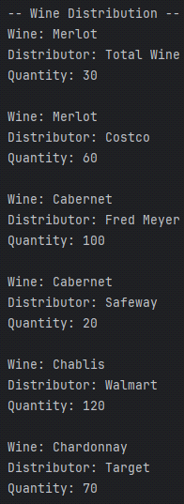

The Wine Distribution report displays information about how each wine is selling. The report displays the name of the wine, the distributor who placed the order, and the quantity of that wine the distributor purchased. This can be used to determine what wines are selling and in what amount, as well as if specific distributors are not buying as much as expected.

**Employee Work Hours Report:**

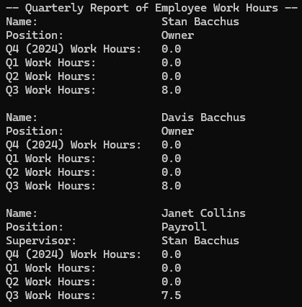 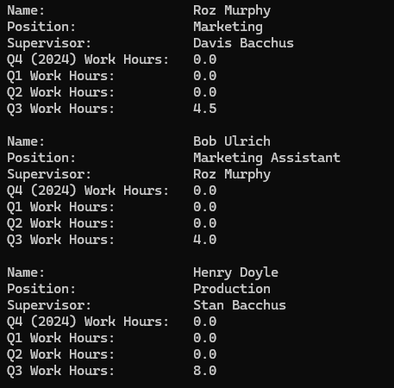

This report displays information about each employee at Bacchus Winery. It displays each employee’s full name, position, and supervisor, if applicable. It also shows how many hours each employee worked for each of the past four quarters. Its primary purpose is to show the work hours of each employee. The test data only includes work hours for quarter 3, but the report is tested to work with data from other quarters as well.

**Supplier Report:**

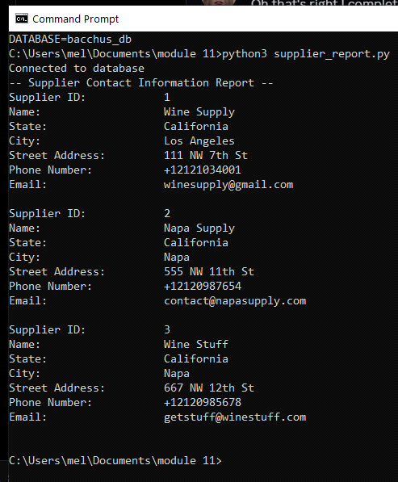

This report displays the information for the 3 suppliers used by Bacchus Winery. It displays the supplier's ID, their company name, and their full address besides zip code (street address, city, state) as well as their phone number and email address. The purpose is to show the contact information for each supplier in the instance that someone at Bacchus would need to contact the supplier or confirm information as it comes in.

The second part of the report shows each order, grouped by supplier. It also shows how many days early or late each order arrived. The primary purpose is to show how each supplier is performing in terms of shipments so decisions about changing suppliers can be made.