CSD-310 GROUP A  
Jeremy Ginter  
Daniel Preller  
Melissa Favelli

BACCHUS WINERY CASE STUDY

**Case Study Summary:**

Stan and Davis Bacchus recently inherited a winery from their father after his retirement. They have been eager to incorporate new business methods into the business, and they have decided to create a business database to do so. They have kept all prior personnel in place, which currently includes Janet Collins, in charge of finances; Roz Murphy, head of marketing; Bob Ulrich, Roz’s assistant; Henry Doyle, production manager; Maria Constanza, head of distribution; and twenty employees. Bacchus Winery grows grapes to produce several types of wines, and they order supplies from multiple suppliers. Their data needs include items such as how well each wine is selling and which distributors carry them, how many hours each employee has worked over the past four quarters, and the difference between the expected and actual delivery time for supply orders.

**Entity Relationship Diagram:**

**Wine Distribution Report:**

The Wine Distribution report displays information about how each wine is selling. The report displays the name of the wine, the distributor who placed the order, and the quantity of that wine the distributor purchased. This can be used to determine what wines are selling and in what amount, as well as if specific distributors are not buying as much as expected.

**Employee Work Hours Report:**

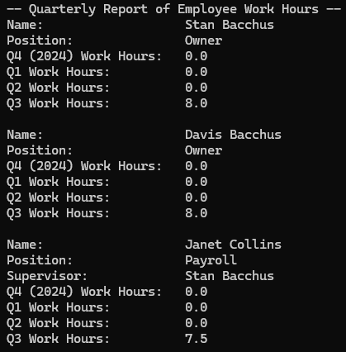 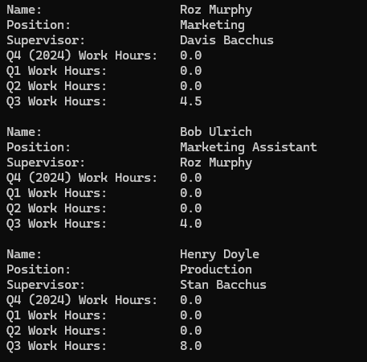

This report displays information about each employee at Bacchus Winery. It displays each employee’s full name, position, and supervisor, if applicable. It also shows how many hours each employee worked for each of the past four quarters. Its primary purpose is to show the work hours of each employee. The test data only includes work hours for quarter 3, but the report is tested to work with data from other quarters as well.

**Assumptions:**

During the design process, we assumed that each employee would have a position that could be stored. We also assumed that each distributor and supplier would have an address that could be stored in a three-field format of state, city, and street address. Additionally, we assumed that storing the current inventory quantity, as well as the quantity of items supplies bought and products sold, would be sufficient for the winery’s inventory tracking needs.