ANA 515 Assignment 3, Visualizations Activity

Mel Sparks

4/17/2022

## Greenhouse Gas Emissions Dataset

This dataset contains information regarding how many tons of greenhouse gas emissions are produced annually in the world and by country from 1990 to 2018. I’m hoping to ascertain whether greenhouse gas production has increased or decreased worldwide, as well as if any top producing countries have made progress towards decreasing their annual output.

## This dataframe has 8 rows and 30 columns. Below, we can see a sample of how the dataframe looks.

## Country X2018 X2017 X2016 X2015 X2014  
## 1 China 11705.81 11408.26 11207.66 11149.68 11155.76  
## 2 United States 5794.35 5613.64 5676.92 5586.69 5711.15  
## 3 India 3346.63 3202.82 3073.24 3002.17 2988.34  
## 4 European Union (27) 3333.16 3401.95 3387.97 3046.38 2990.49  
## 5 Russia 1992.08 1939.26 1918.26 1791.21 1841.26

By looking at the dimensions, we can ascertain that the dataframe continues for another 20+ years. This won’t work for the type of visualizations I mentioned that we wanted to look at in the intro, so we’ll take a few steps to reformat the dataframe.

## Now the dataframe has 29 rows and 9 columns. Below, we can see a sample of how the dataframe looks now.

## Year China United States India European Union (27) Russia  
## 29 1990 2873.00 5543.00 1009.00 4279.00 2885.00  
## 28 1991 3023.38 5501.92 1064.49 4202.13 2788.70  
## 27 1992 3154.54 5583.80 1096.71 4058.11 2551.94  
## 26 1993 3377.79 5691.26 1128.44 3984.95 2294.62  
## 25 1994 3528.81 5782.20 1174.78 3968.32 2011.47

# Visualization 1

## First I want to see the trends for the top GHG emission producing countries for the given time period (1990 - 2018).

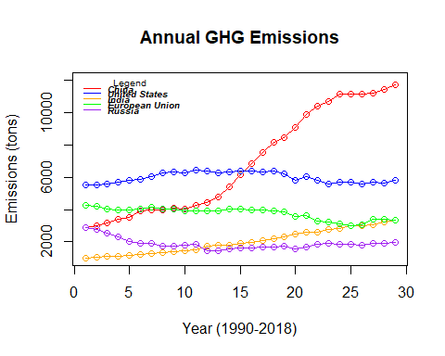

In the graph above, we have the top five GHG producing countries/regions in the world. We can see that China has drastically increased it’s GHG emissions over the years. All other top producing countries, by comparison, have either mostly stayed the same – with the exceptions of Russia, who has allegedly somewhat decreased it’s production over the years, and India, who has increased steadily, but not by the margin that China has.

# Visualization 2

I’m also interested in the overall production of GHG emissions worldwide. I want to make a simple graph that shows the change in greenhouse gas emissions worldwide from 1990 to 2018.

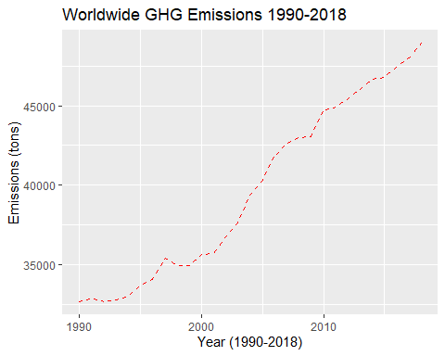

In the graph above, we can see that greenhouse gas emissions have been increasing worldwide since 1990. This isn’t entirely surprising – in fact I expected GHG emissions to have increased over the years. The thing that is somewhat surprising is that this graph makes me wonder who the key contributors are to the increase. We already know that China’s production has drastically increased, but I don’t think they account for the increase overall.

# Visualization 3

I want another graph that’ll show how much each country/region contributes to the overall increase of GHG emissions over the years. Ideally, I would like to make a stacked bar chart that shows the cumulative increase – starting with just the top 8 producing countries/regions to keep things simple.

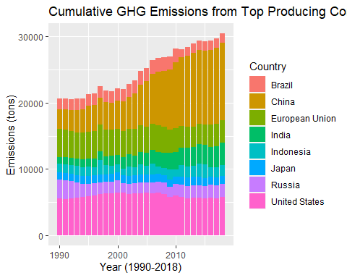

NOTE: I included this graph because I wasn’t sure if we were allowed to use our visualization from the discussion post this week as a part of this assignment. I really wanted to show a bar or area chart that tracked the cumulative GHG production and compare it to worldwide production.